Exhibit B

Business Description

Silver Falls State Park

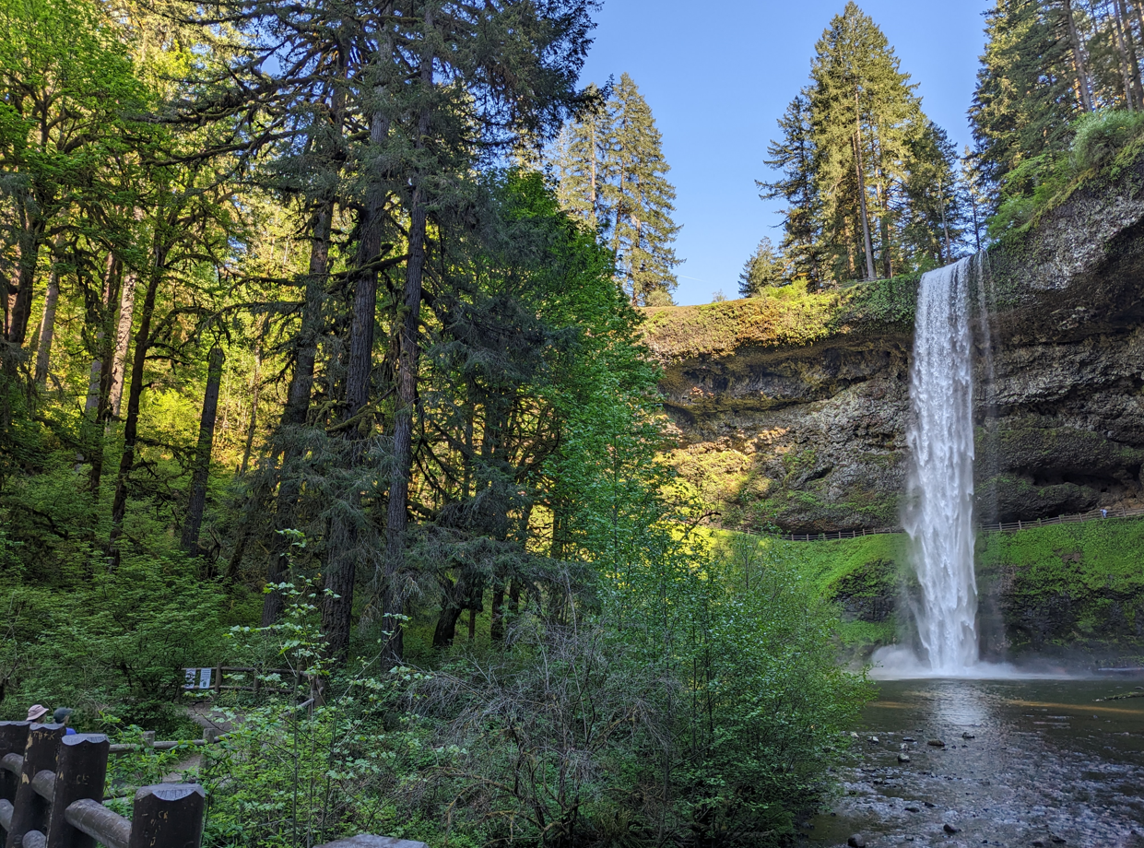

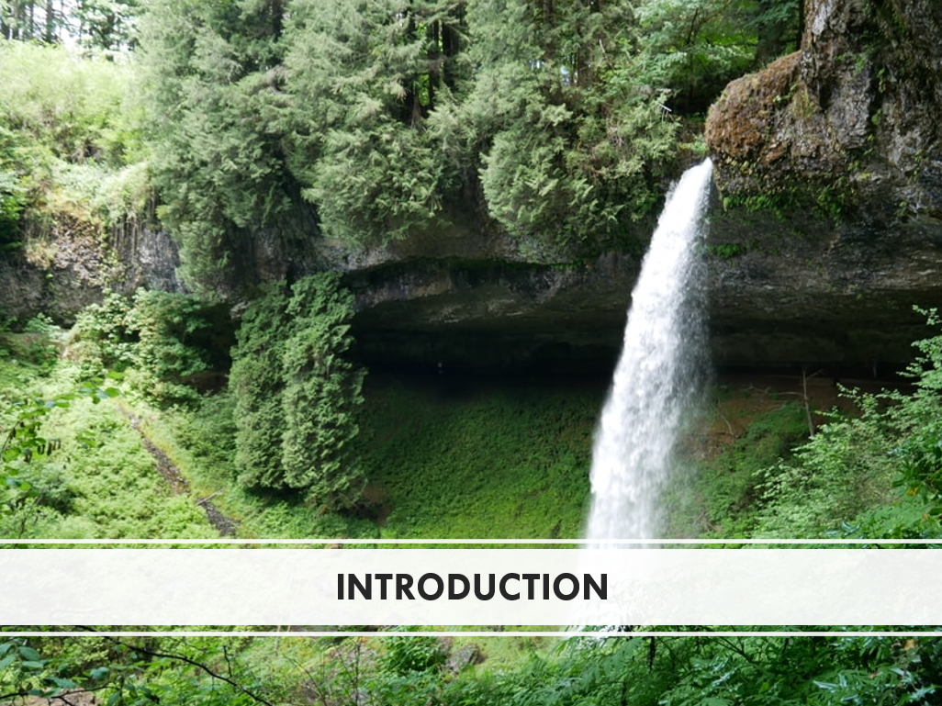
The purpose of this Business Description is to provide the results of a market analysis to interested Parties. This Business Description describes key market and industry trends in consideration of the next operator of the lodging, food and beverage, retail, and other services at Silver Falls State Park (“the Park”).
- Market Overview

Geographic Setting
Silver Falls State Park is in the town of Sublimity, Oregon, which falls in the northern region of Willamette Valley. Silver Falls State Park is a relatively short drive to several major cities. The Park is located approximately 24 miles southeast of Salem, Oregon; 55 miles south of Portland, Oregon; 77 miles northeast of Eugene, Oregon; and 130 miles northwest of Bend, Oregon. The table below provides details on the approximate driving time between the Park and the closest cities.

Approximate Driving Times to Silver Falls State Park
City | Approximate Drive Time to Park
Salem | 35 minutes
Portland | 1 hour 15 minutes
Bend | 1 hour 20 minutes
Eugene | 1 hours 30 minutes
Source: Google Maps
The regions and counties of Oregon are shown in the following maps. Silver Falls State Park is in Marion County, which borders Linn County to the north, Clackamas County to the south, Yamhill and Polk Counties to the east and Jefferson and Wasco Counties to the west. The following exhibit illustrates the location of Silver Falls State Park within the region of Willamette Valley.

Regional Map of Oregon
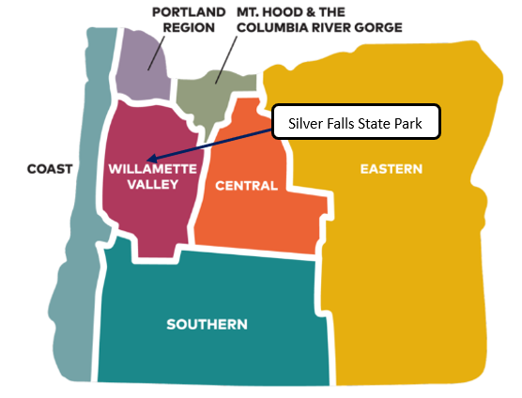
Source: Travel Oregon
The following map illustrates the location of Silver Falls State Park in relationship to the counties in the State of Oregon.

County Map of Oregon
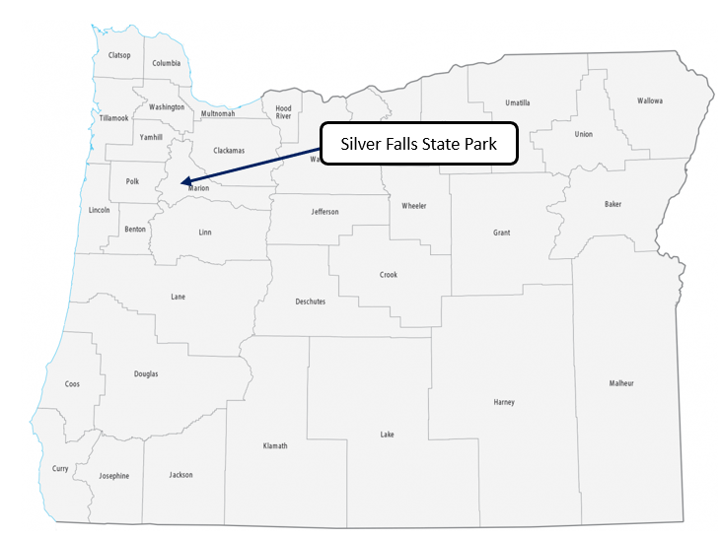
Source: GISGeography

Economic and Demographic Trends
The market for proposed hospitality and recreation developments is dependent upon the overall economic conditions existing within the local, regional, state, and national landscape. To better understand these factors, OPRD considers the economic and demographic trends for Marion County, the State of Oregon, and the United States. The economic and demographic metrics are a critical component of a market analysis and provide context for the trends that the local and regional markets are experiencing.

Economic and Demographic Trends for Marion County, Oregon, and the United States
Variable | Marion County | Oregon | USA
2020 Total Population | 345,920 | 4,237,256 | 331,449,281
2023 Total Population | 353,568 | 4,335,082 | 337,470,185
2028 Total Population | 359,691 | 4,412,462 | 342,640,129
2023-2028 Population: CAGR | 0.34% | 0.35% | 0.30%
2023 Total Households | 125,625 | 1,719,553 | 129,917,449
2028 Total Households | 128,254 | 1,763,689 | 133,099,006
2023-2028 Households- CAGR | 0.42% | 0.51% | 0.49%
2023 Median Household Income | $67,296 | $75,484 | $72,603
2028 Median Household Income | $78,537 | $87,190 | $82,410
2023-2028 Median Household Income- CAGR | 3.14% | 2.93% | 2.57%
2023 Average Household Income | $92,887 | $106,327 | $107,008
2028 Average Household Income | $108,028 | $123,232 | $122,048
2023-2028 Average Household Income- CAGR | 3.07% | 2.99% | 2.67%
2023 Per Capita Income | $33,143 | $42,258 | $41,310
2028 Per Capita Income | $38,656 | $49,344 | $47,525
2023-2028 Average Per Capita Income- CAGR | 3.13% | 3.15% | 2.84%
2023 Employed Civilian Population Age 16+ | 158,514 | 2,081,971 | 163,036,143
2023 Unemployed Population Age 16+ | 9,810 | 122,941 | 7,305,454
2023 Unemployment Rate | 5.80% | 5.60% | 4.30%
Source: ESRI Business Analyst, US Census Bureau
The data provided in the exhibit above indicates positive population growth for all relevant market areas. Total population has increased in all three market areas from 2020 to 2023. However, Marion County and Oregon are expected to grow slightly faster than the United States as a whole over the next five years. From 2023-2028, ESRI projects the Compound Annual Growth Rate (“CAGR”) to be 0.34 percent in Marion County, 0.35 percent in Oregon, and 0.30 percent in the United States. While the median and average household incomes for Marion County are lower than Oregon and the United States, the data also shows that projected increases in in Median Household Income and, Average Household Income in Marion County outpaces growth in Oregon and the United States from 2023 to 2028. This increase bodes well for future economic spending in the area surrounding the Silver Falls State Park. The unemployment rate in Marion County is higher than the State and national average which could indicate a readily available local labor pool.
The size and economic resiliency of the local population is important to understand as it relates to day-use and other retail and food and beverage services. However, overnight accommodations typically draw from a larger market area. Origin data has been analyzed from campers that stayed in Silver Falls State Park from 2018 to 2023 year-to-date, along with guests who stayed at Smith Creek Village from 2021 to 2023 year-to-date. The majority of visitors are from large cities in Oregon, such as Portland, Salem, Eugene, Bend, and Beaverton. The area within these driving distances represents a suitable market drawing area to evaluate for the existing operations.

30-, 60-, and 120-mile driving time from Silver Falls State Park
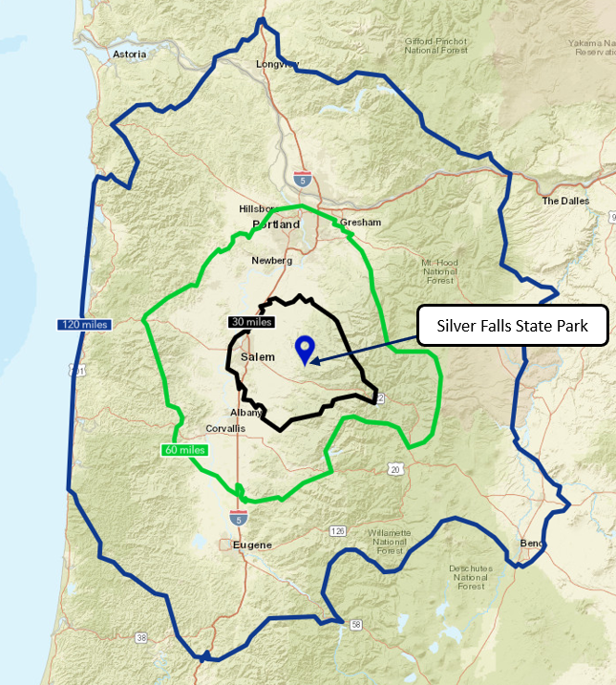
Source: ESRI Business Analyst
ESRI Business Analyst utilizes data from the US Census Bureau to prepare an Economic, Demographic, and Income Profile report. The following exhibit presents the demographic and economic trends for the three driving time rings shown above. The analysis of the market drawing area data indicates that there are projections of population growth within all three driving distances. The data also shows a projected increase for the Median Household Income, Average Household Income, and Per Capita Income in all three driving times from 2023 to 2028.

Demographic and Economic Trends for 30-, 60-, and 120-mile drive time of Silver Falls State Park
Variable | Silver Falls State Park
Variable | 30 miles | 60 miles | 120 miles
2020 Total Population | 341,154 | 1,944,057 | 3,927,499
2023 Total Population | 349,839 | 1,988,301 | 4,038,206
2028 Total Population | 355,894 | 2,027,755 | 4,132,972
2023-2028 Population: CAGR | 0.34% | 0.39% | 0.47%
2023 Total Households | 124,819 | 783,204 | 1,578,216
2028 Total Households | 127,525 | 804,965 | 1,626,497
2023-2028 Households- CAGR | 0.43% | 0.55% | 0.60%
2023 Median Household Income | $68,530 | $82,780 | $80,886
2028 Median Household Income | $79,841 | $97,840 | $94,579
2023-2028 Median Household Income- CAGR | 3.10% | 3.40% | 3.18%
2023 Average Household Income | $94,112 | $117,611 | $113,165
2028 Average Household Income | $109,312 | $136,003 | $131,324
2023-2028 Average Household Income- CAGR | 3.04% | 2.95% | 3.02%
2023 Per Capita Income | $33,723 | $46,432 | $44,307
2028 Per Capita Income | $39,310 | $54,092 | $51,760
2023-2028 Average Per Capita Income- CAGR | 3.11% | 3.10% | 3.16%
2023 Employed Civilian Population Age 16+ | 157,477 | 1,011,963 | 2,003,036
2023 Unemployed Population Age 16+ | 10,039 | 56,638 | 115,111
2023 Unemployment Rate | 6.00% | 5.30% | 5.40%
Source: ESRI Business Analyst, US Census Bureau
- Tourism
While there are ample cultural and historical resources around the state, Oregon credits much of its popularity as a tourist destination to the expansive natural areas within the state. Reportedly, 65 percent of Oregon residents believe scenic destinations are the top draw for tourists. While visiting Oregon, individuals can see a variety of natural beauty, including coastal beaches, expansive forests, flat deserts, and snowy mountains. There are countless recreation opportunities to explore, such as hiking, biking, climbing, skiing, camping, kayaking, fishing, hunting, birding and more.
In 2022, the amount of money spent directly on travel in the state of Oregon increased by 27.5 percent since 2021, from $10.9 billion to $13.9 billion. Further, an estimated 29.7 million people stayed overnight in Oregon in 2022, which is 8.7 percent more than the 27.3 million people who stayed overnight in 2021.

Willamette Valley Tourism
As shown on the map in exhibit 3, Oregon is divided into seven tourism regions: Oregon Coast, Portland, Mt. Hood & The Columbia River Gorge, Willamette Valley, Southern Oregon, Central Oregon, and Eastern Oregon. Silver Falls State Park is located in the Willamette Valley region, which is comprised of farms, vineyards, and forests. This region is where trails wind through old-growth forests, surging waterfalls, and epic vistas, wine grapes grow on verdant rolling hills and scenic backcountry roads are dotted with historic covered bridges. Willamette Valley is home to 15 State Parks, two State Forests, four National Wildlife Refuges, two State Fish Hatcheries, two National Recreation Trails, and one National Forest.
Travel Oregon worked with Dean Runyan Associates to estimate the economic significance of the travel industry in each of its seven tourism regions and all 26 counties, including detailed estimates of travel spending. The following table shows that both total and visitor travel spending in every region increased from 2021 to 2022. Since 2021, total travel spending increased by 23 percent and visitor travel spending increased by 20 percent in the Willamette Valley. Visitors spent an estimated $2.2 billion in the Willamette Valley region in 2021, ranking it 2nd among the state’s 10 tourism regions in total visitor spending, benefiting from its wealth of outdoor product. The following exhibit displays the amount of travel spending that occurred in each region.

Travel Spending by Region in 2021 & 2022
Region | 2021 Total (Millions) | 2022 Total (Millions) | Growth Rate (21-22) | 2021 Visitor (Millions) | 2022 Visitor (Millions) | Growth Rate (21-22)
Portland Region | $3,765 | $5,156 | 36.9% | $2,875 | $3,713 | 29.1%
Willamette Valley | $2,074 | $2,542 | 22.6% | $1,859 | $2,223 | 19.6%
Oregon Coast | $1,934 | $2,403 | 24.3% | $1,911 | $2,373 | 24.2%
Southern Oregon | $1,216 | $1,406 | 15.6% | $1,128 | $1,283 | 13.7%
Central Oregon | $1,056 | $1,310 | 24.1% | $986 | $1,198 | 21.5%
Central Coast | $853 | $1,055 | 23.7% | $827 | $1,021 | 23.5%
North Coast | $695 | $826 | 18.8% | $691 | $820 | 18.7%
Mt. Hood & CRG | $439 | $507 | 15.5% | $423 | $488 | 15.4%
Eastern Oregon | $409 | $545 | 33.3% | $396 | $526 | 32.8%
South Coast | $386 | $522 | 35.2% | $379 | $512 | 35.1%
Source: Travel Oregon, Dean Runyan Associates
As shown in the following exhibit, the trends in tourism spending within the region have remained relatively consistent over the last ten years. In terms of commodities purchased, tourists continue to spend the most on food service and accommodations, followed by arts, entertainment, and recreation. Further, regarding accommodations, visitors spend the most on hotels, motels, and short-term vacation rentals, followed by private homes, and day travel. Every category of visitor spending has increased since 2021.

Travel Spending in Willamette Valley by Accommodation & Commodity Purchased
 | 2018 | 2019 | 2020 | 2021 | 2022 | Growth Rate (‘21-22) | CAGR (18-22)
Direct Travel Spending (Millions)
Destination Spending | $1,710 | $1,772 | $882 | $1,859 | $2,223 | 19.6% | 6.8%
Other Travel | $285 | $287 | $160 | $215 | $319 | 48.5% | 2.9%
Total | $1,995 | $2,059 | $1,042 | $2,074 | $2,542 | 22.6% | 6.2%
Visitor Spending by Commodity Purchased (Millions)
Accommodations | $283 | $294 | $174 | $353 | $445 | 25.9% | 11.9%
Food Service | $475 | $502 | $233 | $498 | $573 | 15.0% | 4.8%
Food Stores | $160 | $166 | $99 | $191 | $215 | 12.4% | 7.6%
Local Tran. & Gas | $254 | $259 | $111 | $245 | $328 | 33.7% | 6.6%
Arts, Ent. & Rec. | $276 | $284 | $130 | $277 | $313 | 12.9% | 3.2%
Retail Sales | $208 | $213 | $113 | $241 | $263 | 9.0% | 6.0%
Visitor Air Tran. | $53 | $55 | $23 | $54 | $88 | 63.3% | 13.6%
Total | $1,709 | $1,773 | $883 | $1,859 | $2,223 | 19.6% | 6.8%
Source: Travel Oregon, Dean Runyan Associates
Although every counties’ travel spending decreased in 2020 due to the Covid-19 pandemic, every county showed a positive CAGR from 2018 to 2022 except for the northern county of Multnomah. Further, every county’s travel spending has increased in the past year by 13 percent or more.

Willamette Valley Tourism Spending by County
County | 2018 |  | 2019 | 2020 | 2021 | 2022 | Growth Rate (21-22) | CAGR (18-22)
Travel Spending (Millions)
Multnomah | $4,165 | $4,381 |  | $1,631 | $2,837 | $4,050 | 42.7% | -0.7%
Lane | $1,024 | $1,041 |  | $566 | $1,050 | $1,394 | 32.7% | 8.0%
Washington | $864 | $894 |  | $419 | $726 | $862 | 18.9% | 0.0%
Clackamas | $626 | $639 |  | $267 | $524 | $632 | 20.6% | 0.2%
Marion | $429 | $455 |  | $236 | $485 | $549 | 13.3% | 6.4%
Polk | $178 | $184 |  | $81 | $192 | $233 | 21.5% | 7.0%
Linn | $151 | $157 |  | $92 | $174 | $209 | 20.0% | 8.5%
Benton | $134 | $143 |  | $78 | $162 | $186 | 14.6% | 8.5%
Yamhill | $136 | $139 |  | $58 | $140 | $172 | 22.9% | 6.0%
Source: Travel Oregon, Dean Runyan Associates

Marion County Tourism
Located south of the Portland metropolitan area, Marion County stretches from the Willamette River to the Cascade Mountains encompassing nearly 1,200 square miles. Salem county is both the Marion County seat and the State Capital; Salem serves as one of the valley’s oldest cities. The city of Salem holds much historic value as it is home of numerous public buildings, such as the Courthouse, Courthouse square, State Capitol, Capitol Mall buildings and Salem Civic Center. The county also acts as a gateway to nature; visitors can fish, kayak, cycle, hike, climb, discover wildlife and gardens, and overall enjoy the natural beauty of the county. Silver Falls State Park, the Enchanted Forest, and the Oregon Garden are rated the top three outdoor attractions in the county. Whether one is interested in museums and history, arts and entertainment, or outdoor recreation, visitors to Marion County will never get bored. In 2022, Marion County hosted a total of 5,718,620 overnight visitors and 2,225,180 overnight parties. From 2021 to 2022, overnight visitors to Marion County have increased at a growth rate of 2.8 percent.
Tourism spending is distributed among multiple categories and the Oregon Travel study provides insight to the breakdown of visitor spending by category. The exhibits on the following page illustrate the distribution of spending by accommodation and commodity purchased in Marion County, followed by the CAGR from 2018 to 2022. According to the exhibit, throughout the past five years, Marion County visitors spend the most on food service, then on accommodations, followed by retail sales. Regarding accommodations, Marion County visitors spend the most on hotels, motels, and short-term vacation rentals, then on private homes, followed by day travel. From 2018 to 2022, visitor spending has remained stable or increased for all accommodation and commodity types except for campgrounds. However, campground spending has increased 11 percent from 2021 to 2022, largely indicating recovery from the pandemic.
Silver Falls State Park is located in Marion County, Oregon. Travel spending in Marion County has increased by 13 percent in the last year and indicates a compound annual growth rate of 6.3 percent from 2018 to 2022.

Breakdown of Travel Spending in Marion County
 | 2018 | 2019 | 2020 | 2021 | 2022 | Growth Rate (21-22) | CAGR (18-22)
Direct Travel Spending (Millions)
Destination Spending | $369 | $393 | $204 | $433 | $481 | 11.1% | 6.9%
Other Travel | $60 | $62 | $32 | $52 | $67 | 29.4% | 2.9%
Total | $429 | $455 | $236 | $485 | $548 | 13.1% | 6.3%
Visitor Spending by Type of Traveler Accommodation (Millions)
Hotel, Motel, STVR | $132 | $144 | $74 | $164 | $203 | 23.5% | 11.3%
Private Home | $122 | $128 | $68 | $141 | $145 | 3.1% | 4.5%
Campground | $20 | $21 | $15 | $17 | $19 | 11.2% | -1.4%
12nd Home | $4 | $4 | $4 | $4 | $4 | 5.0% | 1.2%
Day Travel | $91 | $97 | $43 | $107 | $111 | 3.5% | 5.0%
Total | $369 | $394 | $204 | $433 | $482 | 11.3% | 6.9%
Visitor Spending by Commodity Purchased (Millions)
Accommodations | $67 | $73 | $46 | $97 | $113 | 16.4% | 13.9%
Food Service | $116 | $125 | $59 | $127 | $138 | 8.7% | 4.4%
Food Stores | $43 | $45 | $26 | $51 | $56 | 9.0% | 6.6%
Local Tran. & Gas | $39 | $41 | $17 | $41 | $52 | 26.6% | 7.4%
Arts, Ent. & Rec. | $49 | $51 | $26 | $52 | $54 | 2.9% | 2.2%
Retail Sales | $56 | $58 | $31 | $66 | $70 | 5.8% | 5.7%
Total | $370 | $393 | $205 | $434 | $482 | 11.0% | 6.8%
Source: Travel Oregon, Dean Runyan Associates

National Changes In Relevant Market Industry Trends Since Covid-19
Recreation
Since 2020, the Covid-19 pandemic has influenced consumer behavior, especially when it comes to recreation. The Covid-19 pandemic drastically changed many people’s work lives and altered their ability to participate in their traditional leisure activities, especially group activities. As a result, participation in outdoor recreation increased as people sought recreation activities that were safe and in accordance with Covid guidelines. After the lockdowns eased, people chose to leave their homes, engage in outdoor recreation options and explore surrounding nature. In a study led by Penn State’s Department of Recreation, Park, and Tourism Management, it was found that nearly half of adults from across the United States now participate in outdoor recreation on at least a monthly basis, and approximately 20 percent may be new to outdoor recreation during the pandemic. Outdoor recreation includes a broad range of activities like running, biking, hiking, walking, boating, fishing, hunting, and more.
Lodging
The United States lodging industry was notably impacted by the COVID-19 pandemic. Lodging accommodations worldwide saw sharp declines in occupancy, resulting in hotel closures, layoffs, and furloughs. It took nearly a year after the initial outbreak of the pandemic for lodging occupancies to gradually climb up back above 50 percent. Operators had to adapt quickly to meet consumer demands regarding COVID-19—lodging customers have developed an increasing interest in cleanliness and safety and the changing landscape for meetings and large events. Technological adoptions have also been key to ensure the new standard expectations of employees and guests are being met, including contactless technology. For example, many hotels have incorporated an app-based experience by linking multiple hotel-stay functions to their app. Thus, lodging brands must accept this reality and proactively adapt their lodging experiences when it comes to cleanliness, social distancing, and the ways guests will expect to travel in the future.

Food and Beverage
Due to the COVID-19 pandemic, restaurant operators in the United States had to pivot quickly to address social distancing and limitations on indoor eating. As such, they expanded outdoor dining, instituted contactless self-service, delivery services, and payment practices. Moving forward, remaining flexible and agile will continue to be the keys to survival. The pandemic has altered many trends specific to the food and beverage sector. Consumers now seek more take-out food options, grab & go alternatives, and non-human contact services rather than traditional dine-in options. Industry research shows that preferences for convenient and fresh foods with full transparency on ingredients and nutrition is another trend that is not going away any time soon. Active lifestyles, especially for visitors to national and state parks have influenced the nature of product, product packaging and delivery of product to facilitate guests needs for grab and go, supporting hiking, boating, or other forms of recreation.
Retail
Overall, retail spending increased in the United States due to the COVID-19 pandemic and resulted in a shift to more on-line purchasing platforms. Since the COVID-19 pandemic began, individuals became more concerned with shopping in the safest way possible. Retail consumers began opting for minimal human-contact and moving towards online consumption patterns, which have negatively affected traditional brick and mortar stores. Even prior to COVID-19, online shopping became an important trend in the retail industry, encouraging many retailers to embrace an online presence. According to the National Retail Federation (NRF), retail consumers are also moving away from a consumption-oriented economy to a more experience-oriented economy. Consumers are more attracted to experience-based spaces while shopping and dining. Creating a sustainable business has also become increasingly important. Retailers have become more transparent about the origins of their products and how those products are made, such as adding more locally sourced retail items and items made with recycled materials, which makes customers more inclined to support sustainability.
- Silver Falls State Park

Site Description
Silver Falls State Park is considered by many to be the crown jewel of the Oregon State Parks system and its namesake waterfalls routinely draw visitors from around the world. The Park serves as a standout scenic treasure, helping to put Oregon onto the national and international stage. The park offers beauty, boundless recreational opportunities, and historic presence. Silver Falls State Park is located in Sublimity, which is about 20 miles southeast of Salem, Oregon. It is the largest state park in Oregon with more than 9,000 acres of land. The Park is a natural playground for outdoor enthusiasts and adventure-seekers as it includes more than 35 miles of trails for hiking, biking, or houseback riding. Silver Falls State Park’s famous Trail of Ten Falls runs along the banks of Silver Creek, a rocky canyon, and offers views of ten waterfalls. South Falls, which drops a 177-foot curtain of water is the most well-known on the trail.
The Park is open for day use year-round. There is a day-use area at South Falls with spacious lawns, picnic shelters and tables, a playground, barbeque stands, and a charming creek. There are also overnight accommodations available in the park. First, there is a main campground with 48 electrical sites with water, 43 tent sites, 14 cabins, and toilets and showers. Howard Creek Horse Camp offers five primitive sites with horse stalls and a single group site. Additionally, Smith Creek Village has overnight accommodations with a total of 19 units, including cabins, lodges, and ranches, along with a restaurant and meeting venues.
Motorists access the park via roads from Route 214 from the North and West. A map illustrating regional access is provided in the following exhibit.

Local Access Map – Silver Falls State Park
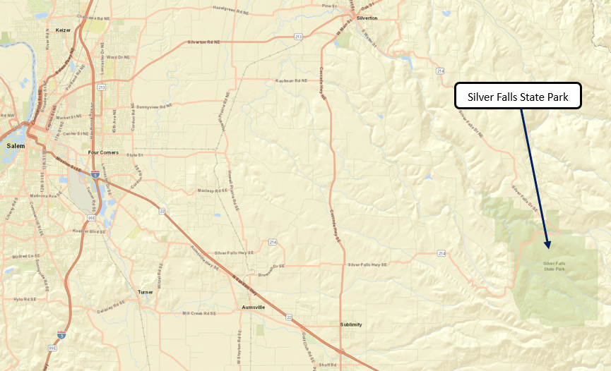
Source: Google Maps
A site map for Silver Falls State Park is provided in the following exhibit. The map details park amenities and recreation opportunities. The map also includes the locations of Smith Creek Village and South Falls Café.

Silver Falls State Park Site Map
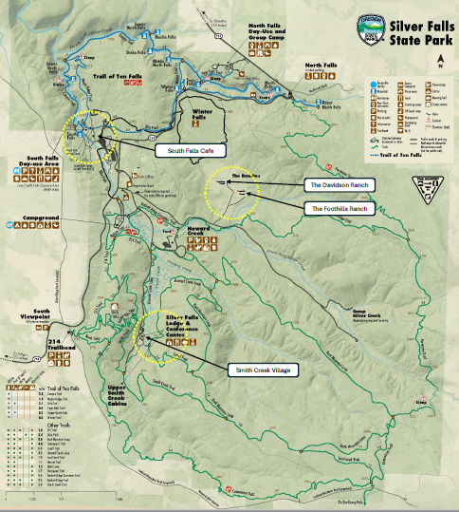
Source: OPRD

Recent and Planned Improvements at Silver Falls State Park
Over the last five years, significant investments have been made in OPRD facilities across the state. These improvements included infrastructure as well as new structures. These improvements will be critical to supporting any additional proposed development at the park.
At Silver Falls State Park, two primary structural improvements are a new parking lot and trailhead which are under construction at North Canyon and a new Silver Falls State Park Visitor Center and campground to be located at North Gateway, approximately three miles north of the South Falls/main Park entrance area.
A new trailhead is under construction at North Canyon and will connect to the Trail of Ten Falls. The trailhead will help to create more day-use activity on the north side of the park, in an attempt to divert some of the total visitor load and alleviate overcrowding at the South Falls area. In order to support this new demand, OPRD is constructing a new parking lot at North Canyon. The first phase of additional parking space construction is complete, containing 59 spaces, with additional plans to create more spaces to accommodate 200 vehicles. Phase one of this project includes the trailhead and first parking lot phase. The project at North Canyon is currently under construction and is scheduled to be completed by July 2023.
The Visitor Center, which is currently under construction, is a two-story building. On the top floor, there will be offices supporting local and regional staff. The main floor will contain visitor services, a conference room, and seating space. There will also be a café, serving coffee and pre-made meals and snacks, which will likely be operated by a concessioner. Storage space will be included in the basement of this building.
A new campground is also planned for the North Gateway site. Although the exact number of sites is not yet defined, there will be no more than 50 standard sites, with water and electricity. The project at North Gateway is targeted for completion by Spring 2026.
A summary of the projects at Silver Falls State Park is provided below:
- General
  - New visitor center at North Gateway
    - Café, visitor, interpretive, and conference services
- Campground
  - New campground at North Gateway
  - South Falls Campground new restroom Summer 2025
- Trail
  - Improvement of South Falls interior trails at historic district
  - New trailhead and viewpoint at North Canyon
  - Several additional miles of biking trails
- Parking
  - Expansion of parking at North Canyon
- Infrastructure
  - Replacement of Smith Creek Meeting Hall roof
  - South Falls Café new historically accurate gutters installed and stone patios pavers rehabilitated, paver walkways installed.

Visitation Profile
Visitation to Silver Falls State Park is recorded using traffic counters at both the North Falls and South Falls day-use entrances and the South Falls overnight entrance. Visitation has decreased slightly over the past five years, likely due to the Covid-19 pandemic and temporary closures. From 2018 to 2022, day visits and overnight visits have declined by a compound annual growth rate of -0.9 percent and -2.4 percent, respectively. Although visitation has not yet fully recovered since the pandemic, the number of visitors has increased greatly since 2020 as individuals feel more comfortable in public areas and have an increased desire to explore nature. The following exhibit shows historical day and overnight visitation at Silver Falls State Park.
The following exhibits reflect both day and overnight monthly visitation to the park for the last five years. OPRD has stated that the park was closed from March 23 to May 15, 2020, explaining the decline in visitation in 2020.

Day and Overnight Visitation to Silver Falls State Park (2018-2022)
Silver Falls State Park Visitation | 2018 | 2019 | 2020 | 2021 | 2022 | CAGR
Day Visits | 1,142,264 | 1,203,848 | 877,044 | 1,124,340 | 1,102,324 | -0.9%
Overnight Visits | 79,167 | 78,142 | 51,503 | 76,079 | 71,828 | -2.4%
Source: OPRD
The following charts indicate seasonality for monthly day-use and overnight visitation to the park. The peak season lasts from May to October for both day-use and overnight use. The summer months of June, July, and August are the most popular months to visit, given the favorable weather conditions and traditional vacation season. November through April represents the off-season for Silver Falls State Park, with May and October as the shoulder months.

Day Visitation by Month (2018-2022)

Source: OPRD

Overnight Visitation by Month (2018-2022)

Source: OPRD

Special Events at Silver Falls State Park
Silver Falls State Park holds numerous special events throughout the year. There are smaller-scale evening programs and larger-scale, all-weekend events. The following chart describes some of the well-known events that take place at the park annually.

Events at Silver Falls State Park
Event | Type | Description | Date
Owl Prowls | Evening Program | Introduction to species of owls found at Silver Falls | February-April
Star Party | Evening Program | Introduction to the night sky with volunteer astronomers | Year-Round
Birding & Wildflower Festival | All-Weekend Event | Introduction to native plants and birds found at Silver Falls, including a wildlife show, native plant sale, birding/wildflower walks, live raptor presentations, art and science-based classes, and bird house building | Mother’s Day Weekend
Historic Silver Falls Days | All-Weekend Event | Provides representation of the history of Silver Falls during its pre-park and formative years, including historical displays, a mini boat race, live music, a logging display, a car show, and more | Second Weekend in July
Winter Festival | All-Weekend Event | Celebration of the winter season, highlighting seasonal changes and encouraging winter recreation in the park | Second Week of December
Silver Falls Trail Runs | All-Weekend Event | Various races, including a 5k, 7-miler, Half-Marathon, Marathon, and 50k | First Weekend in November
Source: OPRD, CHMGS
Additionally, there are school field trips, summer programs, and evening programs at the Park. In spring and autumn, school field trips make up a large portion of programming, where interpretive rangers help students to engage with nature and history and expose them to the natural world. Summer programming is centered around daily campground programs and are offered from mid-June to Labor Day, with weekend programs offered in May and September as staff is available. Formal evening programs are aimed at the general campground audience. These 45-minute programs are held in the amphitheater at 7:30 pm, covering a wide variety of topics. Attendance ranges from 20 to 150 visitors per program.

- Off-Park Competitive Market by Service

Market Supply: Lodging
The competitive/comparable supply of lodging alternatives includes a limited range of lodging options including basic, cabin-type accommodations to upscale options. Smith Creek Village, Silver Falls State Park Campground, and Howard Creek horse camp are the only lodging options in the Park. Camp Dakota, located 19 miles northeast (driving distance), approximately 30-minute drive time, is an adventure center with campsites, cabins, yurts, and teepees. Oregon Garden Resort, located 18 miles northwest (driving distance), approximately 25-minute drive time, is an upscale lodge with luxurious amenities, and considered the most proximate viable comparable. Camp Dakota is the option that provides the closest comparability in terms of camping. Oregon Garden Resort is a more upscale and expensive option in terms of lodging product. There are additional lodging options closer to the park, such as the McClaine House and the Gardner House Café and B&B. However, these operations are not viewed as comparable because they are run in a private family home, have a limited number of rooms and offer a different lodging experience.
The following table identifies these lodging operations in the market, the type of service they offer, their setting, the distance to the Park, and their rates. The summer months of June, July, and August appear to be the peak operating months at Silver Falls State Park for overnight usage. Thus, rates for competitive lodging in the market for a July weekend are provided.
The local Airbnb and VRBO markets also provide some competition in terms of leisure lodging options. The Airbnb and VRBO markets are discussed specifically in the following section of the report.

Competitive Market for Lodging
 | Smith Creek Village | Silver Falls State Park Campground | Camp Dakota | Oregon Garden Resort
City | Sublimity, OR | Sublimity, OR | Scotts Mill, OR | Silverton, OR
Distance to Subject |  |  | 40 min (25 mi) | 31 min (21 mi)
Type of Operations | Basic Lodging/Cabins | Campground/Cabins | Campground/Cabins | Upscale Lodging
Setting | Rural Forest | Rural Forest | Rural Forest | Rural open land
Lodging Rates (Peak Season Weekend)
Lodges | $600-800 | - | - | -
Hotel Room | - | - | - | $270-360
Cabin/Cottage | $145 | $43-58 | $90-150 | -
Campsites | - | $21-31 | $60 | -
Yurts | - | - | $165-190 | -
RV | - | - | $80 | -
Teepee | - | - | $90 | -
Ranch | $550-1,800
Other Operations
Food & Beverage | x |  |  | x
Equipment Rental | x |  | x
Retail Shop | x |  | x | x
Spa |  |  |  | x
Adventure Center (ziplining, tree courses, etc.) |  |  | x
Rental Space | x |  |  | x
“-” = Not offered
Source: Silver Falls Hospitality, CHMGS

Leisure Lodging Supply and Demand
Below is an analysis of Airbnb and VRBO supply and demand in the Silverton, OR area that gauges the supply of, and demand for leisure lodging in the market area. The following table presents salient data regarding the Airbnb and VRBO market in the Silverton area.

Transient Lodging Demand in Silverton, OR
 | Average Supply | % Chg | Est. ARN | % Chg | Est. ORN | % Chg | Est. Revenue | % Chg | Est. ADR | % Chg
2019 | 31 |  | 11,444 |  | 6,474 |  | $999,123 |  | $154.34
2020 | 28 | -10.1% | 10,284 | -10.1% | 5,873 | -9.3% | $914,626 | -8.5% | $155.72 | 0.9%
2021 | 31 | 9.5% | 11,264 | 9.5% | 8,384 | 42.8% | $1,462,438 | 59.9% | $174.42 | 12.0%
2022 | 39 | 27.3% | 14,341 | 27.3% | 9,392 | 12.0% | $1,677,991 | 14.7% | $178.66 | 2.4%
YTD May 2022 | 34 |  | 5,108 |  | 3,249 |  | $541,086 |  | $166.56
YTD May 2023 | 46 | 34.8% | 6,887 | 34.8% | 3,661 | 12.7% | $631,889 | 16.8% | $172.58 | 3.6%
Source: AirDNA, CHMGS
The COVID pandemic caused some disruption in the market during 2020, with average supply, available room nights (ARN), occupied room nights (ORN) and revenues all exhibiting significant declines, while ADR remained flat. 2021data indicates some recovery in the market, with supply and ARN recovering to approximately pre-pandemic levels. 2021 occupancy, revenues and ADR all exhibited significant increases during 2021, as pandemic lodging rules and procedures were established, allowing travelers to seek lodging opportunities that may have been perceived as safer than larger, commercial hotels. Industry observations indicate remote workers also contributed to a surge in this type of lodging product during the pandemic.
The following table illustrates monthly average Airbnb and VRBO supply, average daily rate and occupancy for June 2018 through May 2023. Seasonal fluctuations are as expected, with peak demand occurring during summer months. Average daily rate exhibits some variance, with peaks generally during August, but also with some spiking during the December-January time periods, which is likely indicative of holiday travel demand.

Monthly Occupancy, ADR, and Supply of Short-Term Rental Market (June 2018-May 2023)
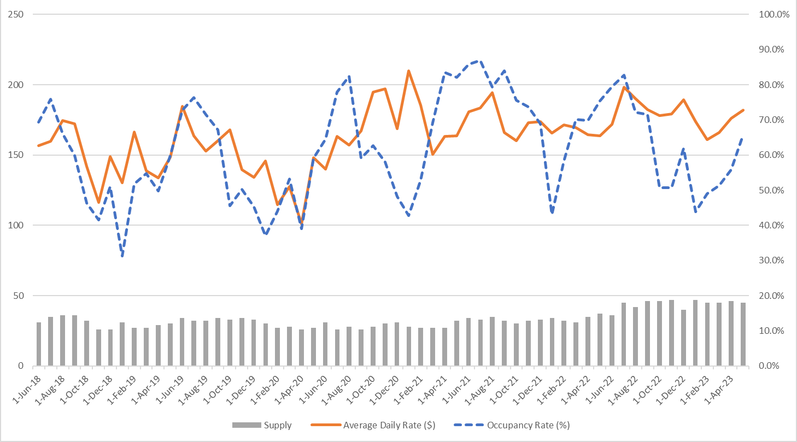
Source: AirDNA, CHMGS

Market Supply: Food and Beverage
An analysis of food and beverage alternatives that could be considered competitive to the food and beverage outlets at Silver Falls. The identified competitive supply of food and beverage alternatives includes a range of options from quick service to fine dining. South Falls Café, located in the South Falls day-use area and Big Leaf Coffeehouse & Grill, located at Smith Creek Village are the only dining options inside the Park. Silver Falls Country Store, a convenience-like store that offers camping essentials and food options, such as burgers and pizza, is the only other food operation within 20 minutes of the Park. The following table identifies various food and beverage operations in the market, the type of service they offer, their setting, and the distance to the Park. It should be noted that significant drive time is required to access food and beverage options outside the park and thus may be of limited competition for guests at the park, especially overnight visitors.

Competitive Market for Food and Beverage
 | City | Distance to Park | Type of Service* | Setting
South Falls Café | Sublimity, OR | In Park | Fast Casual | Rural Forest
Big Leaf Coffeehouse & Grill | Sublimity, OR | In Park | Family Casual | Rural Forest
North Third Bar & Restaurant | Stayton, OR | 20 min (13 mi) | Family Casual | Suburban
Silver Falls Brewery Ale House | Silverton, OR | 20 min (13 mi) | Family Casual | Suburban
Snow Peak Brewing Company | Stayton, OR | 20 min (13 mi) | Family Casual | Suburban
MacLeay Country Inn | Salem, OR | 20 min (15 mi) | Family Casual | Rural Farmland
*Fast Casual: Counter service or limited table service
*Family Casual: Table service, casual sit-down dining
Source: CHMGS
- Operational Performance Review

Current Silver Falls State Park Concession Contracts
There are currently two concession contracts at Silver Falls State Park. One contract is for operations at the Smith Creek Village area of Silver Falls State Park, to include lodging, food and beverage, catering, conference/meeting, and retail services. This contract also includes the Davidson Ranch, and Foothills Ranch facilities, located approximately 2.7 miles (driving distance) north of the Smith Creek Village area. This contract is currently held by Silver Falls Hospitality, with an effective start date of May 14, 2021 and a contract termination date of October 31, 2024.
The second contract is for the operation of the South Falls Café, located in the South Falls Lodge, within the South Falls day use area. This concession contract is operated via an interagency agreement between OPRD and the Oregon Commission of the Blind, Business Enterprise Program. The South Falls Café concession contract’s start date was May 25, 2021, with a termination date of October 31, 2024.
Both of the above contracts result from a early contract cancellation by the previous concessioner in late 2020. The previous concessioner did not fulfil the full term length of the previous contract thus requiring OPRD to obtain new concessioners to facilitate continued operations and provide the related visitor services at the Smith Creek Village and South Falls Café facilities through the end of the original contract term. The previous concessioner operated both Smith Creek Village (to include the Ranches) and South Falls Café under one contract.
The following pages provide salient details regarding the operations at Smith Creek Village and South Falls Café.

Smith Creek Village
Silver Falls Hospitality holds the current concession contract with management oversight provided by the Oregon Parks and Recreation Department. The following table outlines those services covered in the operational performance review.

Smith Creek Village Scope of Services
Service | Description
Lodging | Lodges
Lodging | Cottages
Lodging | Tiny Cabins
Lodging | Ranches (Event Venue)
Meeting Space | Meeting Halls
Meeting Space | Outdoor Venues
Food & Beverage | Family Casual Restaurant
Retail | Small Retail Shop
*Ranches are located 2.7 miles north of Smith Creek Village
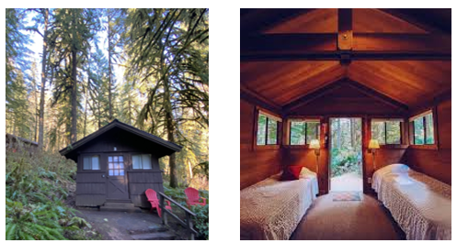
Source: OPRD, Silver Falls Hospitality

Lodging
Lodging Demand
Using guest origin data provided by Silver Falls Hospitality, the following map illustrates the sum of occupied room nights originating in each state in 2022. While individuals travel from all over the country to visit Smith Creek Village, analysis suggests the majority of guests are from Oregon. The top five cities that guests reside in are Portland, Salem, Eugene, Bend, and Beaverton. Many guests also travel from California and Washington. In 2022, 1,731 room nights originated from Oregon, 395 originated from California, and 364 originated from Washington.

Smith Creek Village- Occupied Room Nights, by State of Origin (2022)
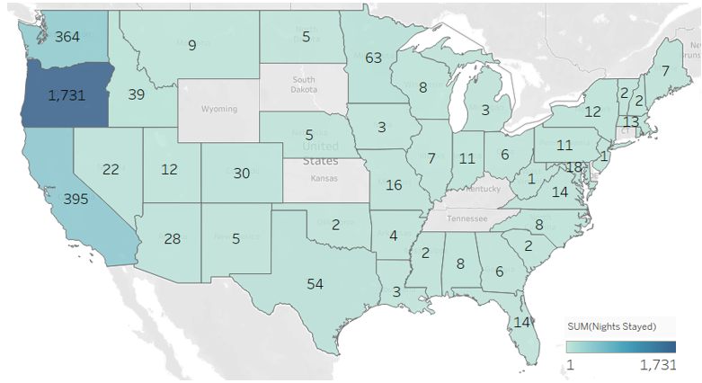
*Alaska and Hawaii had 8 and 13 occupied room nights, respectively (not shown on map)
** Room night totals exclude room nights of international origin and records with missing data (e.g. missing state and zip code)
Source: Silver Falls Hospitality, CHMGS
In Smith Creek Village, there are a total of 19 lodging units in which can accommodate varying numbers of guests. All accommodations have a minimum stay of two nights.
There are four lodges (A, B, C, and D) that offer two queen beds and eight twin beds, accommodating 12 guests each. The lodges are equipped with a wood-burning stove, a microwave, mini fridge, and coffeemaker. These lodges are ideal for large gatherings.
There are also eight Upper Tiny Cabins. Six of the cabins have one double bed—three with an additional futon, while two of them have three twin beds, accommodating two to three guests each. The cabins have a plumbed toilet, full vanity and sink, linens and fleeces, and a coffeemaker with locally sourced coffee. While staying in these tiny cabins, guests have access to a community shower, located adjacent to the Upper Smith Creek Meeting Hall.
The Chickaree and Raccoon cabins are duplex units. The two units in the Chickaree cabins each have two twin beds, accommodating two guests. The units in the Racoon cabins each have a queen bed, accommodating two guests as well. These cabins are heated, with a bathroom, shower, linens, and mini kitchenette.
Calypso Cottage is a more luxurious option—it has a queen bed and two twin-sized day beds in the family-living area, accommodating four guests total. The cottage includes a large bathroom, a jetted bathtub, tiled shower, and a full-sized kitchen, equipped with an oven, 4-burner stove, toaster, coffeemaker, and service ware. The cottage also has a private firepit and picnic table for outdoor dining.
As mentioned previously, there are two ranch facilities, Davidson and Foothills (aka New and Old). These facilities are not located in Smith Creek Village, but are operated by the current concessioner. Each ranch has a kitchen, two bathrooms, event space, a fire-pit, bunkbeds, and a parking lot. There is a 100-person limit on the ranches for day-use and 75-person limit for overnight-use. Guests also have the option of bringing ten personal tents as an additional lodging option; however, those guests count towards the 75-person limit.
The following table summarizes the composition of the lodging supply at Smith Creek Village.

Lodging Department Composition
Type of Unit | Lodges | Cottage | Cabins* | Tiny Cabins | Ranches
Number of Units | 4 | 1 | 4 | 8 | 2
*The Raccoon and Chickaree Cabins are duplex units
Source: Silver Falls Hospitality
Lodging Rates
Every lodging accommodation at Smith Creek Village is open year-round except for the Davidson Ranch, which is closed in the winter months. While the majority of guests book lodging directly on the website, five to ten percent book through other platforms, such as Airbnb and The Dyrt. The following table outlines the current 2023 weekday (W/D) and weekend (W/E) rack rates for each type of accommodation based on the season and the day of the week.

2023 Pricing List: Silver Falls Hospitality Lodging
Season | Winter |  | Spring |  | Summer |  | Fall |  | Holiday Weekend
Dwelling or Venue | W/D | W/E | W/D | W/E | W/D | W/E | W/D | W/E
Calypso | $214 | $219 | $223 | $234 | $274 | $279 | $214 | $219 | $310- 375
Lodges
A,B,C,D | $549 | $605 | $604 | $662 | $715 | $769 | $549 | $605 | $850-1,100
Lower Cottages
Chickaree (Twin Beds) | $109 | $114 | $126 | $132 | $129 | $136 | $114 | $119 | $145-159
Raccoon (Double Bed) | $109 | $114 | $126 | $132 | $129 | $136 | $114 | $119 | $145-159
Upper Tiny Cabins
Double w Porch | $109 | $114 | $126 | $132 | $129 | $136 | $114 | $119 | $159-175
Triple Bed Layout | $114 | $119 | $132 | $136 | $136 | $145 | $119 | $124 | $145-159
Double Studio-style Suite | $129 | $136 | $132 | $136 | $136 | $145 | $129 | $136 | $159-175
Davidson Ranch | Closed | Closed | $750 | $900 | $950 | $1,250 | $850 | $1,100 | < $2,450
Foothills Ranch | $650 | $900 | $750 | $900 | $950 | $1,250 | $850 | $1,100 | < $2,450
Source: Silver Falls Hospitality
Historical Lodging Performance
The following exhibit illustrates total revenue for both the lodging (including the lodges, cottage, cabins, and tiny cabins) and the ranches (including Davidson and Foothills Ranch) from 2019 to 2022. Due to the Covid-19 pandemic, which resulted in closures, lodging revenue decreased in 2020. Smith Creek Village did not offer lodging accommodations from October 2020 to May 2021, resulting in a decline in revenues. However, in 2022, lodging revenue recovered to near pre-pandemic levels of 2019, totaling $704,654.

Yearly Lodging Revenue by Type (2019-2022)

Year | 2019 | 2020 | 2021 | 2022
All Lodging Revenue | $674,051 | $222,716 | $221,859 | $567,628
Ranches Revenue | $89,056 | $26,548 | $36,607 | $137,026
Total Lodging Revenue | $763,107 | $249,264 | $258,467 | $704,654
Source: OPRD, Silver Falls Hospitality
The following exhibit shows the total monthly lodging revenue from 2019 to 2023 year-to-date. May to October is the peak season for lodging at Smith Creek Village, with July being the most popular month, likely due to the favorable weather conditions. November through April appears to be the off-season. While total revenue decreased in 2020 and 2021, revenue began to recover in 2022, almost reaching pre-pandemic levels as individuals returned to normal life and developed more interest in exploring nature and enjoying the outdoors.

Monthly Total Lodging Revenue (2019-2023 YTD)

Source: OPRD, Silver Falls Hospitality
The following five exhibits indicate lodging trends at Smith Creek Village for the years 2019 through 2023 year-to-date (April). The tables include available room nights, occupied room nights, occupancy rate, average daily rate, and revenue for each year.

Lodging Operating Trends in 2019
Lodging | January | February | March | April | May | June | July | August | September | October | November | December | Total
Available Room Nights | 1,147 | 1,036 | 1,147 | 1,110 | 1,147 | 1,110 | 1,147 | 1,147 | 1,110 | 1,147 | 1,110 | 1,147 | 13,505
Occupied Room Nights | 151 | 236 | 156 | 378 | 475 | 670 | 741 | 809 | 662 | 574 | 331 | 194 | 5,377
Occupancy | 13.2% | 22.8% | 13.6% | 34.1% | 41.4% | 60.4% | 64.6% | 70.5% | 59.6% | 50.0% | 29.8% | 16.9% | 39.8%
Average Daily Rate | $118 | $96 | $136 | $111 | $137 | $131 | $143 | $129 | $124 | $124 | $114 | $85 | $125
Total Revenue | $17,886 | $22,748 | $21,257 | $41,891 | $65,127 | $87,774 | $105,685 | $104,643 | $81,883 | $71,119 | $37,616 | $16,422 | $674,051
Ranches | January | February | March | April | May | June | July | August | September | October | November | December | Total
Available Room Nights* | 31 | 28 | 31 | 30 | 62 | 60 | 62 | 62 | 60 | 31 | 30 | 31 | 518
Occupied Room Nights | 10 | 9 | 6 | 11 | 10 | 11 | 32 | 18 | 19 | 19 | 11 | 7 | 163
Occupancy | 32.3% | 32.1% | 19.4% | 36.7% | 16.1% | 18.3% | 51.6% | 29.0% | 31.7% | 61.3% | 36.7% | 22.6% | 31.5%
Average Daily Rate | $464 | $282 | $513 | $374 | $472 | $773 | $367 | $554 | $827 | $619 | $671 | $698 | $546
Total Revenue | $4,644 | $2,540 | $3,078 | $4,114 | $4,721 | $8,502 | $11,740 | $9,975 | $15,709 | $11,769 | $7,379 | $4,885 | $89,056
Total Lodging Revenue | $22,530 | $25,288 | $24,335 | $46,005 | $69,848 | $96,276 | $117,425 | $114,618 | $97,593 | $82,888 | $44,995 | $21,307 | $763,107
*Davidson Ranch closed in Winter months
Source: OPRD

Lodging Operating Trends in 2020
Lodging | January | February | March | April | May | June | July | August | September | October | November | December | Total
Available Room Nights | 1,147 | 1,073 | 1,147 | 1,110 | 1,147 | 1,110 | 1,147 | 1,147 | 1,110 | 1,147 | 1,110 | 1,147 | 13,542
Occupied Room Nights | 329 | 240 | 118 | 0 | 19 | 222 | 662 | 644 | 81 | 0 | 0 | 0 | 2,315
Occupancy | 28.7% | 22.4% | 10.3% | 0.0% | 1.7% | 20.0% | 57.7% | 56.1% | 7.3% | 0.0% | 0.0% | 0.0% | 17.1%
Average Daily Rate | $90 | $84 | $116 | N/A | $173 | $135 | $90 | $89 | $120 | N/A | N/A | N/A | $96
Total Revenue | $29,639 | $20,146 | $13,634 | $0 | $3,286 | $30,031 | $59,281 | $56,999 | $9,700 | $0 | $0 | $0 | $222,716
Ranches | January | February | March | April | May | June | July | August | September | October | November | December | Total
Available Room Nights | 31 | 29 | 31 | 30 | 62 | 60 | 62 | 62 | 60 | 62 | 30 | 31 | 550
Occupied Room Nights | 2 | 7 | 2 | 0 | 0 | 7 | 15 | 14 | 2 | 0 | 0 | 0 | 49
Occupancy | 6.5% | 24.1% | 6.5% | 0.0% | 0.0% | 11.7% | 24.2% | 22.6% | 3.3% | 0.0% | 0.0% | 0.0% | 8.9%
Average Daily Rate | $285 | $397 | $865 | N/A | N/A | $640 | $557 | $553 | $449 | N/A | N/A | N/A | $542
Total Revenue | $571 | $2,779 | $1,731 | $0 | $0 | $4,478 | $8,356 | $7,735 | $898 | $0 | $0 | $0 | $26,548
Total Lodging Revenue | $30,209 | $22,926 | $15,364 | $0 | $3,286 | $34,508 | $67,637 | $64,734 | $10,598 | $0 | $0 | $0 | $249,264
*Davidson Ranch closed in Winter months
Source: OPRD

Lodging Operating Trends in 2021
Lodging | January-May | June | July | August | September | October | November | December | Total
Available Room Nights | Closed | 510 | 527 | 527 | 510 | 527 | 510 | 527 | 3,638
Occupied Room Nights | Closed | 80 | 283 | 266 | 219 | 242 | 185 | 194 | 1,469
Occupancy | Closed | 15.7% | 53.7% | 50.5% | 42.9% | 45.9% | 36.3% | 36.8% | 40.4%
Average Daily Rate | Closed | $160 | $173 | $178 | $155 | $135 | $127 | $117 | $151
Total Revenue | Closed | $12,821 | $48,893 | $47,218 | $33,884 | $32,752 | $23,521 | $22,772 | $221,859
Ranches | January-May | June | July | August | September | October | November | December | Total
Available Room Nights | Closed | 60 | 62 | 62 | 30 | 62 | 30 | 62 | 368
Occupied Room Nights | Closed | 3 | 3 | 9 | 9 | 8 | 9 | 10 | 51
Occupancy | Closed | 5.0% | 4.8% | 14.5% | 30.0% | 12.9% | 30.0% | 16.1% | 13.9%
Average Daily Rate | Closed | $226 | $372 | $784 | $994 | $995 | $548 | $592 | $718
Total Revenue | Closed | $678 | $1,115 | $7,052 | $8,950 | $7,960 | $4,928 | $5,924 | $36,607
Total Lodging Revenue | N/A | $13,499 | $50,008 | $54,270 | $42,834 | $40,712 | $28,449 | $28,695 | $258,467
*Davidson Ranch closed in Winter months
Source: Silver Falls Hospitality

Lodging Operating Trends in 2022
Lodging | January | February | March | April | May | June | July | August | September | October | November | December | Total
Available Room Nights | 527 | 476 | 527 | 510 | 527 | 510 | 527 | 527 | 510 | 527 | 510 | 527 | 6,141
Occupied Room Nights | 112 | 177 | 221 | 235 | 302 | 386 | 405 | 393 | 359 | 359 | 239 | 239 | 3,427
Occupancy | 21.3% | 37.2% | 41.9% | 46.1% | 57.3% | 75.7% | 76.9% | 74.6% | 70.4% | 68.1% | 46.9% | 45.4% | 55.8%
Average Daily Rate | $107 | $109 | $132 | $141 | $160 | $187 | $205 | $184 | $184 | $185 | $142 | $133 | $166
Total Revenue | $12,038 | $19,370 | $29,240 | $33,053 | $48,436 | $72,021 | $82,929 | $72,407 | $66,159 | $66,296 | $33,959 | $31,720 | $567,628
Ranches | January | February | March | April | May | June | July | August | September | October | November | December | Total
Available Room Nights | 62 | 56 | 62 | 60 | 62 | 60 | 62 | 62 | 60 | 62 | 60 | 62 | 730
Occupied Room Nights | 3 | 9 | 23 | 14 | 29 | 21 | 28 | 29 | 23 | 25 | 6 | 5 | 215
Occupancy | 4.8% | 16.1% | 37.1% | 23.3% | 46.8% | 35.0% | 45.2% | 46.8% | 38.3% | 40.3% | 10.0% | 8.1% | 29.5%
Average Daily Rate | $401 | $367 | $329 | $489 | $679 | $651 | $932 | $749 | $748 | $605 | $500 | $320 | $637
Total Revenue | $1,202 | $3,304 | $7,560 | $6,852 | $19,700 | $13,672 | $26,090 | $21,708 | $17,206 | $15,130 | $3,002 | $1,600 | $137,026
Total Lodging Revenue | $13,240 | $22,674 | $36,800 | $39,905 | $68,136 | $85,693 | $109,019 | $94,115 | $83,365 | $81,426 | $36,961 | $33,320 | $704,654
*Davidson Ranch closed in Winter months
Source: Silver Falls Hospitality

Lodging Operating Trends 2022 and 2023 Year-to-Date
Lodging | January | February | March | April | May | June | July | August | September | Total 2022 YTD
Available Room Nights | 527 | 476 | 527 | 510 | 527 | 510 | 527 | 527 | 510 | 4,641
Occupied Room Nights | 112 | 177 | 221 | 235 | 302 | 386 | 405 | 393 | 359 | 2,590
Occupancy | 21.3% | 37.2% | 41.9% | 46.1% | 57.3% | 75.7% | 76.9% | 74.6% | 70.4% | 55.8%
Average Daily Rate | $107 | $109 | $132 | $141 | $160 | $187 | $205 | $184 | $184 | $168
Total Revenue | $12,038 | $19,370 | $29,240 | $33,053 | $48,436 | $72,021 | $82,929 | $72,407 | $66,159 | $435,654
Lodging | January | February | March | April | May | June | July | August | September | Total 2023 YTD
Available Room Nights | 527 | 476 | 521 | 510 | 527 | 510 | 527 | 527 | 510 | 4,635
Occupied Room Nights | 174 | 199 | 262 | 264 | 349 | 387 | 434 | 379 | 363 | 2,811
Occupancy | 33.0% | 41.8% | 50.3% | 51.8% | 66.2% | 75.9% | 82.4% | 71.9% | 71.2% | 60.6%
Average Daily Rate | $127 | $119 | $150 | $154 | $168 | $194 | $225 | $208 | $204 | $182
Total Revenue | $22,088 | $23,732 | $39,177 | $40,754 | $58,770 | $75,167 | $97,849 | $78,992 | $74,225 | $510,755
Ranches | January | February | March | April | May | June | July | August | September | Total 2022 YTD
Available Room Nights | 62 | 56 | 62 | 60 | 62 | 60 | 62 | 62 | 60 | 546
Occupied Room Nights | 3 | 9 | 23 | 14 | 29 | 21 | 28 | 29 | 23 | 179
Occupancy | 4.8% | 16.1% | 37.1% | 23.3% | 46.8% | 35.0% | 45.2% | 46.8% | 38.3% | 32.8%
Average Daily Rate | $401 | $367 | $329 | $489 | $679 | $651 | $932 | $749 | $748 | $655
Total Revenue | $1,202 | $3,304 | $7,560 | $6,852 | $19,700 | $13,672 | $26,090 | $21,708 | $17,206 | $117,294
Total Lodging Revenue | $13,240 | $22,674 | $36,800 | $39,905 | $68,136 | $85,693 | $109,019 | $94,115 | $83,365 | $552,947
Ranches | January | February | March | April | May | June | July | August | September | Total 2023 YTD
Available Room Nights | 62 | 56 | 62 | 60 | 62 | 60 | 62 | 62 | 60 | 546
Occupied Room Nights | 4 | 7 | 12 | 22 | 38 | 30 | 33 | 31 | 35 | 212
Occupancy | 6.5% | 12.5% | 19.4% | 36.7% | 61.3% | 50.0% | 53.2% | 50.0% | 58.3% | 38.8%
Average Daily Rate | $800 | $577 | $407 | $177 | $416 | $856 | $726 | $768 | $836 | $635
Total Revenue | $3,200 | $4,037 | $4,882 | $3,904 | $15,800 | $25,693 | $23,960 | $23,823 | $29,265 | $134,564
Total Lodging Revenue | $25,288 | $27,770 | $44,059 | $44,658 | $74,570 | $100,860 | $121,809 | $102,815 | $103,490 | $645,319
*Davidson Ranch closed in Winter months
*October-December 2023 N/A
Source: Silver Falls Hospitality

The above tables summarize lodging performance year-to-date from January to September 2023, compared to January to September 2022 at Smith Creek Village. Overall, total lodging revenue has been 16.7 percent higher in 2023 year-to-date than 2022, likely due to efficient management and increased attraction to an outdoor setting since the pandemic. Occupancy and revenue for lodging at the village, including the cabins, lodges, and the cottage, have increased in 2023 by nine and 17 percent, respectively. Occupancy and revenue at the ranches have also increased in 2023, by 18.4 and 14.7 percent, respectively.
The following exhibit displays occupancy for both lodging and ranches. Occupancy decreased in 2020 due to the pandemic, but quickly began recovering in 2021. While occupancy at the ranches has not quite reached pre-pandemic levels in 2022, occupancy at the other accommodations is 15.4 percent higher in 2022 than 2019. As stated before, after being trapped inside for a long period of time during the pandemic, individuals are more inclined to enjoy the outdoors and experience surrounding nature, contributing to increased occupancy. Additionally, in recent years, Silver Falls Hospitality has bolstered their marketing tactics. For example, they created a social media program, in which once a month they will allow an individual to stay at Smith Creek Village for free in exchange for social content, art, or more. The content likely attracts more visitors, helping to increase occupancy.

Lodging Occupancy Rates 2019-2022

Source: OPRD, Silver Falls Hospitality
Meeting Space
Supplementary to lodging, there are two meeting halls available to rent, Upper Smith Creek Meeting Hall and Lower Smith Creek Meeting Hall. There are additional outdoor spaces, including the Elopement Arch, Ceremony Lawn, and Mackenzie Meadows available to rent at Smith Creek Village for special events, such as weddings; these spaces are included under ‘Special Event at the Village’ in the chart below. In prior years, Smith Creek Village held a large number of weddings, both at the Village and the ranches. Moving forward, Silver Falls Hospitality is allowing only one large, full property wedding per month in order to save lodging space for regular customers. Silver Falls Hospitality took over the concession contract in May 2021; thus, the food and beverage analysis was completed subsequent to the Silver Falls Hospitality takeover. The exhibit below shows revenue generated from the meeting spaces from 2021 to 2023 year-to-date along with the number of events. From 2021 to 2022, total meeting space revenue has increased by 282 percent as pandemic restrictions eased and individuals have become more comfortable in large gatherings. The number of events year-to-date has increased by 6 percent, while revenue has increased by 39 percent.

Meeting Spaces Revenue & Number of Events 2021-2023 YTD
Space Type | 2021 | 2022 | 2022 (Sept) | 2023 (Sept)
LSC Meeting Hall | $3,000 | $18,850 | $11,700 | $17,482
USC Meeting Hall | $1,762 | $3,748 | $2,848 | $4,000
Special Event at the Village | $9,135 | $26,650 | $23,655 | $31,620
Total | $13,897 | $53,038 | $38,203 | $53,102

Space Type | 2021 | 2022 | 2022 (Sept) | 2023 (Sept)
LSC Meeting Hall | 13 | 12 | 63 | 75
USC Meeting Hall | 20 | 57 | 47 | 41
Special Event at the Village | 8 | 22 | 18 | 20
Total | 41 | 91 | 128 | 136
Source: Silver Falls Hospitality

Food & Beverage And Retail
Food & Beverage
Smith Creek Village manages a food and beverage operation called The Big Leaf Coffeehouse & Grill. The operation is a family casual restaurant with both indoor and outdoor seating. While one can sit down for a full-service meal, visitors can also stop in for grab and go items, including beer, wine and snacks. The restaurant space is also available to rent for special events.
Silver Falls Hospitality started operating the restaurant in May 2021. In 2021, the operation served breakfast only. In 2022, the operation started serving lunch in April and dinner every day in July, explaining lower revenue in the earlier months of the year. In 2023, The Big Leaf Coffeehouse & Grill will serve breakfast every day, lunch on weekends year-round and seven days a week from Memorial Day to the end of October, and dinner on weekends only.
Because Silver Falls Hospitality took over the concession contract in mid-2021, previous concessionaire reports were utilized from 2019 and 2020 data. The exhibit below displays all food and beverage revenue from 2019 to 2023 year-to-date, including restaurant food & beverage, restaurant alcohol, event food & beverage, and event alcohol. Event food, beverage, and alcohol includes catering of events held at Smith Creek Village. The village holds events throughout the year, including the Smith Creek Village Christmas/ Holiday Dinner, Thanksgiving at the Falls, and Love at the Falls. The revenue generated from these events is included in the total food and beverage revenue seen in the following exhibit.

Monthly Food & Beverage Revenue 2019-2023 YTD

Year | Jan | Feb | March | April | May | June | July | Aug | Sept | Oct | Nov | Dec | Total
2019 | $13,793 | $18,259 | $5,955 | $31,703 | $51,978 | $56,581 | $70,151 | $85,609 | $62,788 | $53,632 | $19,603 | $7,746 | $477,797
2020 | $17,342 | $17,242 | $4,115 | Closed | Closed | $5,330 | $6,920 | $8,425 | $945 | Closed | Closed | Closed | $60,319
2021 | Closed | Closed | Closed | Closed | Closed | $1,669 | $5,160 | $7,255 | $5,856 | $8,913 | $6,495 | $3,883 | $39,230
2022 | $3,167 | $4,526 | $4,928 | $7,897 | $12,656 | $19,037 | $29,474 | $29,124 | $26,631 | $30,471 | $16,843 | $12,245 | $196,999
2023 (Sept) | $13,842 | $16,308 | $17,403 | $20,201 | $23,600 | $32,086 | $43,289 | $45,519 | $28,890 | N/A | N/A | N/A | $241,138
Source: OPRD, Silver Falls Hospitality
Based on the chart above, Smith Creek Village generates the most revenue from food and beverage sales in June through October, when most visitors come to enjoy the warmer months at the Park. Silver Falls Hospitality obtained the contract in May of 2021. They had experienced operational difficulties at the restaurant due to variation of visitation post-pandemic. However, the concessioner adjusted hours dynamically throughout the year to accommodate demand, improving the efficiency and performance of the operation. Although revenue is not nearly as high at the operation as it was pre-pandemic when the prior concessioner managed it, 2022 revenue increased greatly over 2021. Further, as individuals became more comfortable since the pandemic, shifting to full-service rather than quick, grab and go options, Smith Creek Village likely received more attraction, especially as the only full-service restaurant available in the Park and within 20 minutes of the Park. Within the first nine months of 2023, the food and beverage revenue was significantly higher than it was in 2022; January through September revenue in 2023 is 75 percent higher than January through September revenue in 2022.
According to Silver Falls Hospitality average checks from 2021 to 2022, presented in following exhibit. The average check is based on food, beverage, and retail. Due to more efficient operations and hours, the average check has increased from 2021 to 2023.

Average Check Per Occupied Room Night 2019-2023 YTD
 | 2021 | 2022
Total Food, Beverage & Retail Revenue | $40,338 | $200,270
Average Check | $19.01 | $26.07
Number of Covers | 2,122 | 7,682
Source: OPRD, Silver Falls Hospitality
Retail
Within The Big Leaf Coffeehouse and Grill, there is a small retail operation, selling gift certificates, soaps, mugs, patches, coffee, post cards, and stickers. Due to Covid-related closures, there was only a small amount of retail revenue by the end of 2021, totaling $1,108. The following exhibit displays the revenue generated from the retail operation in 2021 to 2023 year-to-date. Retail revenue has grown significantly in the first few nine months of 2023. 2023 year-to-date retail revenue has increased by 124 percent compared to 2022 year-to-date revenue. This growth can be attributed to more desirable retail options, such as Silver Falls Coffee Co.’s grounds and sustainable, locally made soap bars. Additionally, the retail items are placed in the entrance of the restaurant, adjacent to the grab and go counter, which attracts immediate attention of the customer. Detailed retail data at Smith Creek Village, from the prior concessioner, is not available prior to 2021. Silver Falls Hospitality took over the concession contract in May 2021; thus, the food and beverage operation analysis was completed subsequent to the Silver Falls Hospitality takeover.

Monthly Retail Revenue in 2021-2023 YTD

Year | Jan | Feb | March | April | May | June | July | Aug | Sept | Oct | Nov | Dec | Total
2021 | Closed | Closed | Closed | Closed | Closed | Closed | Closed | Closed | $50 | $324 | $143 | $591 | $1,108
2022 | $0 | $115 | $148 | $70 | $272 | $281 | $257 | $595 | $276 | $238 | $530 | $492 | $3,271
2023 (Sept) | $333 | $328 | $439 | $606 | $553 | $886 | $670 | $284 | $411 | N/A | N/A | N/A | $4,509
Source: Silver Falls Hospitality

South Falls Café
As mentioned previously Oregon Commission for the Blind holds the current concession contract at the South Falls Café location. The following table outlines services covered in the operation.

South Falls Cafe Scope of Services
Service | Description
Food & Beverage | Fast Casual
Retail | Retail Items at Counter
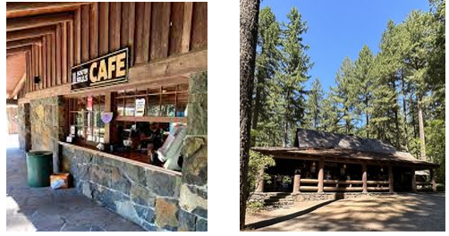
South Falls Café is located in the Lodge at the South Falls day-use area. Adjacent to the lodge is South Falls, one of the larger waterfalls in the Park. There are multiple trails in which visitors can view the waterfall and even continue on the Trail of Ten Falls to view other waterfalls.
While Oregon Commission for the Blind operates the food, beverage, and retail operation in the Lodge, they have access only to a portion of the space. In the layout below, the areas highlighted in red have been assigned to the concessioner. The concessioner operates an area in the front of the lodge to take customer orders, provide grab and go options, such as snacks, beverages, and alcohol, and to take payment. In the back of the lodge is the kitchen, where employees make the food and customers pick up their orders. When paying for an order, the customer will receive a handheld pager that allows the operation to inform them when their order is ready. The concessioner is also assigned a storage area and refrigerator space across from the kitchen, where they store materials and food. Because they are assigned only a small amount of storage space, the concessioner has faced operational challenges. Although the concessioner is allowed to use part of the basement for storage, it is difficult to access for some employees due to their disabilities. The Lodge has indoor seating on the main floor and two outdoor seating areas where customers can enjoy their meal. There is a large, paved patio in the back, surrounded by forest, with picnic tables and umbrellas. The patio includes a theatre as well, which currently serves as an interpretive learning space. Next, there is a smaller stone patio at the backside of the building, offering shaded benches. The exhibits below display the layouts of the main floor and basement of the South Falls Lodge.

South Falls Lodge Main Floor Layout
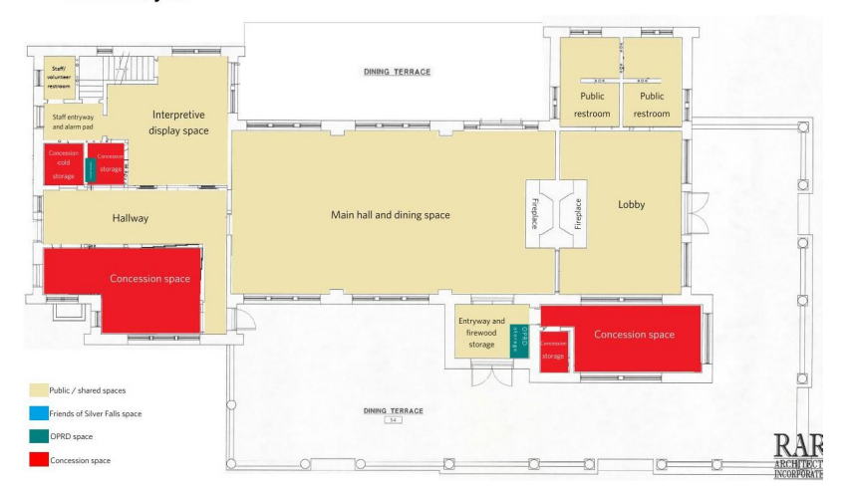
Source: Oregon Commission for the Blind

South Falls Lodge Basement Layout
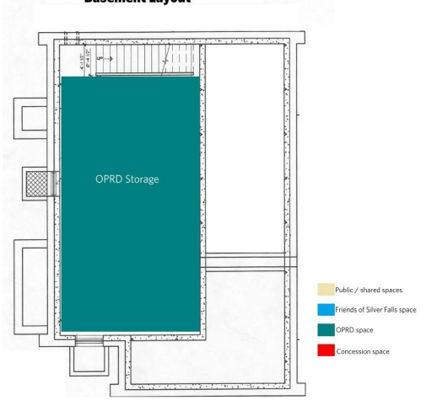
Source: Oregon Commission for the Blind
South Falls Café is open from 10:00 AM to 6:00 PM, seven days a week, April through September. In the off-season months of October through March, the Café is open five days a week, including Friday, Saturday, and Sunday from 11:00 AM to 6:00 PM. Oregon Commission for the Blind (OCB) assumed the concession contract for South Falls Café in May 2021. There have been two operators since OCB assumed operations. The current operator commenced operations at South Falls Café in September 2022.
The following exhibit shows the customer transaction counts for each month in 2019 through year-to-date 2023. From 2019 to 2022, South Falls Café has had the highest number of customer transactions in July. May through October appears to be the peak-season for the café with over 3,800 transactions monthly in 2022, likely due to warmer weather and increased interest in spending time outdoors. November through December appears to be the off-season. In the first nine months of 2023, transactions have been 46 percent higher than those in 2022, indicating the potential for future growth at the café. A new operator started running South Falls Café in September 2022, suggesting that better organization, cooking, and efficiency has increased the number of sales in recent months. Further, as more time passes since the Covid-19 pandemic, individuals have felt increasingly comfortable eating in public areas.

Customer Transaction Count (2019-2023 YTD)

Source: OPRD, Oregon Commission for the Blind
The following exhibit displays total sales at South Falls Café from 2019 to 2023 year-to-date. While total sales decreased in 2020 and 2021 due to the pandemic, sales recovered greatly in 2022, surpassing pre-pandemic levels. Total sales in 2022 were 129 percent higher than total sales in 2019, likely due to better management and a greater interest to recreate outdoors. In the first nine months of 2023, sales were 53 percent higher than they were in 2022. As stated above, a new operator started running the café in September 2022, ultimately improving sales.

Total Sales 2019-2023 YTD

Year | 2019 | 2020 | 2021 | 2022 | 2022 (Sept) | 2023 (Sept)
January | $5,398 | $10,446 | $0 | $12,466 | $12,466 | $26,284
February | $3,105 | $9,384 | $0 | $13,635 | $13,635 | $21,691
March | $9,332 | $7,096 | $0 | $23,834 | $23,834 | $34,449
April | $5,983 | $0 | $0 | $35,503 | $35,503 | $47,326
May | $10,264 | $9,965 | $0 | $48,950 | $48,950 | $87,547
June | $28,324 | $19,508 | $48,793 | $59,079 | $59,079 | $101,545
July | $45,250 | $41,222 | $62,362 | $86,443 | $86,443 | $128,897
August | $46,108 | $44,134 | $50,208 | $73,764 | $73,764 | $100,221
September | $22,701 | $11,388 | $33,481 | $51,073 | $51,073 | $73,223
October | $17,841 | $0 | $22,136 | $50,379 | N/A | N/A
November | $15,161 | $0 | $16,259 | $30,825 | N/A | N/A
December | $11,948 | $0 | $9,274 | $20,450 | N/A | N/A
Total | $221,415 | $153,143 | $242,512 | $506,401 | $404,747 | $621,184
Source: OPRD, Oregon Commission for the Blind
As total sales increased from 2021 to 2022, the average check increased from $10.42 to $12.94. Although visitation decreased slightly from 2021 to 2022, the number of transactions increased by 68 percent due to more efficient operations. Thus, transactions per visitor increased from .02 to .03 from 2021 to 2022.

South Falls Café Performance Metrics
 | 2019 | 2020 | 2021 | 2022 | 2022 (Jan-Sept) | 2023 (Jan-Sept)
Total Sales | $221,415 | $153,143 | $242,512 | $506,401 | $404,747 | $621,184
Total Visitation to the Park | 1,281,990 | 928,547 | 1,200,419 | 1,174,152 | 959,300 | *
Number of Transactions | 25,661 | 15,469 | 23,269 | 39,140 | 30,558 | 44,674
Average Check | $8.63 | $9.90 | $10.42 | $12.94 | $13.25 | $13.90
Transaction per Visitor | 0.02 | 0.02 | 0.02 | 0.03 | 0.03 | *
*Awaiting clarifying data from OPRD
Source: OPRD, Oregon Commission for the Blind
Prior to 2021, all sales at South Falls Café were combined into one category. Since Oregon Commission for the Blind has taken over the operation, sales are separated into food & beverage, beer & wine, and retail. The following charts detail monthly revenue by category from 2021 to 2023 year-to-date.

South Falls Café Sales by Category in 2021
Month | Food & Beverage | Retail Merchandise | Beer & Wine | Gross Sales | Customer Transaction Count
January | N/A | N/A | N/A | N/A | N/A
February | N/A | N/A | N/A | N/A | N/A
March | N/A | N/A | N/A | N/A | N/A
April | N/A | N/A | N/A | N/A | N/A
May | N/A | N/A | N/A | N/A | N/A
June | $48,754 | $40 | $0 | $48,793 | 4,925
July | $62,290 | $72 | $0 | $62,362 | 5,705
August | $50,154 | $54 | $0 | $50,208 | 4,662
September | $33,468 | $14 | $0 | $33,481 | 3,330
October | $21,805 | $3 | $328 | $22,135 | 2,113
November | $15,904 | $4 | $352 | $16,259 | 1,615
December | $9,080 | $6 | $188 | $9,274 | 919
Total | $241,454 | $191 | $868 | $242,512 | 23,269
Source: Oregon Commission for the Blind

South Falls Café Sales by Category in 2022
Month | Food & Beverage | Retail Merchandise | Beer & Wine | Gross Sales | Customer Transaction Count
January | $12,045 | $1 | $420 | $12,466 | 1,237
February | $13,230 | $1 | $404 | $13,635 | 1,316
March | $22,869 | $5 | $960 | $23,834 | 2,030
April | $34,280 | $12 | $1,211 | $35,503 | 3,107
May | $46,928 | $14 | $2,008 | $48,968 | 4,026
June | $57,162 | $102 | $1,815 | $59,079 | 4,628
July | $83,668 | $49 | $2,726 | $86,443 | 6,205
August | $71,576 | $7 | $2,181 | $73,764 | 3,831
September | $51,073 | $0 | $0 | $51,073 | 4,178
October | $50,377 | $2 | $0 | $50,379 | 4,159
November | $30,825 | $0 | $0 | $30,825 | 2,648
December | $20,445 | $5 | $0 | $20,450 | 1,775
Total | $494,479 | $197 | $11,725 | $506,419 | 39,140
Source: Oregon Commission for the Blind

South Falls Café Sales by Category in 2023 (YTD Sept)
Month | Food & Beverage | Retail Merchandise | Beer & Wine | Gross Sales | Customer Transaction Count
January | $25,714 | $2 | $568 | $26,284 | 2,206
February | $20,869 | $2 | $820 | $21,691 | 1,853
March | $33,105 | $2 | $1,343 | $34,449 | 2,615
April | $45,146 | $5 | $2,175 | $47,326 | 3,491
May | $81,148 | $11 | $6,388 | $87,547 | 5,985
June | $95,205 | $14 | $6,326 | $101,545 | 7,393
July | $121,342 | $16 | $7,539 | $128,897 | 8,626
August | $94,004 | $0 | $6,218 | $100,221 | 7,012
September | $68,483 | $4 | $4,737 | $73,223 | 5,493
October-December | N/A | N/A | N/A | N/A | N/A
Total YTD | $585,017 | $54 | $36,114 | $621,184 | 44,674
Source: Oregon Commission for the Blind
South Falls Café serves a variety of breakfast, lunch, and dinner items, such as breakfast burritos, wraps, burgers, hot sandwiches, salads, and snacks (packaged candy, trail mix, bars, chips). For beverages, the café serves coffee, fountain soda, Italian soda, smoothies, energy drinks, beer and wine. The following exhibits display the monthly revenue for food & beverage and beer & wine from 2021-2023 year-to-date.

Food & Beverage Revenue (2021-2023 YTD)

Source: Oregon Commission for the Blind

Beer & Wine Revenue (2021-2023 YTD)

Source: Oregon Commission for the Blind
The charts above indicate that South Falls Café generates the most revenue on food, beverage, and alcohol in the months of May through October, which are the busiest months according to the count of customer transactions. Food and beverage revenue grew from 2021 to 2022—revenue increased by 34 percent from July 2021 to July 2022, which is the most active month at the café. Further, in the first nine months of 2023, revenue for food, beverage, and alcohol is 54 percent higher than it was in 2022. The first operator for Oregon Commission for the Blind was late to obtain an alcohol permit and therefore was not able to realize the full potential of beer and wine sales. Overall, more efficient operations, more enjoyable weather, and a greater selection has helped to increase sales in recent months.
South Falls Café has a small selection of sundry retail items. There are limited retail items for sale due to facility space limitations and also that the café does not want to compete with a nearby gift shop operated by ‘Friends of Silver Falls’. The following chart shows monthly retail revenue, indicating that the Café makes the most retail revenue June through July when customers are most in need of items, such as sunscreen and ponchos.

Retail Revenue (2021-2023 YTD)

Source: Oregon Commission for the Blind
- Future Demand Projections

Visitation
The following exhibit shows estimated future visitation for both day and overnight use at Silver Falls State Park. Projections were completed by a third-party Contractor named CHMGS.

Estimated Future Day and Overnight Visitation at Silver Falls State Park (2022-2027)
Day Visits | 2022 | 2023 | 2024 | 2025 | 2026 | 2027
Total Visits | 1,102,324 | 1,195,995 | 1,219,915 | 1,244,313 | 1,269,200 | 1,294,584
Overnight Visits | 2022 | 2023 | 2024 | 2025 | 2026 | 2027
Total Visits | 71,828 | 72,732 | 74,187 | 75,671 | 77,184 | 78,728
Total Visitation | 1,174,152 | 1,268,727 | 1,294,102 | 1,319,984 | 1,346,384 | 1,373,311
Source: OPRD, CHMGS

Smith Creek Village
In the exhibit below, 10-year lodging demand estimates are based on analyzing the monthly occupancy of each type of lodging accommodation. The pattern of demand increased from 2022 to 2023 year-to-date. Occupied room nights in 2023 year-to-date (Jan-Sept) have increased by 8.5 percent since 2022 year-to-date.

Future Lodging Demand at Smith Creek Village (2022-2027)
 | 2022 | 2023 | 2024 | 2025 | 2026 | 2027
Lodging (Cabins, Cottage, Lodges)
Available Room Nights | 6,205 | 6,205 | 6,205 | 6,205 | 6,205 | 6,205
Occupied Room Nights | 3,427 | 3,723 | 3,785 | 3,847 | 3,909 | 3,971
Occupancy | 55% | 60% | 61% | 62% | 63% | 64%
Ranches
Available Room Nights | 550 | 551 | 551 | 551 | 551 | 551
Occupied Room Nights | 214 | 226 | 231 | 237 | 237 | 242
Occupancy | 39% | 41% | 42% | 43% | 43% | 44%
Meeting/Event Space
Number of Meetings/Events | 170 | 176 | 181 | 198 | 203 | 209
*4 twin cabins closed for remodel in November 2022
Source: Silver Falls Hospitality, CHMGS
For future food and beverage demand at Smith Creek Village, the historical relationship was analyzed of food & beverage sales to occupied room nights. Within the first nine months of 2023, the average check was $77, compared to $49 within the same period in 2022. The Big Leafe Coffeehouse and Grill has extended operating hours in 2023. It is assumed, that per one occupied room night, a person or group will eat two breakfasts and one lunch and/or dinner at the restaurant. Therefore, it is estimated that an average check of $95 per occupied room night in 2023, adjusting for inflation going forward. Retail sales at the restaurant are also estimated using a check per occupied room night.
Future Food & Beverage Demand at Smith Creek Village (2022-2027)
 | 2022 | 2023 | 2024 | 2025 | 2026 | 2027
Occupied Room Nights | 3,427 | 3,723 | 3,785 | 3,847 | 3,909 | 3,971
F&B Check per Occupied Room Night | $50 | $95 | $97 | $100 | $102 | $105
Retail Check per Occupied Room Night | $0.95 | $1.60 | $1.64 | $1.68 | $1.72 | $1.77
Source: Silver Falls Hospitality, CHMGS

South Falls Cafe
In order to estimate future demand at South Falls Café, day-use visitation numbers were utilized and analyzed the number of transactions per visitor at the café from 2019 to 2022. An estimated number of total customer transactions at the café from 2023 to 2027 based on a historical ratio of transactions to number of visitors. Because there is such a small amount of retail sales annually, a combination of retail sales with food, beverage, and alcohol transactions. It is projected that the number of transactions at South Falls Café to increase from 39,140 to 58,566 from 2022 to 2027, which grows at a CAGR of 8.4 percent.

Future Demand at South Falls Café (2022-2027)
 | 2022 | 2023 | 2024 | 2025 | 2026 | 2027
Total Visitation to the Park | 1,174,152 | 1,268,727 | 1,294,102 | 1,319,984 | 1,346,384 | 1,373,311
Number of Transactions | 39,140 | 54,106 | 55,188 | 56,292 | 57,418 | 58,566
Transaction per Visitor | 0.03 | 0.04 | 0.04 | 0.04 | 0.04 | 0.04
Source: OPRD, Oregon Commission for the Blind, CHMGS
The market analysis helps to establish the potential market position of, and demand for existing and proposed facilities within Silver Falls State Park. Before analyzing trends and making recommendations, it is critical to develop an understanding of the market surrounding the Park, the tourism industry, and relevant market trends, informing demand expectations of visitor services provided under the contract. In order to support potential visitor service changes to the Park, it is critical to identify a comparable/competitive set for the current facilities.
The following section presents a variety of scenarios for changes to the Silver Falls State Park concession operations.
Scenarios Under Consideration
The following includes a list of scenarios under consideration:
- Food and Beverage
  - Expand outdoor patio seating at South Falls Café
  - Conversion of Theatre
    - Convert the theatre at South Falls to a with food and beverage options (ex. wood-fired pizza oven)
- Lodging
  - Renovation of Lodging
    - Replace flooring and lighting, add fans, and improve kitchenettes
- Bicycle Rentals
  - Introduction of bicycle rental service at Smith Creek Village

https://oregonvbc.org/tourism-in-oregon/
Travel Oregon
https://industry.traveloregon.com/regions/willamette-valley/
https://stateparks.com/willamette_valley_oregon_parks.html
https://www.co.marion.or.us/Pages/about.aspx
https://www.psu.edu/news/health-and-human-development/story/how-has-covid-19-pandemic-affected-outdoor-recreation-america
https://stateparks.oregon.gov/index.cfm?do=park.profile&parkId=151

