Local Government Grant Program
2026 Pre-Application Worksheet

for DEVELOPMENT / REHABILITATION Grant Applications

This document contains the questions that will be asked on the Oregon Parks and Recreation Department’s online LGGP grant application. This document will NOT be accepted as a grant application but is designed to help applicants prepare answers, in advance, for the LGGP application. Once answers are completed here, they can easily be cut and pasted or entered into the online application. This does not represent the entire application.

Applications must be completed and submitted on https://OPRDGrants.org.

Refer to the OPRD LGGP section website for a copy of the LGGP Grant Manual, forms, grant cycle deadlines and online application instructions for using the OPRD Grants website:
https://www.oregon.gov/oprd/GRA/Pages/GRA-lggp.aspx
____________________________________________________________________________

ATTACHMENTS - Be prepared to upload the following attachments. Refer to the Grant Manual for which attachments are required. Some forms are provided in the application. Please combine PDFs into a single file when possible.

- Construction Drawings/Design Plan or Restoration Work Plan
- Environmental Checklist - Completed
- Land Use Compatibility Statement (LUCS) - Completed
- Letters of Support
- Map - Location / Vicinity
- Map - Park Boundary
- Map - Project Area
- Map - Site Map / Site Plan
- Map - Urban Growth Boundary
- Other (if needed)
- Photos
- Property Deed or Easement or Lease Agreement
- Resolution to Apply for a Grant - Completed
- SHPO Clearance Form (Built Environment Resources Assessment) - Completed
- SHPO Map: 7.5 min. USGS Topo Map or 1 Sq. Mile Map
- SHPO Submittal Form (Archaeological Assessment) – Completed
- State Agency Review Forms – (DSL, ODF&W, and DEQ) + Others as relevant
____________________________________________________________________________

BRIEF PROJECT DESCRIPTION: What will this project do (in 40 words or less). Please complete the sentence: The project will…
Example: The project will replace existing playground equipment with new accessible playground equipment and construct 500 feet of paved trail at [park name] in [city or town or area name], Oregon.

FINANCIAL INFORMATION: Prepare a project budget in advance. Refer to the Grant Manual for minimum matching requirements. Administration, engineering, and other pre-agreement costs submitted as match cannot exceed 15% of the total project cost. Refer to the Online Grant Application Instructions for how to properly fill out the Online Grant Budget Worksheet.

SUPPLEMENTAL INFORMATION

1. PROJECT NARRATIVE (Please limit answers to each question to 400 words or less)

- What is the population of the applicant City, County or Service Provider Area (if a Parks and Recreation District or Port District)?

- What will this project do? Describe all elements of the project. What new facilities will be constructed? What existing facilities will be renovated or removed? Describe present development on the site and how the proposed project fits in with current and future development.

- Why is this project a priority? What needs will be met by this project? How will these needs be met?

- Who will do the project work? Who will provide project supervision?

- Who and how many people will benefit from this project?

2. CONSISTENCY WITH STATEWIDE PRIORITIES SCORP CRITERIA: (0-20 points)

- Is your project in a CLOSE-TO-HOME AREA (located within an urban growth boundary (UGB), unincorporated community boundary, or in a Tribal Community), or in a DISPERSED AREA located outside of these boundaries? If the project is located within a UGB, unincorporated community boundary, or a Tribal Community, use the CLOSE-TO-HOME area priorities. Projects outside of these areas will use the DISPERSED AREA priorities. A map clearly identifying the project location and UGB, or unincorporated community boundary drawn on it, must be uploaded in the attachments section of this application.

- If your project is in a CLOSE-TO-HOME AREA, select the statewide priorities your project will address. Select all that apply. (See 2025-2029 SCORP, page 152, Table 11.1-11.2)

Answer: Multiple choice
☐ My project is not located in a Close-to-Home Area.
☐ Restrooms
☐ Community trail system
☐ Accessibility and opportunities for people with disabilities (e.g., trails for hand cycles or trail chairs)
☐ Children’s playgrounds and play areas built with manufactured structures (swing sets, slides, and climbing apparatuses)
☐ Outdoor sports courts (pickleball, tennis, basketball, hockey, volleyball, in-line skating, hockey)
☐ Sports fields (soccer, baseball, football)
☐ Free-of-charge recreation opportunities
☐ Directional signs and details about trails (e.g., distance, difficulty, elevation gain) at the trailhead
☐ Nature and wildlife viewing areas
☐ Natural/dirt or other soft surface walking trails
☐ None of the above

- If your project is in a DISPERSED AREA, select the statewide priorities your project will address. Select all that apply. (See 2025-2029 SCORP, page 152, Table 11.1-11.2)

Answer: Multiple choice
☐ My project is not located in a Dispersed Area.
☐ Accessibility and opportunities for people with disabilities (e.g., trails for hand cycles or trail chairs)
☐ Restrooms
☐ Connecting trails into larger trail systems
☐ Interpretive displays
☐ Day-use hiking trails
☐ Tent campgrounds and facilities (car camping)
☐ Free-of-charge recreation opportunities
☐ Nature and wildlife viewing areas
☐ Directional signs and details about trails (e.g., distance, difficulty, elevation gain) at the trailhead
☐ Natural/dirt or other soft surface walking trails
☐ None of the above

3. DIVERSITY, EQUITY and INCLUSION PRIORITIES - SCORP Criteria: (0-10 points)

The 2025-2029 SCORP report builds on previous Oregon SCORP reports by evaluating specific differences in recreation behaviors, priorities, motivations, and constraints for underserved populations. The report has highlighted that key differences in recreation behaviors for underserved groups are likely explained by differences in constraints to recreation rather than different motivations or activity preferences. Therefore, the intent of this criteria is to award points to applicants who demonstrate a strong commitment to diversity, equity, and inclusion by lowering barriers to outdoor recreation. This commitment can be shown by addressing AT LEAST ONE of the following categories (3a-3d).

- Outdoor Recreation Needs of The Low-Income Population. Select the outdoor recreation needs of low-income residents addressed by this project. (See 2025-29 SCORP, page 153, Table 11.3 Low-Income Population)

Answer: Multiple choice
☐ Provide drive-in tent campsites
☐ Provide cabin and yurt sites
☐ Restrooms
☐ Free-of-charge recreation opportunities
☐ Nature and wildlife viewing areas
☐ Directional signs and details about trails at the trailhead
☐ Accessibility and opportunities for people with disabilities
☐ Farmer’s markets
☐ Community gardens
☐ Educational activities (e.g., environmental, health, computer, orienteering and geocaching, historical tours)
☐ None of the above

- Outdoor Recreation Needs of Underserved Racial/Ethnic Communities. Select the outdoor recreation needs of underserved racial/ethnic communities addressed by this project. (See 2025-29 SCORP, page 153-155, Tables 11.4-11.7)

Answer: Multiple choice
☐ Provide drive-in tent campsites
☐ Provide cabin and yurt sites
☐ Restrooms
☐ Free-of-charge recreation opportunities
☐ Directional signs and details about trails at the trailhead
☐ Nature and wildlife viewing areas
☐ Accessibility and opportunities for people with disabilities
☐ Farmers’ markets
☐ Community gardens
☐ Outdoor sports (youth and adult)
☐ Quiet zones for reading, meditating, or games (e.g., chess, cards)
☐ Outdoor concerts and movies
☐ Functional strength training (training the body for activities performed in daily life)
☐ Educational activities (e.g., environmental, health, computer, orienteering and geocaching, historical tours)
☐ Public pools and/or waterparks
☐ Children’s playgrounds and family-friendly areas
☐ Natural/dirt or other soft surface walking trails
☐ None of the above

- Outdoor Recreation Needs of Additional Underserved Communities. Does the project satisfy one or more needs of an underserved demographic group that is not included in question 3a or 3b?

- Needs Identified for Residents over 60 (See 2025-29 SCORP, page 155, Table 11.8, Age 60+ Population).

Answer: Multiple choice
☐ Provide drive-in tent campsites
☐ Provide cabin and yurt sites
☐ Restrooms
☐ Free-of-charge recreation opportunities
☐ Directional signs and details about trails at the trailhead
☐ Nature and wildlife viewing areas
☐ Accessibility and opportunities for people with disabilities
☐ Farmer’s markets
☐ Seniors’ activity centers
☐ Community gardens
☐ Outdoor sports (youth and adult)
☐ None of the above

- Needs Identified for the Rural Population (See 2025-29 SCORP, page 155, Table 11.9 Rural Population). Select all that apply.

Answer: Multiple choice
☐ Not applicable
☐ Provide drive-in tent campsites
☐ Provide cabin and yurt sites
☐ Restrooms
☐ Free-of-charge recreation opportunities
☐ Directional signs and details about trails at the trailhead
☐ Accessibility and opportunities for people with disabilities
☐ Nature and wildlife viewing areas
☐ Farmer’s markets
☐ Community gardens
☐ Outdoor sports (youth and adult)
☐ Seniors’ activity centers

- If the targeted demographic group’s needs are not identified in the Oregon Resident Outdoor Recreation Survey, please describe how the needs have been identified through citizen involvement, such as public workshops, public meetings, or surveys. Enter N/A if not applicable.

- Diversity, Equity, and Inclusion Strategy. Diversity, equity, and inclusion strategies direct organizations to address inequity in the communities they serve; ensure diverse representation in the planning and decision-making process, and promote welcoming environments for all visitors, employees, and volunteers.

If your organization has an inclusion strategy or is working towards an inclusion strategy, describe that here. If applicable, describe your organization’s diversity, equity, and inclusion strategy as it relates to this proposed project. Upload supporting documentation, if applicable.

4. ACCESSIBILITY ACCOMMODATIONS - SCORP Criteria (0-5 points)

The SCORP Oregon resident survey found that 25% of respondents had a household member with a disability. These households are underserved in outdoor recreation, participating less frequently and in fewer activities compared to households without disabilities. The Americans with Disabilities Act (ADA) ensures equal access to parks and recreation facilities, setting design standards for accessibility. Oregon Parks and Recreation Department (OPRD) encourages efforts to provide accommodations beyond ADA requirements to improve access for people with disabilities.

Priority need is demonstrated at the statewide level for households with disabilities. Will the project satisfy one or more of the needs identified in Table 11.10 (See 2025-29 SCORP, page 156)? If the project does not address any of these needs, enter N/A.

Answer: Multiple choice
☐ Provide drive-in tent campsites
☐ Provide cabin and yurt sites
☐ Restrooms
☐ Free-of-charge recreation opportunities
☐ Accessibility and opportunities for people with disabilities
☐ Directional signs and details about trails at the trailhead
☐ Nature and wildlife viewing areas
☐ Farmer’s markets
☐ Community gardens
☐ Seniors’ activity centers
☐ Outdoor concerts and movies
☐ Educational activities (e.g., environmental, health, computer, orienteering and geocaching, historical tours)
☐ Not applicable

5. ACCESSIBILITY COMPLIANCE

All facilities developed with grant funds must be designed and built in conformance with all state and federal regulations (i.e. Americans with Disabilities Act Accessibility Guidelines (ADAAG), State Building Codes).

- Does your agency have a board or city council adopted/approved ADA Transition Plan? ☐ Yes
☐ No

If your agency does not have an approved ADA Transition Plan, the applicant needs to conduct an ADA Site Evaluation for the project. An ADA Site Evaluation should identify and propose how to fix problems that prevent people with disabilities from gaining equal access to programs, services, and activities. To review and access ADA evaluation tools, see the ADA Resources included with this application.

- If your agency does not have a board or city council adopted/approved ADA Transition Plan, has an ADA Site Self-Evaluation been completed for this project?
☐ Yes
☐ No

- How will your proposed project meet current ADA accessibility standards? To what extent will this project involve consultation with building officials, contractors or companies required to know and apply ADA requirements?

6. BALANCING CONSERVATION and RECREATION - SCORP Criteria (0–5 points)

Many places in the Oregon outdoors have seen record visitation in recent years. Outdoor recreation should continue to be promoted for its health and economic benefits, but increased usage can lead to overcrowding and environmental degradation, potentially reducing participation.

The 2023 Oregon Resident Outdoor Recreation Survey https://bit.ly/scorp24a1 highlights these challenges in Oregon. To address this, outdoor recreation providers must balance conservation and recreation to enhance visitor experiences and protect resources for future generations. The survey shows strong support for strategies like acquiring new areas and expanding existing ones to reduce resource impacts and crowding. Applicants may also refer to the 2025–2029 SCORP report titled “Balancing Conservation and Recreation” for additional examples of how outdoor recreation providers can help protect natural resources and visitor experiences.

Describe how this project expands opportunities in existing recreation areas. If applicable, explain how this project will address crowding while also decreasing the burden on current natural resources.

7. LOCAL NEEDS AND BENEFITS - SCORP Criteria (0-25 points)

Project applicants are strongly encouraged to develop project applications that meet high priority needs of their jurisdiction. Need can be demonstrated through results of 1) the SCORP needs assessments, 2) through a coordinated, long-range plan with a minimum 5-year planning horizon, or 3) through a substantive public involvement process.

Please identify how the project satisfies local, State or county level needs by identifying AT LEAST ONE of the following planning processes (7a-7d).

- SCORP Needs Assessment: Public Recreation Provider Identified Need (see 2025-29 SCORP, pages 156-162, Tables 11.11-11.46). If the project addresses county-level needs identified by the Public Recreation Provider Survey, identify the priority or priorities and which table number used in your answer. Use either the CLOSE-TO-HOME Priorities or DISPERSED AREA Priorities, NOT BOTH.

CLOSE-TO-HOME: projects located within an urban growth boundary (UGB), unincorporated community boundary, or a Tribal Community.
DISPERSED AREA: projects located outside of these boundaries.

- SCORP Needs Assessment: Oregon Resident Identified Need. If the project addresses statewide level needs identified by the Oregon Resident Survey, please identify which priority or priorities and which table number used in your answer. For CLOSE-TO-HOME projects, priority need is identified at the urban, suburban, and rural areas. Please select one of these three community types that best describes your service area (pages 162-163, Tables 11.47-11.49). For DISPERSED AREA projects, priority need is identified at the statewide level (page 163, Table 11.50).

CLOSE-TO-HOME: projects located within an urban growth boundary (UGB), unincorporated community boundary, or a Tribal Community.
DISPERSED AREA: projects located outside of these boundaries.

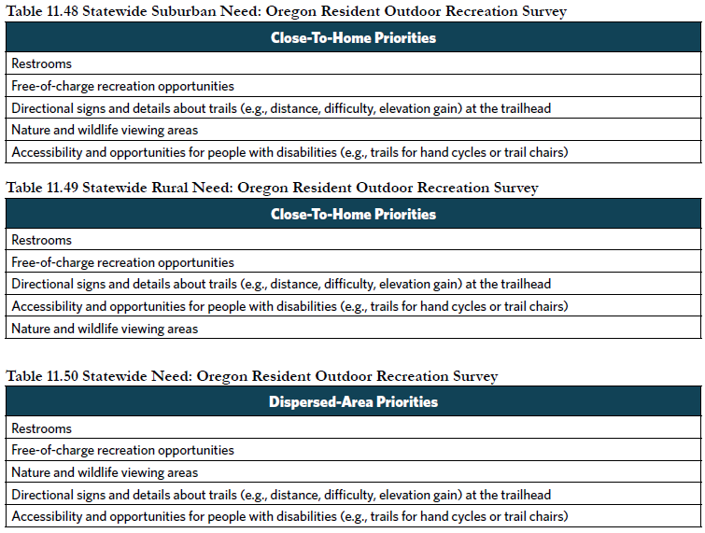
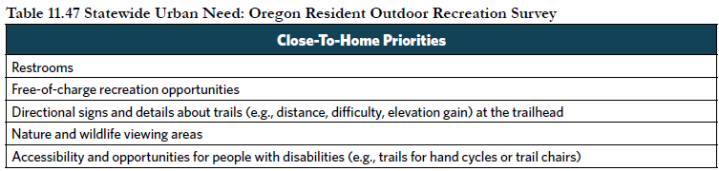
- Coordinated, Long-range Planning. If the priority is not identified in 7a or 7b, is it identified in a current local planning document (park and recreation master plan, city or county comprehensive plan, trails master plan, transportation system plan or a bicycle and pedestrian plan)? Please include the name of the plan and when it was adopted.

- Public Involvement Process. If the project is not included in 7a-7c, describe the public involvement effort that led to the selection of the project including citizen involvement through public workshops, public meetings, surveys, and local citizen advisory committees during the project’s planning process.

8. PHYSICAL ACTIVITY BENEFITS - SCORP Criteria (0-5 points):

The Oregon Resident Outdoor Recreation Survey and the Oregon SCORP physical activity study highlight that the environment impacts physical activity participation, with parks playing a key role in increasing activity, especially in local settings. Priority needs are identified both statewide and in high-priority areas of the state, based on outdoor recreation infrastructure that supports activities with low participation but high energy expenditure and cost of illness savings. High-priority locations for physical activity are identified as counties that have disproportionately lower participation rates in numerous activity categories, both inside and outside communities.

The highest number of points will be awarded to applicants demonstrating need at both the statewide level and within high-priority areas of the state.

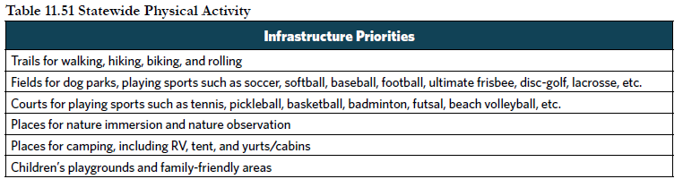
- Statewide Physical Activity Needs. Please identify if the project satisfies one of the five physical activity infrastructure priorities included in Table 11.51 (page 163).

- Physical Activity Priority Counties. Please identify if the project is in one of the physical activity priority counties listed in Table 11.52 (page 163).

9. UNIVERSAL DESIGN / INCLUSIVE OUTDOOR RECREATION OPPORTUNITIES – SCORP Criteria (0–10 Points)

Universal design attempts to meet the needs of all people, and includes those of all ages, physical abilities, sensory abilities, and cognitive skills. It includes using integrated and mainstream products, environmental features, and services without needing adaptation or specialized design. The 2025–2029 SCORP recommends that park amenities and features should be planned with universal design principles. This approach can help address barriers related to personal health and accessibility that were found to be especially prominent for low-income residents and households with disabilities. For more information about Universal Design approaches, see the Universal Design Guidance under the Files tab.

Please describe how your project goes beyond ADA and strives to incorporate Universal Design concepts and design considerations. For examples of Universal Design concepts, please see the Universal Design Guidance under the Files tab.

10. NEED for MAJOR REHABILITATION - SCORP Criteria (0-5 points)

- MAJOR REHABILITATION projects involve the restoration or partial reconstruction of eligible recreation areas and facilities. If the project includes major rehabilitation, please check all that apply:
☐ Not applicable
☐ The recreation area or facility is beyond its normal life expectancy
☐ The recreation area or facility is destroyed by fire, natural disaster or vandalism
☐ The recreation area or facility does not meet health and safety codes/requirements
☐ The recreation area or facility requires rehabilitation to ensure critical natural resource protection
☐ Changing recreation needs (e.g., changes in demographics within the service area) dictate a change in the type of recreation area or facility provided

- Please list the specific facilities that need rehabilitation. Upload photos in the Attachments tab showing the facilities in need of rehabilitation.

- If only part of the project is rehabilitation, approximately what percentage of the project is rehabilitation?

11. COMMUNITY SUPPORT (0-5 points)

To what extent can you demonstrate broad community support for the project by providing information such as letters of support and/or survey analysis? Can you provide results or summary documentation of recent community or neighborhood meetings concerning the project; letters of support from park users, neighbors, and/or a variety of project stakeholders; community fundraising through grassroots efforts for the project? If yes, please include supporting documentation with this application.

12. FINANCIAL COMMITMENT (0-10 points)

Project applicants should demonstrate that funds are available for the project by showing agency budget information or other documents demonstrating financial commitment to the project.

- What is the source of local matching funds for the project? If it is another grant, please indicate whether it is pending or secured. A Resolution to Apply must be submitted with this application to indicate a commitment of local match funding for the project.
- Project applicants are encouraged to develop applications involving partnerships between the applicant, other agencies, or non-profit organizations. Project applicants are also encouraged to demonstrate solid financial commitment to providing necessary project maintenance and upkeep. To what extent does the project involve partnerships with other agencies or groups? Is the funding from other agencies or groups guaranteed?

- To what extent are local matching funds available? What is the local commitment to the project from the local community through donations?

- How did you develop your project budget? To what extent has enough money been budgeted to successfully complete the project?

*** REMINDER: Please Limit Answers to Each Question to 400 Words or Less ***

13. SUSTAINABILITY (0-5 points)

Sustainability means using, developing, protecting, and managing resources in a manner that enables people to meet current and future needs from the multiple perspectives of environmental, economic, and community objectives. Examples may include but are not limited to sustainable design methods, projects that will have a minimal impact on the surrounding ecosystem, and projects that will result in user protection of natural resources such as water quality/conservation, plant conservation, wildlife conservation, energy conservation, pollution control, and environmental protection and restoration.

Describe how sustainability was considered in the intent, strategies, and long-term management plans for the proposed project.

14. READINESS TO PROCEED (0-5 points)

OPRD intends to ensure that available grant funds are used in a timely manner and that appropriate local land use and consistent zoning are applied to the property once funding is awarded to a project applicant.

- Have you submitted a signed Land Use Compatibility Statement with this application? Only an Oregon Parks and Recreation Department grant program specific form will be accepted.
☐ Yes
☐ No

- Have you submitted construction or concept plans with this application? If not, please explain why. If plans are in progress, when are they expected to be complete?

- List required permits and status of permit applications for the project (i.e. Corps of Engineers, Division of State Land, Building Permits, etc.). Describe any possible delays or challenges that could occur in receiving permits. If you need a Corps of Engineers permit, when do you expect to receive it?

- To what extent is the project ready to proceed? If this project is selected for funding, what will be the next step in the process? E.g., pursue construction drawings, apply for permits, solicit bids, etc. Describe any potential issues that may prevent the project from proceeding in a timely manner. If available, attach an estimated project timeline in the “Other” attachments category.

15. ACTIVE AND PAST GRANTS PERFORMANCE

The successful completion of projects in a timely and efficient manner is an important goal of the grant program. A project applicant’s past performance in effectively meeting the administrative guidelines of the program is also an important factor in evaluating performance and compliance. Past projects are available to review in your organization‘s OPRDgrants.org account in the projects panel.

- Is your organization on schedule with all active OPRD-administered grant projects? List all open OPRD-administered grants.

- Is your organization in compliance with the applicable guidelines at previously assisted sites? (e.g., no unresolved conversions, maintenance issues, or public access restrictions).

- Do you have any additional comments or information about your organization’s performance and compliance with active and past OPRD grant awards?

17. WORKSHOP PARTICIPATION

Have you or someone on your staff attended an LGGP Program webinar prior to applying to this program? If so, when?

