Land and Water Conservation Fund Grant Program
2025 Pre-Application Worksheet

for DEVELOPMENT / REHABILITATION PROJECT Grant Applications

This document contains the questions that will be asked on the Oregon Parks and Recreation Department’s online LWCF grant application. This document will NOT be accepted as a grant application but is designed to help applicants prepare answers, in advance, for the LWCF application. Once answers are completed here, they can easily be cut and pasted or entered into the online application. This does not represent the entire application.

Applications must be completed and submitted on https://OPRDGrants.org. The online application becomes available September 15, 2025. Completed applications are due by 11:59 PM on November 17, 2025.

Refer to the LWCF section of OPRD’s website for a copy of the LWCF Grant Manual, forms and online application instructions for using the OPRD Grants website:
https://www.oregon.gov/oprd/GRA/Pages/GRA-lwcf.aspx

____________________________________________________________________________

ATTACHMENTS - Be prepared to upload the following attachments. Most are required. Some forms are provided in the application. Please combine PDFs into a single file when possible.

☐ Application & Revision (A&R) Form (Submit this as a Word document)
☐ Concept or Construction Drawings
☐ LWCF Park Boundary Map
☐ Land Use Compatibility Statement (LUCS)
☐ Letter(s) of Support
☐ Photos
☐ Property Deed or Easement or Lease Agreement
☐ Resolution to Apply for Grant
☐ SHPO Clearance Form (Submit this as a Word document)
☐ SHPO Map: 7.5 min. USGS Topo Map or 1 Sq. Mile Map
☐ SHPO Submittal Form (Submit this as a fillable PDF, do not submit a scanned copy)
☐ Site Plan
☐ State Agency Reviews: Upload responses from the following agencies. Other agencies may be contacted in addition to those listed below.
☐ Oregon Department of State Lands
☐ Oregon Department of Fish & Wildlife
☐ Oregon Department of Environmental Quality
☐ Urban Growth Boundary Map
☐ Vicinity Map
☐ Additional Attachments – if needed

____________________________________________________________________________

BRIEF PROJECT DESCRIPTION: What will this project do (in 40 words or less). Please complete the sentence: The project will . . .
Example: The project will replace existing playground equipment with new accessible playground equipment, and construct 500 feet of paved trail at [park name] in [city or town or area name], Oregon.
FINANCIAL INFORMATION: Prepare a project budget in advance. The budget should include detailed information on all costs and must clearly identify all estimated project costs. Unit costs should be provided for all budget items including but not limited to the cost of work to be provided by contractors. Projects are limited to using a maximum of 15% of the total budget for costs not directly attributable to physical development/rehabilitation activities, supplies, equipment, or cost of land. Additionally, the LWCF Act specifically excludes acquisition support costs (such as acquisition research and appraisals).
The financial section of the application should identify sources of funding, agency match and grant request amount. LWCF assistance shall not exceed 50 percent of the total eligible costs.
The LWCF Act prohibits the use of other federal financial assistance in a project assisted with LWCF. However, in those instances where the statutory provisions of a subsequent federal grant-in-aid program explicitly allows recipients to use such assistance as match for another federal grant, such as in Community Development Block Grants (CDBG) and Recreational Trails Program (RTP), this section of the LWCF Act is superseded and a matching arrangement is possible.

SUPPLEMENTAL INFORMATION

1. PROJECT NARRATIVE (Please limit answers to each question to 400 words or less)

- Describe all elements of the project. What will this project do? What new facilities will be constructed? What existing facilities will be renovated or removed? Describe present development on the site and how the proposed project fits in with current and future development.
- Why is this project a priority? What needs will be met by this project? How will these needs be met?
- Who will do the project work? Who will provide project supervision?
- Who and how many people will benefit from this project?

- Any income received by the project sponsor for non-recreation activities must be used in accordance with federal LWCF rules (see the Federal Financial Assistance LWCF Manual, Vol. 72.1, chapter 7.A.7: Income from properties acquired or developed with LWCF assistance). Please explain how you will comply with these requirements, if applicable.

2. SCORP CRITERIA: CONSISTENCY WITH STATEWIDE PRIORITIES (0-20 points)

- Is your project in a CLOSE-TO-HOME AREA (located within an urban growth boundary (UGB), unincorporated community boundary, or in a Tribal Community), or in a DISPERSED AREA located outside of these boundaries? If the project is located within a UGB, unincorporated community boundary, or a Tribal Community, use the CLOSE-TO-HOME area priorities. Projects outside of these areas will use the DISPERSED AREA priorities. A map clearly identifying the project location and UGB, or unincorporated community boundary drawn on it, must be uploaded in the attachments section of this application.

- If your project is in a CLOSE-TO-HOME AREA, select the statewide priorities your project will address. Select all that apply. (See 2025-2029 SCORP, page 152, Table 11.1-11.2)
Answer: Multiple choice
☐ My project is not located in a Close-to-Home Area.
☐ Restrooms
☐ Community trail system
☐ Accessibility and opportunities for people with disabilities (e.g., trails for hand cycles or trail chairs)
☐ Children’s playgrounds and play areas built with manufactured structures (swing sets, slides, and climbing apparatuses)
☐ Outdoor sports courts (pickleball, tennis, basketball, hockey, volleyball, in-line skating, hockey)
☐ Sports fields (soccer, baseball, football)
☐ Free-of-charge recreation opportunities
☐ Directional signs and details about trails (e.g., distance, difficulty, elevation gain) at the trailhead
☐ Nature and wildlife viewing areas
☐ Natural/dirt or other soft surface walking trails
☐ None of the above

- If your project is in a DISPERSED AREA, select the statewide priorities your project will address. Select all that apply. (See 2025-2029 SCORP, page 152, Table 11.1-11.2)
Answer: Multiple choice
☐ My project is not located in a Dispersed-Area
☐ Accessibility and opportunities for people with disabilities (e.g., trails for hand cycles or trail chairs)
☐ Restrooms
☐ Connecting trails into larger trail systems
☐ Interpretive displays
☐ Day-use hiking trails
☐ Tent campgrounds and facilities (car camping)
☐ Free-of-charge recreation opportunities
☐ Nature and wildlife viewing areas
☐ Directional signs and details about trails (e.g., distance, difficulty, elevation gain) at the trailhead
☐ Natural/dirt or other soft surface walking trails
☐ None of the above

3. SCORP CRITERIA: DIVERSITY, EQUITY, and INCLUSION PRIORITIES (0-10 points)

The 2025-2029 SCORP report builds on previous Oregon SCORP reports by evaluating specific differences in recreation behaviors, priorities, motivations, and constraints for underserved populations. The report has highlighted that key differences in recreation behaviors for underserved groups are likely explained by differences in constraints to recreation rather than different motivations or activity preferences. Therefore, the intent of this criteria is to award points to applicants who demonstrate a strong commitment to diversity, equity, and inclusion by lowering barriers to outdoor recreation. This commitment can be shown by addressing AT LEAST ONE of the following categories (3a-3d).

- Outdoor Recreation Needs of The Low-Income Population. Select the outdoor recreation needs of low-income residents addressed by this project. (See 2025-29 SCORP, page 153, Table 11.3)
Answer: Multiple choice
☐ Not applicable
☐ Provide drive-in tent campsites
☐ Provide cabin and yurt sites
☐ Restrooms
☐ Free-of-charge recreation opportunities
☐ Nature and wildlife viewing areas
☐ Directional signs and details about trails at the trailhead
☐ Accessibility and opportunities for people with disabilities
☐ Farmer’s markets
☐ Community gardens
☐ Educational activities (e.g., environmental, health, computer, orienting and geocaching, historical tours)

- Outdoor Recreation Needs of Underserved Racial/Ethnic Communities. Select the outdoor recreation needs of underserved racial/ethnic communities addressed by this project. (See 2025-29 SCORP, page 153-155, Tables 11.4-11.7)
Answer: Multiple choice
☐ Not applicable
☐ Provide drive-in tent campsites
☐ Provide cabin and yurt sites
☐ Restrooms
☐ Free-of-charge recreation opportunities
☐ Directional signs and details about trails at the trailhead
☐ Nature and wildlife viewing areas
☐ Accessibility and opportunities for people with disabilities
☐ Farmer’s markets
☐ Community gardens
☐ Outdoor sports (youth and adult)
☐ Quiet zones for reading, meditating, or games (e.g., chess, cards)
☐ Outdoor concerts and movies
☐ Functional strength training (training the body for activities performed in daily life)
☐ Educational activities (e.g., environmental, health, computer, orienting and geocaching, historical tours)
☐ Public pools and/or waterparks
☐ Children’s playgrounds and family-friendly areas
☐ Natural/dirt or other soft surface walking trails

- Outdoor Recreation Needs of Additional Underserved Communities. Does the project satisfy one or more needs of an underserved demographic group that is not included in question 3a or 3b?
- Needs Identified for Residents over 60 (See 2025-29 SCORP, page 155, Table 11.8).
Answer: Multiple choice
☐ Not applicable
☐ Provide drive-in tent campsites
☐ Provide cabin and yurt sites
☐ Restrooms
☐ Free-of-charge recreation opportunities
☐ Directional signs and details about trails at the trailhead
☐ Nature and wildlife viewing areas
☐ Accessibility and opportunities for people with disabilities
☐ Farmer’s markets
☐ Seniors’ activity centers
☐ Community gardens
☐ Outdoor sports (youth and adult)

- Needs Identified for the Rural Population (See 2025-29 SCORP, page 155, Table 11.9):
Answer: Multiple choice
☐ Not applicable
☐ Provide drive-in tent campsites
☐ Provide cabin and yurt sites
☐ Restrooms
☐ Free-of-charge recreation opportunities
☐ Directional signs and details about trails at the trailhead
☐ Accessibility and opportunities for people with disabilities
☐ Nature and wildlife viewing areas
☐ Farmer’s markets
☐ Community gardens
☐ Outdoor sports (youth and adult)
☐ Seniors’ activity centers

- If the targeted demographic group’s needs are not identified in the Oregon Resident Outdoor Recreation Survey, please describe how the needs have been identified through citizen involvement, such as public workshops, public meetings, or surveys. Enter N/A if not applicable.

- Diversity, Equity, and Inclusion Strategy. Diversity, equity, and inclusion strategies direct organizations to address inequity in the communities they serve; ensure diverse representation in the planning and decision-making process, and promote welcoming environments for all visitors, employees, and volunteers.

If your organization has an inclusion strategy or is working towards an inclusion strategy, describe that here. If applicable, describe your organization’s diversity, equity, and inclusion strategy as it relates to this proposed project. Upload supporting documentation, if applicable.

4. SCORP CRITERIA: ACCESSIBILITY ACCOMMODATIONS (0-5 points)

The SCORP Oregon resident survey found that 25% of respondents had a household member with a disability. These households are underserved in outdoor recreation, participating less frequently and in fewer activities compared to households without disabilities. The Americans with Disabilities Act (ADA) ensures equal access to parks and recreation facilities, setting design standards for accessibility. Oregon Parks and Recreation Department (OPRD) encourages efforts to provide accommodations beyond ADA requirements to improve access for people with disabilities.
Priority need is demonstrated at the statewide level for households with disabilities. Will the project satisfy one or more of the needs identified in Table 11.10 (See 2025-29 SCORP, page 156)? If the project does not address any of these needs, enter N/A.
Answer: Multiple choice
☐ Not applicable
☐ Provide drive-in tent campsites
☐ Provide cabin and yurt sites
☐ Restrooms
☐ Free-of-charge recreation opportunities
☐ Accessibility and opportunities for people with disabilities
☐ Directional signs and details about trails at the trailhead
☐ Nature and wildlife viewing areas
☐ Farmer’s markets
☐ Community gardens
☐ Seniors’ activity centers
☐ Outdoor concerts and movies
☐ Educational activities (e.g., environmental, health, computer, orienting and geocaching, historical tours)

5. ACCESSIBILITY COMPLIANCE
- Does your agency have a board or city council adopted/approved ADA Transition Plan? ☐ Yes
☐ No
If your agency does not have an approved ADA Transition Plan, the applicant needs to conduct an ADA Site Evaluation for the project. An ADA Site Evaluation should identify and propose how to fix problems that prevent people with disabilities from gaining equal access to programs, services, and activities. To review and access ADA evaluation tools, see the ADA Resources included with this application.

- If your agency does not have a board or city council adopted/approved ADA Transition Plan, has an ADA Site Self-Evaluation been completed for this project?
☐ Yes
☐ No
- How will your proposed project meet current ADA accessibility standards? To what extent will this project involve consultation with building officials, contractors or companies required to know and apply ADA requirements?

6. SCORP CRITERIA: BALANCING CONSERVATION AND RECREATION (0-5 points)

Many places in the Oregon outdoors have seen record visitation in recent years. Outdoor recreation should continue to be promoted for its health and economic benefits, but increased usage can lead to overcrowding and environmental degradation, potentially reducing participation.

The 2023 Oregon Resident Outdoor Recreation Survey https://bit.ly/scorp24a1 highlights these challenges in Oregon. To address this, outdoor recreation providers must balance conservation and recreation to enhance visitor experiences and protect resources for future generations. The survey shows strong support for strategies like acquiring new areas and expanding existing ones to reduce resource impacts and crowding. Applicants may also refer to the 2025–2029 SCORP report titled “Balancing Conservation and Recreation” for additional examples of how outdoor recreation providers can help protect natural resources and visitor experiences.

Describe how this project expands opportunities in existing recreation areas. If applicable, explain how this project will address crowding while also decreasing the burden on current natural resources.

7. SCORP CRITERIA: LOCAL NEEDS AND BENEFITS (0-25 points)

Project applicants are strongly encouraged to develop project applications that meet high priority needs of their jurisdiction. Need can be demonstrated through results of 1) the SCORP needs assessments, 2) through a coordinated, long-range plan with a minimum 5-year planning horizon, or 3) through a substantive public involvement process.

Please identify how the project satisfies local, State or county level needs by using AT LEAST ONE of the following priority local public planning processes (7a-7d).

- Public Recreation Provider Identified Need. Will the project address county-level needs identified by the Public Recreation Provider Survey (see 2025-29 SCORP, pages 156-162, Tables 11.11-11.46). If so, enter which priority or priorities are identified for the project county. Use either the CLOSE-TO-HOME Priorities or DISPERSED AREA Priorities, NOT BOTH.
- Oregon Resident Identified Need. Will the project address statewide level needs identified by the Oregon Resident Survey beginning on page 162 in the SCORP? If so, enter which priority or priorities are identified. For CLOSE-TO-HOME projects, priority need is identified at the urban, suburban, and rural areas. Please select one of these three community types that best describes your service area (pages 162-163, Tables 11.47-11.49). For DISPERSED AREA projects, priority need is identified at the statewide level (page 163, Table 11.50).

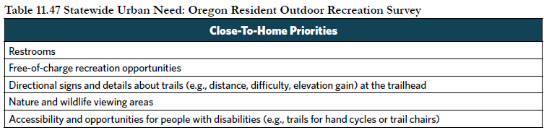
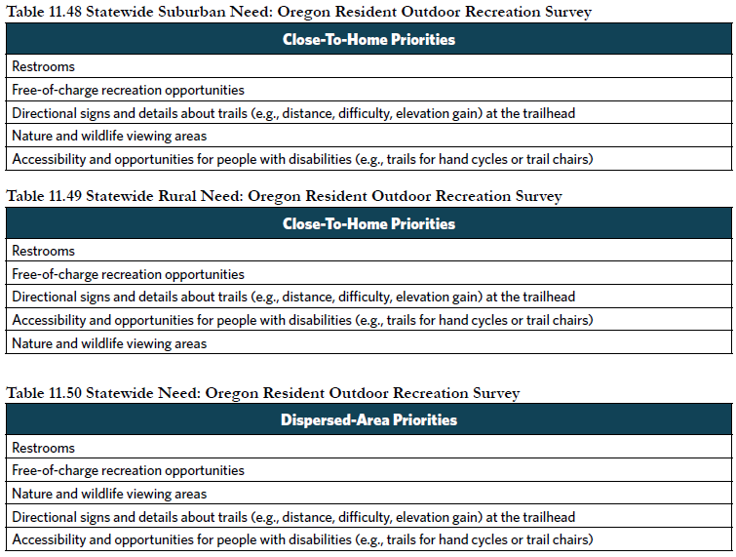

- Coordinated, Long-range Planning. To what extent will the project satisfy priority needs, as identified in a current local planning document (park and recreation master plan, city or county comprehensive plan, trails master plan, transportation system plan or a bicycle and pedestrian plan)?
- Public Involvement Process. If the project is not included in a current local planning document, describe the public involvement effort that led to the selection of the project including citizen involvement through public workshops, public meetings, surveys, and local citizen advisory committees during the project’s planning process.

8. SCORP CRITERIA: PHYSICAL ACTIVITY BENEFITS (0-5 points)

The Oregon Resident Outdoor Recreation Survey and the Oregon SCORP physical activity study highlight that the environment impacts physical activity participation, with parks playing a key role in increasing activity, especially in local settings. Priority needs are identified both statewide and in high-priority areas of the state, based on outdoor recreation infrastructure that supports activities with low participation but high energy expenditure and cost of illness savings. High-priority locations for physical activity are identified as counties that have disproportionately lower participation rates in numerous activity categories, both inside and outside communities.

The highest number of points will be awarded to applicants demonstrating need at both the statewide level and within high-priority areas of the state.

- Statewide Physical Activity Needs. Please identify if the project satisfies one of the five physical activity infrastructure priorities included in Table 11.51 (page 163).

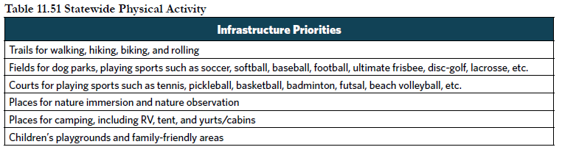

- Physical Activity Priority Counties. Please identify if the project is in one of the physical activity priority counties listed in Table 11.52 (page 163).

9. SCORP CRITERIA: UNIVERSAL DESIGN / INCLUSIVE OUTDOOR RECREATION OPPORTUNITIES (0-10 points)

Universal design attempts to meet the needs of all people, and includes those of all ages, physical abilities, sensory abilities, and cognitive skills. It includes using integrated and mainstream products, environmental features, and services without needing adaptation or specialized design. The 2025–2029 SCORP recommends that park amenities and features should be planned with universal design principles. This approach can help address barriers related to personal health and accessibility that were found to be especially prominent for low-income residents and households with disabilities.

Please describe how your project goes beyond ADA and strives to incorporate Universal Design concepts and design considerations.

10. SCORP CRITERIA: NEED FOR MAJOR REHABILITATION (0-5 points)

- MAJOR REHABILITATION projects involve the restoration or partial reconstruction of eligible recreation areas and facilities. If the project includes major rehabilitation, please check all that apply:
☐ Not applicable
☐ The recreation area or facility is beyond its normal life expectancy
☐ The recreation area or facility is destroyed by fire, natural disaster or vandalism
☐ The recreation area or facility does not meet health and safety codes/requirements
☐ The recreation area or facility requires rehabilitation to ensure critical natural resource protection
☐ Changing recreation needs (e.g., changes in demographics within the service area) dictate a change in the type of recreation area or facility provided
☐ The recreation area recreation area or facility does not meet accessibility standards of the Americans with Disabilities Act (ADA) and/or the Architectural Barriers Act (ABA).

- List the specific facilities that need rehabilitation and upload photos of the facilities.
- Approximately what percentage of the project is rehabilitation?

11. COMMUNITY SUPPORT CRITERIA (0-5 points)

To what extent can you demonstrate broad community support for the project by providing information such as letters of support and/or survey analysis? Can you provide results or summary documentation of recent community or neighborhood meetings concerning the project; letters of support from park users, neighbors, and/or a variety of project stakeholders; community fundraising through grassroots efforts for the project.? If yes, please include supporting documentation with this application.

12. FINANCIAL COMMITMENT CRITERIA (0-10 points)

Project applicants should demonstrate that funds are available for the project by showing agency budget information or other documents demonstrating financial commitment to the project.
- What is the source of local matching funds for the project? A Resolution to Apply must be submitted with this application to indicate a commitment of local match funding for the project.
- Project applicants are encouraged to develop applications involving partnerships between the applicant, other agencies, or non-profit organizations. Project applicants are also encouraged to demonstrate solid financial commitment to providing necessary project maintenance and upkeep. To what extent does the project involve partnerships with other agencies or groups? Is the funding from other agencies or groups guaranteed?
- To what extent are local matching funds available?
- What is the local commitment to the project from the local community through donations?
- To what extent has enough money been budgeted to successfully complete the work?

*** REMINDER: Please Limit Answers to Each Question to 400 Words or Less ***

13. SUSTAINABILITY CRITERIA (0-5 points)

Sustainability means using, developing, protecting, and managing resources in a manner that enables people to meet current and future needs from the multiple perspectives of environmental, economic, and community objectives.

Describe how sustainability was considered in the intent, strategies, and long-term management plans for the proposed project. Examples may include but are not limited to sustainable design methods, projects that will have a minimal impact on the surrounding ecosystem, and projects that will result in user protection of natural resources such as water quality/conservation, plant conservation, wildlife conservation, energy conservation, pollution control, and environmental protection and restoration.

14. READINESS TO PROCEED CRITERIA (0-5 points)

OPRD intends to ensure that available grant funds are used in a timely manner and appropriate local land use and consistent zoning are applied to the property once funding is awarded to a project applicant.

- Have you submitted a signed Land Use Compatibility Statement with this application? Only an Oregon Parks and Recreation Department grant program specific form will be accepted.
☐ Yes
☐ No
- Have you submitted construction or concept plans with this application? If not, please explain why. If plans are in progress, when are they expected to be complete?
- List required permits and status of permit applications for the project (i.e. Corps of Engineers, Division of State Land, Building Permits, etc.). Describe any possible delays or challenges that could occur in receiving permits. If you need a Corps of Engineers permit, when do you expect to receive it?
- To what extent is the project ready to proceed? If this project is selected for funding, what will be the next step in the process (e.g. pursue construction drawings, apply for permits, solicit bids, etc.). Describe any potential issues that may prevent the project from proceeding in a timely manner. If available, attach an estimated project timeline.

15. CONTROL AND TENURE
The project land is controlled:
☐ In Fee simple (Deed)
☐ Through a Lease (leased from the Federal Government or from one public agency to another for a term not less than 25 years)
☐ Through a permanent recreation-use easement or similar device

16. ACTIVE AND PAST GRANTS PERFORMANCE

The successful completion of projects in a timely and efficient manner is an important goal of the grant program. A project applicant’s past performance in effectively meeting the administrative guidelines of the program is also an important factor in evaluating performance and compliance. Past projects are available to review in your organization’s OPRDgrants.org account in the projects panel.

- Is your organization on schedule with all active OPRD-administered grant projects?
- Is your organization in compliance with the applicable guidelines at previously assisted sites? (e.g., no unresolved conversions, maintenance issues, or public access restrictions).
- Do you have any additional comments or information about your organization’s performance and compliance with active and past OPRD grant awards?

17. WORKSHOP PARTICIPATION

Have you or someone on your staff attended an LWCF Program webinar prior to applying to this program? If so, when?

