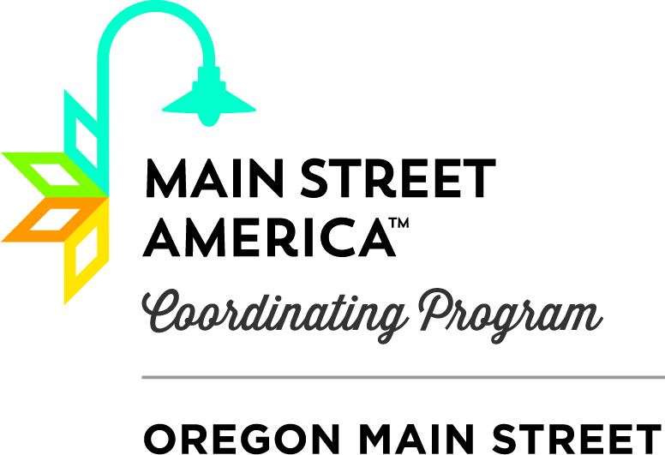
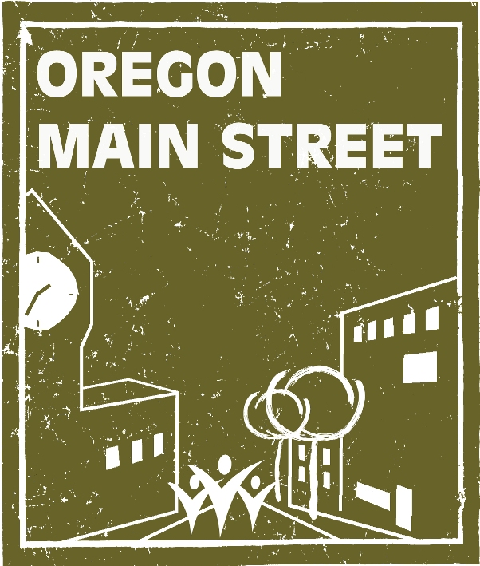

Oregon Main Street Network
2020 Exploring Downtown Level Application
Oregon Main Street works with communities to develop comprehensive, incremental revitalization strategies based on a community’s unique assets, character, and heritage. Services are based on the successful Main Street Approach developed by the National Main Street Center and include training and technical assistance. The goal is to build high quality, livable, and sustainable communities that will grow Oregon’s economy while maintaining a sense of place.
An important objective of Oregon Main Street is to provide assistance to all communities in Oregon whether they are just beginning to explore options for their downtown or seeking national recognition as an accredited Main Street® town. To accomplish this, services are offered through a tiered system. Exploring Downtown is for communities starting a downtown revitalization effort and want to get organized based on the Main Street® model. Interested communities may join at any time by completing a brief application form.
Communities participating at this level must have:
- A cohesive core of historic or older commercial and mixed-use buildings that represent the community’s architectural heritage and may include compatible in-fill.
- A sufficient mass of businesses, buildings, and density to be effective.
- A compact and pedestrian-oriented district.
Communities participating at the Exploring Downtown level agree to:
- Provide a local contact.
- Work towards forming a downtown revitalization organization within one year if one isn’t already in place.
- Send a representative to at least one Oregon Main Street training per year. We find that communities that attend all of our training opportunities tend to move forward more quickly in their revitalization efforts.
- Take time to learn about the Main Street Approach®.
In exchange, the Oregon Main Street Program will provide:
- Invitation and notification of all statewide Oregon Main Street workshops and conferences.
- “Introduction to the Main Street Approach®” Community Presentation (as requested).
- Board Work Plan Retreat (as requested).
- Reconnaissance level historic building surveys.
- Telephone consultations.
- Oregon Main Street listserve access.
- Eligibility for the “Excellence in Downtown Revitalization” Awards and the OMS Revitalization Grant.
- Other types of assistance may be available depending on community readiness and staff availability.
Within three years, we expect communities participating at the Exploring Downtown level to have:
- The organizational structure in place to support the main street effort.
- Broad-based community support and involvement.
Submission Instructions:
- Application for the Oregon Main Street Exploring Downtown level may be submitted at any time.
- The answers to the questions are to help us serve your community effectively.
- All five questions must be answered and attachments provided.
Send form to: Sheri Stuart, Coordinator, Oregon Main Street
725 Summer Street N.E., Suite C, Salem, Oregon, 97301
Questions: 503.986.0679 or sheri.stuart@oregon.gov
Exploring Downtown Level Commitment Statement & Application:

1: Applicant Information

Name of Designated Contact Person & Title or Affiliation:
Downtown Organization or Host Entity (if applicable):
Name of Community:
Population:
County:
Email Address of Contact Person:
Mailing Address:
Phone Number of Contact Person:
Website Address (if applicable):

2: Briefly describe the economic and physical characteristics of your downtown district.
- Attach a map of the primary focus area of your downtown revitalization effort.

3: Briefly describe the structure of your organization or host entity (if you have a board of directors and officers, attach a list). How will the main street effort be implemented through this structure?

4: Briefly describe any efforts to improve the downtown or historic commercial district over the past 5 years.

5: How supportive is the community of the downtown (i.e., residents, downtown business and property owners, local government, etc.)? Attach a letter of support or resolution by the City.

6: Briefly describe what you hope to achieve by participating as an Exploring Downtown level community.

7. Certification: We agree to meet the requirements of Oregon Main Street as outlined above and will be eligible to receive Exploring Downtown level services from Oregon Main Street if the requirements are met. We understand that our Exploring Downtown level membership within the Oregon Main Street network does not authorize us to use the Main Street® trademark name and further understand that the Main Street® name is a trademarked brand, owned by the National Main Street Center.

_____________________________________________________ ______________________
Signature of Designated Contact Person Date

