Theory of Change

Writing and Critiquing Your Theory of Change

Introduction
At its core, the Theory of Change is the foundational piece to your program design – it serves as a method to define and describe your program. A Theory of Change is the underlying idea of how you believe your program design (or intervention) will create change. It describes the cause-and-effect relationship that exists between the intervention (or service activities) you plan to implement and the results (or outcomes) you hope to achieve. Your Theory of Change should be based on evidence or a strong hypothesis of how and why the expected change will occur. A well-written and developed theory of change should shift your thinking away from the day-to-day question “what are we doing” to the longer term question “what do we want to achieve?”
The Theory of Change is also a narrative section of the AmeriCorps application, accounting for approximately 25-30% of the length (approximately 2-3 pages) of your narrative application response. As such, this activity will become the basis for what will ultimately become your AmeriCorps application narrative. While many organizations have engaged in a process to create a Theory of Change, the planning grantee cannot assume that the organization-wide Theory of Change will address AmeriCorps’ needs and should plan to spend time adopting it for the AmeriCorps program and/or creating a new AmeriCorps-specific Theory of Change.

Definitions
A theory of change defines a cause-and-effect relationship between a specific intervention, or service activity, and an intended outcome. There are three main components to a theory of change: 1) the community problem, 2) the specific intervention and 3) the intended outcome. The community problem should be supported by statistics and the causal relationship between the intervention and the intended outcome should be supported with evidence.
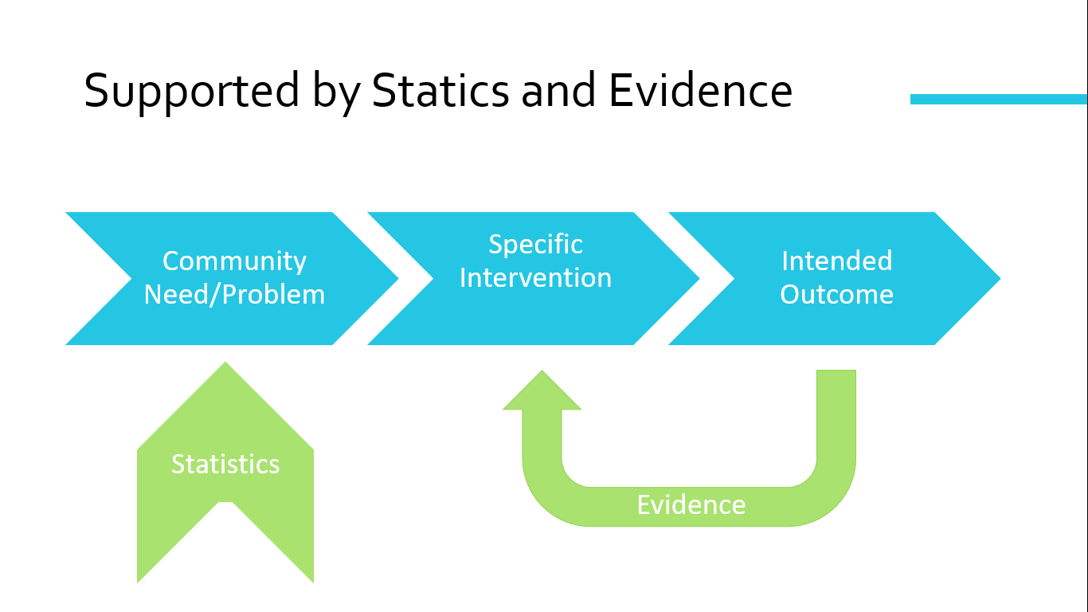
Community problem is the specific need in the community you have chosen to address through your program/project.
An Intervention is a set of activities that you have chosen as a means to address the need, based on evidence that a similar approach has worked in the past or elsewhere. The intervention should very specifically address the dosage, or frequency (how often), intensity (for how long), and duration (total weeks/months/sessions of the intervention).
Outcome is the change in attitude, knowledge, behavior, or condition that the intervention generates.
Statistics are the data documenting the extent and severity of the community problem or need your program/project will address. The best data come from reputable primary sources, (such as government agencies, institutes, foundations, and universities that have conducted their own research), are as current (up to date, ideally within the past 7 years) as possible, and are as locally relevant, as possible. News reports are NOT primary sources. Data from multiple (reputable) sources increase reliability.
Evidence is information from performance measurement results or evaluation/research findings that inform your understanding of why the intervention you have selected will result in the change identified as the outcome.

Instructions
- Use the Theory of Change worksheet to list bullet point elements of the program’s theory of change. Be specific and use relevant statistics and evidence, including the citation. Make sure an independent reader can clearly identify the unmet community need and plainly link how the intervention (members’ service) will address the need and lead to the projected outcomes. This worksheet should be several pages in length.
- After completing the worksheet, use the Theory of Change Checklist to review the worksheet and identify where you have written a well-defined element and/or which elements need further strengthening.
- The final step is using your bulleted points within each element to create a cohesive narrative response that is 2-3 pages in length.

Before You Begin
Before you begin, it’s helpful to consider some reflection questions in order to properly frame your Theory of Change. Ask yourself:
- What real and concrete data exist to document the extent or severity of this problem in your community?
- Why does the problem exist? What data or evidence supports your rationale for why the problem exists?
- Who are the beneficiaries of the service members will provide?
- Is my design PLAUSIBLE: If we do these things, will we get the results we expect?
- Is my design FEASIBLE: Are resources sufficient to implement the chosen intervention?
- Is my design MEANINGFUL: Are the intended outcomes important? Is the magnitude of expected change worth the effort?
- What evidence exists to document that the proposed intervention (specific activities delivered at the dosage described) is an effective way to solve the problem?

Sticking Points and Common Issues
Next, consider some common issues that frequently arise with each section of the Theory of Change. You may encounter the following issues as you are developing and/or critiquing your theory of change.

Community Problem/Need Issues:
- Explains the intervention activities instead of presenting data demonstrating the specific problem/issue in the community the intervention will address.
  - This makes it difficult to know if there is truly a need for the proposed intervention and whether the intended outcome identified makes sense.
- Uses state or national data instead of local data describing the need in the specific communities where the service will occur.
  - This makes it difficult to know if program resources are being utilized effectively to address critical local needs and if it is even a community need.
- Turns into a “data dump” with too many indirect or unrelated statistics provided.
  - This makes it difficult to identify the specific need that the intervention will address as there is irrelevant information to sift through.
- The community need and intended outcome are not closely related.
  - This makes it difficult to know if an appropriate intervention has been selected and if the activities will address the identified need. It is also unclear which is inaccurate - the need statement or the identified outcome. The need and outcome should be very closely related.
Intervention Issues:
- Description of the design and service dosage (frequency, intensity, and duration) is incomplete.
  - This makes it difficult to know if the intervention can produce the intended outcome.
  - It also is difficult to assess whether the target (expected degree of change) is likely to be achieved based on the design and dosage.
- The intervention is duplicating or supplanting existing staff or volunteer efforts, or it is unclear what AmeriCorps members will accomplish.
  - This makes it difficult to know if AmeriCorps members are adding meaningful value to the community.
- The description of member service activities is unreasonable to accomplish in the timeframe described.
  - This makes it difficult to assess if the intended outcome is likely to be achieved.
- The intervention described includes unallowable/prohibited activities.
  - This demonstrates that the applicant has not familiarized themselves with AmeriCorps rules and regulations.
Outcome Issues:
- The intended outcome isn’t likely to occur based on the specific intervention.
  - May need to rethink choice of intervention or choose another outcome to measure.
- The intended outcome is unreasonable or unattainable (i.e. doesn’t take attrition into account).
  - May need to revisit the outcome targets.
- The intended outcome doesn’t directly relate to the community need.
  - This makes it difficult to know where the issue is – is it just a poorly chosen outcome or is it that the intervention doesn’t directly address the community need?

Theory of Change Worksheet
Program: ________________________________________________________
Community Need/Problem | Intervention | Outcome(s)
 | If members/volunteers do this… | …then this will happen.
Describe the negative condition that exists in the community.  Documentation (reputable, current, local) | Describe your intervention design—the specific member or volunteer activities designed to address the need. Include why AmeriCorps members are a reasonable way to address the need.  Describe the dosage of your intervention.  Frequency (how often):  Intensity (for how long):  Duration (total length of intervention): | Describe the change in beneficiary attitude, knowledge, behavior or condition that will occur as a result of the intervention (should be closely related to the community need and supported by evidence).

Theory of Change Checklist
Use the following checklist to determine if the theory of change has all needed components.
Element | Criteria | Status | Ideas for improvement
Community Need | - Makes clear statement of the problem or issue the program will focus on | ❑ Yes   No
 | - Provides statistics to document the problem: From a reputable source | ❑ Yes   No
 | Local (Relevant to the proposed service locations) | ❑ Yes   No
 | Current (if not within past few years provides explanation) | ❑ Yes   No
Intervention | - Provides a clear description of the activities volunteers / members will provide (design) | ❑ Yes   No
 | - Clearly describes the dosage:  Frequency | ❑ Yes   No
 | Intensity | ❑ Yes   No
 | Duration | ❑ Yes   No
 | - Intervention directly addresses the identified need | ❑ Yes   No
Evidence | - Demonstrates high likelihood intervention will achieve intended outcome | ❑ Yes   No
 | - Provides directly relevant performance measurement, evaluation and/or research results | ❑ Yes   No
 | - Data used appears to be high quality and collected using rigorous methodology. | ❑ Yes   No
 | - From a program with similar design | ❑ Yes   No
 | - From a program with similar dosage | ❑ Yes   No
Outcome | - Change likely to occur based on proposed intervention | ❑ Yes   No
 | - Relates to community need | ❑ Yes   No
 | - Is achievable within one year | ❑ Yes   No
Overall | - All elements are in alignment. | ❑ Yes   No
 | - Clearly shows cause and effect relationships | ❑ Yes   No

Theory of Change Narrative
After your Theory of Change worksheet is updated and completed to your satisfaction, including all relevant statistics and evidence to clearly identify your community need and how your intervention will address that need, use the space below to turn that into a narrative that is approximately 2-3 pages in length.
Generally, AmeriCorps the Agency looks for the Theory of Change narrative to include the following elements (this is subject to some change year to year, but generally includes):
- The proposed intervention is responsive to the identified community problem.
- The applicant’s proposed intervention is clearly articulated including the design, dosage, target population, and roles of AmeriCorps members and (if applicable) leveraged volunteers.
- The rationale for utilizing AmeriCorps members to deliver the intervention(s) is reasonable, and the service role of AmeriCorps members will produce significant contributions to existing efforts to address the stated problem.
- The applicant’s intervention is likely to lead to the outcomes identified in the applicant’s Theory of Change based on the evidence provided.
- The expected outcomes articulated represent meaningful progress in addressing the community problem identified by the applicant.

Community Need

Intervention

Outcome(s)

