
Rule Advisory Committee - Liquid Petroleum Gas
Company Audits
Attendees-Eleesa Markham, Michael Pargeter, Cody Shanley, EmmaLee Brickell, Mark Johnston, Sara Zavala, David Holmes – Ryan Moreland, Ryan Buller, Brett Hauth, Bryan Adams, Kevin Karpstein, Stormy Slovieg, Gregory Haigwood, Rodger Smith, Branden Prentice, Zepp Charlton

7/9/2025, 09:00 to 12:00, Mt. Hood Conference Room - GHQ Salem, OR

- Introduction and Round Table
- Executive Comments – Chief Johnston
- Progress of the Project
- Blackline OAR Review
- Artifact
- What we need from RAC
- Interactive session
- Next Steps
- Closing

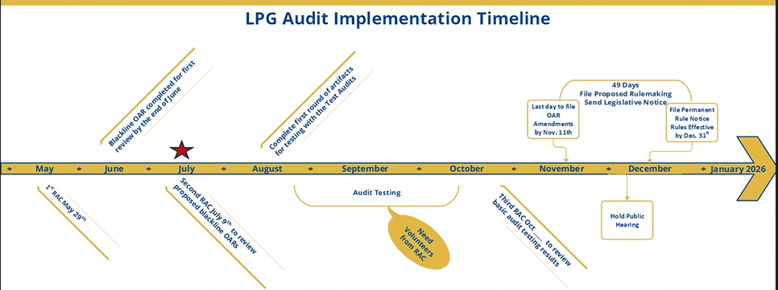
- We have black-line rules and will be moving into audit testing and creation of document artifacts – we really want to have as much input as possible and test everything before rolling anything out.
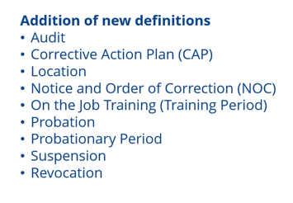
  - Main changes:

- Ryan Buller– Audits NEED to have notice – we can’t have it be unannounced.
  - Michael Pargeter – by statute there may be times we need to do it without notice and that is why we need that language in there – we took the definition from the cardlock rules – often we will provide notice but there are times we will need to have the option if we need to.
  - Ryan Buller- How are you going to handle multiple locations?
    - Eleesa Markham – there should be someone for each location (Company Rep) – we can add some clarity about what defines a location.
  - Bryan Adams – putting a geographic boundary for what the company rep covers – something along those lines – Milage perimeter?
    - Michael Pargeter – company’s all do things a little different so defining location is important so that we can have everyone on the same page.
    - Mark Johnston – We will work on the language around it – but we need what has been in practice to match across the board.
  - Ryan Moreland – Sometimes we are not in office for the audit so we would like to make sure we are there for an audit.
    - Michael Pargeter – We will always lean toward notification prior to coming.
- Probationary period – 60 days on the job training
  - Now it is a status vs a new employee going through training – we want probation to be a license status we set for being out of compliance – we are still working on language around it especially with current language saying probationary period is for new employees and we would like to change that definition to “Training Period”
- Suspension and Revocation
  - This has always been in OAR we are just moving the definitions
- Bryan Adams – one thing going off definition – is there consideration about suspending and revoking company license and employee license? – ex. An employee doing unsafe things and moving to a different company – how would policing that go so we aren’t sending/inheriting someone who is not doing what they should be
  - Brandon Prentice – we would like to see a record around those people.
    - Eleesa Markham – it is all public record and can be shared.
    - Mark Johnston – it’s hard to police – we don’t usually track individuals.
      - We can’t save notes in everyone’s account and what they set.
    - Zepp Charlton – that may open the door for retaliatory things.
    - Bryan Adams – Does OSFM have the bandwidth for appeals in that case?
      - Mark Johnston – Yes there is always due process.
  - Michael Pargeter – Do we think this would happen a lot?
    - Bryan Adams – we can’t speak for the entire industry, but we do see people that have been terminated stay in the industry somewhere else.
    - Eleesa Markham – people can request their license statuses from us.
  - Our vision and practice – notice of correction (just fix it and we are good) – Probation is still operating but do better – suspension is a fixed period – and something we hope to never get to is Revocation, but we need it to be defined.
  - Bryan Adams – We worry about the survivability of the rules and follow-through on enforcement.
- 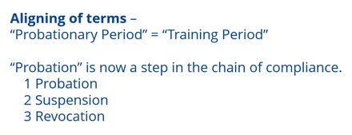
  - Brayn Adams – Requiring a customer email? – not all our customers have or are willing to give.
    - Eleesa Markham – when we are trying to schedule inspections email is something that will be easier in the future for scheduling.
    - Michael Pargeter – David historically would be spending days calling customers for inspections – but email will end up being more efficient
    - Bryan Adams– if they don’t or are unwilling to give email are we not able to set a tank?
    - Zepp Charlton– some are just off grid people and don’t like people to want to provide that.
    - Brandon Prentice – we would love to require that – but trying to force isn’t super feasible.
    - There is support on requiring it – but we don’t want to lose out on customers if they don’t want to provide it.
- Audits – Completely new section.
  - Bryan Adams – under 5(a) – concerned the description of duties – clarity on the format.
    - We just want to know what employees do to determine if they need to be licensed – we will not approve or deny duties
    - We will not hold the data – it stays at the company, and we will not release that data.
    - Bryan Adams – Inheriting tanks – some tanks have been installed by other companies but now we service.
      - Eleesa Markham – They should have already been reported by the other company, but it should be good practice to email in and check with us.
      - Mark Johnston – if the tank gets reset – it might be on our list more than once. – Every time tanks are moved it needs to be reported.
      - Michael Pargeter – Serial, Address, Company, Fitter ID - everything else is beneficial information.
    - Bryan Adams – OSFM doesn’t track when tanks get removed?
    - Ryan Buller – what about a temp tank? Like one being set for 2 weeks?
      - Eleesa Markham– all tanks need to be reported for any period of time.
    - What information should we not want to report? – No exemption for name and address.
      - Brandon Prentice – we don’t want to be in a place where we are stepping on toes – the concern is that the information is so easily accessible.
  - Mark Johnston – we can add language around not keeping any data when on an audit.
    - Bryan Adams – it might help to have records on when tanks are removed.
    - RSD - About 20% of tanks have been reset – but not reported.
    - Would industry be interested in reporting removals and changes?
      - Bryan Adams – as long as we don’t get charges for that.
      - Ryan Buller – Repaying for changing out tanks is ridiculous.
    - Bryan Adams – for the intent of what the program is trying to do is good – but we don’t want to have to pay for something additional.
    - Eleesa Markham -The intent is to inspect for compliance to make sure industry is at a level playing field – we don’t want to change that intent – tracking removal or changes would be a bit workload.
      - The purpose of the audit is just to ensure all tanks sets have been reported.
  - Ryan Buller – What is the point of coming to the office if everything is digital?
    - Michael Pargeter - Face to face works better – truck audits – being able to ask direct questions. – we added in there that we can potentially do the audits remote – but our preference is going to be in person. Audits are not a requirement but something we have the power to do. Intended to just be a quick-ish check in. We aren’t shifting our focus from what we already do with inspections – it will just be an occasional check in feel. It shouldn’t come off as a burden.
  - Mark Johnston – how would we feel about more compliance specialist?
    - Ryan Buller – with the audit process it should help clear that up.
    - Bryan Adams – hopefully the probation steps also add the necessary teeth to gain compliance – we wouldn’t want a fee increase.
  - Bryan Adams – license renewals – obligation for 30-day notice – are we not liable to pay if we didn’t get notified?
    - If the license lapses you are liable for the late fee.
- Anticipation of economic impact?
  - It should – but not sure how much
  - Would there be a greater impact upfront? But level out?
    - Bryan Adams – we maintain files – it’s the resources are available for the audits is where we see the impact – taking people from their normal day-to-day to participate in the audit – possible software maintenance on the required template for files. – digitizing paper records is an impact
- Artifacts to come: 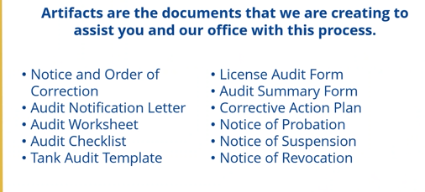
- Any really big red flags on things heard today?
  - Nothing major other than details – how intense the process is – certain times of the year audits would be hard
  - Our goal is successful audits and to not add burden
    - Summer – May, June, July are the preferable times
- Next Steps:
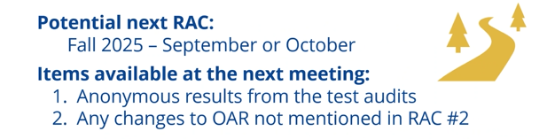
- Blueprint of the timeline would be great to see – the more information we can disseminate would be great.
Meeting end 11:14AM

Contact information for Attendees:

Brandon Prentice – Carson - brandon.prentice@carsonteam.com
Zepp Charlton – Carson - zepp.charlton@carsonteam.com
Gregory Haigwood – Carston - gregory.haigwood@carsonteam.com
Brett Hauth – Pacer Propane - Brett.Hauth@pacerpropane.com
Rodger Smith – Ferrellgas - rogersmith@ferrellgas.com
Ryan Moreland – Pape’ Material Handling - rmoreland@Papemh.com
Kevin Karpstein – CoEnergy - kkarpstein@coenergy.net
Bryan Adams – CoEnergy - badams@coenergy.net
Ryan Buller – McMinnville Gas - rbuller@mcminnvillegas.com
Stormy Slovieg – CoEnergy - stormy@coenergy.net
Michael Pargeter – OSFM – Michael.pargeter@osfm.oregon.gov
Eleesa Markham – OSFM – Eleesa.markham@osfm.oregon.gov
Mark Johnston – OSFM – mark.johnston@osfm.oregon.gov
Cody Shanley – OSFM – Cody.shanley@osfm.oregon.gov
EmmaLee Brickell – OSFM – emmalee.brickell@osfm.oregon.gov
Sara Zavala – OSFM – sara.zavala@osfm.oregon.gov
David Holmes – OSFM – David.holmes@osfm.oregon.gov

