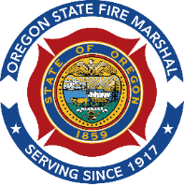
Oregon State Emergency Response Commission (SERC) and
Local Emergency Planning Committee (LEPC) FAQ Sheet

In 1986, Congress passed the Emergency Planning & Community Right to Know Act (EPCRA) after a series of incidents in the United States and abroad raised concerns about a lack of planning and preparation for accidental releases of hazardous materials. The goal is to give emergency responders, emergency planners and the public information on the types and quantities of extremely hazardous substances (EHS) within their communities. With this information, they can develop and tailor a chemical emergency planning and response program to protect the public and their communities in the event of a hazardous material release. In order for this mandate to be addressed, the law requires each state to establish a SERC, develop Emergency Planning Districts (EPD)s throughout the state and appoint LEPCs to each of those districts.
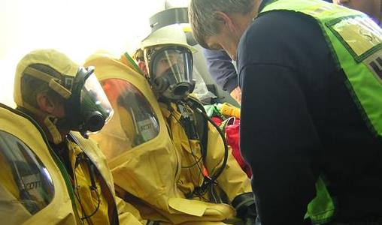
What is the SERC? The SERC is a team of individuals from State and local government, industry, and the public sector that have technical expertise in the emergency planning and response field. The primary goals of the SERC are to develop EPDs throughout the state, appoint LEPCs to each EPD and to assist the LEPCs in accomplishing their mandates.
What is a LEPC? A committee of individuals from state and local government, emergency responders, emergency planners, hospital, transportation, health, environmental groups, media, industry and the local community. LEPCs address risks from hazardous chemical releases at fixed sites or in transit. They use a variety of methods and strategies to ensure emergency planning and preparedness is accomplished within their districts. LEPCs do not respond to emergencies, rather, they are tasked with ensuring the broad issues of planning for a response to a chemical incident has occurred.
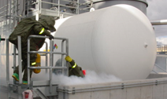
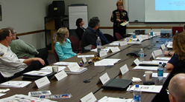
What is an Emergency Planning District? One of the responsibilities of the SERC is to divide the state into EPDs. Currently in Oregon, these planning districts mirror county boundaries. Two or more counties can create a single multi-county planning district if they so choose. An LEPC is responsible to facilitate preparation and implementation of the LEPC emergency response plan within their EPD.
What is required in the plan? Each EPD must have a written plan that covers response to incidents involving facilities with a threshold planning quantity (TPQ) of EHS. These plans identify at risk areas, response responsibilities on and off the facility, and describes evacuation plans. This allows both planning and practicing of the plan.
What is an EHS? Although all chemicals can be dangerous to life and health, EPA has established a list of over 330 chemicals considered to be “Extremely Hazardous Substances”. These are substances that even in very small amounts can be immediately dangerous to life and the environment. The EHS list includes substances such as chlorine, phosgene, anhydrous ammonia and formaldehyde.
What is a Threshold Planning Quantity (TPQ)? For each of the chemicals on the EPA EHS list, there is a corresponding threshold quantity that if exceeded, subjects the facility possessing the substance to the requirements of EPCRA and participation with the LEPC in the planning process.

How can I learn more? For more information on Oregon’s SERC or LEPCs go to the State Fire Marshal’s website at https://www.oregon.gov/osfm/emergency_response/Pages/LEPC.aspx

For more information on EHS facilities in your area go to the State Fire Marshal’s website at https://www.oregon.gov/osfm/industry/Pages/CR2K.aspx
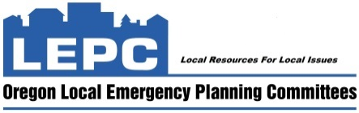
For questions, send an email to MaryAnn.Christian@osfm.oregon.gov

