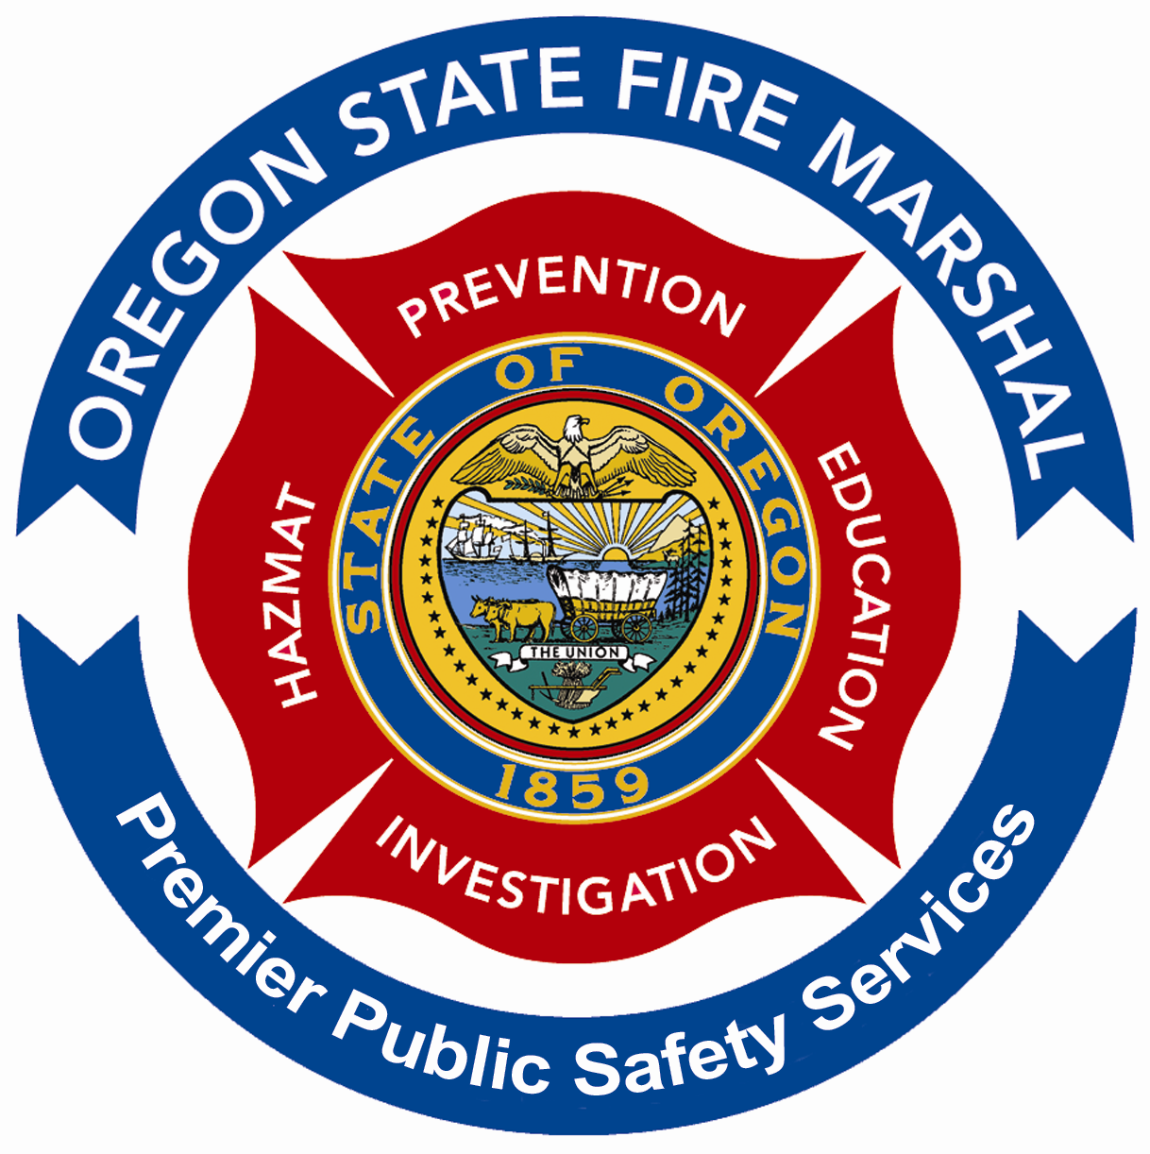 | APPLICATION TO TAKE  GENERAL OPERATOR  CERTIFICATION EXAMINATION  OREGON STATE POLICE  OFFICE OF STATE FIRE MARSHAL  Regulatory Services Division – Fireworks Program | OSFM USE ONLY  Exam Date
IMPORTANT: COMPLETE A SEPARATE APPLICATION FOR EACH APPLICANT REQUESTING TO TAKE THE GENERAL OPERATOR CERTIFICATION EXAMINATION.

Please submit the application by one of the following options:

Email: SFM.LP@state.or.us

PHONE: 503-934-8272 OR 8274 fAX: (503) 373-1825

Mail Applications to:
Office of State Fire Marshal
Regulatory Services Division – Fireworks Program
3565 Trelstad Ave SE
Salem, OR 97317

FEES: There is no fee for the examination.

STUDY MATERIALS: Oregon Administrative Rules 837-012-0700 through 837-012-0970

EXAMINATION TYPE: 62 Questions (Multiple Choice, T/F)

EXAM INSTRUCTIONS: After receipt of application, an email containing detailed instructions will be sent to the address provided. NOTE: The address must be the applicants own email address. The system will not allow multiple users for one email address.

Applicant's Name
Last First Middle

Mailing Address
Street or Route, Box Number City State Zip

Telephone

PLEASE PRINT CLEARLY APPLICANT’S EMAIL ADDRESS

NOTE: The email address must be the applications own email address as the system won’t allow multiple users for one email address.

SIGNATURE OF APPLICANT DATE

