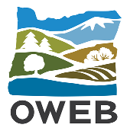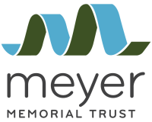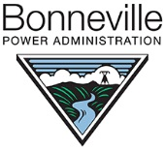

Willamette River Anchor Habitat Investments
Application Supplemental Questionnaire
Upload to OWEB Project Application by 5 pm, April 16, 2021
Questions? Email Andrew Dutterer, OWEB (andrew.dutterer@oregon.gov), or call 971-345-7233.

1. Project Overview
Project Name

Applicant

Project Type (check one):
Restoration Technical Assistance (TA) Monitoring

2. Project Location
Identify the location using the following information.
See the SLICES website for each location item except anchor habitat.
Name of River
Slices #’s (100m slice by number):
River Mile
Does the proposed project occur in an anchor habitat? Yes No
If yes, refer to the Solicitation Announcement and enter the name of the anchor habitats map:
Does the proposed project occur within the 2-year flood inundation zone?
Yes No Not Sure

3. Project Goals
Check as many goals below as apply to your project:
Increased channel complexity and length
Floodplain reconnection
Floodplain forest expansion, restoration, and/or enhancement

4. Project Description
Provide a brief response to each of the following prompts. If information for a prompt has been provided elsewhere in the application, a response is not necessary, but please reference where in the application that information can be found.
For TA and Monitoring applicants – relate responses to your proposed work, not resulting restoration work.
  - Current Site Conditions
- Habitat type(s) (e.g., floodplain, floodplain forest, side channel)
- Land uses and land conditions two kilometer slices immediately above and below your site, both sides of the river (e.g., intact forest, floodplain sloughs, commercial farm, suburban residential community, etc.)
- Aquatic habitat conditions, including the presence of cold water refugia, if any (see the SLICES website)
- How the project might contribute functional connectivity to adjacent floodplain forests immediately upstream and downstream of your site

  - Impact of River Processes
Describe how the project might be affected by river flows- both high flows and regulated summer flows.

  - Contribution to the SLICES 2050 Conservation Scenario
If you checked “floodplain forest restoration” and/or “increased channel complexity” as project goals in Question 3, outline in bullets below how the project will contribute to meeting the objectives of the SLICES 2050 Conservation Scenario. If you did not check either or both of these goals, skip this question.
Instructions: Go to the “Tabular Attribute Data” spreadsheet of the SLICES website. Locate in the first column the 100m slice numbers you designated in Section 1. Scan across the spreadsheet to the appropriate 2050 goal column. Outline in bullets how your project will contribute to advancing the floodplain forest and/or channel complexity goals of the 2050 Conservation Scenario for the project site’s 100m slices.

  - Anticipated Social Benefits
List any social benefits of the proposed project. If it’s a phase of a larger project, list social benefits of the complete project (all phases) as well.

7. Project Maps & Aerial Photos
A) Upload to the application 4 maps of your project location:
- Location context - major structural and biological features of the project site in its context with both sides of the Willamette River and two meander bends above and below the project site.
- Site context - areas of proposed work and habitat types.
- 2-year flood inundation zone, as applicable. See SLICES website for more information.
- Historical context, if available (see example).
B) Attach aerial photo(s) of your project location. See UO Libraries Aerial Photography Collection.

