Small Grant Program
Guidance for the Planning and Review of Juniper Projects
When planning and/or evaluating juniper projects under OWEB’s small grant program it is important to consider the long-term success and maintenance of the project and its ecological benefit. Applicants should answer these questions as part of the Problem or Solution narrative portion of the application. These questions are intended to help both the applicant and the reviewers evaluate whether the benefits from the juniper project are proportionate to the site potential, the degree of encroachment, and the length of time the site has been subject to the effects of occupation. If the questions are not answered, reviewers may ask applicants for additional information via email. This form is required to be sent in to OWEB with every small grant application for juniper management projects along with any additional information the applicant may have been asked to provide by the reviewers.
OWEB has published several guidance documents related to juniper management. We recommend reading the references listed below prior to planning and implementing any juniper management projects.
Western Juniper Management: A Field Guide http://oregon.gov/OWEB/MONITOR/docs/WesternJuniperManagementFieldGuide.pdf
Juniper Management in the Crooked River Watershed
http://oregon.gov/OWEB/MONITOR/docs/ContrastingJuniperManagement_CrookedRiver.pdf
Juniper Removal Evaluation: Phase I and II Final Reports
http://oregon.gov/OWEB/MONITOR/docs/juniper_report.pdf
http://oregon.gov/OWEB/MONITOR/docs/Juniper_PhaseII_report.pdf
Project Name:
Project #:
1) What is the phase of juniper woodland succession? (see attached sheet)
Phase 1 Phase 2 Phase 3
2) Has the existing vegetation structure, aspect and slope of the site been described? Has the applicant addressed whether or not seeding is needed?
Yes No
3) Is there a grazing strategy for the site?
Yes No
If not, the applicant has clearly explained why it is unnecessary.
Yes No
4) Has a long-term management plan for the juniper site been discussed and identified? (Using chainsaws and loppers to maintain in the long-term, Burning in 10 years)
Yes No
5) Is the project located near any other juniper treatment projects either completed or planned?
(Does not have to be OWEB funded)
Yes No Unknown
If yes, how do they relate? (Examples: adjacent to other juniper or rangeland health projects, part
of CREP or a watershed restoration plan)

6) Is the ecological benefit of the juniper project clearly articulated?
Yes No
Woodland Succession of Juniper
The full gradient of juniper encroachment extends from the period of seed introduction and germination, through stand maturation, to the full occupation of a site by juniper trees. The following phases of woodland succession described in Miller et al. (2005) serve as useful benchmarks along this gradient.

Phase 1
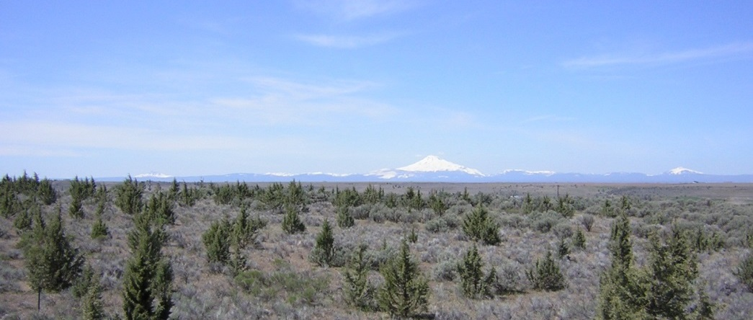
This early stage of juniper encroachment involves an actively-expanding, open canopy of young trees (usually 40 years old or younger), exhibiting no die-off of lower limbs. The trees are a subordinate component of the plant community. Active recruitment is taking place (tree seedlings in the shrub layer). Grasses, forbs, and shrubs are able to express their full productive potential, apparently uninhibited by competition from juniper. In this stage, little or no observable change in plant community composition or in soil cover and overland flow can be attributed to juniper. Sometimes, however, excessive shrub canopy closure or heavy, long-term grazing use causes perennial grasses and forbs to be sparse or absent. In this phase, a number of treatment options are available for preventing further site degradation.
Photo 1
Phase 1 of Woodland Succession

Phase 2
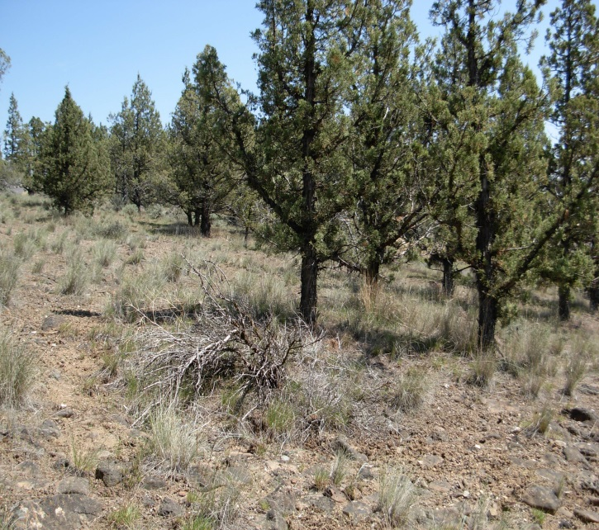
This mid-successional stage of juniper encroachment also entails an actively expanding canopy of trees now co-dominant in the plant community. In this phase, the maturing juniper may produce berries at moderate to high levels. Depending on several site factors including slope, soil depth, soil texture, and available water capacity of the soil profile, shrubs may die off as the network of shallow juniper roots begins to extend its occupation of the upper soil profile. On moisture-limited sites (those with shallow soils) or on steep slopes with high rates of overland flow (low infiltration rates), shrubs may exhibit stress or die-off as a result of competition. Moderately deep and deep soil sites may retain their shrub, grass, and forb components and exhibit few biotic or abiotic effects. As the site progresses into the later stages of Phase II, shrubs may die off on shallow and moderately deep soils while grasses persist. In the mid to late-stage of succession, fewer treatment options will be effective in preventing further site degradation. Late Phase II and early Phase III constitute the period of transition when biotic and, in many cases, abiotic conditions worsen and the focus of treatment options changes from prevention to restoration and repair.
Photo 2
Phase 2 of Woodland Succession. Note shrub die-off.

Phase 3
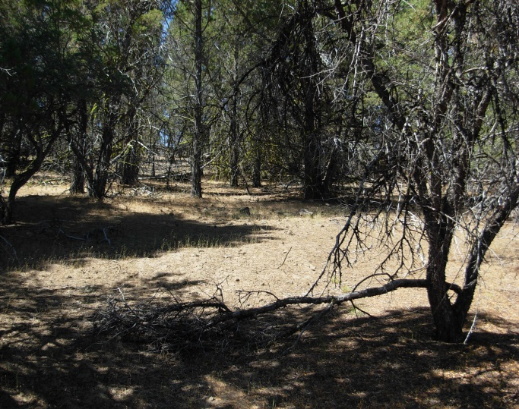
At this stage, occupation of the site by juniper is complete, and juniper and its effects dominate the site. Full grow-out of the surface root network concludes; the tree’s leader growth has slowed; berry production has declined and tree recruitment is limited. Biotic and abiotic conditions on the site are visibly degraded. Shrub die-off will likely exceed 75 percent. Understory plant production declines, as do species richness and diversity. In the tree interspaces, the loss of understory plant cover exposes bare soil, particularly on drier, harsher sites and those with an effective rooting depth of less than 20 inches. Soil organic matter declines, and raindrop impact promotes physical crusting of the soil surface, reducing infiltration rates and, on sloping sites, overland flow and soil erosion increase. Grasses like Idaho fescue (Festuca idahoensis), squirreltail (Sitanion hystrix syn. Elymus elymoidies), bluebunch wheatgrass (Agropyron spicatum syn. Pseudorogneria spicata), Thurber needlegrass (Stipa thurberiana syn. Achantherum thurberianum), and others may persist on moderately deep and deep soils, especially on east- and north-facing slopes or high-elevation terraces and sites with higher precipitation (average annual precipitation over 14 inches). On slopes with southern and western exposures (harsh sites) throughout the range of juniper, the loss of understory vegetation is often most pronounced. Note, however, that under certain soil and site conditions, Idaho fescue may persist and in some cases increase in the northeast quadrant of the canopy of individual trees on some otherwise-harsh sites at mid-elevation. This phenomenon is believed to be a response by Idaho fescue to a favorable microclimate created in the shade cast by the tree.
Photo 3

