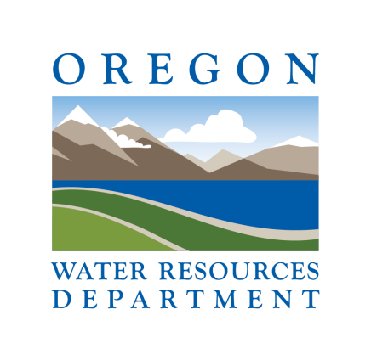

Call for Nominations

OWRD Conservation Awards

Saluting entities that are making the effort to conserve water

Nominations Deadline: July 31, 2018
To submit nomination form email to: Kerri.H.Cope@oregon.gov or;
Chris.C.Kowitz@oregon.gov

1. Nominee Name:

2. Nominee address

3. Contact Name: Phone Number:
First Last

4. Title:

7. Submitted by:
First Last
8. Title:

9. Email Address: 10. Phone Number:

The following questions on page two (2) are intended to help guide the nomination process.

* Please note that a short essay describing why the nominee is being nominated may be submitted in lieu of responding to the background questions.

Background:

In 150 words or less, please describe a policy, program or initiative that the nominee has launched or spearheaded to advance the nominee’s efforts to conserve water

Explain the specific purpose of the policy, project or initiative. Why was it launched? What need, goal or gap does it address?

How was the policy, project or initiative implemented?

What were the results or success rate of the policy, project or initiative?

What percentage of water (if applicable) was saved as a result of the policy, project or initiative?

Does the nominee track and measure progress?

What additional policies or projects towards conservation has the nominee implemented within the last five (5) years?

How has this benefitted the community as a whole?

Please provide any additional information related to the nominee’s efforts to conserve water.

