Application for a Permit to Use  Surface Water | Oregon Water Resources Department  725 Summer Street NE, Suite A  Salem, Oregon 97301-1266  503-986-0900  www.oregon.gov/OWRD

SECTION 1: APPLICANT INFORMATION AND SIGNATURE
Applicant
name |  |  |  |  | phone (hm)
phone (wk) |  | cell |  |  | fax
MAILING address

city | state |  | zip | e-mail *

Organization
name |  |  |  | phone | fax
MAILING address |  |  |  |  | cell
city | state | zip | e-mail *

Agent – The agent is authorized to represent the applicant in all matters relating to this application.
agent / business name |  |  |  | phone | fax
MAILING address |  |  |  |  | cell
city | state | zip | e-mail *
Note: Attach multiple copies as needed
* By providing an e-mail address, consent is given to receive all correspondence from the Department electronically. (Paper copies of the proposed and final order documents will also be mailed.)

By my signature below I confirm that I understand:
- I am asking to use water specifically as described in this application.
- Evaluation of this application will be based on information provided in the application.
- I cannot legally use water until the Water Resources Department issues a permit.
- The Department encourages all applicants to wait for a permit to be issued before beginning construction of any proposed diversion. Acceptance of this application does not guarantee a permit will be issued.
- If I begin construction prior to the issuance of a permit, I assume all risks associated with my actions.
- If I receive a permit, I must not waste water.
- If development of the water use is not according to the terms of the permit, the permit can be cancelled.
- The water use must be compatible with local comprehensive land use plans.
- Even if the Department issues a permit, I may have to stop using water to allow senior water right holders to receive water to which they are entitled.

I (we) affirm that the information contained in this application is true and accurate
__________________________________ ____________________________________ _________________________
Applicant Signature Print Name and Title if applicable Date
__________________________________ ____________________________________ _________________________
Applicant Signature Print Name and Title if applicable Date

SECTION 2: PROPERTY OWNERSHIP

Please indicate if you own all the lands associated with the project from which the water is to be diverted, conveyed, and used.

YES, there are no encumbrances.
YES, the land is encumbered by easements, rights of way, roads or other encumbrances.

NO, I have a recorded easement or written authorization permitting access.
NO, I do not currently have written authorization or easement permitting access.
NO, written authorization or an easement is not necessary, because the only affected lands I do not own are state-owned submersible lands, and this application is for irrigation and/or domestic use only (ORS 274.040).
NO, because water is to be diverted, conveyed, and/or used only on federal lands.

Affected Landowners: List the names and mailing addresses of all owners of any lands that are not owned by the applicant and that are crossed by the proposed ditch, canal or other work, even if the applicant has obtained written authorization or an easement from the owner. (Attach additional sheets if necessary).

Legal Description: You must provide the legal description of: 1. The property from which the water is to be diverted, 2. Any property crossed by the proposed ditch, canal or other work, and 3. Any property on which the water is to be used as depicted on the map.

SECTION 3: SOURCE OF WATER

A. Proposed Source of Water

Provide the commonly used name of the water body from which water will be diverted, and the name of the stream or lake it flows into (if unnamed, say so), and the locations of the point of diversion (POD):

Source 1: | Tributary to:
TRSQQ of POD:
Source 2: | Tributary to:
TRSQQ of POD:

If any source listed above is stored water that is authorized under a water right permit, certificate, or decree, attach a copy of the document or list the document number (for decrees, list the volume, page and/or decree name).

B. Applications to Use Stored Water

Do you, or will you, own the reservoir(s) described in Section 3A above?

Yes. No. (Enclose a copy of your written notification to the operator of the reservoir of your intent to file this application, which should have been mailed or delivered to the operator.)
If all sources listed in Section 3A are stored water, the Department will review your application using the expedited process provided in ORS 537.147, unless you check the box below. Please see the instruction booklet for more information.

By checking this box, you are requesting that the Department process your application under the standard process outlined in ORS 537.150 and 537.153, rather than the expedited process provided by ORS 537.147. To file an application under the standard process, you must enclose the following:

- A copy of a signed non-expired contract or other agreement with the owner of the reservoir (if not you) to impound the volume of water you propose to use in this application.

- A copy of your written agreement with the party (if any) delivering the water from the reservoir to you.

SECTION 4: SENSITIVE, THREATENED OR ENDANGERED FISH SPECIES PUBLIC INTEREST INFORMATION

This information must be provided for your application to be accepted as complete. The Water Resources Department will determine whether the proposed use will impair or be detrimental to the public interest with regard to sensitive, threatened or endangered fish species.

To answer the following questions, use the map provided in Attachment 3 or the link below to determine whether the proposed point of diversion (POD) is located in an area where the Upper Columbia, the Lower Columbia, and/or the Statewide public interest rules apply.

For more detailed information, click on the following link and enter the T,R,S,QQ or the Lat/Long of a POD and click on “Submit” to retrieve a report that will show which section, if any, of the rules apply:
https://apps.wrd.state.or.us/apps/misc/lkp_trsqq_features/

If you need help to determine in which area the proposed POD is located, please call the customer service desk at (503) 986-0900.

Upper Columbia - OAR 690-033-0115 thru -0130
Is the POD located in an area where the Upper Columbia Rules apply?
Yes No
If yes, you are notified that the Water Resources Department will consult with numerous federal, state, local and tribal governmental entities so it may determine whether the proposed use is consistent with the “Columbia River Basin Fish and Wildlife Program” adopted by the Northwest Power Planning Council in 1994 for the protection and recovery of listed fish species. The application may be denied, heavily conditioned, or if appropriate, mitigation for impacts may be needed to obtain approval for the proposed use.

If yes,
- I understand that the proposed use does not involve appropriation of direct streamflow during the time period April 15 to September 30, except as provided in OAR 690-033-0140.
- I understand that I will install, operate and maintain a fish screen and fish passage as listed in ORS 498.301 through 498.346, and 509.580 through 509.910, to the specifications and extent required by Oregon Department of Fish and Wildlife, prior to diversion of water under any permit issued pursuant to this application.
- I understand that the Oregon Department of Environmental Quality will review my application to determine if the proposed use complies with existing state and federal water quality standards.
- I understand that I will install and maintain water use measurement and recording devices as required by the Water Resources Department, and comply with recording and reporting permit condition requirements.
Lower Columbia - OAR 690-033-0220 thru -0230
Is the POD located in an area where the Lower Columbia rules apply?
Yes No
If yes, you are notified that that the Water Resources Department will determine, by reviewing recovery plans, the Columbia River Basin Fish and Wildlife Program, and regional restoration programs applicable to threatened or endangered fish species, in coordination with state and federal agencies, as appropriate, whether the proposed use is detrimental to the protection or recovery of a threatened or endangered fish species and whether the use can be conditioned or mitigated to avoid the detriment.
If a permit is issued, it will likely contain conditions to ensure the water use complies with existing state and federal water quality standards; and water use measurement, recording and reporting required by the Water Resources Department. The application may be denied, or if appropriate, mitigation for impacts may be needed to obtain approval of the proposed use.
If yes, provide the following information (the information must be provided with the application to be considered complete).
Yes No The proposed use is for more than one cubic foot per second (448.8 gpm) and is not subject to the requirements of OAR 690, Division 86 (Water Management and Conservation Plans).
If yes, provide a description of the measures to be taken to assure reasonably efficient water use:

Statewide - OAR 690-033-0330 thru -0340
Is the POD located in an area where the Statewide rules apply?
Yes No

If yes, the Water Resources Department will determine whether the proposed use will occur in an area where endangered, threatened or sensitive fish species are located. If so, the Water Resources Department, Department of Fish and Wildlife, Department of Environmental Quality, and the Department of Agriculture will recommend conditions required to achieve “no loss of essential habitat of threatened and endangered (T&E) fish species,” or “no net loss of essential habitat of sensitive (S) fish species.” If conditions cannot be identified that meet the standards of no loss of essential T & E fish habitat or no net loss of essential S fish habitat, the agencies will recommend denial of the application unless they conclude that the proposed use would not harm the species.

SECTION 5: WATER USE

Provide the amount of water you propose to use from each source, for each use, in cubic feet-per-second (cfs) or gallons-per-minute (gpm). If the proposed use is from storage, provide the amount in acre-feet (af):
(1 cfs equals 448.8 gpm. 1 acre-foot equals 325,851 gallons or 43,560 cubic feet)

SOURCE | USE | PERIOD OF USE | AMOUNT
 |  |  | cfs gpm af
 |  |  | cfs gpm af
 |  |  | cfs gpm af
 |  |  | cfs gpm af

Please indicate the number of primary, supplemental and/or nursery acres to be irrigated.
Primary: Acres Supplemental: Acres Nursery Use: Acres
If supplemental acres are listed, provide the Permit or Certificate number of the underlying primary water right(s):
Indicate the maximum total number of acre-feet you expect to use in an irrigation season:

- If the use is municipal or quasi-municipal, attach Form M
- If the use is domestic, indicate the number of households:
- If the use is mining, describe what is being mined and the method(s) of extraction:

SECTION 6: WATER MANAGEMENT

- Diversion and Conveyance
What equipment will you use to pump water from your source?

Pump (give horsepower and type):
Other means (describe):

Provide a description of the proposed means of diversion, construction, and operation of the diversion works and conveyance of water.

- Application Method
What equipment and method of application will be used? (e.g., drip, wheel line, high-pressure sprinkler)

- Conservation
Please describe why the amount of water requested is needed and measures you propose to: prevent waste; measure the amount of water diverted; prevent damage to public uses of affected surface waters.

SECTION 7: RESOURCE PROTECTION

In granting permission to use water from a stream or lake, the state encourages, and in some instances requires, careful control of activities that may affect the waterway or streamside area. See instruction guide for a list of possible permit requirements from other agencies. Please indicate any of the practices you plan to undertake to protect water resources:

Diversion will be screened per ODFW specifications in ORS 498.301 through 498.346 to prevent uptake of fish and other aquatic life.
Describe planned actions:

Excavation or clearing of banks will be kept to a minimum to protect riparian or streamside areas.
Note: If disturbed area is more than one acre, applicant should contact the Department of Environmental Quality to determine if a 1200C permit is required.
Describe planned actions and additional permits required for project implementation:

Operating equipment in a water body will be managed and timed to prevent damage to aquatic life. Describe planned actions and additional permits required for project implementation:

Water quality will be protected by preventing erosion and run-off of waste or chemical products.
Describe planned actions:

List other federal and state permits or contracts to be obtained, if a water right permit is granted.

SECTION 8: PROJECT SCHEDULE

- Date construction will begin:
- Date construction will be completed:
- Date beneficial water use will begin:

SECTION 9: WITHIN A DISTRICT

Check here if the point of diversion or place of use are located within or are served by an irrigation or other water district.

Irrigation District Name | Address
City | State | Zip

SECTION 10: REMARKS

Use this space to clarify any information you have provided in the application. (Attach additional sheets if necessary).

Minimum Requirements Checklist
Minimum Requirements (OAR 690-310-0040, OAR 690-310-0050 & ORS 537.140)
Include this checklist with the application

Check that each of the following items is included. The application will be returned if all required items are not included. If you have questions, please call the Water Rights Customer Service Group at (503) 986-0900.

Please submit the original application and signatures to the Water Resources Department. Applicants are encouraged to keep a copy of the completed application.

SECTION 1: Applicant Information and Signature
SECTION 2: Property Ownership
SECTION 3: Source of Water
SECTION 4: Sensitive, Threatened or Endangered Fish Species Public Interest Information
SECTION 5: Water Use
SECTION 6: Water Management
SECTION 7: Resource Protection
SECTION 8: Project Schedule
SECTION 9: Within a District
SECTION 10: Remarks

Include the following additional items:
Land Use Information Form with approval and signature of local planning department (must be an original) or signed receipt.
Provide the legal description of: (1) the property from which the water is to be diverted, (2) any property crossed by the proposed ditch, canal or other work, and (3) any property on which the water is to be used as depicted on the map.
Fees - Amount enclosed: $
See the Department’s Fee Schedule at www.oregon.gov/owrd or call (503) 986-0900.
Map that includes the following items:

Permanent quality and drawn in ink
Even map scale not less than 4" = 1 mile (example: 1" = 400 ft, 1" = 1320 ft, etc.)
North Directional Symbol
Township, Range, Section, Quarter/Quarter, Tax Lots
Reference corner on map
Location of each diversion, by reference to a recognized public land survey corner (distances north/south and east/west)
Indicate the area of use by Quarter/Quarter and tax lot identified clearly.
Number of acres per Quarter/Quarter and hatching to indicate area of use if for primary irrigation, supplemental irrigation, or nursery
Location of main canals, ditches, pipelines or flumes (if well is outside of the area of use)

Water-Use Permit Application Processing

1. Completeness Determination

The Department evaluates whether the application and accompanying map contain all of the information required under OAR 690-310-0040 and OAR 690-310-0050. The Department also determines whether the proposed use is prohibited by statute. If the Department determines that the application is incomplete, all fees have not been paid, or the use is prohibited by statute, the application and all fees submitted are returned to the applicant.

2. Initial Review

The Department reviews the application to determine whether water is available during the period requested, whether the proposed use is restricted or limited by rule or statute, and whether other issues may preclude approval of or restrict the proposed use. An Initial Review (IR) containing preliminary determinations is mailed to the applicant. The applicant has 14 days from the mailing date to withdraw the application from further processing and receive a refund of all fees paid minus $310. The applicant may put the application on hold for up to 180 days and may request additional time if necessary.

3. Public Notice

Within 7 days of the mailing of the initial review, the Department gives public notice of the application in the weekly notice published by the Department at www.oregon.gov/owrd. The public comment period is 30 days from publication in the weekly notice.

4. Proposed Final Order Issued

The Department reviews any comments received, including comments from other state agencies related to the protection of sensitive, threatened or endangered fish species. Within 60 days of completion of the IR, the Department issues a Proposed Final Order (PFO) explaining the proposed decision to deny or approve the application. A PFO proposing approval of an application will include a draft permit, and may request additional information or outstanding fees required prior to permit issuance.

5. Public Notice

Within 7 days of issuing the PFO, the Department gives public notice in the weekly notice. Notice includes information about the application and the PFO. Protest must be received by the Department within 45 days after publication of the PFO in the weekly notice. Anyone may file a protest. The protest filing fee is $480.00 for the applicant and $950.00 for non-applicants. Protests are filed on approximately 10 percent of Proposed Final Orders. If a protest is filed the Department will attempt to settle the protest but will schedule a contested case hearing if necessary.

6. Final Order Issued

If no protests are filed, the Department can issue a Final Order within 60 days of the close of the period for receiving protest. If the application is approved, a permit is issued. The permit specifies the details of the authorized use and any terms, limitations or conditions that the Department deems appropriate

Land Use Information Form
Oregon Water Resources Department
725 Summer Street NE, Suite A
Salem, Oregon 97301-1266
(503) 986-0900
www.oregon.gov/OWRD

NOTE TO APPLICANTS
In order for your application to be processed by the Oregon Water Resources Department (OWRD), this Land Use Information Form must be completed by a local government planning official in the jurisdiction(s) where your water right will be diverted, conveyed, used, and developed. The planning official may choose to complete the form while you wait or return the “Receipt Acknowledging Request for Land Use Information” to you. Applications received by OWRD without the Land Use Information Form, or the signed receipt, will be returned to you. IMPORTANT: Please note that while OWRD can accept a signed receipt as part of intake for an application for a new permit to use or store water, a completed Land Use Information Form is required for OWRD’s acceptance of all other applications. Please be aware that your application cannot be approved without land use approval.

This form is NOT required if:
- Water is to be diverted, conveyed, and used on federal lands only; OR
- The application is for a water right transfer, allocation of conserved water, exchange, permit amendment, or ground water registration modification, and all of the following apply:
  - The existing and proposed water use is located entirely within lands zoned for exclusive farm-use or within an irrigation district;
  - The application involves a change in place of use only;
  - The change does not involve the placement or modification of structures, including but not limited to water diversion, impoundment, distribution facilities, water wells and well houses; and
  - The application involves irrigation water uses only.

NOTE TO LOCAL GOVERNMENTS
The person presenting the attached Land Use Information Form is applying for a new water right or modifying an existing water right. The Oregon Water Resources Department (OWRD) requires applicants to obtain land use information to ensure the water right does not result in land uses that are incompatible with your comprehensive plan. Please complete the form and return it to the applicant for inclusion in their application. NOTE: For new water right applications only, if you are unable to complete this form while the applicant waits, you may complete the “Receipt Acknowledging Request for Land Use Information” and return it to the applicant.

You will receive notice via OWRD’s weekly Public Notice once the applicant formally submits their request to OWRD. The notice will give more information about OWRD's water right process and provide additional comment opportunities. If you previously only completed the receipt for an application for a new permit to use or store water, you will have 30 days from the Public Notice date to complete the Land Use Information Form and return it to OWRD. Your attention to this request for information is greatly appreciated. If you have questions concerning this form, please contact OWRD's Customer Service Group at 503-986-0900 or WRD_DL_customerservice@water.oregon.gov.

This page intentionally left blank.

Land Use Information Form
Oregon Water Resources Department
725 Summer Street NE, Suite A
Salem, Oregon 97301-1266
(503) 986-0900
www.oregon.gov/OWRD

NAME |  |  |  | PHONE
MAILING ADDRESS

CITY | STATE | ZIP | EMAIL
A. Land and Location
Please include the following information for all tax lots where water will be diverted (taken from its source), conveyed (transported), and/or used or developed. Applicants for municipal use, or irrigation uses within irrigation districts, may substitute existing and proposed service-area boundaries for the tax-lot information requested below.
Township | Range | Section | ¼ ¼ | Tax Lot # | Plan Designation (e.g., Rural Residential/RR-5) | Water to be: |  |  | Proposed  Land Use:
 |  |  |  |  |  | Diverted | Conveyed | Used
 |  |  |  |  |  | Diverted | Conveyed | Used
 |  |  |  |  |  | Diverted | Conveyed | Used
 |  |  |  |  |  | Diverted | Conveyed | Used
List all counties and cities where water is proposed to be diverted, conveyed, and/or used or developed:
NOTE: A separate Land Use Information Form must be completed and submitted for each county and city, as applicable.
B. Description of Proposed Use
Type of application to be filed with the Oregon Water Resources Department:
Permit to Use or Store Water Water Right Transfer Permit Amendment or Ground Water Registration Modification
Limited Water Use License Exchange of Water Allocation of Conserved Water
Source of water: Reservoir/Pond Ground Water Surface Water (name)
Estimated quantity of water needed: cubic feet per second gallons per minute acre-feet
Intended use of water: Irrigation Commercial Industrial Domestic for household(s)
Municipal Quasi-Municipal Instream Other
Briefly describe:

Note to applicant: For new water right applications only, if the Land Use Information Form cannot be completed while you wait, please have a local government representative sign the receipt on the bottom of page 4 and include it with the application filed with the Oregon Water Resources Department.
See Page 4
For Local Government Use Only
The following section must be completed by a planning official from each county and city listed unless the project will be located entirely within the city limits. In that case, only the city planning agency must complete this form. This deals only with the local land use plan. Do not include approval for activities such as building or grading permits.
Please check the appropriate box below and provide the requested information
Land uses to be served by the proposed water use(s), including proposed construction, are allowed outright or are not regulated by your comprehensive plan. Cite applicable ordinance section(s): ___________________________________
Land uses to be served by the proposed water use(s), including proposed construction, involve discretionary land-use approvals as listed in the table below. (Please attach documentation of applicable land-use approvals which have already been obtained. Record of Action/land-use decision and accompanying findings are sufficient.) If approvals have been obtained but all appeal periods have not ended, check "Being Pursued."
Type of Land-Use Approval Needed  (e.g., plan amendments, rezones,  conditional-use permits, etc.) | Cite Most Significant, Applicable Plan Policies & Ordinance Section References | Land-Use Approval:
 |  | Obtained  Denied | Being Pursued  Not Being Pursued
 |  | Obtained  Denied | Being Pursued  Not Being Pursued
 |  | Obtained  Denied | Being Pursued  Not Being Pursued
 |  | Obtained  Denied | Being Pursued  Not Being Pursued
Local governments are invited to express special land use concerns or make recommendations to the Oregon Water Resources Department regarding this proposed use of water in the box below or on a separate sheet.
Name: Title:
Signature: Date:
Governmental Entity: Phone:

Receipt Acknowledging Request for Land Use Information
Note to Local Government Representative:
Please complete this form and return it to the applicant. For new water right applications only, if you are unable to complete this form while the applicant waits, you may complete this receipt and return it to the applicant. If you sign the receipt, you will have 30 days from the date of OWRD’s Public Notice of the application to submit the completed Land Use Information Form to Oregon Water Resources Department. Please note while OWRD can accept a signed receipt as part of intake for an application for a new permit to use or store water, a completed Land Use Information Form is required for all other applications.
Applicant Name:
Staff Name: Title:
Staff Signature: Date:
Governmental Entity: Phone:

Figure 1: Map of Division 33 Areas

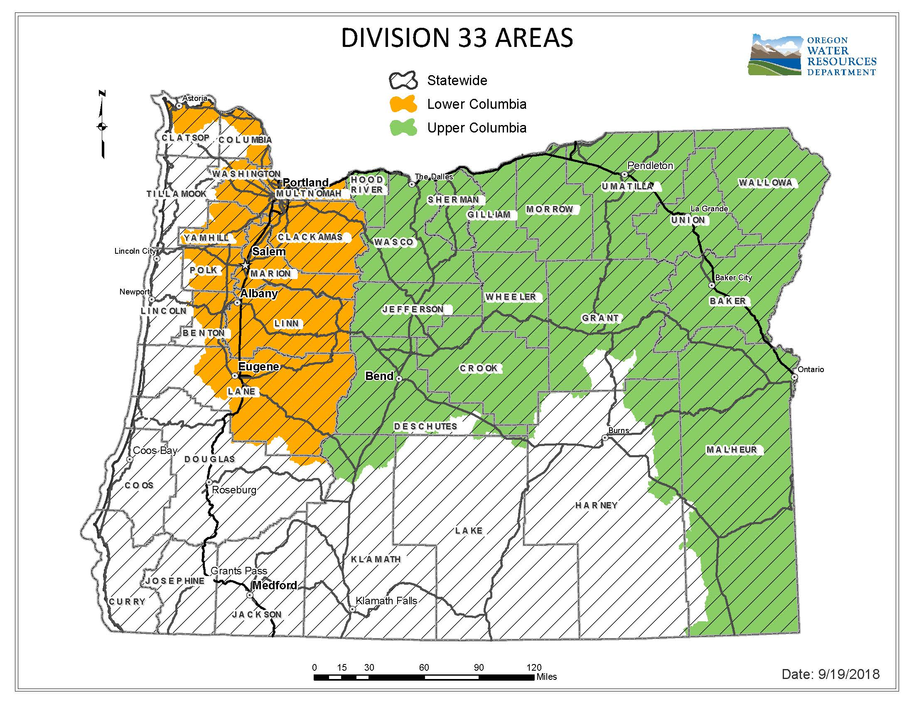

For more detailed information, click on the following link and enter the TRSQQ or the Lat/Long of a POA and click on “Submit” to retrieve a report that will show which section, if any, of the Division 33 rules apply: https://apps.wrd.state.or.us/apps/misc/lkp_trsqq_features/

