Oregon Public Utility Commission (OPUC) Five-Year Information Technology (IT) Strategic Plan

  - Last Updated 2025

Document Revision History
Date | Description | Version | Author
12/22/2023 | Initial Draft | 0.1 | Qing Liu
12/26/2023 | Updated document following ASCIO instructions | 0.2 | Qing Liu
12/29/2023 | Final Version of the 2023-2027 plan  - Addressed COO’s comments  - Accepted all changes  - Removed all comments | 1.0 | Qing Liu
5/6/2025 | Updates to the 2023-2027 plan in order to create the 2025 - 2030 plan.  - Executive Summary  - Current IT Landscape  - IT Context/IT Goals  - IT Operating Model  - IT Strategic Initiatives  - Metrics and Targets  - IT Roadmap  - IT Strategy Communication  - IT Strategy Continuous Lifecycle | 1.1 | Qing Liu
5/29/2025 | Inserted one pager visualization | 1.2 | Qing Liu
6/2/2025 | Final version of 2025 updated 5 year plan | 2.0 | Qing Liu

Table of Contents
Document Revision History 2
Executive Summary 5
OPUC Mission 7
OPUC Vision 7
OPUC Values 7
Accountability: 7
Integrity: 7
Inclusion: 7
Adaptability: 7
OPUC Goals 7
Current IT Landscape 8
Strengths 8
Challenges 8
Opportunities 8
Threats 9
Project Portfolio 9
EIS’ Stage Gate Oversighted project: 9
None EIS’ State Gate Oversighted projects: 9
Current Maturity Level 11
Customer Feedback 11
Satisfaction Survey for 2024: 11
IT Context 12
IT Mission, Vision, Values, and Goals 12
IT Mission 12
IT Vision 12
IT Values 12
IT Goals 12
Target Maturity Level 12
IT Operating Model 13
IT Strategic Initiatives 14
Goals Cascade 14
Business Support Initiatives 14
IT Excellence 15
Innovation Initiatives 15
Metrics and Targets 16
Modernize legacy applications 16
Improve data quality 16
Raise end-user satisfaction 16
Research New Technology 16
IT Roadmap 17
IT Strategy Communication 18
IT Strategy Continuous Lifecycle 19
Progress Report 20

Executive Summary
This IT Strategic Plan was first created in 2023 based on the PUC’s 2023-2025 Strategic Plan. It is updated periodically and provides a holistic view of where The OPUC Information Systems (IS) department will go in the next five years. The plan demonstrates how we align our resources, efforts, and budget to support the OPUC’s direction and top initiatives. It is our roadmap.
To achieve this strategy, our IS department must remain focused on the key IT initiatives outlined in this document. These initiatives are the tactics we will use to support our business stakeholders in achieving their goals.
A round of appreciations to the many business stakeholders and the input of IS employees in the creation of this plan. It is a combined effort we will use to gain alignment and buy-in from our staff. Thank you to all those who have helped assess our current state, envision our future state, and determine the gaps necessary to fill to achieve those goals.

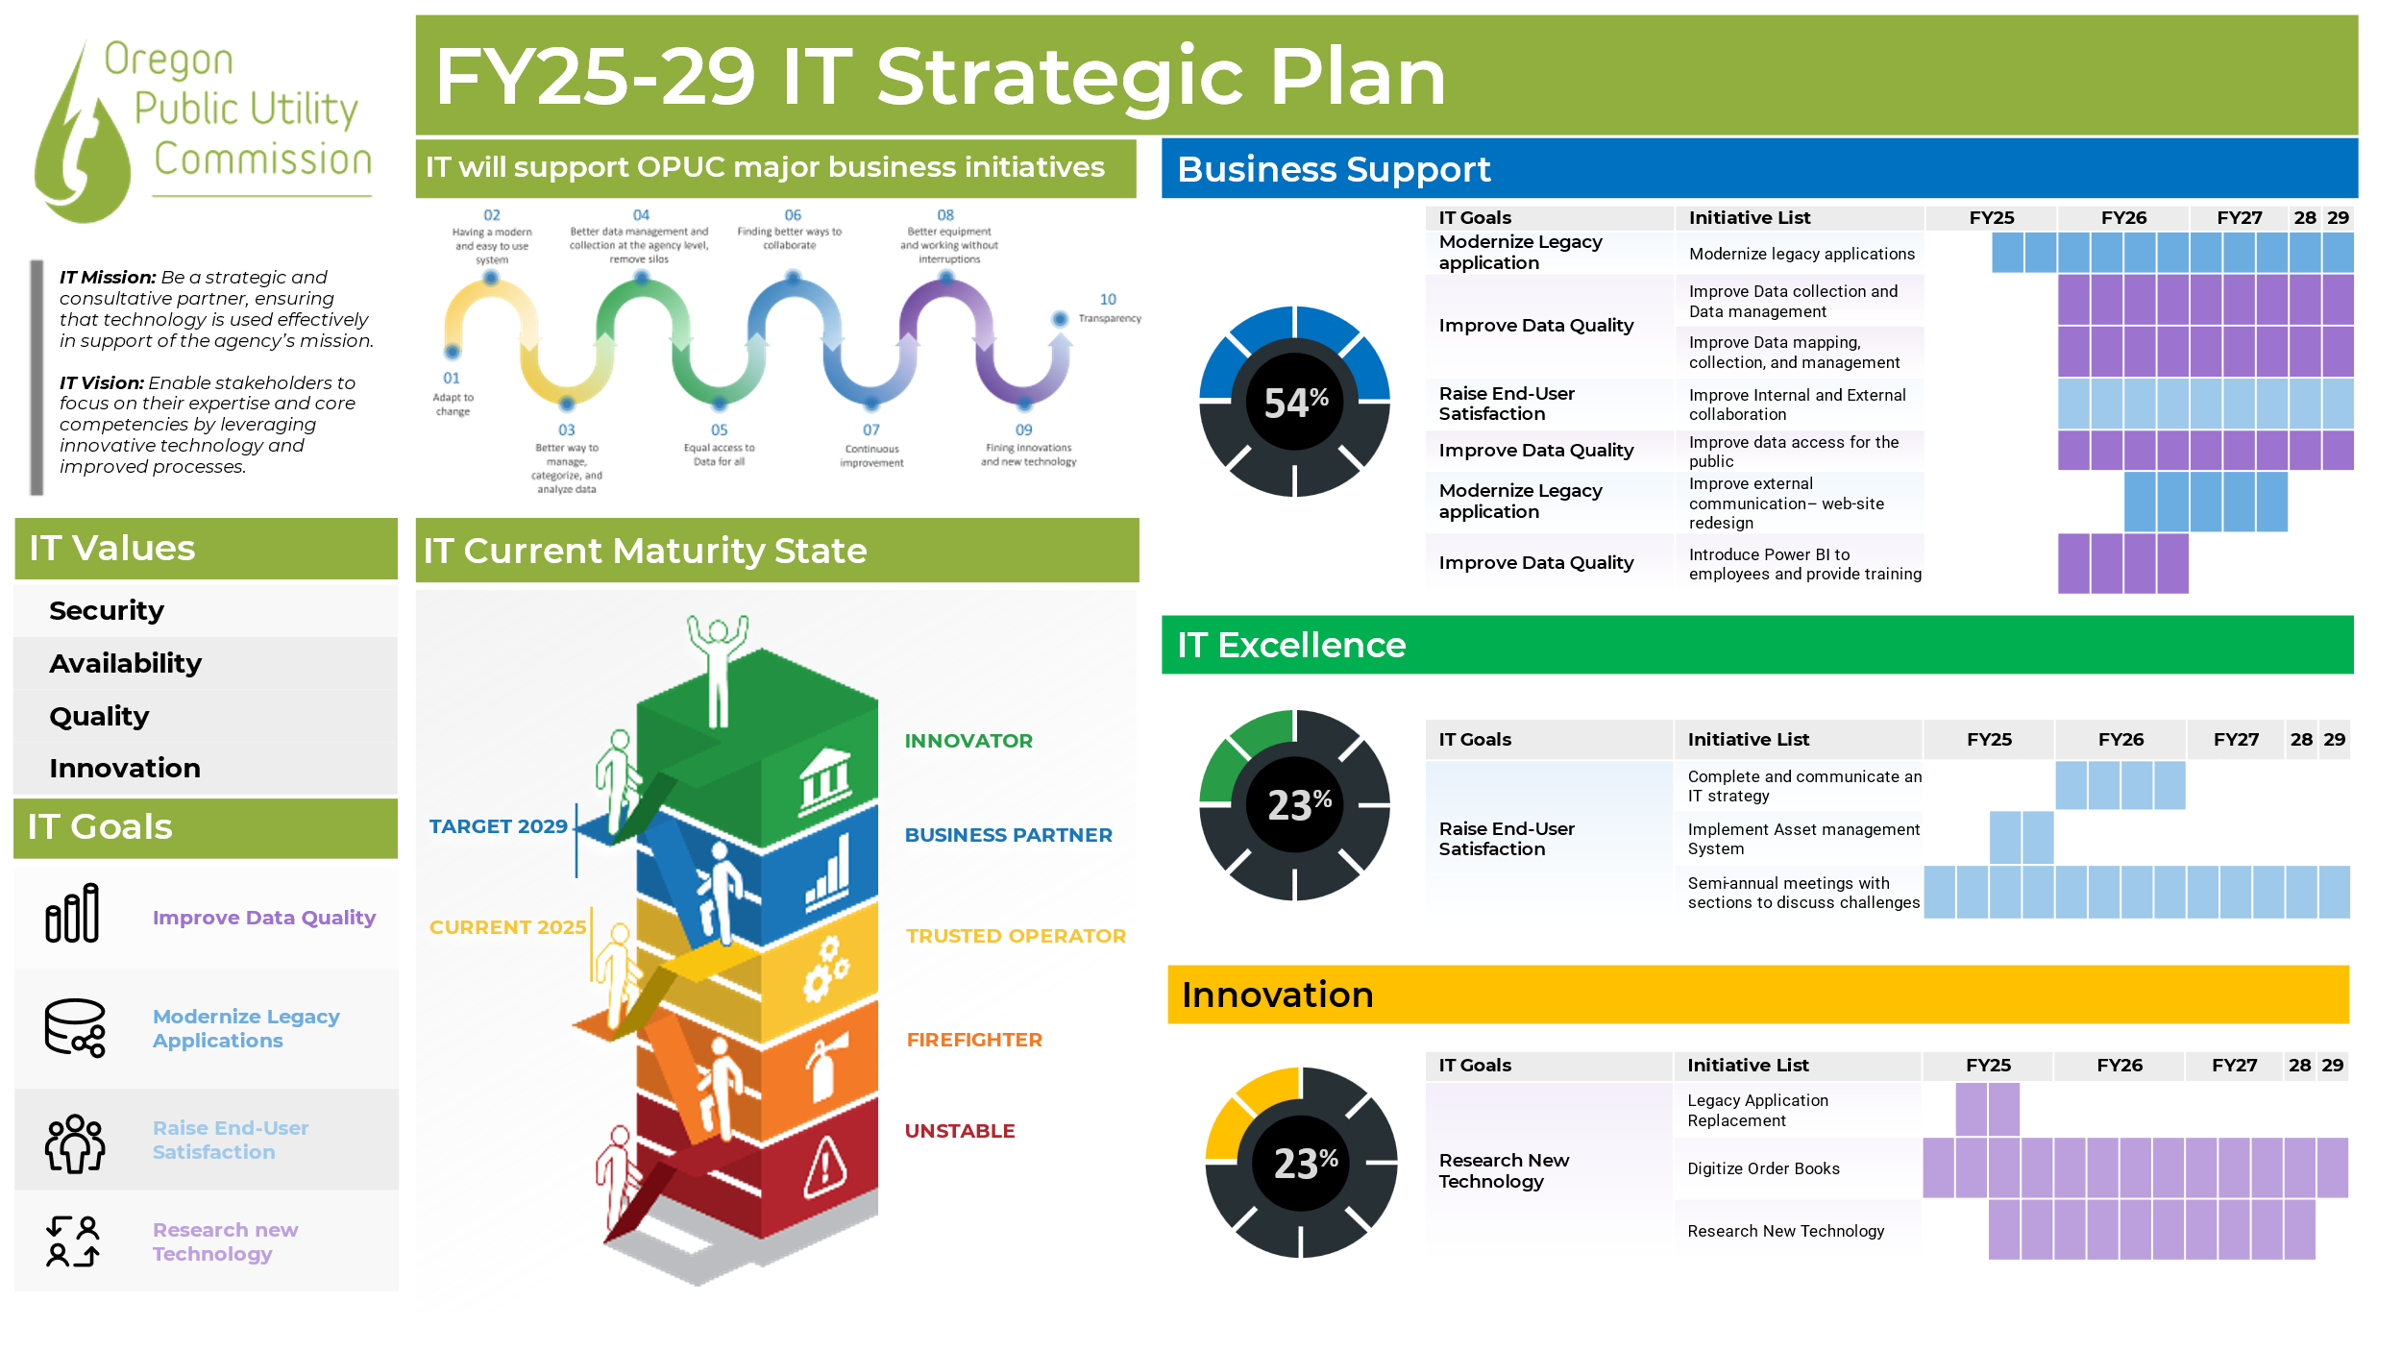

Agency Drivers

OPUC Mission
Our mission is to ensure Oregonians have access to safe, reliable and fairly priced utility services that advance state policy and promote public interest. We use an inclusive process to evaluate differing viewpoints and visions of the public interest and arrive at balanced, well-reasoned, independent decisions supported by fact and law.

OPUC Vision
Our vision is to improve the lives of Oregonians through effective utility regulation and leadership in the utility sector. We serve Oregon by:
- holding utilities to high standards of performance and value
- guiding a transformation in utility services consistent with Oregon's social, environmental, and economic goals, and
- adapting regulatory processes to improve inclusion, learning, collaboration, and problem-solving
Our success depends on recruiting and retaining talented and engaged employees to provide independent analysis in support of agency decision-making. We strive to offer meaningful work, mentoring and training, and a positive workplace culture.

OPUC Values
Accountability: Our responsibility to serve utility customers drives us to be diligent in our work, and efficient and effective in managing financial and human resources.
Integrity: As individuals, we are honest, trustworthy, and respectful. As an organization, we use open, fair processes and independent analysis to reach informed and just decisions.
Inclusion: We strive to advance equitable access, engage diverse perspectives, promote collaboration, and recognize our impact on all communities.
Adaptability: We develop expertise and adapt our skills, our organization, and our regulatory processes and tools in order to meet rapid change in our regulated industries.

OPUC Goals
- Use regulatory tools effectively to balance interests and ensure utility service is reliable, affordable, and advances the public interest.
- Promote safety, reliability, and resiliency of utility services.
- Guide integration of new technology, customer offerings, and market mechanisms to benefit customers.
- Inform and influence utility sector solutions that create value for all.
- Improve business practices and organizational effectiveness.

Current IT Landscape
The OPUC IS team is tasked with three objectives: keep the agency data secure, provide great customer service, and ensure IT resources are available for employees when they need it.

Strengths
- Great customer service: The OPUC IS team offers fast response, expert knowledge, and easy ways for employees to receive service.
- Experiences IT team: Most of the IS team has been working at the State or OPUC for more than 10 years. More than half of the team has been in the IT field for over 20 years. The team has over 150 years of combined IT experience.
- Adequate funding: The OPUC leadership team allocates appropriate budget for IS to receive proper training and acquire new technology for the agency.
- Innovation: With adequate funding, the OPUC IS team can replace out-of-date equipment with newer generation technology.

Challenges
- Legacy applications: The OPUC has multiple legacy applications that need to be updated. We are currently focusing on the BizApps Docketing system modernization. This project is going through the Oregon State Enterprise Information Services’ Stage Gate oversight process.
- Project management: The OPUC does not have a dedicated Project Manager. Projects are managed by sections. There is no agency wide visibility.
- IT documentation: The longevity of IS staff allowed the employees to maintain institutional knowledge without documentation. The IS team lacks documentation of procedures.
- Asset management: The OPUC IS team does not have an accurate asset inventory. This is due to change in helpdesk personnel and lack of a formal Hardware Asset Management procedure.

Opportunities
- Application modernization: There are multiple legacy applications still in production at the OPUC. IS can take the opportunity to create a modernization road map.
- Digitization: There are a lot of physical documents at the OPUC. Our business partners are complaining about the lack of search capabilities and worrying about damaged physical copies. It would be a great to make the documents searchable by digitizing them.
- Non-IT job shadowing: There are many business processes used at the OPUC. Each Division and Section in the agency has different needs. For IS to better understand the business needs and provide services, we are going to setup job shadowing sessions with our business partners.
- Focused IT application training: Technology has evolved so much in the past few years. Microsoft Office 365 (M365) offers a suite of productivity applications. The OPUC business would greatly benefit from productivity training focused on how all the M365 applications works together. There are other OPUC specific developed applications that the IS team can offer training on as well.

Threats
- Employee turnover: In recent years, the OPUC has seen major turn overs in the agency. Over 40% of employees were hired during the pandemic. Most of these employees had no State government work experience before the OPUC.
- Shadow IT: With newer employees coming in from the private sector, they want to bring in the tools they are used to and do not understand the State’s procedures on requesting technology. This created many unauthorized applications showing up on the OPUC network.

Project Portfolio

EIS’ Stage Gate Oversighted project:
The OPUC has one IT project under Stage Gate oversight, Project Valence (BizApps Replacement). The project was terminated in 2023 due to technology constraints. The OPUC has restarted the project with a different vendor in Oct. 2024. We have updated the State Gate documents and estimating that project Valence will complete Apr. 2026.

None EIS’ State Gate Oversighted projects:
- Project Phoenix: IS is updating the code of the legacy application, BizApps, to the latest .NET version. This is a stop gap project as we work on Project Valence scheduled to go-live Apr. 2026. The reason for Project Pheonix is in case the current legacy application stops working due to Microsoft operating system updates.
- Business Process mapping, process improvement, and functional requirements documentation: The OPUC Residential Service Protection Fund (RSPF) section requested a Policy Option Package (POP) to purchase a new system to track cases for AY 25-27. In anticipation of this POP getting approved, we have started a business process mapping project to document current business processes, find improvements for these processes, and create a functional requirements document in order to share our requirements with vendors.
- Call center replacement: The OPUC has 15 employees answering calls from the public. We are working with EIS and AWS to replace the current call center. The project is in its initial fact-finding phase.
- Information Technology Service Management system replacement: The OPUC currently utilizes Track-It! as our IT service ticketing system. We are looking at Service Desk Plus as a possible replacement. Proof of concept to start Jun. 2025.
- Agency move: The OPUC is reducing our leasing footprint from 4 floors to 2 floors. IS is responsible to collect all IT equipment so that workers can reconfigure different areas and then install all IT equipment once the reconfiguration of cubicle furniture is complete.
- Windows 11 upgrade: Windows 10 will be end of life in Oct. 2025. IS is working diligently to deploy Windows 11 before the end-of-life date.
Americans with Disabilities Act Title II (ADA) Web and Mobile Application Accessibility Rule Compliance: In April of 2024, the federal Department of Justice published its final rule updating regulations for Title II of the American with Disabilities Act (ADA). Title II of the ADA applies to all state and local governments (including agencies of state governments), and contractors that provide public services for those governments that require their services, programs and activities are accessible to people with disabilities.
- Intranet and file server replacement: migrate current intranet and file server to SharePoint.
- Supported application standardization: we cataloged all agency applications and ended up with 140 applications including desktop, mobile, in-house developed, end-user web, and server and backend apps. We are starting to review all these applications to consolidate applications that perform similar functions.

Current Maturity Level
EIS has determined that the OPUC is at Maturity Assessment Score 0.5 in 2024.
Year | Score
2022 | 1
2023 | 0.4
2024 | 0.5

The reason for the score drop from 1 in 2022 to 0.3 in 2023 is that EIS changed the assessment criteria and the scale of the assessment. The OPUC is in the process of setting up an IT Governance structure.
The Maturity Assessment assesses the agency maturity level using the following:
- IT Governance: The OPUC does not have a mature IT governance process in place.
- Portfolio & Project Management: The OPUC does not have staff with project management skillsets.
- Demonstrated Project Management: The OPUC is currently engaged with EIS on a Stage Gate application modernization project.

Customer Feedback
The OPUC IS department conducts customer satisfaction survey annually.
Year | IT Satisfaction | IT Value
2022 | 93% | 93%
2023 | 92% | 95%
2024 | 90% | 92%

Satisfaction Survey for 2024:
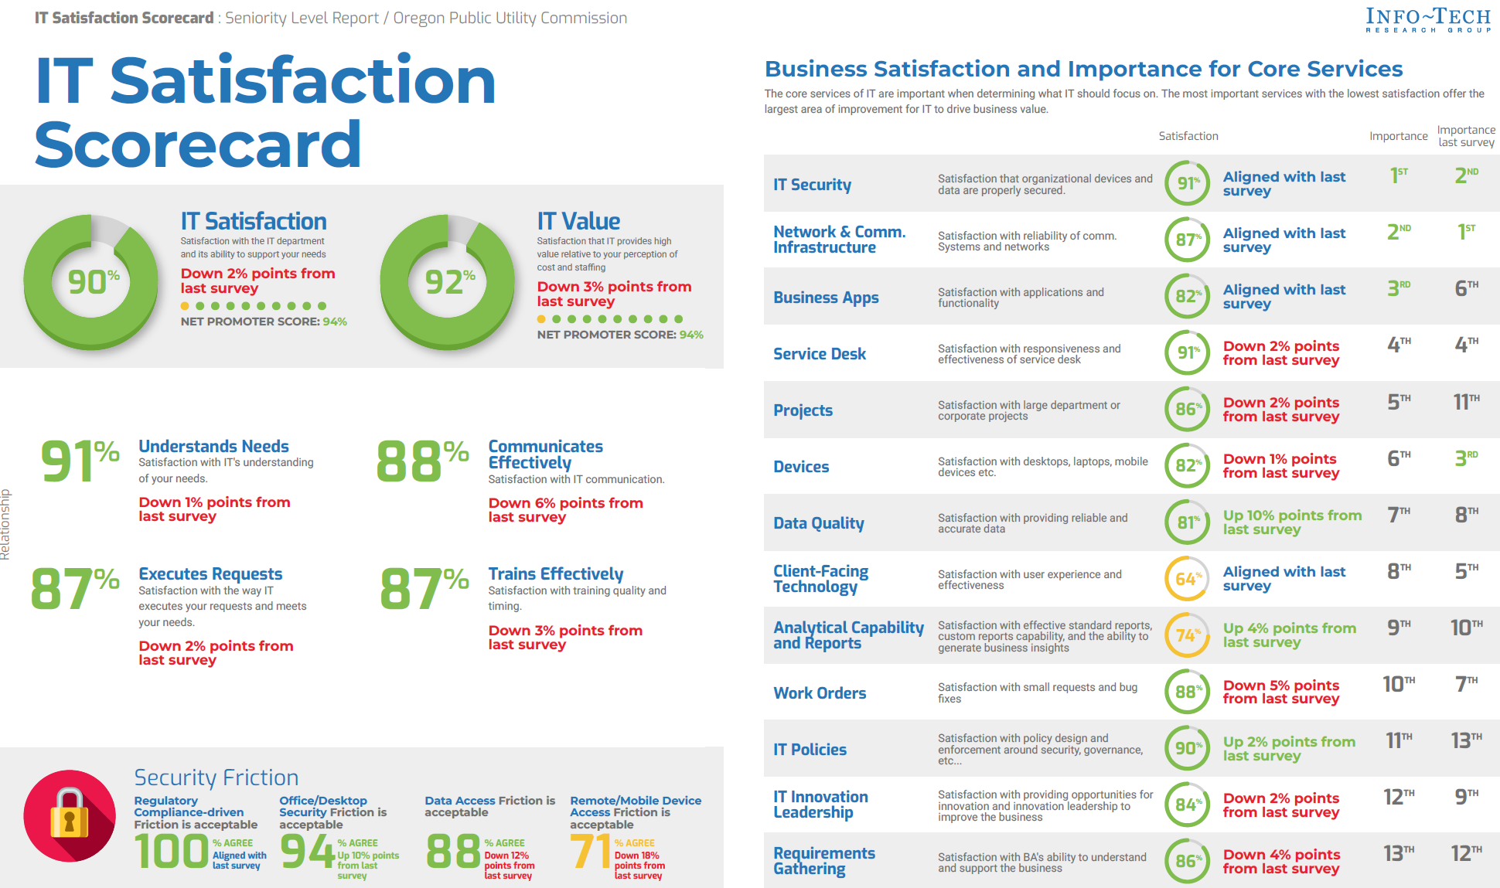

IT Context

IT Mission, Vision, Values, and Goals

IT Mission
Be a strategic and consultative partner, ensuring that technology is used effectively in support of the agency’s mission.

IT Vision
Enable interested parties to focus on their expertise and core competencies by leveraging innovative technology and improved processes.

IT Values
- Security
- Availability
- Quality
- Innovation

IT Goals
- Modernize legacy applications:
  - Modernizing legacy systems to enhance utility services, ensuring reliability, affordability, and alignment with Oregonians' evolving needs, advancing the public interest.
  - Aligns with OPUC's vision of effective utility regulation and leadership.
- Improve data quality:
  - Enhance data quality to fortify decision-making processes, foster informed utility service improvements, and ensure accurate, reliable information that supports effective regulatory decisions.
  - Aligns with OPUC’s Goals:
    - Promote safety, reliability, and resiliency of utility services.
    - Inform and influence utility sector solutions that create value for all.
- Raise end-user satisfaction:
  - Elevate end-user satisfaction to optimize utility service experiences, foster increased trust, reliability, and alignment with customer needs, to promote public interest and enhancing the effectiveness of utility services.
  - Aligns with OPUC's mission of ensure Oregonians have access to safe, reliable and fairly priced utility services that advance state policy and promote the public interest.
- Research new technology:
  - Identify new technology to improve work efficiency of OPUC employees.
  - Aligns with OPUC’s Goals:
    - Use regulatory tools effectively to balance interests and ensure utility service is reliable, affordable, and advances the public interest.
    - Improve business practices and organizational effectiveness.

Target Maturity Level
The OPUC aims to improve Maturity Assessment Score.
- IT Governance: The OPUC will need to setup a Governance structure to govern IT projects.
- Portfolio & Project Management: The OPUC will need to create a Project Portfolio Office at the agency level or a part time Project Manager within IS. The OPUC IS section plan to improve our project intake and management process. See IT Strategic Initiatives, IT Excellence, Improve IS project intake and management process in this plan.
- Demonstrated Project Management: This score will be low since PUC rarely have major projects.

IT Operating Model
The OPUC does not follow a governance model. All IT projects go through IS and the Chief Information Officer makes the decision on project priorities. We are working on an IT Governance process to ensure that agency leadership is involved in prioritizing IT projects.

IT Strategic Initiatives

Goals Cascade
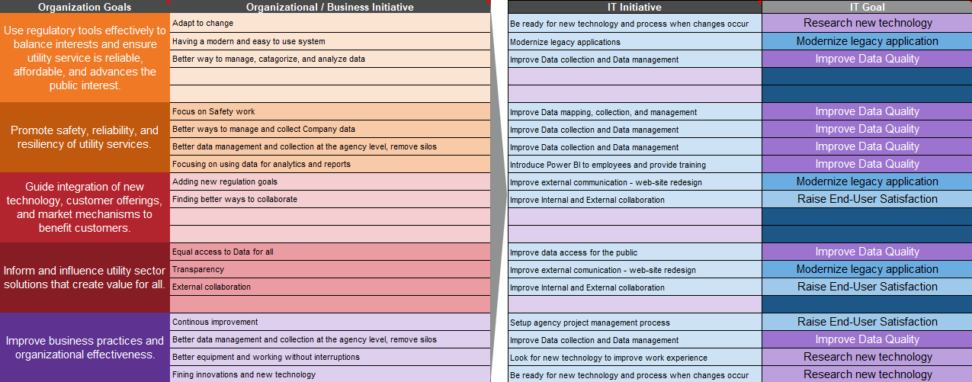

Business Support Initiatives
- Modernize legacy applications: The OPUC has multiple legacy custom-developed applications. IS will create a road map to modernize these applications.
- Improve Data collection and Data management: Data has been accumulated over the past decades at the OPUC. There has not been any initiative to clean up our data. IS, in conjunction with the PUC’s Open Data Coordinator, will create a new Data Management plan to periodically clean up our data and enforce data integrity when data is stored.
- Improve Data mapping, collection, and management: We need to identify a better way to collect data and manage the data we collect in order to meet our business goals.
- Improve Internal and External collaboration: Collaboration is key in the new remote work world. We need to fully utilize Microsoft Teams for internal and partner agency collaboration. We also need to find a way to better collaborate with our external partners.
- Improve data access for the public: We need to be transparent to the public we serve. Having better data access for the public will allow the public to communicate and monitor agency activities more effectively.
- Improve external communication - web-site redesign: The OPUC website was last updated in 2019. We have received public feedback regarding the usability of our website. IS will work with the OPUC Public Information Officer to update the layout and language of our public website to allow the public to find information easier and ensure that all areas of the website are ADA compliant.
- Introduce Power BI to employees and provide training: We have been using M365 since 2021. Microsoft Power BI is included in our M365 licenses. OPUC employees have been asking for a more powerful tool to analyze data. IS will introduce Power BI to our employees and provide training on how to properly use this tool.

IT Excellence
- Complete and communicate an IT strategy: Employees need to know about the IT Strategic plan and changes IS is trying to make. We need to better communicate our plan and intents.
- Implement Asset Management System: One of the items we have identified through a recent move is that we do not have good records of our Assets. We have created a new IT Asset Management Plan and will be implementing a new IT Service Management System that will include an Asset Management component.
- Semi-annual meetings with sections to discuss challenges: Most of the IS employees have been with the agency for over 10 years. There has never been a formal process to introduce IS employees to all the different agency business processes. We will start job shadowing for IS employees to learn the different business processes. The OPUC Chief Information Officer (CIO) will coordinate with agency leadership to establish a formalized job shadowing plan that includes expected outcomes and staff identified to lead the job shadowing effort. This will afford IS employees the opportunity to better understand these business processes and to provide better advice and services to the agency employees.

Innovation Initiatives
- Legacy Application Replacement: Legacy systems are used throughout the agency. We need to identify and create a replacement roadmap to replace all legacy systems.
- Digitize Order Books: The OPUC has decades of published Orders in paper format. It’s hard to search through these Order books to find information when the OPUC receives public record requests. IS will partner with the Administrative Hearings Division to digitize all paper documents to allow easier search and public access.
- Research New Technology: Technology changes rapidly and IS is always looking for new technologies that will enhance productivity.

Metrics and Targets
To support the different initiatives and continue with the level of customer service IS provides to the agency, we have come up with the following metrics and targets for the IT goals.

Modernize legacy applications
- Target: In 2025, we identified 100% of our agency’s legacy applications. We plan to create plans for 100% of the identified legacy applications by the end of 2026.
- Measure: Percent of legacy applications on the road map for upgrade.

Improve data quality
- Target: Identify 100% of the agency data by the end of 2026.
- Measure: Percent of data inventory identified through this process.

Raise end-user satisfaction
- Target: Increase Customer satisfaction (CIO Business Vision satisfaction) scores from 90% to 93% for 2025. We scored 93% in 2023 and the score went down to 90% in 2024.
- Measure: Satisfaction score.

Research New Technology
- Target: Digitize 100% of all the Order Books in the agency by the end of 2027.
- Measure: Order Book digitized.

IT Roadmap
This is our five-year roadmap.
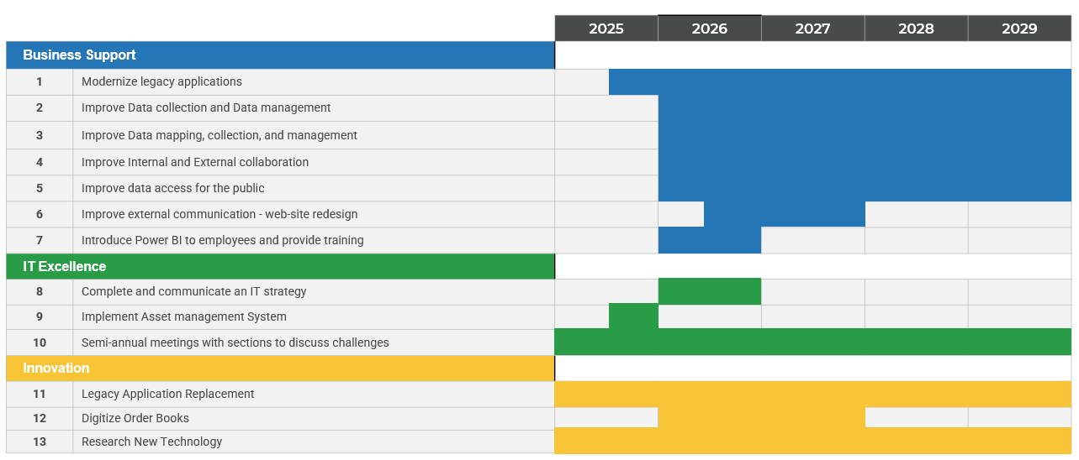

IT Strategy Communication
The IT Strategic Plan will be presented to the OPUC leadership and all employees.
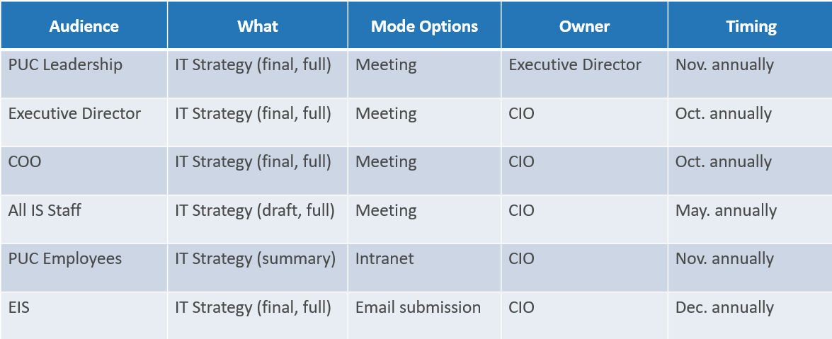

IT Strategy Continuous Lifecycle
The OPUC IT Strategic Plan will be reviewed annually.
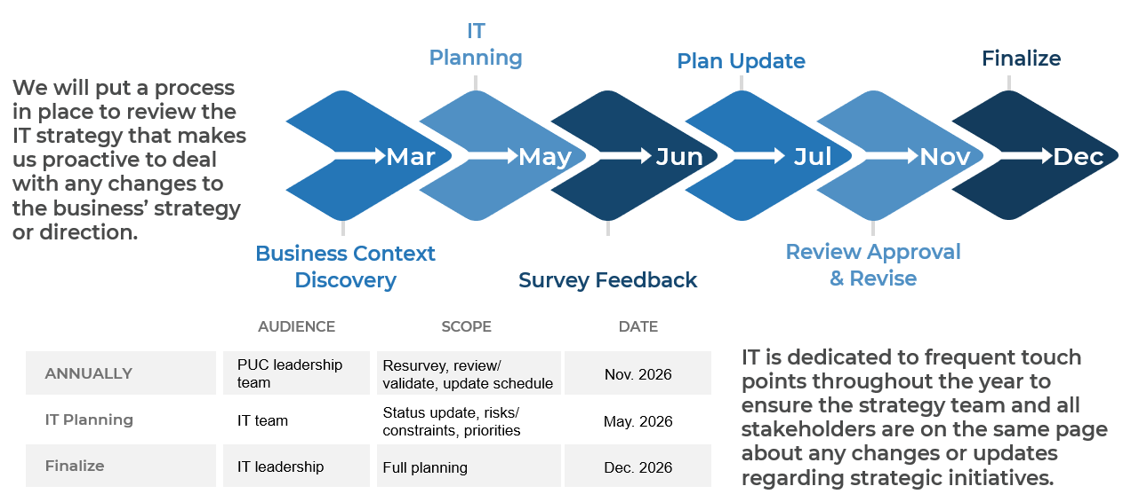

Progress Report
We set three goals in 2023:
Number | Goals | Result
1 | Identify and create plan for 100% of the agency’s legacy applications by end of 2024. | We identified 100% of the agency’s legacy applications. However we did not create plans to modernize these legacy applications.
2 | Identify 100% of the agency data and ensure at least 50% of the data is high quality by end of 2024. | With shifting priorities, we did not get a chance to identify the agency’s data nor had a chance to ensure the data is of high quality.
3 | Increase CIO BV satisfaction scores from 93% to 94% for 2024 | Our satisfaction score dropped from 93% to 90%. However, we are still 14% above industry average. Industry being State government.

We also had 9 IT initiatives identified:
Number | Goals | Result
1 | Website redesign for better transparency. | Due to shifting priorities, we have not started this initiative in 2024.
2 | Digitizing physical documents. | Due to shifting priorities, we have not started this initiative in 2024.
3 | Bring in new technology to meet business needs | We deployed a network monitoring tool, Elastic, implemented InTune for Mobile Device Management, and upgraded 60% laptops.
4 | Legacy application modernization. | We signed a contract with a vendor to upgrade our legacy business application Oct. 2024.
5 | Provide IT training on productivity applications. | We worked with Microsoft to create a training plan on M365 products. The training is scheduled for late 2025.
6 | Improve IS project intake and management process | Due to shifting priorities, we have not started this initiative in 2024.
7 | Job Shadow to understand business processes. | We started semi-annual meetings with our employees to talk about challenges and how technology could automate portions of their daily work.
8 | Improve data inventory and management. | Due to shifting priorities, we have not started this initiative in 2024.
9 | Enable Power BI. | We enabled Power BI licenses and installed Power BI desktop client for all employees.

