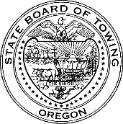
Oregon State Board of Towing
Public Comments and Testimony

This form is an opportunity for the public, partners, and industry members to formally submit public comments or testimony on proposed administrative rules, policies, or legislative concepts.

To submit a public comment or testimony:
- Complete this form, replacing all [bracketed labels] with your information
- Send the form as an email attachment to info@towboard.oregon.gov
- To be considered, the completed form must be
  - Legible
  - Statements are clear and concise and relevant to the proposed rule, policy, or legislative concept.
  - Form is complete and contains all required and relevant information
- Attachments supporting and substantiating public comment and testimony are recommended.

Contact Information
Name: [Your Name]
Organization: [Name of business, organization, or agency]
Mailing address: [Provide phone number]
Email: [Provide email]
Your Background (click on one checkbox):
Public Testimony or Comment
Select One:
☐ Proposed administrative rule No.:
☐ Proposed legislative concept
☐ Proposed policy
☐ Other:___________________________________________________________________

Public Comment or Testimony:

