Internal Control Standards
Greenbook - GAO
The Government Accountability Office (GAO) publishes the ‘Standards for Internal Control in the Federal Government’ commonly referred to as the Greenbook and found at https://www.gao.gov/assets/670/665712.pdf . The Greenbook defines internal controls as a “process effected by an entity’s oversight body, management, and other personnel that provides reasonable assurance that the objectives of an entity will be achieved” (GAO-14-704G Federal Internal Control Standards, pg. 5)/
According to the Greenbook, there are five components of internal control. They are: control environment, risk assessment, control activities, information and communication; and monitoring. An objective can fall under more than one category, address different needs, and can be the responsibility of more than one person.
COSO Internal Controls
https://www.coso.org/Pages/default.aspx
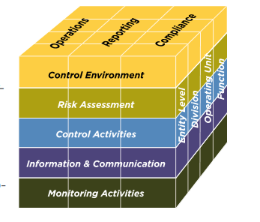
The Committee of Sponsoring Organizations of the Treadway Commission, or COSO, says that internal controls “help entities achieve important objectives and sustain and improve performance” (Internal Control-Integrated Framework Executive Summary, May 2013). COSO has identified five components of internal controls: control environment, risk assessment, control activities, information and communication; and monitoring activities; and three objectives (or what an organization strives to achieve), operations, reporting, and compliance (Internal Control-Integrated Framework Executive Summary, May 2013). These objectives and components work together to create the COSO Cube. The other side of the cube is the organizational structure of company.

NIST Internal Controls
These standards are primarily associated with the security of information technology (IT). Within the National Institute of Standards and Technology, U.S. Department of Commerce, is the Internal Controls and Management Evaluation Office (ICEMO) which performs a variety of internal control activities that provides the DOC and NIST management with reasonable assurance that NIST’s internal controls are operating effectively (https://www.nist.gov/office-financial-resource-management-ofrm/internal-controls-management-and-evaluation-office-icmeo). ICEMO provides audit and assurance services and expert guidance throughout the year, and as needed internal control reviews and audits as requested by NIST management.
ISO Standards
The International Organization of Standardization (ISO) is an independent, non-governmental organization that creates industrial standards for manufacturing and technology (https://www.iso.org/iso-9001-quality-management.html). The ISO 9000 Family is for Quality Management and creates standards that provide guidance and tools for companies and organizations who want to ensure that their products and services consistently meet customer requirements.

Developed in July of 2019 by Ashley Alberts, OPRD Internal Audit Intern

