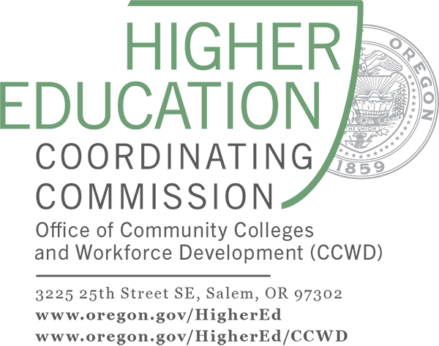
Oregon ABS – Title II
Standards-based PLCs

OACCRS Language Arts PLC – Sample Activities

Submission by Cybele Higgins, Lane Community College,
and Kiersta Gostnell, Rogue Community College

- Discuss OACCRS
- Choose 1-2 OACCRS to implement
- Design a lesson or activity
- Try it out
- Close loop

Discuss OACCRS: As a group, discuss OACCRS, including the process skills and key advances, and how they are relevant to your teaching and student learning. Use key points from the OACCRS/OAELPS Orientation or LA Module 1 as the basis for your discussion.

Choose 1-2 OACCRS to implement and design a lesson or activity: In a small group or with a partner, instructors pick 1-2 Language Arts OACCRS and develop a lesson plan or activity using the standard(s). Alternatively, instructors can come to the PLC with a lesson they have already created that is not correlated to OACCRS and adapt the lesson to include the standard(s).
Pro Tip: Choose the lesson plan/standards based on student data. You can gather this data by reviewing previous classroom formative/summative assessments and/or by running a CASAS TOPSpro report. The “Individual Skills Profile Summary by CCRS” report will show how a class performed on CCR Reading and Math Standards. Use the evidence from these sources to identify areas where students exhibit need for further instruction. Then choose relevant lesson plan/standards to work on.

Try it out: Instructors try out the lesson plan or activity with students and take notes about how the lesson went: How was the standard addressed? How were the learning objectives of the lesson met? What formal and/or informal assessments were used and what were the results? Were students actively engaged in the lesson? How?

Close the loop: Instructors refer to their notes and review the evidence of student learning after instruction. In the next PLC, instructors informally summarize their lesson and how their lesson went, or they can demonstrate part of the lesson to the PLC, to get feedback. The PLC gives the instructor feedback about what worked well or how to change, adapt, or augment the lesson. This can be done in partners, small groups, or as a whole group.

Instructors have enjoyed collaborating on lesson plans and resources, deepening their understanding of how OACCRS can support their teaching and student learning.

Example OACCRS Activity Summary: ABE/GED Language Arts, Social Studies

Choosing the Standards - OACCRS Reading Anchor 7 and Writing Anchor 8

Integration of Knowledge and Ideas - Reading Anchor 7: Integrate and evaluate content presented in diverse media and formats, including visually and quantitatively, as well as in words.

Research to Build and Present Knowledge - Writing Anchor 8: Gather relevant information from multiple print and digital sources, assess the credibility and accuracy of each source, and integrate the information while avoiding plagiarism.

OACCRS Reading Anchor 7 and Writing Anchor 8 - Summary of Lesson Activity and Student Work: As part of our unit on the Great Depression, in a lower-level ABE/GED integrated Language Arts and Social Studies class, students researched Works Progress Administration (WPA) artists and chose one that interested them. They read and evaluated content from diverse media, including text, photos, charts, and video. They assessed the credibility and accuracy of the information by examining their sources and integrated what they learned in a one or two slide infographic about their WPA artist. This was the first or second time they had used the presentation tool, Canva. They successfully integrated information from multiple sources, including prior knowledge from previous lessons, to demonstrate their understanding of their artist. They presented this information in a visually appealing manner in Canva and answered questions from the class. In addition, they became proficient at using charts and other infographics with a new digital presentation tool. There was some plagiarism from texts despite a mini-lesson in paraphrasing. This pointed to the need to further practice the skills of synthesis and paraphrasing. On the whole, students were highly engaged in the project and enjoyed choosing their artist, integrating information from multiple sources, and presenting it in an appealing visual with a new digital tool.

