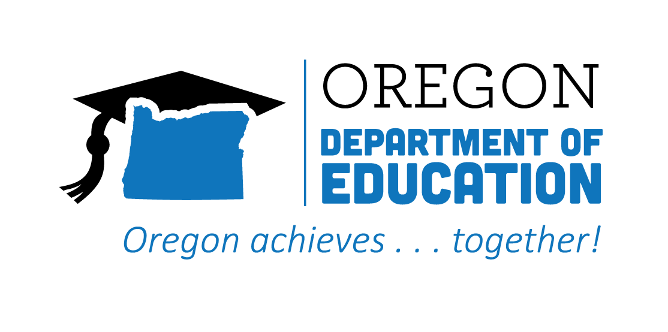
CTE STATE PLAN ACCOMPLISHMENTS 2022-2023
Data Literacy & Accountability

The Oregon CTE State Plan is a high level, four-year strategic plan that integrates state and federal priorities to implement the "Strengthening Career and Technical Education for the 21st Century Act" (commonly known as Perkins V). Powerful data literacy and accountability policies and practices help users identify critical trends and information that support continuous improvement and enhance supports and opportunities for learners. The following are Local and State accomplishments made around Data Literacy and Accountability goals during the third year.
2022-2023 ACCOMPLISHMENT HIGHLIGHTS
Educated faculty around data and its importance, increased awareness on what is working, identifying gaps in student achievement/outcomes, and implementing strategies for continuous improvement.

Utilized CTE Participation Explorer, a data visualization dashboard, to address gaps in access and achievement, and to ensure equitably achievable goals within CTE Participant and CTE Concentrator statuses.

Evaluated each program through disaggregated data, followed by planning initiatives moving forward, and maintaining this work through Continuous Improvement cycle training.
Provided timely professional development and technical assistance for local data preparers and submitters on reporting for the CTE System and the secondary CTE spring collections.
Shared data with CTE teams, walking through root cause analysis with our consortium and brainstorming ways to improve student equity in CTE participation through data analysis.

Presented webinars on Perkins V data elements, covering both secondary and postsecondary Perkins V terminology, performance indicators, student cohorts, performance results, and performance disaggregation.

