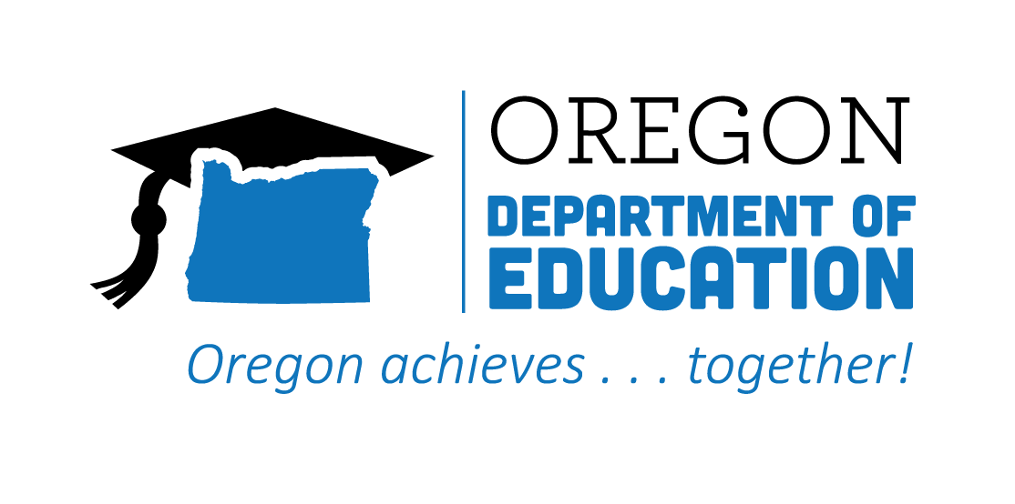
CTE STATE PLAN ACCOMPLISHMENTS 2022-2023
Equity & Civil Rights

The Oregon CTE State Plan is a high level, four-year strategic plan that integrates state and federal priorities to implement the "Strengthening Career and Technical Education for the 21st Century Act" (commonly known as Perkins V). Equity has been infused as an important consideration in all aspects of the state plan, and we have identified specific goals to help support this important work. The following are Local and State accomplishments made around Career Exploration goals during the third year.

2022-2023 ACCOMPLISHMENT HIGHLIGHTS
Increased support of CTE among target population by partnering with affinity groups, such as Migrant Education, African American Black Student Success, and Native Youth Wellness.
Worked with a cross-agency team to create the document, Supporting Gender Expansive Students: Guidance for Schools in support of schools, families, and the community.

Helped teachers build inclusive classroom environments through Courageous Conversation training.

Provided program-level demographic data to each program and school to help identify where programs were not meeting student needs; followed up with guidance to help districts build capacity in equity work.

Increased access for diverse populations by hiring bilingual instructors, developing general marketing campaigns in Spanish, and providing focused strategic outreach to students per gender, race, and ethnicity.

Partnered with Career Connected Learning and Work-Based Learning Teams to provide equity support, technical assistance, collaborating on guidance documents, resources, and webinars.

