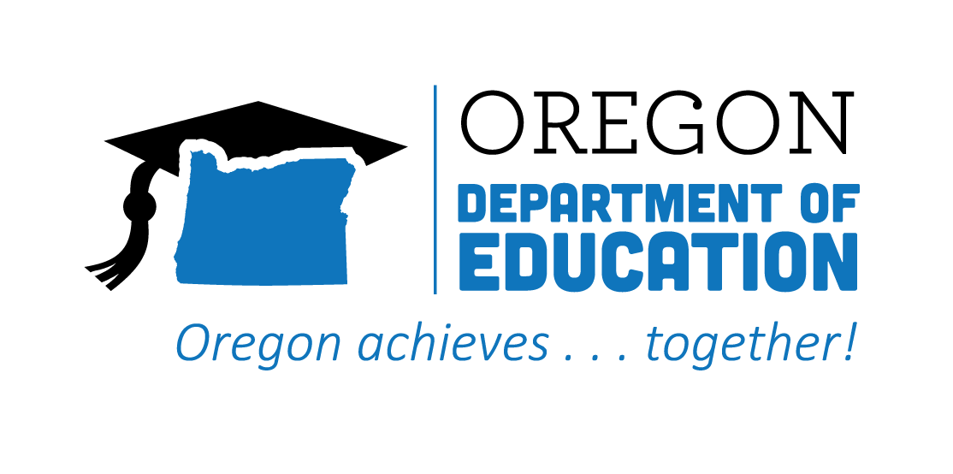

Statewide Advisory Council

Rolling Meeting Minutes

Date: October 19, 2022
Time: 9:00 AM - 11:00 AM

List of Attendees
Group Norms

Working Agenda
Please note: Meetings will be recorded for those that are unable to attend

Time | Topic | Notes
9:00 | First Welcome  (Malinda) | Please introduce yourself in chat  Don’t forget to check out the Advisory Council Slides to learn more about our membership!
 | Second Welcome and State Director Updates  (Jennell and Donna/Celia) | Jennell:  Equity  - Focus for the coming year  - Career Connected Learning  - Middle School Career Exploration  - Youscience (career aptitudes)  - Career Journey’s Videos  - Career Information Systems for all  - Work-based Learning (WBL)  - WBL Guidebook updated  - Partnerships to create videos and guides for employers  - Support for districts on implementing equitable WBL experiences (Oregon was highlighted nationally as being an example of equitable participation in WBL)  - CTE Teacher Recruitment and Retention  - New CTE state-wide educator mentors  - Pipelines into education  - Statewide POS  - Education, Law Enforcement, Automotive, Natural Resources  - New Integrated Application for CTE funding  - All school districts and community colleges are participating in community engagement and a needs assessment process to inform their plans that will be submitted in the spring of 2023  - Preparing for new Policy Makers  - Creating foundational materials to onboard new policy makers  - Seek an volunteers to review or advise us on our materials  Celia - HECC/CCWD  - Jennifer Purcell, new FRO Director Kerry Thomas, FRO Project Manager  - Shalee Hodgson, CCWD FRO point Julia Steinberger, OWI Director  - Kyle Thomas, Career Pathways Coordinator  - The Future Ready Oregon Team is currently hiring staff for capacity.  - HECC received over 145 applications for the Workforce Ready Grants. Applicants will be notified soon.  - The Prosperity 10,000 funds have been distributed to LWDBs  - The industry consortia project is in the planning phase.  - The Workforce Benefits Navigator work has not started  - Credit for Prior Learning (CPL)  Of the 24 public institutions that were eligible for the funds,  - 14 community colleges  - 5 public universities applied.  - A total of $10 million was awarded
 | Subcommittee Updates | - Equity (Elaine)  - Alignment (Charlie via Malinda)  - Legislative recommendation: dynamic, interactive, multi-level map that would allow an audience (educator, administrator, parent, student, etc) the ability to inquire and then have the map lead them to coordinated information both locally, regionally, statewide and possibly even nationally.  - Oregon Essential Skills:  - Gaining tracking  - Knitting with Statewide Program of Study  - Coordination project to help weave skills into education and workforce  - Keep the Council updated on progress  - Full Notes  - System of Sharing/Communication (Malinda)  - Legislative recommendation: Support investment in ongoing marketing of the value of CTE and the pathways that are available to students across the state.  - Exploring ways to bolster what is currently being done  - Student Advisory Team (Malinda)  - Exploring a partnership with the Workforce and Talent Development Board to create a larger Student Advisory team that can advise on more than just CTE  Reminder about serving on a subcommittee.
 | 2023 Meetings | Timeframe still work?  - Quarterly on the third Wednesday  - January  - April  - July  - October  - Once a year in person  - Rotate location  Time frame is working for those present today -  Q: How long would the in-person meeting be? Malinda said more time than our usual 2 hour meetings. Help creating agenda.  Q: Would there still be a zoom option if in-person? Malinda said Yes - Hybrid  Suggestion to hold on in-service day, and/or invite CTE students to share experiences/voice
 | Council Membership Recruitment | Planting Seeds:  - We have a couple open positions currently and will need to start thinking about how to fill those  - Survey to determine whether you will be continuing on the Council  - Hopefully some of you will choose to continue to help with the transition process  - Nomination and Selection Process  - Would love to have your help to recruit new members  - Two positions currently open:  - Postsecondary Equity/Diversity  - CTE Administrator
10:00 | BREAK
 | CTE State Plan Retrospective  (Malinda) | Slide Deck  Jamboard  Large Group Discussion Notes:  DICE = Diversity, Inclusion, Culture, Equity  Planting Seeds:  - Future State Plan initiatives  - Community Engagement  - State Plan revision/update  - Hoping to have Council participation and engagement
 | Announcements/Good of the Order  (ALL) | The data repository does not always work for schools/districts
 | Public Comment | None.
 | Next Meeting(s) | TBD based on group discussion

