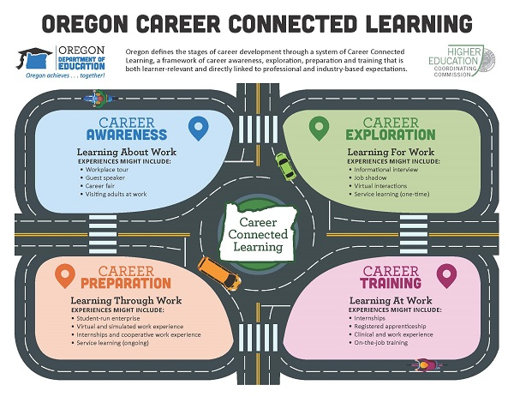

Oregon Career Connected Learning
Oregon defines the stages of career development through a system of Career Connected Learning, a framework of career awareness, exploration, preparation and training that is both learner-relevant and directly linked to professional and industry-based expectations.

Career Awareness/Learning About Work
Experiences might include:
- Workplace tour
- Guest speaker
- Career fair
- Visiting adults at work

Career Exploration/Learning for Work
Experiences might include:
- Informational interview
- Job shadow
- Virtual interactions
- Service learning (one-time)

Career Preparation/Learning Through Work
Experiences might include:
- Student-run enterprise
- Virtual and simulated work experience
- Internships and cooperative work experience
- Service learning (ongoing)

Career Training/Learning At Work
Experiences might include:
- Internships
- Registered apprenticeship
- Clinical and work experience
- On-the-job training

