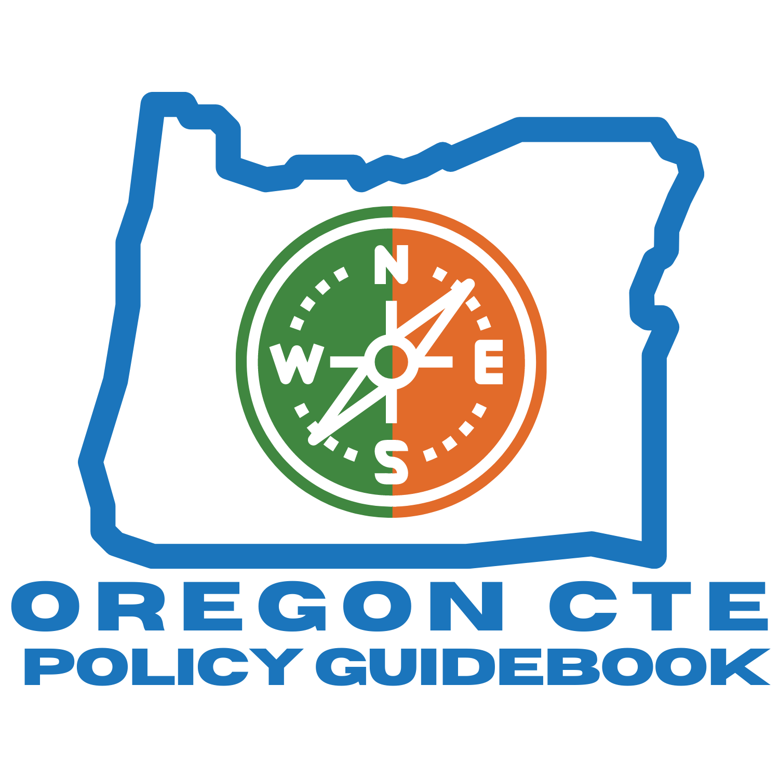

2020-2021

It is a policy of the State Board of Education and a priority of the Oregon Department of Education that there will be no discrimination or harassment on the grounds of race, color, sex, marital status, religion, national origin, age, sexual orientation, or disability in any educational programs, activities, or employment.

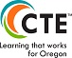
Joint Statement from HECC/CCWD/ODE

FOREWARD
Oregon will reimagine and transform learner experiences to enhance learners’ future prospects; empower their communities; and ensure equity in an inclusive, sustainable, innovation-based economy.
This vision can be accomplished only through partnership, collaboration, and coordination among education and workforce stakeholders. Together, the Oregon Department of Education and the Oregon Higher Education Coordinating Commission are committed to this work.
For the more than 75,000 K-12 learners participating in CTE, and over 8,000 postsecondary students completing CTE Programs at Oregon colleges annually, we have an opportunity to remove barriers and ensure high quality learning and access for each learner regardless of race, gender, or zip code.
The 2020-2024 Oregon CTE State Plan underlines the importance of collaboration and coordination and the value of engagement of partners across the systems. It provides a strategic plan and broad goals to achieve that plan. In addition, it contains action steps to achieve those goals. Together, they form a foundation for the work ahead.
The commitment to—and focus on—equity continues to be at the forefront as we move forward in achieving our vision. CTE will be truly high quality only when race, gender, and place are not predictors of economic stability and career opportunity. The following essential elements have been identified in partnership with multiple stakeholders as we strive to transform student experiences:
1. All learners will benefit from High Quality CTE Programs of Study leading to meaningful careers in high-skill, high-wage, in-demand careers that provide individuals with a sense of pride and contribution to their communities.
2. All learners, at all age levels, will be empowered with information to successfully navigate career pathways to a meaningful career through intentional exposure to and communication about careers.
3. All learners will be able to make connections between technical and academic learning in education settings and the workplace through work-based learning opportunities.
4. All learners will learn from knowledgeable experts who contextualize learning and create robust integration of academic and technical content.
5. All learners will benefit from flexible learning systems that allow Oregonians to gain
necessary skills where and how they best meets learners’ needs.
The Oregon Department of Education and the Office of Community Colleges and Workforce Development are committed to advancing equity in these five essential elements through the following practices:
1. Centering on equity in rule-making, budgeting, and resource allocation processes by drawing upon data and stakeholder feedback to identify and interrupt patterns of inequity.
2. Building fluency and comfort with change through continually working to strengthen systems and partnerships to remove barriers.
3. Pursuing meaningful collaboration with communities and students who are affected by decisions about CTE by providing comprehensive outreach and communication about CTE.
If you see areas of inequity or places to improve CTE, please reach out to our state team.

The development of this Policy Guidebook to help implement CTE in the State of Oregon is an important step in ensuring the development of and access to high quality CTE. It creates a one-stop shop of information on how to appropriately manage and implement Programs of Study. This is our first year of creating and disseminating a comprehensive CTE Policy Guidebook, and there may be areas that need further clarification or items that would be useful to add. We want this Guidebook to be a starting place for ongoing dialogue about growing and improving CTE implementation in Oregon. We intend to update this Guidebook on an annual basis. The state will take the lead in gathering updates and reach out to stakeholders and partners to inform the necessary changes. We hope that our guidance continues to improve and change to meet the needs of CTE in Oregon and that this Guidebook is one way we work together in achieving Oregon’s vision for CTE.
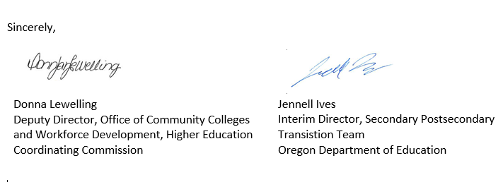

The CTE brand logo, brand positioning theme and brand extensions are the property of NASDCTEc. www.careertech.org
Table of Contents
ODE Education Equity Stance 1
What is Career and Technical Education? 1
CTE Companion Definition 1
Career and Technical Education Contacts 3
2020-2021 Important Perkins Dates 4
1 - Introducing the Oregon CTE Policy Guidebook 5
1.1 Purpose of the Guidebook 5
1.2 How to Effectively Navigate This Document 5
1.3 Process for Handbook Revision 6
1.4 Errors and Omissions 6
1.5 Common Acronyms 7
1.6 Notice of Nondiscrimination 7
2 - CTE Programmatic Supports in Oregon 8
2.1 State and Federal Initiatives in Addition to Perkins V 8
2.2 Overarching State and Federal Initiatives Supporting CTE 8
Federal Initiatives 8
State Initiatives 9
2.3 CTE Specific State and Federal Initiatives 10
Federal Initiatives 10
State Initiatives 10
3 - The Strengthening Career and Technical Education for the 21st Century Act (Perkins V) 11
3.1 Purpose of the Act (Section 2) 11
3.2 Title I—Career and Technical Education Assistance to the States (the Basic Grant) 12
3.3 Title II—General Provisions 13
3.4 Title III—Amendments to Other Laws 13
3.5 Understanding Perkins V Shifts 13
Perkins IV 13
Prior to July 1, 2020 13
New Oregon CTE State Plan 13
(Moving forward starting July 1, 2020) 13
4 - Oregon Career and Technical Education Program Overview 16
4.1 Definition of CTE 16
What is Career and Technical Education? 16
Companion Definition 16
4.2 Vision for CTE in Oregon 17
4.3 Commitment to Equity 17
4.4 Essential Components to Achieve Vision for CTE 17
4.5 Oregon CTE State Plan Goal Areas 18
4.6 Partners in Implementation 19
Responsibility of State Leadership 19
State Plan Implementation Team 20
Perkins Action Teams 20
CTE Regional Coordinators 20
Community College CTE Leaders 20
Local Education Partners 21
Local Business and Industry Partners 21
Parents and Students 21
Equity Partners 21
4.5 Communication and Engagement 22
CTE STEM Network 22
2020-2021 CTE and STEM Leadership Groups 23
Statewide CTE Advisory Committee 23
Website 23
5 – High Quality CTE Programs of Study 24
5.1 Overview 24
5.2 Elements of a High Quality Program of Study 24
5.3 Continuum of CTE Programs 27
5.4 Types of Approved CTE Programs of Study: 28
5.5 Size, Scope, and Quality 29
Evidence 29
Benchmark 29
5.6 CTE Program Quality 30
5.7 CTE Program Development and Approval 31
New CTE Program of Study Database Development - Secondary 31
Statewide CTE Program of Study Framework Development Process 31
Individual CTE Program Development and Application 32
CTE Program Development and Approval Cycle 32
Career Clusters 32
New Expiration Date 32
CTE Program Development Process 32
Application Due 32
Begin Newly Approved CTE Program of Study 32
New CTE Program Development 34
5.8 CTE During the COVID-Impacted School Year 34
CTE Program Dormancy 34
5.9 CTE Program Closure Guidance 35
Perkins Eligible Recipient: 36
Perkins Eligible Investments: 36
Notification: 36
Distribution of Assets: 36
Recordkeeping 38
Data Submission 38
Secondary Teacher Licensure 38
6 - Student Support Services 39
6.1 Career Connected Learning Overview 39
6.2 Career Exploration in CTE – Emerging Work 39
6.3 Work-Based Learning 40
Work-Based Learning Definition 40
Perkins Program Quality Indicator: Participation in Work-Based Learning 41
6.4 Flexible Learning – Emerging Work 41
6.5 Career Technical Student Organizations (CTSOs) – Student Leadership 42
Criteria for Becoming a Chartered Student Leadership Organization 42
Oregon CTE Student Leadership Foundation (OCTESLF) 43
7. Business and Community Partnerships 44
Stakeholder Engagement 44
Advisory Committee 44
7.1 Developing an Effective Advisory Committee 45
Size of the Advisory Committee 45
Me 45
7.2 Responsibilities and Roles of Committee Members 46
Secretary 47
7.3 Committee Operations 47
Orientation for Advisory Committee Members 47
Establishing Annual Priorities 48
Program of Work/Plan(s) of Action 48
7.4 Specifying Committee Activities 49
Assigning Responsibilities 49
Establishing Timelines 49
7.5 CTE Program Evaluation 50
7.6 In Summary 50
7.7 Resources for Advisory Committees 51
8 - Educator Recruitment, Retention, and Training 57
9 - Perkins Grant Funding Distribution 58
9.1 Current Year State Distribution and Allocations 58
9.2 Perkins Funding Distribution for Grant in Aid 59
Secondary Formula (Sec 131) 59
Postsecondary Formula (Sec 132) 59
Funding for State Institution 59
Consortia Allocations (Sec 131 and 132) 59
Perkins Reserve Allocations 59
Allocation for Charter Schools 60
Allocation for Private Nonprofit Schools 60
9.3 State Leadership Funds (Sec 112; Sec. 124) 60
9.4 State Administration Funds (Sec. 112) 62
10 - Perkins Grant Recipient Roles and Responsibilities 63
10.1 Direct Grant Recipients 63
Leadership Roles and Responsibilities 63
10.2 Consortia 66
Consortia Requirements 67
A request to form or make changes to a consortium must be made in writing to the State Director of Career and Technical Education by February 1 for the upcoming school year. 67
Consortium Change Requirements 67
Regional Leadership and Coordination 68
11 - Perkins Comprehensive Local Needs Assessment 70
11.1 Guide to the Regional CTE Needs Assessment: Merging Needs Assessment Findings and Setting Priorities 70
Labor Market and System Alignment 70
Recruitment, Retention, and Training of CTE Educators (Regional) 72
Equity and Participation 73
11.2 Guide to the Local CTE Needs Assessment and Stakeholder Engagement 74
Goals of the Needs Assessment 74
Stakeholders 74
Local CTE Needs Assessment Process 76
Oregon Equity Lens 76
Secondary Recipients 76
Postsecondary Recipients 76
Merging Needs Assessment Findings and Setting Priorities 77
11.3 CTE Student Performance 77
Materials to Review 77
Questions to Ask 78
Thought Questions 78
Deep Dive Questions 78
Summary and Priorities 79
Oregon Equity Lens 79
11.4 Equity and Participation 79
Materials to Review 79
Questions to Ask 80
Summary and Priorities 80
Oregon’s Equity Lens 81
11.5 Program Size, Scope, and Quality 81
Materials to Review 81
Questions to Ask 81
Summary and Priorities 82
Oregon Equity Lens 82
11.6 Labor Market and System Alignment 82
Materials to Review 82
Questions to Ask 82
11.7 Implementation of CTE Programs 82
Materials to Review 82
Questions to Ask 83
Summary and Priorities 83
11.8 Recruitment, Retention, and Training of CTE Educators 84
Materials to Review 84
Questions to Ask 84
Summary and Priorities 84
Oregon's Equity Lens 84
11.9 Career Exploration and Guidance 84
Materials to Review 84
Questions to Ask 85
Summary and Priorities 85
Oregon’s Equity Lens 85
12. Perkins Basic Grant Application and Annual Report 86
12.1 Introduction 86
Required Local Use of Funds 87
Annual Action Plan, Budget, and Budget Narrative 88
Student Performance 88
Consortium Regional Investment Planning (Required for Consortium Basic Grant Plans ONLY) 88
Annual Spending Report 88
Statement of Assurances 88
Special Notes 88
Publication Information 88
Due Dates 89
Submission Process 89
12.2 Perkins Basic Grant Application Components 89
12.3 Overview to the Basic Grant Application 89
12.4 Annual Action Plan and Budget Narrative 90
Annual Action Plan Components 90
Annual Perkins Basic Budget Narrative Components 91
Curriculum – Standards, Content, Alignment, and Articulation 92
Curriculum – Student Support Services, Work-Based Learning, and Career Exploration Activities 93
Professional Development 93
Scientifically Based Research 93
Staffing 93
Grant Indirect Charges 94
12.5 Annual Report 94
Summary of Activities and Goals 94
Budget Summary Report 94
Inventory 94
12.6 Four-Year Perkins Basic Grant Timeline 95
13. Perkins Reserve Grant Application 96
13.1 Introduction 96
Revised Project Elements: 96
Program Leadership 97
Travel Differential 97
Statement of Assurances 97
Special Notes 97
Publication Information: 97
Due Dates 97
Submission Process 97
13.2 Reserve Grant Plan 98
Overview to the Reserve Grant Application 98
Two-Year Goals 98
Reserve Grant Action Plan 99
Annual Perkins Reserve Budget Narrative Components 99
Reserve Grant Annual Report 99
13.3 Two-Year Perkins Reserve Grant Timeline 99
14 - Perkins Peer Review Process 100
15 - Perkins Data and Accountability 101
Overview of Accountability Measures 101
Attention to Equity 102
Overview of Secondary Performance Indicators 102
Overview of Postsecondary Performance Indicators 105
Data Confidentiality and Data Sharing 106
Data Sharing Agreements 107
Data Reports 107
90% Reports – Secondary Level 107
Pivot Tables – Postsecondary Level 107
Improvement Plans 109
CTE Data Collections – Secondary 110
CTE Program Update 110
CTE Program Update User Guide 110
CTE Student and Course Collection - Secondary 127
CTE Data Collections – Postsecondary 128
Data Literacy 128
Technical Assistance 128
16 - Financial Requirements 129
16.1 Overview of Perkins Grant Resources 129
16.2 Grant Type and CFDA Number 129
16.3 Grant Award Period 129
16.4 Period of Obligation 130
If the obligation is for: 130
The obligation is made: 130
16.5 Suspended and Debarred Service Providers 130
16.6 Expectations of Perkins Grant 130
16.7 Requirement for Local Use of Funds Sec 135(b) 131
16.8 Algorithm for Making Local Funding Decisions 131
16.9 Allowable and Unallowable Costs and Activities 132
Allowable Costs/Activities 132
Unallowable Costs and Activities 132
16.10 Supplement not Supplant 134
16.11 Administrative Cost 134
Indirect Cost Rate (ICR) 134
Direct Administrative Costs 134
16.12 Repayment of Reimbursed Expenses 135
16.13 Eligibility Exclusion Lists (Sec 135(b)) CFR 200.328 & 200.330 135
16.14 Funding CTE Programs 135
Postsecondary Customized Training Courses and Programs 136
16.15 Funds for Support Services (Careers Nontraditional by Gender) 136
16.16 Perkins Funds in the Middle Grades 137
Career Exploration and Development 137
Programs of Study 137
16.17 Braided Funding 137
16.18 Perkins One-Stop Collaboration - 1.5% Set-aside 137
16.19 Individual Elements of Cost 138
16.19.1 Equipment 138
16.19.2 Professional Development – Waived for 2020-2021 due to COVID-19 Impacted School Year 140
16.19.3 Personnel 140
16.19.4 Field Trips 141
16.19.5 Career and Technical Student Organization (CTSO) Activities 141
16.19.6 Perkins Funding for Curriculum Software/License 142
16.20 Required Local Policies 142
Written Cash Management Procedures –200.302(b)(6); 200.305 142
Written Conflicts of Interest Policy - 200.318(c) 142
Written Procurement Procedure 200.319(c) &200.320 143
Written Travel Policy - 200.474(b) 143
Written Procedures for Managing Equipment - 200.313(d) 143
Written Time and Effort Policies and Procedures §200.430(i) 143
Written Teacher Stipend/Curriculum Rate Policy - Employee Benefits – 200.431 143
16.21 Budget Narrative Changes and Revisions §200.308 144
16.22 Records Retention 200.333 144
16.23 Appeals Procedure Section 131 (e)(3) 144
Level 1: Review 144
Level 2: Appeal 144
16.24 Technical Assistance 145
17. Charter Schools and CTE 146
18. Correctional Education Programs and CTE 147
18.1 Juvenile Detention Education Program (JDEP) 147
18.2 Youth Corrections Education Program (YCEP) 147
18.3 Oregon Department of Corrections 147
18.4 Funding 147
18.5 Administration and Guidance 148
18.6 CTE Program Requirements 148
19. Oregon School for the Deaf and CTE 148
20. Private Nonprofit School Participation 149
Personnel 149
Student Participation 149
Consultation 149
21 - Methods of Administration 150
22. Monitoring 151
22.1 Oregon’s Approach to Monitoring 151
22.2 Carl D. Perkins Monitoring 152
Identification of Risk Factors 152
Conducting the Risk Assessment 153
22.3 Technical Assistance and Support Resources 154
22.4 Fiscal Monitoring Elements 154
Annual Budget Approval and Revision Process 154
General Technical Assistance Activities 154
Targeted Monitoring Activity 155
Data Accuracy and Reporting Elements 155
Program Quality and Outcome Monitoring Elements 156
22.5 Monitoring Resources 157

Oregon will reimagine and transform learner experiences in order to enhance their future prospects; empower their communities; and ensure equity in an inclusive, sustainable, innovation-based economy.
Oregon CTE Plan Vision

ODE Education Equity Stance
Education equity is the equitable implementation of policy, practices, procedures, and legislation that translates into resource allocation, education rigor, and opportunities for historically and currently marginalized youth, students, and families, including civil rights protected classes. This means the restructuring and dismantling of systems and institutions that create the dichotomy of beneficiaries and the oppressed and marginalized.
Oregon’s commitment to equity is reflected in the Oregon CTE State Plan, referenced later in this document and posted on the Oregon Department of Education website.

What is Career and Technical Education?
Career and Technical Education (CTE) is content, programs, and instructional strategies based on business and industry skill sets and needs. Instruction incorporates standards-based academic content, technical skills, and workplace behaviors necessary for success in careers of the 21st century. CTE incorporates applied learning that contributes to the individual’s development of higher-order reasoning and problem-solving skills; work attitudes; general employability skills; technical skills; occupation-specific skills; and knowledge of all aspects of an industry, including entrepreneurship. Instruction focuses in areas such as Agriculture, Food, and Natural Resources Systems; Arts, Information, and Communications; Business and Management; Health Sciences; Human Resources; and Industrial and Engineering Systems.

CTE Companion Definition
The following companion definition has been developed and may be useful for those in education as well as those outside of education who must understand CTE in order to be strong partners and effective critical friends:
Career and Technical Education (CTE) is an educational program for high school and community college students based on individual interest and industry need. CTE comprises programs offered in six career areas: Agriculture, Food, and Natural Resources Systems; Arts, Information, and Communications; Business and Management; Health Sciences; Human Resources; and Industrial and Engineering Systems. It includes intentional programs in high-wage, in-demand areas. CTE prepares and supports students in acquiring the technical skills, professional practices, and academic knowledge critical for success in highly skilled careers.
CTE is good for business because it equips potential employees with certifications as well as the technical, collaboration, and problem-solving skills to succeed in the diverse, increasingly complex workplace of today and tomorrow.

CTE is good for community colleges because it engages students in relevant learning that increases the completion rate, improves persistence and retention through contextual learning, and is a means to collaborate with high school teachers and business partners to strengthen systems and remove barriers that prevent students from being career and college ready.
CTE is good for high schools because it engages students in relevant learning that increases the graduation rate, improves student performance through authentic and applied learning experiences, and is a means to collaborate with community college instructors and business partners to build a robust path to success after the high school experience. CTE provides opportunities for meaningful collaboration with historically underrepresented communities and students to drive and communicate the best decisions supporting career and college readiness.
CTE is good for students and parents because the hands-on, meaningful, and engaging learning experiences inspire students to stay in school, participate, and learn. CTE increases marketable skills and thus students’ ability to strive for careers that make sense with their goals and aspirations.
The CTE educational experience is practical and affordable, providing the shortest path to a student’s first earned dollar.

Career and Technical Education Contacts
State CTE Director and Secondary-Postsecondary Director, Office of Teaching, Learning and Assessment:
Jennell Ives, Interim - 503-947-5777, Jennell.Ives@state.or.us

Deputy Director, Office of Community Colleges and Workforce Development (CCWD):
Donna Lewelling - 503-947-2428, donna.j.lewelling@state.or.us

Oregon Department of Education (ODE) Secondary-Postsecondary Team (SPST) Staff—CTE/STEM
Denise Brock | Education Program Specialist—Arts, Information, and Communications; Human Resources; Local CTE Annual Application and Report | 503-947-5794
Ron Dodge | Education Program Specialist—Business and Management; Oregon Skill Sets; Programs of Study; Student Leadership | 503-947-5653
Lauren Dressen | Program Analyst—CTE and Perkins Data and Reporting | 503-947-5700
Daniel Findley, Ph.D. | Education Program Specialist—Industrial and Engineering Systems | 503-947-0338
Reynold Gardner, Ph.D. | Education Program Specialist—Agriculture, Food, and Natural Resources Systems; Expanded Options; Virtual Charter School Programs; Perkins Budget Approval | 503-947-5615
Megan Helzerman | Education Program Specialist—CTE Revitalization, CTE and STEM Projects | 503-947-8530
Jennell Ives | Interim State CTE Director and Perkins Administration | 503-947-5777
Margaret Mahoney | Education Program Specialist—Teacher Licensure | 503-947-8458
Karin Moscon | Education Program Specialist—Perkins Civil Rights | 503-947-5706
Barbara O’Neill | Program Analyst | 503-947-5787
Carly Sichley | Program Analyst—CTE and Perkins Data | 503-947-5685
Linda Simeone | Project Administration | 503-947-6500
Gabby Sloss | Education Program Specialist—Apprenticeship Liaison and Work-Based Learning | 503-947-5660
Callen Sterling | Program Analyst—Perkins Civil Rights | 503-947-5706
Jim Taylor | Education Program Specialist—Career Education and Human Resources CTE | 503-947-8529
Art Witkowski | Education Program Specialist—Health Sciences and Student Support Services; Literacy in CTE; CTE Network Liaison | 503-947-5834
Community Colleges & Workforce Development (CCWD) Staff— Perkins/CTE staff
KC Andrew | Education Program Specialist—Adult Basic Skills and CTE; Agriculture, Food, and Natural Resources Systems (NR Ag), Health Sciences and Human Resources | 503-947-5742
Kasena Dailey | Program Coordinator—Adult Basic Skills, Title II, CTE, GED | 503-947-5608
Luis Juárez | Education Program Specialist—CTE and Perkins Postsecondary Reporting; Arts, Information and Communications (AC), Business and Management (BU), Industrial and Engineering Systems (IE) | 503-947-2430
Eric Juenemann | Career Connected Learning Specialist | 503-947-2431
Kelly Zinck | Education Team Research Analyst | 503-947-2409
Other Key Staff
Angela Allen | Education Program Specialist—TAG | 503-947-5931
Patrick Crane, Ph.D. | Adult Basic Education State Director, CCWD | 503-947-2414
Tonya Davis | Fiscal Analyst | 503-373-0072
Sam Ko | Education Program Specialist—Youth Corrections Education | 503-947-5745
Carol Park | Fiscal Administrative Specialist (EGMS); Perkins Claims | 503-947-5604
Jennifer Patterson | Assistant Superintendent—Teaching, Learning and Assessment | 503-947-5663
Cynthia Stinson | Director—Data, Operations and Grant Management | 503-947-5816
Beth Wigham | Education Program Specialist—CCR/School Counseling | 503-947-5708

2020-2021 Important Perkins Dates

June 30, 2020 | 2019-2020 Local Needs Assessments completed/submitted  2020-2021 Perkins V Assurances submitted (fiscal agent)
July 1, 2020 | 2020-2021 Perkins grant funds available - 20% of preliminary award amount  Implementation of 2020-2024 Perkins Plan
September 18, 2020 | 2020-2021 CTE Program update (Fall) opens
September 20, 2020 | 2020-2021 (or 4-year) Perkins Basic Grant Application  2020-2021 Perkins Basic Grant Budget due  2020-2021 Perkins Reserve Grant and Budget due  2020-2021 Consortia Agreement and Consortia Handbooks submitted
September 30, 2020 | 2020-2021 Perkins Basic and Reserve Grants approved  2019-2020 Perkins Basic and Reserve Grant funds must be encumbered
October 1, 2020 | 2020-2021 Perkins official grant award notifications available in EGMS for full allocation
October 23, 2020 | 2020-2021 CTE Program Update (Fall) due for schools – ALL secondary programs must be updated in the fall
November 15, 2020 | 2019-2020 Final Basic and Reserve final claims made in EGMS  2019-2020 Perkins Annual Report Due  2019-2020 Perkins 90% Report validation begins
November 27, 2020 | 2020-2021 CTE Program update due for Regional Coordinators
November 30, 2020 | 2019-2020 Perkins 90% Report validation closes
December 28, 2020 | 2020-2021 CTE Program Update completed by ODE Education Specialists
December 31, 2020 | 2019-2020 Consolidated Annual Report due from ODE to OCTAE
February 1, 2021 | 2021-2022 Consortium documentation due, including any fiscal agent requests
February 18, 2021 | 2021-2022 Perkins Basic Grant informational web
March 2021 | Local and Regional CTE Needs Assessment updated, if necessary
March-May 2021 | 2020-2024 CTE Plan Peer Review for Perkins Basic and Reserve and HSS  2021-2023 Perkins Basic Grant submitted, May 30 last date
April 12, 2021 | 2021-2022 Perkins Basic and Reserve preliminary allocations available (tentative)
April 30, 2021 | 2021-2022 CTE Program of Study applications – early submission
May 14, 2021 | 2020-2021 Student Data Collections Open
May 31, 2021 | 2021-2022 All CTE Program of Study Applications due
June 29, 2021 | 2020-2021 Student Data Collections Close
June 30, 2021 | 2021-2022 Perkins Basic progress on goals and budget submitted  2021-2022 Reserve Grant applications progress on goals and budget submitted  2021-2022 Perkins Assurances

1 - Introducing the Oregon CTE Policy Guidebook

1.1 Purpose of the Guidebook
This Guidebook is a resource for secondary and postsecondary educators who are interested in Career and Technical Education (CTE) or who work directly in CTE programming. The purpose of this Guidebook is not only to provide an understanding of federal and state requirements and guidance developed for CTE Programs benefiting from Perkins funding; it also seeks to provide a broader perspective of the system of CTE in Oregon. This Guidebook highlights specific sections of the federal Perkins V Act and the Oregon CTE State Plan that are critical for understanding the requirements of the Act for implementation in Oregon.
The Oregon CTE Policy Guidebook has been developed and reviewed by a team of secondary and postsecondary CTE leaders and state staff to be the main and trusted source of information for CTE administrators in administering CTE Programs in Oregon. This is the first version of a comprehensive Policy Guidebook of this type in Oregon, and as such it has some sections that will need to be completed over the coming years, some sections that will need to be updated with new dates, and other sections that will need to change with the implementation of the new Perkins V law and as the education landscape changes in the shadow of the COVID-19 pandemic. The intent is to eventually include all state and federal CTE resource information so that it becomes a one-stop shop for high quality CTE programming. The Guidebook is intended to undergo an annual review process to maintain the most updated information. The Oregon Department of Education (ODE) and the Office of Community Colleges and Workforce Development (CCWD) gratefully appreciate any feedback. Please submit your comments to Jennell.ives@ode.state.or.us.

1.2 How to Effectively Navigate This Document
There is a tremendous amount of information contained in this document. To easily jump to the specific topic, follow these steps:
- Open document to full screen.
- Click on the view tab.
- Under the show section, select Navigation Pane.
This will open a navigation tool on the left side of the page that will appear like a table of contents. Users may scroll down through the navigation pane or use the Search Document function at the top.

1.3 Process for Handbook Revision
This handbook will be revised annually to reflect changes in policy and practice. The process for revision will be:
When | Who | What
August 2020-February 2021 | Internal and External Workgroups | Scheduled revisions and development of identified sections
December 15, 2020-February 15, 2021 | Barbara O’Neill  Jennell Ives  Network Liaison | Solicit input on proposed revision
February 15, 2021 | Barbara O’Neill  Jennell Ives  Network Liaison | Compile collection of proposed revisions  February CTE/STEM Network agenda item  Establish new review team
March 1, 2021 | Barbara O’Neill | Share list with ODE/HECC team for review
March 11, 2021 | All HECC/ODE  CTE/STEM Network | Brainstorm additional items for addition or editing
March 12, 2021 | Barbara O’Neill  Jennell Ives  Network Liaison | Finalize list of needed revisions  Assign sections to team members
May 1, 2021 | ALL | Revisions/Edits due to AS/OS for incorporation into Guidebook
May 14, 2021 | ALL | Review revisions at review team meeting, provide final input
June 1, 2021 | Barbara O’Neill | Review revised Guidebook at June CTE/STEM Network meeting
June 15, 2021 | CTE State Director | Assess feedback for further revision and assignment
June 29, 2021 | Barbara O’Neill | Post updated Guidebook to internet

1.4 Errors and Omissions
As users find information that may be erroneous, unclear, or left out of the Guidebook, they are requested to use the Oregon CTE Policy Guidebook Update Request Form.

1.5 Common Acronyms
A variety of acronyms are commonly used in CTE; they are listed in Oregon Career and Technical Education Acronyms.

1.6 Notice of Nondiscrimination
It is a policy of the State Board of Education and a priority of the Oregon Department of Education that there will be no discrimination or harassment on the grounds of race, color, sex, marital status, religion, national origin, age, sexual orientation, or disability in any educational programs, activities, or employment. Persons having questions about equal opportunity and nondiscrimination should contact:
Kate Hildebrandt
255 Capitol Street NE
Salem, Oregon 97310
Phone: 503-947-5667

2 - CTE Programmatic Supports in Oregon

2.1 State and Federal Initiatives in Addition to Perkins V
The Oregon Legislature values Career and Technical Education (CTE), and has been rapidly increasing the state funding available for high quality CTE Programs for all students across the state over the last ten years. Federal funds have also been used to supplement state funding available for CTE. Oregon strives to coordinate the use of all funds to ensure equity in access to high quality CTE Programs across the state. Teams within the agency are working closely to align processes and reduce duplication. One example is the required needs assessment across several funding streams (ESSA, High School Success, and Perkins); having a single assessment will assist partners in the application process.

2.2 Overarching State and Federal Initiatives Supporting CTE
These initiatives are managed largely outside of the CTE team but are part of the overall collaborative efforts to improve outcomes for Oregon students. A brief explanation and link to the work is provided below.

Federal Initiatives

Every Student Succeeds Act (ESSA):
The Every Student Succeeds Act (ESSA) is a federal school accountability law rooted in supporting all students equitably and building systems that eliminate barriers to student success; it replaced No Child Left Behind in 2015. As part of ESSA, all states developed a plan for improving education which were submitted to the U.S. Department of Education. The plan that Oregon submitted to the U.S. Department of Education centers on four key commitments:
- Advancing Equity
- Promoting a Well-Rounded Education
- Strengthening District Systems
- Fostering Ongoing Engagement

Workforce Innovation and Opportunity Act (WIOA):
WIOA was signed into law on July 22, 2014. WIOA is designed to help job seekers access employment, education, training, and support services to succeed in the labor market and to match employers with the skilled workers they need to compete in the global economy. WIOA strengthens and improves the nation's public workforce system, helps Americans—including youth and those with significant barriers to employment—obtain high quality jobs and careers, and helps employers hire and retain skilled workers. WIOA's three hallmarks of excellence are:
- The needs of businesses and workers drive workforce solutions, and local boards are accountable to communities in which they are located.
- One-Stop Centers provide excellent customer service to job seekers and employers and focus on continuous improvement.
- The workforce system supports strong regional economies and plays an active role in community and workforce development.

State Initiatives

Student Success Act (SSA):
During the 2019 legislative session, Oregon’s leaders made a real commitment to the state and its children, educators, and schools with the passage of the Student Success Act (SSA). When fully implemented, the SSA is expected to invest $2 billion in Oregon education every two years; that will be a $1 billion investment in both early learning and K-12 education each year. Of those funds, $200 million will go into the State School Fund and the remaining will be distributed into three accounts: the Early Learning Account, the Student Investment Account (SIA), and the Statewide Education Initiatives Account.

High School Success (Measure 98):
High School Success is a fund initiated by ballot Measure 98 in November 2016. The measure passed with 65% voter support and allowed the Oregon Department of Education (ODE) to disperse $170 million total during the 2017-19 biennium among districts and charter schools that serve students in grades 9 through 12. During the second biennium (2019-2021), 252 school districts, charters, Youth Corrections Education Programs (YCEPs), and Juvenile Detention Education Programs (JDEPs) throughout the state of Oregon benefit from funds through the creation of 230 High School Success plans. Funding is provided to establish or expand programs in three specific areas; projected funding for 2019-2020 is listed beside each area:
- Dropout Prevention - $35.6M
- Career and Technical Education - $44.6M
- College Level Education Opportunities - $13.4M

Science, Technology, Engineering, and Math (STEM) Investment Council:
Oregon’s STEM Investment Council, established and authorized by HB 2636 (2013), functions under the direction and control of the State Board of Education and Higher Education Coordinating Commission (HECC). The Council receives staff support from the HECC’s Office of Workforce Investments. The Council has a legislative mandate to assist the State Board of Education and HECC in developing and overseeing a long-term strategy to meet the following statutorily established STEM education goals by 2025:
- Double the percentage of students in 4th and 8th grades who are proficient or advanced in mathematics and science, as determined using a nationally representative assessment of students’ knowledge in mathematics and science.
- Double the number of students who earn a postsecondary degree requiring proficiency in science, technology, engineering, or mathematics.

Workforce and Talent Development Board (WTDB):
The WTDB is dedicated to investing in Oregonians to build in-demand skills, matching training and job seekers to opportunities, and accelerating career momentum. From innovative apprenticeships in the healthcare and information technology fields to credentials that certify essential skills for workplace success, there are many opportunities to build skills and training, accelerate career momentum, and advance along career pathways. The WTDB vision states that, "A strong state economy and prosperous communities are fueled by skilled workers, quality jobs, and thriving businesses." Talent development work "is focused on identifying in-demand occupations and skills, current and future talent needs and gaps, engaging the voice of business and industry, and including public workforce system stakeholders."

2.3 CTE Specific State and Federal Initiatives

Federal Initiatives

Strengthening Career and Technical Education for the 21st Century Act (Perkins V):
The federal investment in vocational or career and technical education has been in place for well over 100 years. In 2018, the legislation governing this grant program—commonly referred to as Perkins V—was reauthorized. The requirements and recommendations of Perkins V are largely contained later in this Guidebook.

State Initiatives
The following initiatives are also funded by the Oregon Legislature and are specifically intended to support CTE. A brief overview is provided below; as the Guidebook evolves, additional information will be included.

Name | Amount Funded 2019-2021 Biennium* | Purpose
CTE Revitalization | $7M | CTE Revitalization grants are intended to help rejuvenate existing Programs of Study that have fallen into decline and to foster the creation of new programs where they did not exist prior. Grants emphasize community and business engagement, postsecondary alignment so that learners can progress after completing high school, and alignment with principles of High Quality Programs of Study.
Secondary Career Pathways Funding | $8.4M | Secondary Career Pathways grants were initially provided to financially incentivize the development of CTE Programs of Study that encapsulated three credits, earned industry credentials, and provided access to historically underserved students. Funds were provided directly to benefit programs and ranged from $2,500 to $45,000.
CTSO Chapter Grant | $726K | The purpose of this grant is two-fold: 1) to support the administration and operation of each of the nine student leadership organizations in the state, and 2) provide for Chapter (mini) Grants for local chapters of the organizations to help cover the costs of operating a local chapter (including travel, fees, uniforms, testing materials, etc.).
FFA Grant | $2M | Funds are provided for FFA programming, including dues, Ag Experience Tracker software, and career development experiences. Teacher stipends for summer work are also included.
*Final amounts will be determined by the Governor’s final biennial budget.

3 - The Strengthening Career and Technical Education for the 21st
Century Act (Perkins V)
The Strengthening Career and Technical Education for the 21st Century Act (Perkins V) amends the Carl D. Perkins Career and Technical Education Act of 2006 (Perkins IV). The new act was signed into law July 31, 2018, and went into effect July 1, 2019. For the sake of brevity, throughout this Guidebook, the Strengthening Career and Technical Education for the 21st Century Act will be referred to as Perkins V.

There are three Titles in Perkins V:
- Title I – Career and Technical Education Assistance to the States
This section is most applicable to readers of this Guidebook as it applies largely to all local grant recipients and state level grant requirements.
- Title II – General Provisions
This section mostly references federal administration requirements.
- Title III – Amendments to Other Laws
This section aligns other federal initiatives.

Some provisions of Perkins V went into effect for the 2019-2020 school year, which served as a transition year for the new law. Full implementation will begin for the 2020-2021 school year.
The reauthorization process was driven largely by a desire to ensure that students are prepared for 21st century careers. This framing led to a workforce development focus throughout Perkins V with an emphasis on encouraging and incentivizing innovation within Career and Technical Education (CTE).
Each state is required to develop a state plan to describe the implementation of the new federal law. In Oregon, the planning team decided to develop a plan to guide the entire system of CTE in Oregon. Below is high-level information about Perkins V; additional information about the Oregon CTE State Plan is in Section 4 of this Guidebook.

3.1 Purpose of the Act (Section 2)
According to Section 6 of the Perkins V Act, the purpose of the Act is to develop more fully the academic knowledge, technical skills, and employability of secondary and postsecondary education students who elect to enroll in CTE Programs and Programs of Study by:
- building on the efforts of States and localities to develop challenging academic and technical standards and to assist students in meeting such standards, including preparation for high-skill, high-wage, or in-demand occupations in current or emerging professions.
- promoting the development of services and activities that integrate rigorous, challenging academic and career and technical instruction that link to secondary and postsecondary education for participating CTE students.
- increasing State and local flexibility in providing services and activities designed to develop, implement, and improve CTE.
- conducting and disseminating national research and disseminating information on best practices that improve CTE Programs of Study, services, and activities.
- providing technical assistance that (A) promotes leadership, initial preparation, and professional development at the State and local levels; and (B) improves the quality of CTE teachers, faculty, administrators, and counselors.
- supporting partnerships among secondary schools, postsecondary institutions, baccalaureate degree granting institutions, area CTE schools, local workforce investment boards, business and industry, and intermediaries.
- providing individuals with opportunities throughout their lifetimes to develop, in conjunction with other education and training programs, the knowledge and skills needed to keep the United States competitive.
- increasing the employment opportunities for populations who are chronically unemployed or underemployed, including individuals with disabilities, individuals from economically disadvantaged families, out-of-workforce individuals, youth who are in (or have aged out of) the foster care system, and homeless individuals. (New in Perkins V.)

3.2 Title I—Career and Technical Education Assistance to the States (the Basic Grant)
The Perkins V Act provides financial support for innovation and program improvement in CTE at both secondary and postsecondary levels.
Title I of the Act outlines the structure and requirements related to the Basic Grant under Perkins V. The Act specifies the formula to be used for the allotment and distribution of funds to states, as well as requirements for how states distribute Perkins V funds to local eligible agencies. In addition, the Act specifies uses of funds by both state and local recipients. The specific allocation process used for allocations to local recipients is included in Section 9.2 of this Guidebook. Perkins V legislation includes several requirements related to reporting and accountability, with many of the state-level requirements having parallel provisions for local recipients (Section 15) These requirements include submission of applications and performance reports at both the state and local level (Section 11, 12 and 13). There is a requirement that both state and local recipients submit improvement plans if the agreed-upon, state-determined performance measures are not met. (See Table 1.)
Table 1: Selected provisions related to the basic grant Title II – General Provisions
Perkins V – Title I: Selected Provisions Related to the Basic Grant
Financial Provisions | Distribution of Funds
 | Section 111 | Reservations and State Allotment
 | Section 112 | Within-State Allocation
 | Section 131 | Distribution of Funds for Secondary Education Programs
 | Section 132 | Distribution of Funds for Postsecondary Education Programs
 | Section 133 | Special Rules for Career Technical Education
 | Use of Funds
 | Section 124 | State Leadership Activities
 | Section 135 | Local Uses of Funds
Plans | Section 122 | State Plan
 | Section 134 | Local Application for CTE Programs
Accountability | Section 113 | Accountability  State and Local Levels of Performance  State and Local Reports (including disaggregated data)
Improvement Plans | Section 123 | Improvement Plans  State, Local Program Improvement

3.3 Title II—General Provisions
Title II of the Perkins V Act refers to federal and state administrative provisions and is not largely of interest to the users of this policy Guidebook. However, in Section 211, readers will find information about supplement—not supplant (Section 16)—and maintenance of effort requirements.

3.4 Title III—Amendments to Other Laws
This section points out that the authors of this Perkins V Act were clear that they intended to link Perkins with other federal initiatives. The overlap of Perkins V with the Every Student Succeeds Act (ESSA) and the Workforce Innovation and Opportunity Act (WIOA) is clearly evident.

3.5 Understanding Perkins V Shifts
The Association for Career and Technical Education (ACTE) provides a full summary of the new law on its website. Below is a chart developed for professional development with the CTE Network during the 2019-2020 school year.
Perkins IV  Prior to July 1, 2020 | New Oregon CTE State Plan  (Moving forward starting July 1, 2020)
Annual Grant Application for Perkins Basic Funding | Four-year CTE Strategic Plan as application for Perkins Basic Funding and state funds (such as High School Success)
Conversations and planning at local level to build Perkins plan | Comprehensive Local Needs Assessment Process to identify needs and involve stakeholders in design of plan and direct areas of funding to address equity gaps and other identified areas of need
Perkins CTE Planning separate from other CTE planning | CTE strategic plans based on identified needs and informed by diverse voices drive the work and budgeting from state and federal sources
CTE Program of Study development has loose guidance from the state | Development of Statewide CTE Program of Study Frameworks that engage business and industry, professional organizations, teachers, faculty, community members, and others to provide consistency and guidance for locally developed programs  **Locally developed programs will still be an option**
Paper Based CTE Program of Study Approval Process based on static documentation | Online CTE Program of Study approval and renewal process focused on a continuous improvement model
Secondary CTE Concentrator Definition: Any student who has earned a minimum of one (1) credit in a single, approved CTE Program of Study, with at least .5 credits being designated by the school as required | To acknowledge the growth of CTE in Oregon Secondary Schools and to honor the desire for more in-depth opportunities for students to explore and learn skills necessary to successfully transition into careers and college, the secondary CTE concentrator definition is revised to read: Any student who has earned a minimum of two (2) credits in a single, approved CTE Program of Study, with at least one course being designated by the school as intermediate or advanced.
Program Quality Measured through Technical Skills Assessment | Opportunity to choose from federally required program quality indicators (Work-based Learning, Industry Recognized Credential, and College Credit while in High School). Oregon chose Work-based learning as the federally reported secondary quality indicator but will be developing a multiple measures approach that includes all three indicators as part of a state continuous improvement system.
Secondary and Postsecondary Technical Skill Assessment (TSA) collected by the state | Secondary Technical Skill Assessment (TSA) is no longer collected at state level but is still an appropriate measure of program quality to use in needs assessment and continuous improvement at the local level.  Postsecondary TSA: The HECC is suspending data collection on technical skills assessments for the 2019-20 academic year. However, new versions of these measures will be used in other reporting requirements in upcoming years.
Adult Basic Skills programs and services sometimes connected to CTE programs | Intentional engagement of Adult Basic Skills providers and programs in CTE plan development and engagement in the local needs assessment
Tribal entities engaged sometimes at the local level | Intentional involvement of Oregon’s nine federally recognized tribes in the formulation of the CTE State Plan and guidance on required tribal consultation at the local level
Perkins spending restricted to approved CTE programs | Career exploration and guidance are a critical piece of recruiting more and diverse students into CTE and fulfilling employers’ need for skilled workers. Strategic planning must include career exploration, and guidance and spending on these activities tied to CTE programs is allowed. Middle school career exploration can be a part of the CTE plan.
Equity and access addressed through identification of special populations and Perkins Performance Indicators measured through participation and completion of nontraditional careers by gender at the secondary and postsecondary level | Implement continuous improvement process (e.g., application of Oregon Equity Lens, professional learning) to address equity gaps in performance by special populations and identify barriers to accessing and completing CTE POS at the secondary and postsecondary level

4 - Oregon Career and Technical Education Program Overview
Oregon’s CTE State Plan 2020-2024 serves as the required Perkins State Plan. Using the vision for CTE (Section 4.2 of this Guidebook), the plan was developed to provide a high-level, four-year strategic plan outlining broad goals to guide Oregon’s work around CTE. The State Plan was developed with input from more than 1300 stakeholders, and was adopted by the State Board of Education in March 2020. This plan also serves as the compliance document for Perkins V.

4.1 Definition of CTE
The definition of Career and Technical Education (CTE) is in the introduction, but for ease of use, it is repeated in this section.

What is Career and Technical Education?
Career and Technical Education (CTE) is content, programs, and instructional strategies based on business and industry skill sets and needs. Instruction incorporates standards-based academic content, technical skills, and workplace behaviors necessary for success in careers of the 21st century. CTE incorporates applied learning that contributes to the individual’s development of higher-order reasoning and problem solving skills; work attitudes; general employability skills; technical skills; occupation-specific skills; and knowledge of all aspects of an industry, including entrepreneurship. Instruction focuses in areas such as Agriculture, Food, and Natural Resources Systems; Arts, Information, and Communications; Business and Management; Health Sciences; Human Resources; and Industrial and Engineering Systems.

Companion Definition
The following companion definition has been developed and may be useful for those in education as well as those outside of education who must understand CTE in order to be strong partners and effective critical friends:
Career and Technical Education (CTE) is an educational program for high school and community college students based on individual interest and industry need. CTE comprises programs offered in six career areas: Agriculture, Food, and Natural Resources Systems; Arts, Information, and Communications; Business and Management; Health Sciences; Human Resources; and Industrial and Engineering Systems. It includes intentional programs in high-wage, in-demand areas. CTE prepares and supports students in acquiring the technical skills, professional practices, and academic knowledge critical for success in highly skilled careers.
CTE is good for business because it equips potential employees with certifications as well as the technical, collaboration, and problem-solving skills necessary to succeed in the diverse, increasingly complex workplace of today and tomorrow.
CTE is good for community colleges because it engages students in relevant learning that increases the completion rate, improves persistence and retention through contextual learning, and is a means to collaborate with high school teachers and business partners to strengthen systems and remove barriers that prevent students from being career and college ready.

CTE is good for high schools because it engages students in relevant learning that increases the graduation rate, improves student performance through authentic and applied learning experiences, and is a means to collaborate with community college instructors and business partners to build a robust path to success after the high school experience. CTE provides opportunities for meaningful collaboration with historically underrepresented communities and students to drive and communicate the best decisions supporting career and college readiness.
CTE is good for students and parents because the hands-on, meaningful, and engaging learning experiences inspire students to stay in school, participate, and learn. CTE increases marketable skills and thus students’ ability to strive for careers that make sense with their goals and aspirations.
The CTE educational experience is practical and affordable, providing the shortest path to a student’s first earned dollar.

4.2 Vision for CTE in Oregon
Oregon will reimagine and transform learner experiences in order to enhance their future prospects, empower their communities, and ensure equity in an inclusive, sustainable, innovation-based economy.

4.3 Commitment to Equity
The CTE community is focused on more fully integrating the academic knowledge and technical employability skills for all learners, ensuring that historically and currently marginalized populations have the supports needed to feel welcome and be successful in the CTE Program of their choice.
ODE’s commitment to equity means continuous examination of policies, practices, and procedures to ensure access to high quality CTE regardless of a learner’s zip code or other demographic characteristics. To advance this commitment, the following practices will be emphasized:
- Center on equity in rule making, budgeting, and resource allocation processes through close examination of data and stakeholder feedback to not only identify, but to also interrupt patterns of inequity.
- Build fluency and comfort with change by continually strengthening systems and partnerships to remove barriers.
- Utilize meaningful collaboration with communities and students who are impacted by decisions about CTE through comprehensive outreach and communication.
For more information about Oregon’s commitment to equity, please visit the ODE Equity Initiatives Page or the HECC Equity and Student Success Page.

4.4 Essential Components to Achieve Vision for CTE
Equipped with a vision for CTE in Oregon with a commitment to equity, the following five essential components have been identified as necessary to transform student experiences and achieve the vision.
- All learners will benefit from high quality CTE Programs leading to meaningful high-skill, high-wage, in-demand careers that provide individuals with a sense of pride and contribution to their communities.
- All learners will be empowered with information to successfully navigate career pathways to a meaningful career through intentional exposure to and communication about careers at all age levels.
- All learners will be able to transition seamlessly between technical and academic learning in education and the workplace through work-based learning opportunities.
- All learners will learn from a variety of knowledgeable experts who contextualize learning and create robust integration of academic and technical content.
- All learners will benefit from flexible learning systems that allow Oregonians to gain necessary skills where and how they best meet their needs.

4.5 Oregon CTE State Plan Goal Areas
In order to achieve the vision for CTE in Oregon, action plans have been developed, many of which are discussed later in this Guidebook. Each of these goal areas has teams assigned to implement specific strategies and timelines, as discussed in the next section.
Goal Area | Goals to Achieve Vision for CTE in Oregon
High Quality Education | - Continue to focus on building and improving strong CTE Programs of Study by strengthening our commitment to increase the enrollment of students in programs leading to high-wage, high-skill, and in-demand careers.  - Create voluntary statewide Program of Study Frameworks that will promote greater consistency in quality across the state, ensure more geographic equity, intentionally engage business and industry in a very tangible manner in the development of CTE Programs across the state, and allow for resources to be more efficiently shared.  - Focus on continuous improvement usage and ensure it is of sufficient size, scope, and quality.  - Strengthen meaningful collaboration between secondary and postsecondary education and employers in Program of Study application, design, and implementation.  - Create a multiple-measures indicator of career and college readiness that looks at college credit while in high school, industry recognized credentials, and work-based learning to support well-rounded, equitable approaches to preparing learners for life after secondary education.
Career Exploration | - Focus on providing learners with opportunities to experience careers earlier by allowing Perkins funds to be spent in middle school to support activities linked to CTE Programs of Study.  - Develop systems and support for Oregon career education for all learners.  - Build a scope and sequence for career exploration and development, map resources and assets, and integrate with comprehensive counseling programs and community college guided pathways.  - Provide K-12, postsecondary, and adult learners with systems of support and professional learning about career opportunities and the paths to entering those careers in Oregon.  - Provide work-based learning opportunities for educators and students to support seamless transitions.
Work-Based Learning | - Create an Oregon work-based learning (OWBL) website.  - Adopt a vision for work-based learning in Oregon.  - Implement a work-based learning data collection system with clear definitions and measurements for Oregon.
Educator Recruitment, Retention, and Training | - Improve the recruitment and retention of CTE educators, including individuals in groups underrepresented in the teaching profession and those transitioning from business and industry.  - Align systems of educator licensure and initial and ongoing professional development to enhance access to business and industry experts and currently licensed teachers who want to add a CTE endorsement.
Flexible Learning | - Incentivize innovative approaches to creating multiple on-ramps and off-ramps to CTE Programs in Perkins Reserve Fund Grants provided regionally.  - Support at the state level creation of online CTE Programs of Study as appropriate while ensuring high quality to broaden opportunities for students to participate in and benefit from CTE.  - Support and share practices such as competency-based education, credit for prior learning, and accelerated learning.
Data Literacy and Accountability | - Improve the use of data to inform continuous improvement in CTE with a specific focus on equitable access, participation, and outcomes for historically underserved students.  - Improve data reporting systems for various end users of the data.  - Improve data quality.

4.6 Partners in Implementation

Responsibility of State Leadership
The Oregon State Board of Education is the designated eligible agency responsible for the administration of Perkins V, and the Oregon Department of Education (ODE) is the fiscal agent for Perkins funding to the state of Oregon. The Secondary-Postsecondary Transitions (SPST) team housed within the ODE is responsible for managing the operations of the grant- and subgrant-supported activities to assure compliance with applicable Federal requirements and that performance goals are being achieved.
A Memorandum of Understanding is held between ODE and the Higher Education Coordinating Commission (HECC) to outline the shared responsibility of the Office of Community Colleges and Workforce Development (CCWD) in implementation and compliance.
A list of staff members at both ODE and CCWD is included in the introduction of this Guidebook, providing names, contact information, and the current areas of responsibility for each staff member.
For more than a decade, both ODE and CCWD have worked closely on shared implementation, communication, oversight, and compliance strategies.
The responsibilities of an eligible agency under Perkins V include (Section 121)
- coordination of the development, submission, and implementation of the State plan, and implementation of the State plan, and the evaluation of the program, services, and activities assisted under this title, including preparation for nontraditional fields;
- consultation with the Governor and appropriate agencies, groups, and individuals including teachers, faculty, specialized instructional support personnel, paraprofessionals, school leaders, authorized public chartering agencies and charter school leaders (consistent with State law), employers, representatives of business (including small businesses), labor organizations, eligible recipients, local program administrators, State and local officials, Indian Tribes or Tribal organizations present in the State, parents, students, and community organizations;
- convening and meeting as an eligible agency (consistent with State law and procedure for the conduct of such meetings) at such time as the eligible agency determines necessary to carry out the eligible agency’s responsibilities under this title, but not less than four times annually; and
- the adoption of such procedures as the eligible agency considers necessary to—
  - implement State level coordination with the activities undertaken by the State boards under section 101 of the Workforce Innovation and Opportunity Act; and
  - make available to the one-stop delivery system under section 121 of the Workforce Innovation and Opportunity Act within the State a listing of all school dropout, postsecondary education, and adult programs assisted under this title.

State Plan Implementation Team
As the name implies, the State Plan Implementation Team is a cross-agency team charged with transparent oversight into the implementation of the Oregon CTE State Plan. The team comprises internal staff responsible for resource allocation, progress monitoring, and barrier busting to ensure the plan is enacted with an eye toward equity and quality.

Perkins Action Teams
There are six action plans in the Oregon CTE State Plan. Each of these action plans has been assigned a lead at ODE. A team consisting of staff from ODE and CCWD has been formed around each of the action plans to implement the goals and strategies. Other non-agency staff may be consulted or brought into the teams as needed. Each action plan lead participates in the State Perkins Implementation Team.

CTE Regional Coordinators
CTE Regional Coordinators provide the primary source of leadership in the field. Oregon has a long history of leveraging regional leadership structures to ensure teachers and students are afforded consistency in the CTE experience. Each of the 17 CTE Regions in the state has a CTE Regional Coordinator employed by a local college, ESD, or school district to serve on behalf of the region, coordinate CTE activities, and be responsible for Perkins consortia grants. The CTE Regional Coordinators are also responsible for monitoring and coordinating CTE needs and targeting improvement through the Perkins Reserve Grant. The CTE Regional Coordinator serves in the interest of both secondary and postsecondary CTE programming in their region. For a list of duties performed by the CTE Regional Coordinator, see Section 10.2 of this Guidebook.

Community College CTE Leaders
The Oregon Community College Career and Technical Education (CC CTE) Leaders group consists of postsecondary CTE deans, vice presidents, associate deans, directors, and coordinators from all 17 Oregon community colleges. They are part of the Oregon Statewide CTE/STEM Network, which remains the foundation of CTE system building in the state. The CC CTE Leaders group plays a key role in the support of community college CTE instruction, fiscal/budget management, and CTE student success. CC CTE Leaders provide ongoing discussion and professional development opportunities to improve CTE Programs and services, and provide a multi-faceted communication link statewide.

Local Education Partners
Perkins V calls for ongoing consultation with CTE instructors and leaders, and specifically calls for consultation with non-CTE teachers, career guidance and academic counselors, instructional support personnel, and paraprofessionals.

Local Business and Industry Partners
Local business and industry partners are key in the implementation partnership. The legislation clearly includes a broad base of partners, including state and local workforce development board, employers, and industry sector representatives. Section 7 of this policy Guidebook provides more information about the vital role of business and industry partners in program development and quality.

Parents and Students
CTE actively engages students and parents in planning and implementation of education initiatives. At the state and local level, parents and students should feel empowered to be at the table to inform discussion and action in their education.

Equity Partners
The Oregon CTE State Plan places equity at the front and center of the state’s work. Engaging the voices of traditionally underserved students, parents and representatives of our Tribes, and community-based organizations dealing with homelessness and at-risk populations will help to remove barriers and ensure that access to high quality programming is available to all students.

4.5 Communication and Engagement

CTE STEM Network
Historically, secondary and postsecondary CTE leaders have met on a regular basis to enable communication and consistency of program implementation across the state. Dual Credit Coordinators and STEM Hub leaders were added to the Network due to the intersectionality of the work being done by each group. Recognizing that each has a clear purpose, priority, and scope of work, the Network allows for all groups to convene at least twice annually to spend time on shared topics and to attempt to mitigate redundant or duplicative initiatives.

Bringing together four distinct groups can lead to robust conversations and opportunities for collaboration. The Directors and ODE and CCWD are committed to providing this opportunity for collaboration as well as whatever guidance and support is needed by this group.

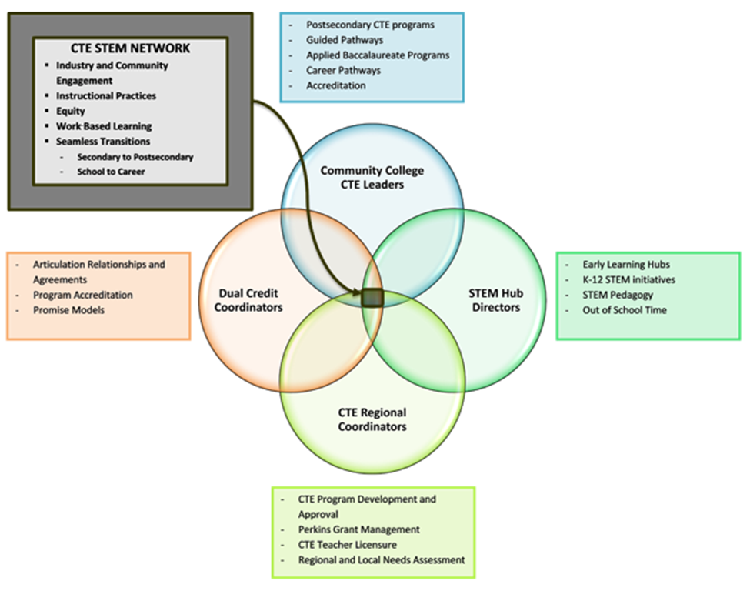

2020-2021 CTE and STEM Leadership Groups
There are four subgroups of the CTE STEM Network, plus a Network Planning Committee. Below is the 2020-2021 structure of those leadership groups.
 | Network Planning Committee | CC CTE Leaders Executive Team | STEM Leadership Team | CTE Regional Coordinator Communication Team | Dual Credit Leadership Team
Purpose | Ensure agenda encompasses all groups  Discuss network-wide issues | Plan CC CTE Leader agenda | Plan Hub Network agenda | Plan CTE RC agenda  Provide collaboration time with ODE staff | Plan Dual Credit meetings
Meetings | First Thursday  Sept, Nov, Jan*, March, May  9-11 am  *January meets on 2nd Thurs | Ad Hoc | 4th Thursday of month | Same as Network Planning  11am-2pm | Ad Hoc
Contact | Megan Helzerman | Luis Juarez | Deb Bailey | Dale Moon | Virginia Mallory

Statewide CTE Advisory Committee
The Oregon CTE State Plan (page 12) calls for the formation of a Statewide Advisory Committee, comprising students, counselors, educators, and administrators from secondary and postsecondary education institutions; workforce development; and business and industry partners. This committee will provide ongoing advice, guidance, and feedback on the strategies and corresponding progress being made throughout the implementation of the CTE State Plan and its goals.

Website
The internet has become a critical means of communication with parents and students. ODE and CCWD Career and Technical Education (CTE) websites are linked to ensure there are multiple options for those seeking information.
Postsecondary: HECC Career and Technical Education Website
Secondary: ODE Career and Technical Education Website

5 – High Quality CTE Programs of Study
For the implementation of Perkins V, extensive review of the elements that composed the Perkins IV CTE Programs of Study, as well as revisions to the CTE Program of Study approval and renewal process, have taken place and will continue to occur. Therefore, some parts of this section are under construction.

5.1 Overview
In Oregon, the CTE Program of Study is the cornerstone of CTE programming. In the Perkins V Act, the term “program of study” means a coordinated, non-duplicative sequence of academic and technical content at the secondary and postsecondary level that
- incorporates challenging state academic standards;
- addresses both academic and technical knowledge and skills, including employability skills;
- is aligned with the needs of industries in the economy of the state, region, or local area;
- progresses in specificity from a broad overview at the Cluster level, to occupation-specific instruction at the Focus Area (Pathway) level;
- has multiple entry and exit points that incorporate credentialing; and
- culminates in the attainment of a recognized postsecondary credential and/or degree.

5.2 Elements of a High Quality Program of Study
Oregon achieves the federal definition of High Quality Program of Study by requiring five core elements essential to every state approved CTE Program of Study in the state:
- Standards and Content
- Alignment and Articulation
- Accountability and Evaluation
- Student Support Services
- Professional Development

Oregon adopted a CTE Program of Study Quality Rubric built around these five core elements and aligned them to the national Association for Career and Technical Education’s (ACTE) High Quality CTE Program of Study framework. This rubric is to help local programs evaluate the health of their CTE Programs. Throughout the 2020-2021 school year, action teams will be meeting to develop processes to ensure CTE Programs of Study have a clear process to engage in continuous improvement.
For CTE administrators, it is important to understand the elements of high quality CTE Programs to help ensure that an institution’s CTE is meeting the needs of students as well as those of business and industry. Below is a high-level overview of the five core elements of a High Quality CTE Program of Study.
- Standards and Content
  - Rigorous Integrated Content: CTE students have access to rigorous core academic coursework relevant to their career interests and the opportunity to apply academic, technical, and professional skills in both CTE courses and academic courses.
  - Engaged Learning: Learning is centered on the student’s interests, strengths, and needed areas of growth. Engaged learning involves opportunities to engage in meaningful projects connected to the community and is supported by the school, college, and community. Assessment of learning addresses industry-based standards and provides feedback to students and instructors that drives program improvement.

- Alignment and Articulation
  - Partnerships: Formalized agreements exist with partners, including secondary and postsecondary education institutions, business and industry, and workforce development, around program development, design, implementation, and evaluation.
  - Credentials: CTE Program completers can participate in work-based learning opportunities and earn industry recognized credentials, certificates, and degrees that increase their employability and ability to advance in their career of choice.
  - Facilities and Equipment: CTE Programs maintain equipment that meets industry standards, and facilities follow safety and cleanliness standards of the industry and create a safe, welcoming, and accessible environment so all students may participate.

- Accountability and Evaluation
  - Continuous Improvement: Schools and institutions that have participating CTE Programs collect and submit CTE data to the state. These data points are frequently used to inform instruction. Programs are continually revised based on employer demand and industry needs, as well as student participation and performance.

- Student Support Services
  - Career Development: There is a coordinated and sequenced career development system to support students before, during, and after participation in the CTE Program. Each CTE student has a personalized career and education plan, and parents and CTE students are informed of opportunities for CTE education and training in high school, college, apprenticeships, and other opportunities.
  - Education for Employability: Students develop employability skills through classroom and course aligned work-based learning opportunities. Students actively develop leadership skills through student leadership opportunities (e.g., Career and Technical Student Organizations, or CTSOs) tied to the CTE Program.
  - Access and Equity: CTE Programs are a central part of the school’s equity strategy, and demographics in CTE mirror school demographics and positively impact local industry representation of underrepresented groups. CTE student outcomes contribute to the elimination of opportunity gaps and institutional discrimination.

- CTE Professional Development: Each CTE educator has a professional development plan in place. The plan is developed with input from industry and community partners and includes goals, plans, and participation clearly aligned to documented CTE Program goals. Any professional development plan adjustments reflect the continuous improvement design of the CTE Program of Study.

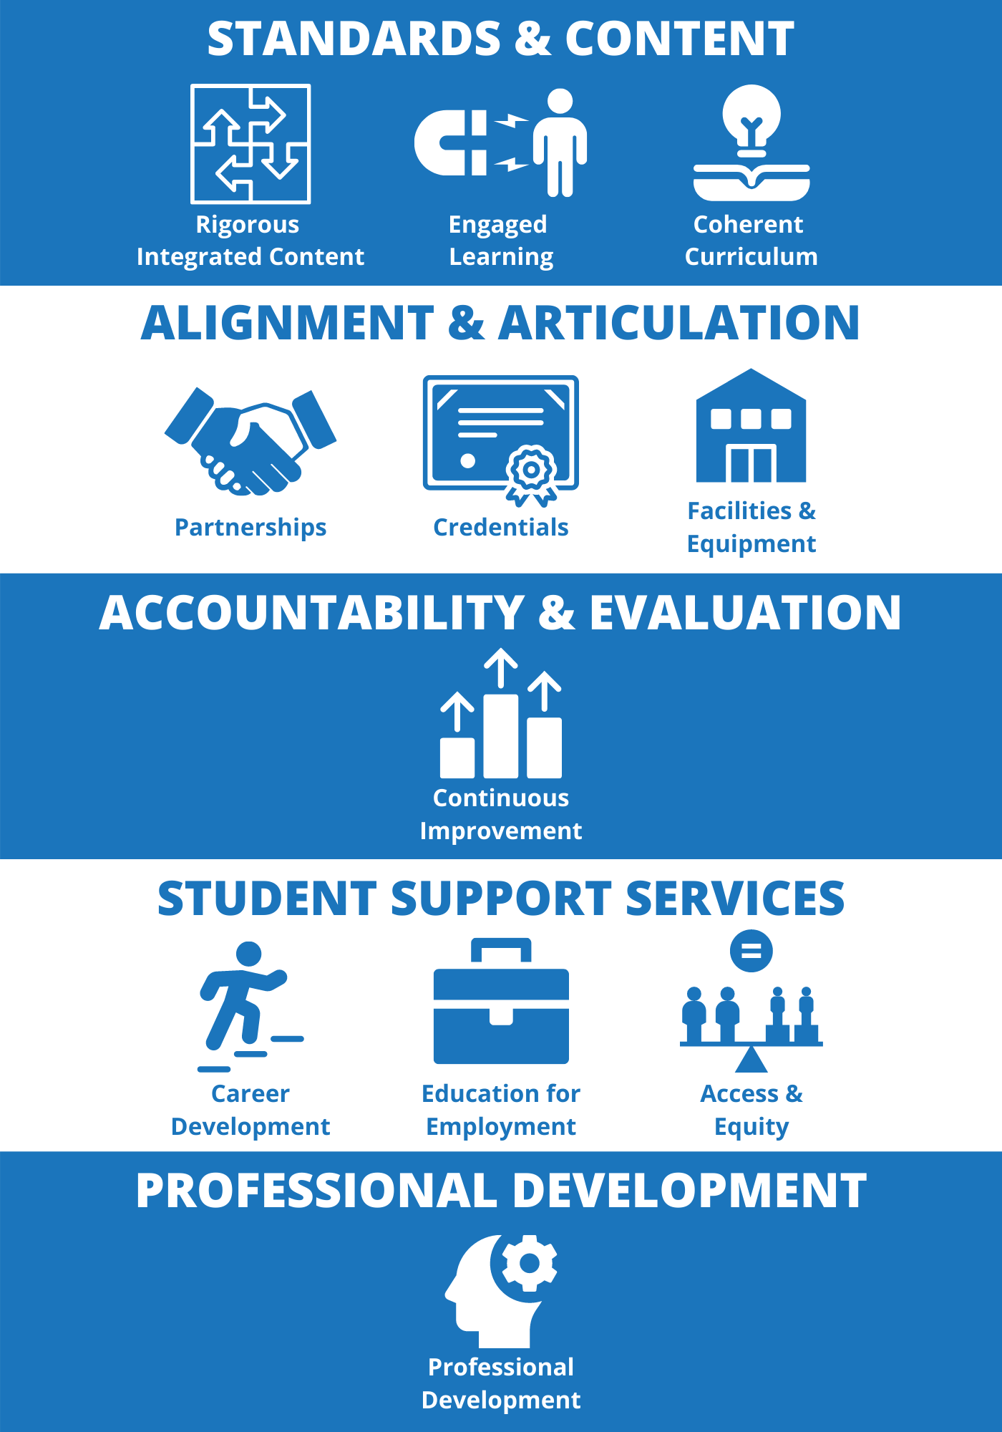
Oregon's 5 Core Elements for CTE POS: Aligned with ACTE's POS Framework

Oregon’s 5 Elements of a CTE Program of Study, and how those Elements align with the national Association for Career and Technical Education’s (ACTE) High Quality CTE Framework

5.3 Continuum of CTE Programs
There is a continuum of CTE programming in Oregon, representing a progression in commitment and intensity. The development of a CTE Program of Study—which generally moves beyond an exploratory program—starts with a community need. Once the decision is made to move beyond random electives, educators and employers come together to design a program to meet that community need. CTE Programs of Study are not something that can be put together quickly. They build and evolve over time, continuously meeting more and more attributes of the High Quality CTE Program of Study. Typically, the progression looks like the following:
- Exploring Interests and Careers
This could be described as a loose collection of interest-based activities and/or courses offered during class time or outside of class hours. Typically, this type of program provides interesting and engaging content for students while exploring information about career options and interests. These opportunities may integrate academic content as well. Some examples might include robotics programs, community-based clubs, maker space, introduction to careers, coding club, summer programs, etc.

- Start-Up CTE Program
This could be described as an intentional and phased-in development of a sequence of courses leading to a full CTE Program of Study. Sometimes it may take up to three years to build the start-up program into a full CTE Program of Study. Some examples might include a new course in entrepreneurship in year one that builds into a marketing program two years later, or a sequence of high school courses that does not initially connect to a college program for the postsecondary component. Perkins federal funding may be used for some of the start-up costs associated with the development of a full CTE Program of Study.

- CTE Program of Study
This could be described as a non-duplicative sequence of secondary and postsecondary courses that could lead to an industry recognized credential. These programs feature contextualized and hands-on courses, with a minimum of two high school credits in 2020-2021 which will increase to three minimum high school credits by 2024-2025. This sequence of courses is aligned to a clear business or industry need. In the CTE Program of Study, students clearly understand the career pathway and have access to career guidance and student support to ensure they receive the academic and technical skills to move to employment or next step education and training for a high-wage, high-skill, or in-demand position. Students participating in these programs will likely experience college coursework, internships, and/or work-based learning. Perkins federal funding may be used to support the additional costs associated with the CTE Program of Study.

5.4 Types of Approved CTE Programs of Study:
There are four types of approved full CTE Programs of Study in Oregon.
- Local (school based) CTE Program of Study:
  - Based on a skill set from the Oregon Skill Sets (or recognized industry skill set)
  - Meets local industry need
  - Meets all five Elements of a CTE Program of Study (including multiple opportunities for students to learn and demonstrate technical and workplace skills in applied, workplace-like experiences)
  - Culminates with the student’s opportunity to earn an industry recognized credential
  - CTE Licensure requirement for secondary teachers

- Regional CTE Program of Study:
  - Based on a skill set from the Oregon Skill Sets (or recognized industry skill set)
  - Meets regional industry need and is developed as a regional model with secondary and postsecondary partnerships
  - Meets all five Elements of a CTE Program of Study (including multiple opportunities for students to learn and demonstrate technical and workplace skills in applied, workplace-like experiences)
  - Culminates with the student’s opportunity to earn an industry recognized credential
  - CTE Licensure requirement for secondary teachers

- Statewide CTE Program of Study (Framework to be developed during 2020-2021 school year):
  - Based on a skill set from the Oregon Skill Sets (or recognized industry skill set)
  - Design follows the Statewide CTE POS framework
  - Developed by a statewide advisory group of industry and workforce development partners, including community college partners
  - Meets all five Elements of a CTE POS (including multiple opportunities for students to learn and demonstrate technical and workplace skills in applied, workplace-like experiences)
  - Culminates with the student’s opportunity to earn an industry recognized credential
  - CTE Licensure requirement for secondary teachers

- Virtual CTE Program of Study (Framework to be developed during 2020-2021 school year):
  - 75% or more of students are not residents of virtual school district attendance area
  - Based on a skill set from the Oregon Skill Sets (or recognized industry skill set)
  - Design follows the CTE POS framework
  - Developed by a statewide advisory group of industry and workforce development partners, including community college partners
  - Meets all five Elements of a CTE POS (including multiple opportunities for students to learn and demonstrate technical and workplace skills in applied, workplace-like experiences)
  - Culminates with the student’s opportunity to earn an industry recognized credential
  - CTE Licensure requirement for secondary teachers
  - ODE provides support to these programs rather than a CTE Regional Coordinator

5.5 Size, Scope, and Quality
Size, Scope, and Quality is a new set of terms being used with Perkins V implementation. These terms are used to measure the overall ability of the CTE Program of Study to address all the standards of its identified skill set and to intentionally prepare the student for his/her next step on a complete and robust career pathway, whatever that next step may be.

The Size, Scope, and Quality definitions create the foundation for a CTE Program of Study. When seeking program approval, the evidence for Program Size, Scope, and Quality listed below will be used jointly by secondary and postsecondary institutions to demonstrate that the CTE Program of Study has the fundamental pieces in place. More on Size, Scope, and Quality can be found in Appendix J of the Oregon CTE State Plan.
 | Evidence | Benchmark
Size | Credits | Secondary component has a minimum of two credits and aligns to a community college certificate or degree that is at least 36 credits.  (NOTE: By 2024-2025, the number of required credits for the secondary component may increase to three.)
 | Current and Relevant Technology | The full CTE Program of Study is a Level 3 or higher on Facilities and Equipment in the CTE Program of Study Quality Rubric.
 | Current and Relevant Curriculum | The full CTE Program of Study is a Level 3 or higher on Coherent Curriculum in the CTE Program Quality Rubric. Postsecondary may use the accreditation equivalent as evidence.
 | Qualified Staff | The full CTE program includes an appropriately licensed secondary teacher and a postsecondary instructor who meets institution requirements.
Scope | Depth of Program | The CTE program includes a sequence of courses that progress from introductory to advanced content, providing students with the opportunity to become secondary and/or postsecondary concentrators.
 | Breadth of Program | The CTE program is built on industry-based technical, academic, and workplace skills, such as the Oregon Skill Sets.  The CTE program is in a partnership between secondary and postsecondary that includes at least one community college and one high school.
Quality | Based on Community Need | CTE program goals and professional development are linked to local and regional needs assessments that include labor market information and the voice of historically and currently underserved populations within the community.
 | Informed by Data | The CTE program uses disaggregated data to inform continuous improvement, including a focus on student retention and completion, particularly for special populations.
 | Student Engagement | Secondary and postsecondary components are at Level 3 or higher on Engaged Learning in the CTE Program of Study Quality Rubric. Students are provided the opportunity to participate in Career and Technical Student Organizations. Postsecondary may use the accreditation equivalent as evidence.
 | Career Development | Level 3 for Career Development in the CTE Program of Study Quality Rubric. Students are actively encouraged to use career services and academic advising at the postsecondary institution.
Illustration 5.5: Evidence of CTE Program Size, Scope, and Quality.

5.6 CTE Program Quality
While much is changing in the program application process, program quality is still the cornerstone for CTE. Oregon has adopted the Advance CTE Program Evaluation and Intervention Guide to assist the state, CTE Regional Coordinators, and local CTE Programs of Study.

Approved Program

Changing Context

Technical Assistance

Program Transformation

Program Phase Out
ACTE cycle of program review, improvement, transformation, and closure. [Adapted from page 2 of the Guide.]

The Guide provides an opportunity to determine if CTE programs are high quality and aligned with the labor market demand. There are several options once the determination is made:
- Improve CTE Program Quality Through Technical Assistance
Assuming the CTE program is still aligned to labor market needs, CTE program quality will require examination to determine the cause of poor learner outcomes. Following the examination, a specific action plan should be developed which includes the specific improvements to be made, actionable targets, and needed supports. The plan should then be regularly monitored.

- Transform CTE Program to Gain Relevance
The relevance of the CTE program may evolve over time. This can be due to changes in the labor market or declining interest and lack of student enrollment. CTE program transformation is hard work and takes commitment on the part of local administration and industry. Again, an action plan would be used for the transformation.

- Phase out CTE Programs that are Low Quality and No Longer Relevant
CTE Programs of Study, by definition, are highly responsive and able to adjust to student interest, industry demand, and community desires. Some CTE programs, as part of their natural life cycle, may need to close. CTE program closure decisions may be made locally, or in consultation with the ODE/HECC staff, during the CTE Program Renewal process. When such a decision is made, there must be a high level of sensitivity to the staff, the students currently enrolled, and the connected industry. When preparing to phase out a CTE program, please work closely with your CTE Regional Coordinator and state agency staff to gain the necessary buy-in and support for the closure.
There are specific administrative steps that must be taken regarding any Perkins funded CTE programs that are closed. This guidance is in the fiscal section.

5.7 CTE Program Development and Approval
Beginning with the 2020-2021 school year, the CTE program development and approval process will be completely redesigned to meet the new Perkins V requirements and to update the systems that have served well over the past decade but need to become more automated.

New CTE Program of Study Database Development - Secondary
The new CTE Program of Study Database has been in the design and development process for the past several years and is nearing completion. At the time of publication of this Guidebook, the following timeline is provided:
- BETA testing begins January 2021 – local data submitters will be included in BETA testing
- BETA testing concludes Spring 2021
- Database goes live Fall 2021
See Section 15 of this Guidebook for more information on data submission and reporting.

Statewide CTE Program of Study Framework Development Process
Beginning in the 2020-2021 school year, a contractor will be hired to develop frameworks that will be used to develop all Statewide CTE Programs of Study. The contractor will focus on developing a framework to be used for those participating in a Statewide CTE Program of Study, but the process designed will also be available for all local, regional, and virtual programs (described in section 5.4 above) seeking approval. At the time of publication, the contractor has not been selected, but the following phases are planned:

Phase One:
Engagement with business and industry for revision and validation of four of the 17 Oregon Skill Sets. Initially, four clusters will be updated during 2020-2021 and will continue in the cycle identified in the chart below.
Phase Two:
Engagement with those business and industry partners on a team with community college instructors, other postsecondary trainers, CTE Regional Coordinators, and secondary teachers to create CTE Program of Study templates to be used in designing statewide CTE programs for each of those four clusters.

Phase Three:
ODE, CCWD, CTE Regional Coordinators, and others will work with CTE Programs in the Clusters to design or redesign their CTE Programs to meet the new CTE Program requirements, bringing all CTE Programs across the state into alignment.
Phase Four:
Submission of the CTE Programs of Study applications through the new online database.
Phase Five:
Engagement with the High Quality CTE Program of Study Rubric and the Advance CTE Program Evaluation and Intervention Guide to continuously improve and evolve CTE Programs of Study to meet identified business and community needs along with program effectiveness indicators.

Individual CTE Program Development and Application
Any CTE Program may participate in the Statewide CTE Program of Study Model, but local, regional, and virtual CTE Programs of Study may instead choose to participate in a more individual program design. For these programs, the CTE Program of Study application will be submitted through the new online database. The process for individual program development will be designed during the 2020-2021 school year.

CTE Program Development and Approval Cycle
All CTE Programs of Study will be on the same program development and approval cycle based on Career Cluster. Therefore, all current CTE Programs will remain approved until their Career Cluster goes through the new development and approval process. There will be no CTE Program renewal during the 2020-2021 or 2021-2022 school years.

Beginning Fall 2021
Career Clusters | New Expiration Date | CTE Program Development Process | Application Due | Begin Newly Approved CTE Program of Study
- Architecture & Construction  - Business, management & administration  - Information & Communications  - Manufacturing | June 2022 | 2021-2022 | June 2022 | Fall 2022
During the 2021-2022 school year, regardless of previous renewal dates, all CTE Programs of Study in the four Career Clusters listed above will either submit a new Statewide CTE Program of Study application using the new templates, or a local renewal application using the new online application process. The process will be complete, and applications submitted, in June 2022.

Beginning Fall 2022
Career Clusters | New Expiration Date | CTE Program Development Process | Application Due | Begin Newly Approved CTE Program of Study
- Automotive & Heavy Equipment  Possible transportion, aviation & aeronautics  - Education  - Law, Public safety & security  - Natural Resource Systems | June 2023 | 2022-2023 | June 2023 | Fall 2023
During the 2022-2023 school year, regardless of previous renewal dates, all CTE Programs of Study in the four Career Clusters listed above will either submit a new Statewide CTE Program of Study application using the new templates, or a local renewal application using the new online application process. The process will be complete, and applications submitted, in June 2023.

Beginning Fall 2023
Career Clusters | New Expiration Date | CTE Program Development Process | Application Due | Begin Newly Approved CTE Program of Study
- Hospitality, Tourism & Culinary  - Arts, A/V & Communications  - Marketing  - engineering technology | June 2024 | 2023-2024 | June 2024 | Fall 2024
During the 2023-2024 school year, regardless of previous renewal dates, all CTE Programs of Study in the four Career Clusters listed above will either submit a new Statewide CTE Program of Study application using the new templates, or a local renewal application using the new online application process. The process will be complete, and applications submitted, in June 2024.

Beginning Fall 2024
Career Clusters | New Expiration Date | CTE Program Development Process | Application Due | Begin Newly Approved CTE Program of Study
- Human Services  - Government & Public Administration  - Finance  - Health & Biomedical sciences  - agriculture & food systems | June 2025 | 2024-2025 | June 2025 | Fall 2025
During the 2024-2025 school year, regardless of previous renewal dates, all CTE Programs of Study in the five Career Clusters listed above will either submit a new Statewide CTE Program of Study application using the new templates, or a local renewal application using the new online application process. The process will be complete, and applications submitted, in June 2025.

New CTE Program Development
Section 5.3 described a Start-Up CTE Program. During the 2020-2021 school year, schools or institutions wishing to begin development of a CTE Program of Study should use the Start-Up CTE process. The first step is to contact the CTE Regional Coordinator in the region to begin developing program readiness.
The Start-Up application will be used for most new CTE Programs beginning in the 2020-2021 school year. After the three-page application is submitted, the CTE Program will be entered into the existing data system, which may trigger eligibility for Perkins fund support (subject to local/regional policies) as well as involvement in student leadership organizations described in Section 6. Students accumulating credits may also expedite program eligibility for Secondary Career Pathway funding.

5.8 CTE During the COVID-Impacted School Year
During the COVID-impacted school year, we anticipate some exceedingly difficult decisions regarding CTE offerings in schools and colleges. While some CTE Programs of Study may continue to be offered, some may be scaled back, while others may be put on hold or eliminated completely. This section provides guidance on handling CTE Program changes during the 2020-2021 school year.

CTE Program of Study | Dormant  CTE Program of Study | Closed  CTE Program of Study
Courses designed to meet full skill set – some or all those courses continue to be offereds  Licensed CTE Instructor  Program update used to reflect current offerings  Data collected | No plan at this time to offer a previously approved CTE Program of Study  AND  Plan to re-establish CTE Program | No plan to offer or re-establish previously approved CTE Program of Study
Continue established Perkins benefits and requirements | Follow CTE Program Dormancy Guidance Below | Follow CTE Program Closure Guidance Below

CTE Program Dormancy
As described above, dormancy refers to a situation where a CTE Program was previously approved as a CTE Program of Study, but a decision has been made to stop offering the CTE Program at the present time, although no decision has been made to permanently shutter the CTE Program. There are many reasons a school or college may decide to stop offering a CTE Program, including the following:
- Inability to offer courses as planned in a particular semester
- Inability to decide about future offerings at the present time
- Loss of a licensed instructor
- Decision to use outside vendor to offer CTE-like courses but content not matched to the skill set

When discussions occur regarding CTE Program dormancy, the following guidance is offered:
Teaching Skill Set for Approved CTE Program | Not required to teach skill set
CTSO | Not required – important to check with state organization for student opportunities to continue
Licensed Teacher | Not required to have CTE licensed instructor for secondary CTE Program
CTE Program Update | No CTE Program Update (secondary) – data from prior year will remain in the ODE database
Perkins Data Submission | No Perkins data submission for secondary or postsecondary*
Use of Perkins Funds | Available for Perkins approved professional development and career exploration activities
Perkins Inventory | Controls in place to prevent loss – annual inventory required
Career Pathway Funding | Not eligible (secondary)
* Subject to change

In the event a decision is made for a secondary or postsecondary CTE Program to enter dormancy, ODE must be notified as soon as possible, but not later than the third week of the current grading term, using the Dormant CTE Program Notification. Direct grant recipients will directly notify ODE. Consortia members must work with the CTE Regional Coordinator when considering CTE Program dormancy, and the CTE Regional Coordinator will provide the notification. Additional guidance is available regarding postsecondary CTE Program closure in the Community College Handbook.

5.9 CTE Program Closure Guidance
During these difficult times, schools and colleges may decide to permanently discontinue CTE Programs of Study. The staff at ODE and HECC should be included as partners in discussions around the CTE Program of Study closure as they may have ideas to assist with the decision making. Program closure is a serious step, with difficult impacts on student learning opportunities, and should be carefully considered. Partners that should be included in this decision include secondary and postsecondary instructors, CTE Regional Coordinators, administrators, business and industry partners, advisory committees, parents, students, and CTSOs.
Program closure will also impact financial resources available. For example, the Perkins Basic and Reserve Grant—and in secondary schools, CTSO Chapter Grants, Secondary Career Pathways funding, and other sources—will not be available for programming.
Program closure should not be used as a temporary step— it should be considered permanent. Occasionally, after a program has closed, the economic circumstances or industry needs will change and a new program may need to be started. To start a program similar to the program that had been closed, the institution will need to begin the application process from scratch, by considering needs identified in the Perkins required local and/or regional needs assessment, and determining readiness. It may take two to three years to gain approval as a CTE Program of Study.
In the event CTE Programs of Study are closed, the following must take place.

Perkins Eligible Recipient:
The Perkins Act requires any eligible recipient to have at least one CTE Program of Study to receive any Perkins funding. If a school reduces their staffing and/or CTE Program offerings to the point where it no longer meets the definition of an Oregon approved CTE Program of Study, the institution is no longer eligible to receive any Perkins allocation. (Perkins Act Section 134)

Perkins Eligible Investments:
In Oregon, the State Perkins Plan requires that Perkins funds may be invested only in an approved CTE Program of Study. By definition, a CTE Program of Study involves a partnership between an Oregon public high school and an Oregon public community college. If this partnership is dissolved due to one entity no longer offering the sequence of courses to complete the CTE Program of Study, then Perkins funds can no longer be used to fund any part of the CTE Program. (Perkins Act Sec 122(c))

It is understood that staffing and course offerings are still under consideration into the early fall. At this time, Perkins recipients are encouraged to plan their Perkins grant activities and budgets with the best information available. As always, if school opens and the scope of the CTE Program changes, the budget and plan must be changed to reflect the actual activities and investments. (EDGAR 80.30)

Notification:
The following guidance should be used when a CTE Program is being eliminated and will no longer qualify as an approved CTE Program of Study.

Notification of Partners:
If a CTE Program is eliminated at the secondary or postsecondary level, the approved CTE Program of Study dissolves and is no longer eligible for Perkins funding. When this happens, it is crucial to notify partners in the CTE Program of Study immediately. As a courtesy, notification should take place when the reduction is being seriously considered, and then immediately following the decision to eliminate the CTE Program(s). This allows the partners to make alternative plans for staffing and course offerings.

Notification of CTE Regional Coordinator:
Please follow the guidance above to notify the CTE Regional Coordinator of impending CTE Program closure. Regional Coordinators may be able to assist with advocacy issues.

Notification of Oregon Department of Education (ODE):
ODE is the state agency responsible for the Perkins grant and reporting, and it is therefore crucial to maintain contact with ODE during this time. Please provide a written notification to ODE when a CTE Program is reduced and no longer qualifies as a Perkins CTE Program of Study.

Distribution of Assets:

Definition of Asset:
Assets purchased with Carl D. Perkins funds are under the control and responsibility of the fiscal agent that purchased those assets and can be used only for the intents and purposes of the Act. In the case of a consortium acting as fiscal agent for a group of schools, the consortium fiscal agents have the management, decision making, and property control responsibility for purchases made on behalf of any component school or institution.
As referenced in this CTE Program of Study closure guidance, assets are defined as any item (equipment, supplies, inventory, etc.) purchased with Carl D. Perkins funds that has an initial usefulness of greater than a single year and an initial cost of more than $200.

According to the Oregon Accounting Manual, capital assets are all tangible or intangible property used in an agency’s operations that have initial estimated useful lives beyond a single year and have an initial cost of at least $5,000. Non-capital assets are all tangible and intangible property used in agency operations that have initial estimated useful lives beyond a single year and have an initial cost of less than $5,000. (OAM 10.50.00PR)

Prior guidance from the Oregon Department of Education further defined assets to include all tangible and intangible property used in agency operations that have initial estimated useful lives beyond a single year and have an initial cost of more than $200.

Use of Assets and Distribution:
Assets shall be used in the CTE Program for which they were acquired as long as needed, whether or not the CTE Program continues to be supported by Federal funds. When no longer needed for the original CTE Program, the asset may be used in other activities currently or previously supported by Carl D. Perkins funds or other Federal funds. (EDGAR 80.32 (c)(1))

Direct Grant Recipients:
If the CTE Program of Study no longer meets the CTE Program of Study level but continues as a State Recognized or Elective CTE Program, the assets could remain in use by that program. If the CTE Program dissolves entirely, the assets could be relocated to another current or previously funded federal program for use. Examples may include other Perkins Programs of Study, 21st Century Community Learning Centers, ESEA programs, or Charter School Program Grant recipients.

Consortium:
In a consortium, the asset is under the control and responsibility of the consortium fiscal agent. Therefore, the consortium project manager must determine if the asset can be used in other approved CTE Programs of Study within the consortium. This means the asset may be relocated to another school or district. If no approved CTE Program of Study needs the asset, the consortium may shift the use to other past or current federally funded programs. The consortium fiscal department should have a policy in place to regulate this distribution process.

Management of Assets:
Regardless of the status of CTE Programs, the fiscal agent must have property management policies in place. At a minimum, until disposition takes place, a fiscal agent is required to meet the following requirements:
- Maintain a property record including description, serial number, funding source, acquisition date, cost of asset, location, use, and condition—and any ultimate disposition data, including date and method of disposal
- Maintain a physical inventory that is reconciled with the property record at least once every two years
- Maintain a control system to ensure safeguards to prevent loss, damage, or theft. Any loss, damage, or theft shall be investigated, and records of investigation kept with property record.
- Maintain property in good condition
- If the asset is sold, records of proper sales procedures must be maintained. Contact ODE staff for guidance. (EDGAR 80.32(d))

Recordkeeping
Federal grant programs require that all financial records, including inventory records, be maintained for three years from the starting date specified in the grant award letter. (EDGAR 80.42(b)) Additionally, the Department of Administrative Services requires financial records be kept for a minimum of seven years. Therefore, it is recommended that records be retained for seven years from the initial award date.

Data Submission
Data will need to be submitted for the final year of CTE Program of Study operation. Additionally, data submission is required if the CTE Program moves to State Recognized CTE status.

Secondary Teacher Licensure
When CTE Programs close, teacher licensure can be impacted. The Restricted CTE teaching license is issued to a teacher and the co-applicant district; it is connected to a specific CTE Program within a specific school district. If the CTE Program is cut, and the teacher moves to a new district with an approved CTE Program in the appropriate career area, the new district may become a co-applicant with the teacher to continue with that Restricted CTE license. A teacher is eligible for annual renewal of the Restricted CTE license with completion of the Professional Development Plan (PDP) requirements. The teacher may continue with the remaining three-year requirements of the PDP, working toward a Preliminary CTE license; ODE may provide verification of completion for purposes of the renewal if the former employing district is unable to do so. In addition to completing other requirements of the PDP for a Preliminary CTE license application, the applicant needs to have only one year or the equivalent of teaching in an approved CTE Program. (OAR 584-042-0031; OAR 584-042-0090) The Preliminary CTE and CTE Professional licenses are not tied to a specific district CTE Program. Therefore, a teacher may fill a position in any district teaching in an appropriate CTE Program for the license. (OAR 584-042-0036)

6 - Student Support Services

6.1 Career Connected Learning Overview
Oregon defines the stages of career development through a continuum of Career Connected Learning—a framework of career awareness, exploration, preparation, and training that is both learner-relevant and directly linked to professional and industry-based expectations.
Awareness (learning about work) - job shadows, career fairs, classroom speakers, and interactions with industry, business, and community partners at networking and introductory levels with low frequency of interpersonal contact which may or may not align with student interests.
Exploratory (learning about types of work) - informational interviews, career focus investigation (e.g., culinary health inspector, chef, food prep), and interest surveys. Interactions with industry, business, and community partners are focused on personalized connection to student interests. Students take an active role in selecting and shaping the experience.
Preparation (learning through work) - student-run enterprise with partner involvement, internships connected to curriculum, work experience, and project-based learning through virtual exchange. Interactions with business, industry, and community partners should provide (develop) transferable experiences to support academic, technical, and professional outcomes for student and partner.
Training (learning for work) - internship, clinical practicum, on-the-job training, and registered pre-apprenticeship/apprenticeship programs. Interactions with business, industry, and community partners are extended over a period of time. Benefits for the student include not only educational credits and credentials but also initial mastery of skills, potential entry into workforce, and other intrinsic values (e.g., union membership, health/medical benefits, mobility, stability, and livable wages).

6.2 Career Exploration in CTE – Emerging Work
Career Exploration is specifically called out in the Oregon CTE State Plan in order to further the opportunities for all students to have improved information about the career opportunities available in the state and to expand the opportunities for learners to see themselves in a variety of career fields, including ones that may be unfamiliar. The career exploration system across Oregon’s K-12 landscape may be best described as a hodgepodge of programs, policies, and practices that lack alignment across levels and often fail in preparing students for the critical transition from one schooling level to the next. Therefore, the goals in the CTE State Plan will be a heavy lift, representing work to develop a cohesive system of support for students in career exploration that will be ongoing across the next four years.

The goals in the State Plan include
- allowing Perkins funds to be spent in middle school so that learners can experience careers earlier by participating in activities linked to Career and Technical Education (CTE) Programs of Study.
- developing systems and support for Oregon learners, counselors, advisors, employers, and others to support career education through career connected learning.
- building a scope and sequence for career exploration and development, supporting implementation of the scope and sequence by regional and local entities, mapping resources and assets, and integrating the scope and sequence with comprehensive counseling programs and community college guided pathways.
- providing K-12, postsecondary, and adult learners with systems of support and professional learning about career opportunities and the paths for entering those careers in Oregon.
- providing work-based learning opportunities for educators and students to support seamless transitions and career connected learning across the learning spectrum, from middle school through career.
- working with Adult Basic Skills providers to strengthen the connections to CTE.

6.3 Work-Based Learning
During the 2020-2021 school year, the Perkins Action team, in collaboration with partners in the field, will develop a Work-Based Learning Handbook to be housed on the internet. When that is accomplished, the Handbook will be linked in this Guidebook.
Work-based learning is a focal point of Perkins V legislation and receives widespread mention in the Oregon CTE State Plan. Work-based learning is a strategy in reaching goals on equity and access, career exploration, and High Quality CTE Programs of Study, and helps educators and counselors better understand the opportunities available in the workplace. Additionally, Oregon chose to measure and report the implementation of work-based learning in secondary schools as one of the state’s federal quality performance measures. Work-based learning is an important part of reaching Oregon’s vision and preparing students for meaningful careers and life-long learning.

Work-Based Learning Definition
Work-based learning is defined as structured learning in the workplace or simulated work environment that provides opportunities for sustained interactions with industry or community professions. This interaction fosters in-depth, first-hand experience of the expectation and application of knowledge and skills that are required in a career field.

There are four criteria to meet the above definition:
- Interaction with the industry/business must be sustained.
- Credit is earned or outcomes are verified to ensure student learning outcomes are achieved.
- Experience is aligned with curriculum and instruction for the Program of Study.
- Experience takes place in the actual workplace, simulated workplace, lab, or other site.
Examples of work-based learning include (but are not limited to):
Clinical/Practicum/Internship
A structured work experience involving specific occupational skills and development goals, the awarding of school credit/outcome verification, and the expectation that the student will demonstrate the skills necessary for entry-level employment and have the knowledge to make informed decisions about next steps in training or employee advancement.

Service-Learning
Structured, sustained learning experiences in organized community service projects that meet actual community needs while also being linked to classroom learning outcomes and career related knowledge and skills through a cycle of service and reflection. Students design service-learning projects collaboratively with community partners.

School-Based Enterprise Experience (SBE)
Hands-on and virtual learning laboratories that provide practical learning experiences to reinforce classroom instruction. SBEs are managed and operated by students as simulated work experiences. SBEs can take place in or out of school and must align with labor market demand and/or have business and industry mentorship.

Workplace Simulation/Technology-Based Learning
Hands-on and virtual learning laboratories that provide practical learning experiences to reinforce classroom instruction. Opportunities are provided to participate in a variety of real-world, worksite activities and engage with business and industry to assist in understanding what it’s like to work in a business. These experiences use a variety of technological tools and can take place in or out of school; they must align with labor market demand and have business and industry mentorship.

Cooperative Work Experience (CWE)
A cooperative work experience can be offered at a secondary or postsecondary level that combines classroom studies with work-related experiences, mostly for those who are enrolled in CTE Programs and are a part of a transfer program (postsecondary only). Most community college CTE Programs (including some Career Pathways and transfer programs) include CWE credit requirements so that students can expand their knowledge of, and experience in, an industry while earning college credit.

Perkins Program Quality Indicator: Participation in Work-Based Learning
Oregon adopted work-based learning as the Program Quality Indicator for Perkins accountability. Beginning with the 2020-2021 school year, student participation in work-based learning experiences must be measured and reported in the Perkins Consolidated Annual Report (CAR). The measurement and collection processes are discussed in the data and accountability section of this Guidebook.
For the 2020-2021 school year, efforts at the state and local level will be made to ensure CTE Regional Coordinators, school personnel, and employers design effective experiences for students.

6.4 Flexible Learning – Emerging Work
Often, the two terms–flexible learning and personalized learning–are used interchangeably.
In Oregon, flexible learning tends to deal with the system and structures used to deliver learning. Flexible learning refers to the ability to customize pace, place, and mode of learning. Some examples include credit for prior learning, proficiency-based credit, competency-based education, and accelerated learning programs. Flexible learning often deals with reimagining policy and removing barriers for students to access learning from wherever they may be.
Personalized learning refers to customized learning for each student’s strengths, needs, skills, and interests. Typically, students will have a learning plan based on prior knowledge and learning style. Personalized learning represents varied instructional strategies that attend to pace and manner of learning.
The Oregon CTE State Plan focuses on providing the best opportunities for all students to access high- quality CTE programming, however and wherever it best meets their needs. There are three goals focusing on the development of a cohesive system of flexible learning for Oregon’s students:
- incentivizing innovative approaches to creating multiple on-ramps and off-ramps to CTE Programs in Perkins Reserve Fund Grants provided regionally
- supporting at the state level creation of online CTE Programs of Study in collaboration with Oregon virtual charter schools, rural schools, and others as appropriate while ensuring high quality to broaden opportunities for students to participate in and benefit from CTE
- supporting and sharing practices such as competency-based education, credit for prior learning, and accelerated learning

6.5 Career Technical Student Organizations (CTSOs) – Student Leadership
Student leadership opportunities are one of the 12 components of a High Quality CTE Program of Study. All CTE Programs of Study must provide student leadership opportunities for students, but for some career areas there is not a formal Career Technical Student Organization (CTSO) with which to affiliate. In Oregon, there are eight State Board recognized chartered student leadership organizations—commonly referred to as CTSOs.

To become a State Board of Education chartered CTSO, the organization must solicit approval from the Oregon State Board of Education, providing evidence that the organization meets the criteria to be recognized in the state.

Criteria for Becoming a Chartered Student Leadership Organization
- Instruction, Career Development, and Assessment
  - Integrates CTE curriculum and academics with leadership development activities and provides documented evidence of that integration
  - Engages students in a learning environment through a process that extends individual student interests beyond the traditional classroom and goes beyond a single event
  - Uses student leadership activities as holistic student learning assessments
  - Provides opportunities for students to network with other students having similar career interests beyond their local school site
  - Provides a student reward and incentive system to recognize and document student achievement related to career related learning projects and experiences, academic proficiency, and technical skill proficiency
  - Provides the context and multiple opportunities for students to address the personal learning requirements of Oregon’s Diploma requirements:
    - Education Plan and Profile
    - Extended Application
    - Career Related Learning Experiences
    - Career Related Learning Standards/Essential Skills
- Community-Based Activities
  - Provides opportunity for and documentation of active community and business partnerships
  - Demonstrates activities related to community involvement including service-learning, mentoring, internships, and structured work experiences related to the context of the leadership opportunity
- Organizational Administration/Management Framework
- Engages students in the process of planning, designing, conducting, and evaluating the success of career related activities
- Operates with a planned program of work for the school year
- Is advised and managed by an appropriately licensed professional technical education teacher
- Uses a school or organization supervised accounting system for student funds
- Maintains records of student participation that may be accessed by the state

For the purposes of getting a CTE Program approved as a CTE Program of Study without providing opportunities for students through one of the chartered CTSOs, it must be shown that the candidate program will provide student leadership opportunities that meet those same criteria.

The eight chartered CTSOs in Oregon:

Name and Weblink | Cluster | Career Areas
DECA | Marketing | Business Management & Administration, Finance,  Hospitality & Tourism, Marketing
FBLA  Educators Rising | Business Management & Administration | Business Management & Administration, Finance,  Information Technology (10 Career Clusters Total)
FCCLA | Human Services | Education & Training, Hospitality & Tourism, Human Services
FFA | Agriculture | Agriculture, Food, & Natural Resources
FNRL | Natural Resources | Natural Resources/Forestry
HOSA | Health Sciences | Health Science
SkillsUSA | Manufacturing, Construction, Culinary | All 16 Career Clusters
TSA | Information & Communication Technology | Science, Technology, Engineering, & Mathematics (STEM)

Oregon CTE Student Leadership Foundation (OCTESLF)
The Oregon CTE Student Leadership Foundation (OCTESLF) was formed to provide cohesion and consistency to the opportunities available for students across Oregon. The foundation board comprises representatives from each of the chartered CTSOs, along with one ex-officio member each from the Oregon Department of Education (ODE) and the Higher Education Coordinating Commission (HECC).

7. Business and Community Partnerships

Stakeholder Engagement
This section of the Guidebook is scheduled for development during the 2020-2021 school year.

Advisory Committee
This section of the Guidebook is scheduled for revision during the 2020-2021 school year. The guidance below needs updating, but the information provided is valuable and should be followed.
One of the most common characteristics associated with quality programs in CTE is the strong relationships they have with their business partners. Local advisory committees are, in many cases, the most effective way to develop and strengthen such partnerships.

Local advisory committees are designed to increase the participation of the public in local CTE Programs and provide greater cooperation with the private sector by

- ensuring CTE students engage with the labor market and business/industry.
- aligning programs.
- promoting quality CTE guidance and counseling.
- preparing individuals for employment and entrepreneurship.
A CTE Program Advisory Committee is a group of individuals whose experience and abilities represent a cross section of an occupational area. The primary purpose of the CTE Program Advisory Committee is to assist educators in establishing, operating, and evaluating the CTE Programs; this serves the needs of the students, the community, and the business/industry partners and provides expertise and insight about current and future industry and technological changes.

In this ever-changing economy and workforce, students need support and guidance. CTE Programs should be tailored to meet the workforce development needs of the community and the needs and interests of the individual students. Advisory committees strengthen collaboration between those responsible for CTE Programs and the communities they serve. CTE Programs that operate without advisory committees could potentially be covering out-of-date materials, teaching students skills that are obsolete, or missing positive opportunities that could be offered to students. CTE Programs with full advisory support typically teach the most current curriculum and apply the newest technology, providing students with unique advantages in comparison to students of programs that rely only on teachers’ experience or occasional curriculum updates.

The dialogue between advisory committee members and CTE educators provides valuable real-world input into the workplace that students will enter.

Advisory committees are needed to advise
- Modify curriculum
- Update facilities/budgets/student competencies
- Purchase new instructional materials and equipment
- Adopt policies
- Suggest relevant industry professional development opportunities

Advisory committees are needed to assist
- Evaluate student skills
- Set up a scholarship program or work to identify and arrange meaningful structured learning experiences for students in the program
- Provide feedback and guidance for CTE licensure and professional development plans
- Provide career exploration and work-based learning opportunities
Advisory committees are needed to advocate
- Build improved relationships between CTE educators, business/industry partners, and the community
- Promote or market CTE Programs by talking to legislators, speaking for CTE at board meetings, writing articles for local newspapers, or obtaining media coverage for special events

Successful CTE Programs are the result of cooperative efforts by key partners and stakeholders. For an effective advisory committee, members should include representatives from relevant businesses and industries that reflect the occupations. Ideally, representation on the committee should reflect the diverse populations within a local community, including people from all genders as well as racial and ethnic minorities.

7.1 Developing an Effective Advisory Committee

Establish the Purpose
To build the membership of an advisory committee, first develop or clarify its purpose and scope. The following questions may also help define the group’s purpose and structure:
- Will the purpose of the advisory committee be to advocate for programs and increase visibility, both internally and externally?
- Will the committee serve as a working committee that can take on specific tasks to support activities, or an advisory group that can provide informed input in planning new activities or developing policies and procedures?
- What decisions can this group make?
- Who will staff the advisory committee? Are any funds available to provide such basics as refreshments at meetings? (federal Perkins funds cannot pay for refreshments)
Other criteria for membership may include diversity of opinions and experience, and a balance of cultural, racial, age, and gender representation.

Size of the Advisory Committee
Effective advisory committees are large enough to reflect the diversity of the community, yet small enough to be managed effectively. Committees with more than fifteen members can become difficult to facilitate in accomplishing committee goals. At a minimum, CTE Program Advisory Committees should have eight members.

Membership Terms of Service
Most prefer to set a time limit for CTE Program Advisory Committee member terms. This procedure promotes a continuous flow of new ideas that helps keep the committee’s advice current and relevant. The most common term of service is two to three years. Teachers are encouraged to update CTE Program Advisory Committee membership and recruit new members periodically; they should also encourage effective advisory committee members to serve consecutive terms. Organizing terms in this way offers the following advantages:
- Terms are long enough for members to become thoroughly familiar with the committee’s purpose.
- Members in the second or third year of their terms have the benefit of experience, while newly appointed members add fresh perspective.
- Members are more likely to give their time freely when the term of service is predetermined.

A sample letter of invitation is provided following Section 7.7, for use when potential committee members have been identified and membership terms determined.

Getting Started
The agenda for the first meeting will be crucial in setting the tone for an effective relationship—whether the committee is new or continuing, or a new staff member is taking over the program.

The first meeting agenda might include the following:
- Welcome and remarks by the chief school administrative officer
- Introduction of members
- Purpose and role of the committee
- Basic school/institution information
- Explanation of CTE philosophy and objectives
- Selection of one or more topics/goals to be discussed at the next meeting
- Organization of the committee
  - Select a chairperson, vice-chairperson, and secretary
  - Select time, dates, and locations for meetings
  - Determine procedures to develop bylaws
- Tour of facilities
- Adjournment

7.2 Responsibilities and Roles of Committee Members
An effective committee is one that knows in advance that something positive will occur as a result of its work. In order for something to occur, the committee must be goal-directed. One of the best ways to encourage attendance and participation is to give the committee real situations to discuss.

Committee Chairperson
The chair’s leadership is key to the success of the advisory committee. It is suggested that a member other than a school representative assume this role. The chair should possess skills and characteristics such as
- experience in business/industry in the community served;
- ability to manage meetings, plan and adhere to schedules, involve members in ongoing activities, and reach closure or consensus on issues;
- skill in oral and written communications as well as willingness to make appearances before school and community representatives;
- experience as a committee member;
- ability to delegate responsibility as well as willingness to accept responsibility for the committee’s actions;
- preparation of agendas and providing assistance to the instructor in handling details regarding meetings;
- keeping group efforts focused and all members involved in tasks;
- representing the committee at official meetings and functions; and
- following-up on committee recommendations or actions.

Secretary
This person should act as the liaison between the school and the community and maintain a close working relationship with members of the committee. The secretary may also assist the chairperson in setting the tone of the committee activities. The responsibilities of the secretary include
- keeping records of attendance of members at meetings;
- keeping a record of discussion and recommendations;
- maintaining a permanent record file of advisory committee activities;
- distributing minutes of committee meetings and copies of other committee documents to committee members, teachers, and others who may be concerned, with the assistance of the school’s staff and the use of the school facilities;
- sending copies of minutes and reminders to the chief administrative officer;
- arranging for meeting space, notifying members and guests of meeting time/location;
- providing statistical information about the school and prepare progress reports; and
- accompanying the committee chairperson to visit school personnel and explaining committee actions.

Committee Vice-Chairperson
The vice-chairperson may be elected to serve as the next chairperson following a set time as vice- chairperson. This person will work closely with the chairperson on all tasks, serve as the leader for many of the committee’s activities, and perform specific tasks assigned by the chairperson.

Teachers
One vital key to a successful program advisory committee is the teacher. This person is the promoter who will do most of the detailed work if a program advisory committee is to be successful. This person should be sensitive to points of view and suggestions from the committee and act as a liaison from committee to administration.

Committee Members
- Are active participants in the group
- Are sensitive to the views of the members
- Are able to listen critically
- Exercise good judgment and fairness
- Serve on special committees as the need arises

7.3 Committee Operations

Orientation for Advisory Committee Members
Although not required, it is recommended that new committee members be provided an orientation to their role on the advisory committee. In addition, both new and current members should have current information on the CTE Program that is offered in the school. Some recommended ways to provide the CTE Program information to the committee members are as follows:
- Interviews with CTE teachers, Regional Coordinators, Superintendent or Board Members
- Tours of CTE Program facilities
- Reviews of curriculum materials, including textbooks
- Conversations with students and/or parents

Recognition for Members of the Advisory Board
Most advisory committee members will continue to serve if their experience and talents are utilized and if their recommendations, even if not accepted and implemented, are at least seriously considered by the committee. Committee members serve without pay, but the rewards are substantial for persons who are dedicated to the welfare of their community and their educational institutions. Members can derive satisfaction from assisting young people to successfully enter the workforce by sharing their own experiences, knowledge, and abilities.

Advisory committee members deserve recognition for their participation and contributions of time, knowledge, and energy. They should be recognized by school/college officials as often as possible. Examples of ways this might be accomplished are as follows:
- Give public recognition to members at meetings and school functions, and through press releases, personal letters of appreciation, and special certificates.
- List the members on advisory committee stationery and publications.
- Record minutes to include members' significant comments, along with their names.
- Invite members to school functions and special CTE events.
- Provide members with relevant materials and publications to review for comment and request feedback.
- Take committee recommendations seriously, and listen and respond to suggestions.
- Post the names of committee members prominently within the institution.
- Provide certificates, plaques, or other mementos upon completion of members' terms.

Establishing Annual Priorities
First, decide what the committee wants to accomplish. Advisory committees are usually involved in some or all the following broad areas:
- Community Relations
- Curriculum Review and Updating
- Community Resources
- Career and Technical Student Organizations (CTSOs)
- Job Placement
- Program Review
- Staff Development
- Recruitment
These areas of advisory committee involvement are not meant to be all-inclusive, but rather are starting points for discussion to determine the overall needs of the program. Instructors and/or administrators are excellent resources to help identify the needs of the program.

The number of priorities the committee selects should be kept manageable; the committee should not take on more than it can realistically accomplish.

Program of Work/Plan(s) of Action
The overall purpose of the advisory committee is to help programs and schools improve the quality of instruction in CTE. As they develop a work program, committee members should keep two things in mind: the needs of the program and the requirements of the business community. A common process for developing a clear and concise plan of action is through the development of long-term SMART goals (Specific, Measurable, Attainable, Results Oriented, Timely).

7.4 Specifying Committee Activities
Once the committee has identified its priorities, the discussion will become more specific as the committee determines exactly what it wants to accomplish. Possible activities in each priority area include:

- Community Relations
- Curriculum Community Resource
- Career and Technical Student Organizations (CTSOs)
- Job Placement
- Program Review
- Staff Development
- Student, Board, and Staff Recruitment
- Public Relations
- Legislative Advocacy

Developing Planning Tasks
Once committee activities have been selected, steps should be identified to carry out the activities. Several factors need to be considered, including time, cost, people power, and community/school support. Some of these factors may influence how the committee carries out a given activity.

Assigning Responsibilities
Even if the entire committee will work on the project, someone needs to get the action started, keep the process moving, and keep everyone working toward the goal. Individuals assigned should have a clear understanding of what is expected.

Establishing Timelines
In addition to clearly understanding what is to be accomplished, each person assigned to a specific planning task should know when the task is to be completed. Tasks completed by the entire committee may be performed during regular committee meetings. This will necessitate the setting of future meeting dates well in advance. Tasks assigned to individual members may need to be completed prior to meetings so that a status report can be presented at the committee meeting.

Advisory Committee Self-Evaluation
Once a CTE Program Advisory Committee is up and running, it is important to understand and reflect on how the advisory committee is operating and how it is impacting the CTE Program or Program of Study. A periodic review of the CTE Program Advisory Committee can help the committee in determining
- the extent to which it is accomplishing its goals.
- the extent to which the recommendations and actions have strengthened the CTE Program.
- future direction and activities for the committee.

The review of the advisory committee can be either formal or informal. The goal of the review is to help the committee determine its overall effectiveness. The teacher and others can be a valuable resource in this review process. The committee should use such a review or evaluation to determine which activities have been successful and which activities deserve additional attention. To aid in this self-evaluation, a suggested checklist is provided later in this section. Reassessing the committee organization, activities, and goals periodically will help maintain the vitality of the committee.

7.5 CTE Program Evaluation
In addition to evaluating its own effectiveness, the advisory committee should also be evaluating the CTE Program. Objective evaluations of the CTE Program make it possible to develop evidence-based recommendations for the program being advised. CTE is intended to prepare students for work that leads to high wages and advanced skills and to meet career goals and human resources needs for today’s and tomorrow’s global high-tech economy, and serves as a link between individuals and employment. (Section 5.7 of this guide relates to High Quality Programs of Study and Program Evaluation.)

7.6 In Summary
In order for evaluation to not be an overwhelming activity—especially for newer advisory committees—committees should select a limited number of significant items for thorough evaluation rather than try to evaluate all aspects.

General suggestions include:

- Be very clear in the purpose of the advisory committee and expectations. Be sure to set up a rotation so that members know how long they are expected to be on the committee. Meet at a time and place appropriate for the committee. Select the members and then survey them for the most convenient time, or set a time and place and when recruiting and ask them if the time would work. If it does not, consider finding other potential members.

- Do not meet unless there is something to discuss. Most people willing to be on an advisory committee are busy people; this means their time should be used wisely. If only a few items need to be discussed, consider an alternative meeting method such as telephone conference call, email, mailed reports and a follow-up individual call, or individual face-to-face. Eventually, the advisory committee will understand that their time is valued, and when a meeting is called, they will know important items will be discussed.

- Keep the advisory committee at a manageable size. An overall county advisory committee might be 15-20 members, while a program advisory committee might be six to ten members. The size of the committee should be based on the knowledge needed and the representation required to reflect the community, rather than the number of people. If a committee has 12 people, but information is missing on a target group, another member who has knowledge of these needs should be added to the committee. If a team is getting too large, the use of subcommittees can be considered.

- Personality issues within the team are likely. Learn about team dynamics and the importance of the different personality types on the committee. Learn to use their strengths and how to neutralize their perceived weaknesses.

- Make the committee a working committee, not just an advisory group. Some members might be interested in being more actively involved—let them. However, make sure that 1) the assignments are short-term, 2) the assignment makes good use of their time, and 3) there are noticeable results.

- People have reasons for being on committees; identify these reasons and try to make their time personally rewarding. Also, letting them know they are appreciated goes a long way. A simple email saying thanks makes a difference. Giving them a public tribute or a certificate also shows appreciation and lets the committee know they are valued.

- Plan something fun for the committee once a year. Good food and a chance for everyone to get to know each other and network is a reliable win-win situation.

7.7 Resources for Advisory Committees

Tips to Creating an Effective Advisory Board/Committee
Determine the Objective of the Advisory Board: Advisory boards can be general in scope or targeted to specific markets, industries, or issues. They provide timely knowledge about trends and identify upcoming political, legislative, and regulatory developments.

Choose the Right People: Formation of a board/committee requires an understanding of its purpose as well as knowledge of which specific skills are being sought. In general, look for diverse skills, expertise, and experience. Members should be problem solvers who are quick studies, have strong communication skills, and are open minded.

Set Expectations: When prospective members are invited to join the advisory board, rules should be set forth about what is expected in terms of time, responsibilities, and term of office. If the advisory board/committee is going to discuss issues that include private information, members should be notified that they will be asked to sign a confidentiality agreement.

Get the Most out of Advisory Meetings: Prepare for meetings well in advance. Choose a site that is comfortable and free of distractions. Solicit input for the agenda, and distribute important information ahead of time. Run the session as any other professional meeting, and follow it with an action plan. The facilitator should know which experts to draw out and how to stimulate a dialogue. He or she should be result-oriented, as ideas without action have diminished efficacy. The minutes should be written up and circulated to top management, and should include recommendations on key issues.

Consider Alternative Feedback Methods: Getting the entire board/committee together on a regular basis may not be possible. Instead, meet or have conference calls with specific members about topics relevant to their expertise as needed.

Respect the Board's Contributions: Don't abuse or waste their time. Listen to what the board/committee says. Sometimes, a business executive is so close to an issue, that he/she can’t see the proverbial forest for the trees. This is not a corporate board, so not all of the suggestions need to be accepted. Determine if the suggestion comfortably works for the situation, then make a decision.

Keep Board/Committee Members Informed: Once they’re on board, keep members excited by giving them updates at times when their advice is not being solicited. The fact that they've agreed to be on the board/committee means they care about the project, so keeping them up-to-date will help them be of greater value to the group.

Sample Letter of Invitation to Join CTE Program Advisory Committee
[Letterhead]
[Date]

Mr. Blaise Pascal [Title]
[Affiliation]
[Address]
[City], OR 00000

Dear Mr. Pascal:

[School Name] is in the process of selecting individuals with workplace knowledge and experience to assist in improving the state-approved [CTE Program] program. We are seeking advice and assistance from key partners to keep our state-approved programs relevant.

We would like to invite you to become a member of the [CTE Program] advisory committee, which meets a minimum of two (2) times a year. The purpose of the advisory committee is to provide assistance and recommendations for the continuous improvement of career and technical education programs.

I will be contacting you in the near future to discuss this opportunity. If you have any questions or concerns, please contact me at [phone number] or [email].

Thank you for your consideration.

Sincerely,
Administrator Instructor
[School Name]
[CTE Program]

Sample Letter of Appointment to Join CTE Program Advisory Committee
[Letterhead]
[Date]

Ms. Miriam Benjamin
[Affiliation]
[Address]
[City], OR 00000

Dear Ms. Benjamin:
Thank you for your willingness to serve on our CTE Program Advisory Committee for [program name].
This letter is to inform you that your appointment to the Program Advisory Committee is effective beginning [date] and ending [date].

The [first/next] meeting of the committee will be held at [place] in [room number] on [date] at [time].

We wish to thank you for accepting this committee appointment. We appreciate your willingness to assist us in supporting career and technical education opportunities for students in our community.

Sincerely,
Administrator and/or Chair of Committee
cc: Appointee’s Supervisor
Note any enclosures and add any specific information to your school, such as parking, security, etc.

Sample Checklist to include in an
Advisory Committee Effectiveness Self-Evaluation Tool
The committee has held at least two meetings.
Percentage of committee members who attended all meetings this year:
100% 90% 80% 70% 60% 50%
The committee utilizes an up-to-date constitution and bylaws to govern its operations.
The committee elects officers on a regular systematic basis (yearly).
The committee reports formally to the appropriate administrators for the school district/institution.
The committee is officially recognized by the governing board and members are officially appointed by the board.
The committee membership is diverse in gender and ethnicity and is composed of individuals whose occupational areas include labor, supervisors, managers, and parents, and represent a broad cross-section of the students.
The committee meeting minutes are maintained as a permanent record and are distributed to the appropriate administrators and members of the advisory committee.
The agendas are prepared and distributed in advance of each meeting.
Members are notified of meetings in a timely manner.
Committee members are aware of the specific purposes of the committee and are familiar with related school policies.
Teachers and administrators attend the committee meetings regularly.
Committee members are officially recognized for their service.
Committee meetings are well attended by members.
The committee has been involved in the development and review of the program curricula.
The committee has reviewed the current program curricula to determine if it is meeting the needs of the students and the projected employment needs of business and industry.
The committee promotes and publicizes the program.
The committee develops and carries out a yearly plan of action/program of work.
The committee assesses the impact of recommendations yearly.
The committee reviews yearly outcome data from the program, including student competencies achieved, placement rates, etc.

Advisory Committee Bylaws Sample
[Program Name] Advisory Committee Bylaws
Article I: Name
The name of this advisory committee shall be [name].
Article II: Purpose
The purpose of this advisory committee shall be to advise, assist, support, and advocate for the [name of CTE Program] on matters that will strengthen instruction and expand learning opportunities for students.
Article III: Members
Section 1. Members shall be selected and appointed by the board and/or administration. The current advisory committee may suggest potential members.
Section 2. Members shall represent a cross section of the industry or occupation for which training is provided and the community served by the program. (Instructor(s) and/or administrator(s) may serve as ex-officio members of the committee.)
Section 3. Member terms will be three years, with one-third of the membership appointed each year. No member will serve consecutive terms. A former member may be reappointed after a one-year absence from the committee.
Section 4. Membership terms will begin immediately following the final meeting of the school year.
Article IV: Officers
Section 1. Officers shall be a chairperson, vice-chairperson, and secretary. These officers shall be the executive council for the advisory committee.
Section 2. The duties of the officers shall be those commonly ascribed to these offices.
Section 3. Officers shall be elected by simple majority at the final meeting of the school year and shall assume their offices immediately following the meeting. Officers may be reelected.
Article V: Meetings
Section 1. The advisory committee shall comply with the Department of Career and Technical Education program requirements for minimum number of meetings. Additional meetings shall be scheduled as necessary to accomplish the Program of Work.
Section 2. A quorum shall consist of a simple majority of appointed members.
Section 3. Decisions will commonly be made by consensus. A formal vote shall be taken when a decision is to be forwarded to the instructor or administration as a recommendation.
Article VI: Subcommittees
Section 1. Subcommittees shall be appointed by the chairperson as needed to accomplish the Program of Work.
Section 2. Subcommittees shall be of the size necessary to carry out their assigned tasks.
Section 3. Subcommittees shall elect their own chairpersons.
Article VII: Parliamentary Authority
Except as otherwise provided in its Bylaws and standing rules, the advisory committee shall be governed in its proceedings by the current edition of Robert’s Rules of Order, Newly Revised.
Article VIII: Amendment of Bylaws
These Bylaws may be amended at any meeting of the advisory committee by a two-thirds (2/3) vote, provided that the amendment has been submitted to advisory committee members in writing at least thirty (30) days in advance of the meeting.
Bylaws adopted [date]
Bylaws amended [date]

8 - Educator Recruitment, Retention, and Training
At the heart of every CTE Program are the educators. Without quality educators who build relationships with learners and support their journey through education to career, the quest to achieve improved outcomes across Oregon’s diverse student population would be severely hindered. The recruitment and support of educators, mentors, counselors, and business and industry partners is an essential element of achieving the vision for CTE. Oregon is committed to addressing the challenges of educator shortages and building a diverse educator workforce through aligning systems of educator licensure and professional development.

In the Oregon CTE State Plan, there are two main goals in this area:
- Improving the recruitment and retention of secondary and postsecondary CTE educators, including individuals in groups underrepresented in the teaching profession and those transitioning from business and industry
- Aligning systems of secondary educator licensure and initial and ongoing professional development to enhance access to business and industry experts and currently licensed teachers who want to add a CTE endorsement

Being a teacher in Oregon’s dynamic CTE classrooms is a challenging and rewarding career that requires a different skill set from that of the regular classroom. In addition to knowledge about teaching strategies, classroom management, lesson design, and the education system, CTE teachers also need to have content knowledge specific to the CTE Program area for which they serve. To that end, in order to teach in an Oregon state approved CTE Program, an instructor must have an appropriate CTE license and/or endorsement that is specific to the program career area.
Currently, all information regarding CTE Licensure can be found on the Oregon Department of Education’s CTE Teacher Licensure web page.

9 - Perkins Grant Funding Distribution

9.1 Current Year State Distribution and Allocations
The purpose of this section is to offer transparency to the Perkins federal grant state allocation and the distribution of that allocation to the sub-recipients. As specified in the Act, Perkins V Title I, funds allocated to the state are distributed among three categories:
- 85 percent of the total Oregon allocation is provided to eligible recipients through formula-based distribution called grant in aid.
  - 85% of the grant in aid is provided to local eligible recipients through Basic Grants.
  - 15% is provided to local eligible recipients through Reserve Grants.
- 10 percent of the total Oregon allocation is dedicated to state leadership activities and allocations for work with state institutions, special population recruitment, and nontraditional participation and completion.
- 5 percent of the total Oregon allocation is dedicated to state-level administration of the grant.
The funds allocated to the formula-based distribution category are split equally between secondary- and postsecondary-eligible recipients as described in the State Plan. All funds that are not used in the fiscal year awarded are recaptured and reallocated through the formula. The chart below provides a visual picture of the distribution of funds in Oregon. The current distribution and allocation information can be found on the Oregon Department of Education (ODE) website.
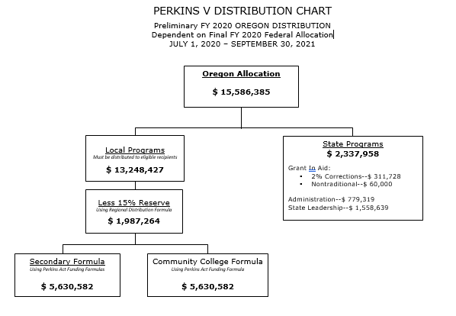

9.2 Perkins Funding Distribution for Grant in Aid
Eighty-five percent of the Perkins state allocation flows to the Oregon eligible recipients by formula distribution. The funds are considered to be grant in aid and are accessible through the Electronic Grants Management System (EGMS) on a reimbursement basis.

Secondary Formula (Sec 131)
The secondary formula is based on the most recent U.S. Census data for the population by school district of individuals aged 5-17, and those aged 5-17 in households of poverty. In the event of school district boundary changes, the formula is adjusted to accommodate the student shift.
Thirty percent of the secondary allocation is based on the following:
- District population of individuals aged 5-17, compared to
- State population of individuals aged 5-17

Seventy percent of the secondary allocation is based on the following:
- District population of individuals aged 5-17 in poverty, compared to
- State population of individuals aged 5-17 in poverty
Results for each district are multiplied by the total secondary formula amount for Oregon from the federal allocation.

Postsecondary Formula (Sec 132)
The postsecondary formula is based on the sum of the most recent number of postsecondary Pell Grant and Bureau of Indian Affairs (BIA) assistance recipients. It compares
- the total number of unduplicated Pell Grant and BIA assistance recipients in the college to
- the number of Pell Grant and BIA assistance recipients in the state.

Funding for State Institution
Two percent of the state leadership set-aside is dedicated to CTE Programming in state institutions. According to Perkins definition, this includes adult and youth corrections facilities and the Oregon School for the Deaf (OSD). More information about CTE programming in these schools is in Sections 16 and 17 of this guide.

Consortia Allocations (Sec 131 and 132)
A consortium of eligible recipients may be formed to operate joint projects that provide services to all public schools and institutions providing Career and Technical Education (CTE) and are of sufficient size, scope, and quality to be effective. The allocation to the consortia will be the sum of the allocation to each eligible recipient that is a member of the consortia. Further guidance on consortia is in Section 10 of this guide.

Perkins Reserve Allocations
As mentioned above, 15% of the grant in aid is dedicated to the Perkins Reserve Grant. Reserve grants are made at the consortium level. More information about the purpose and parameters for the Perkins Reserve Grant can be found in Section 13 of this guide. The Perkins Reserve allocation formula uses secondary and postsecondary performance data. The allocation process begins by splitting the total amount 50/50 for secondary and postsecondary components.
- Secondary uses 4-year graduation rate (Perkins IV was 4S1; Perkins V is 1S1) divided by the total secondary allocation.
- Postsecondary uses CTE certificate or degree completion divided by the total postsecondary allocation.
This provides a per student rate that is multiplied back in for each district/institution. Reserve grants are made at the consortium level.

Allocation for Charter Schools
In Oregon, all charter schools are considered public schools. While a few charter schools are sponsored by the State Board of Education, most public charter schools are sponsored by local school districts. These charter schools fall under the same formula as described above. Charter school allocations will be calculated at the school district level and will be included in the total district allocation. Charter school operators may choose to include language in the charter contract to ensure equitable distribution of these funds. See Section 17 – Charter Schools and CTE.

Allocation for Private Nonprofit Schools
Private schools are not eligible for an allocation. See Section 20 – Private Nonprofit School Participation.

9.3 State Leadership Funds (Sec 112; Sec. 124)
Perkins allows up to 10 percent of the state allotment to be used to implement the required and permissive state leadership activities described in Section 124 of the law. From the amounts set aside for state leadership, ODE, in partnership with CCWD, will do the following:
- Conduct State leadership activities to improve CTE, which shall include support for
  - preparation for nontraditional fields in current and emerging professions, programs for special populations, and other activities that expose students, including special populations, to high-skill, high-wage, and in-demand occupations;
  - individuals in State institutions, such as State correctional institutions, including juvenile justice facilities, and educational institutions that serve individuals with disabilities;
  - recruiting, preparing, or retaining CTE teachers, faculty, specialized instructional support personnel, or paraprofessionals, such as preservice, professional development, or leadership development programs; and
  - technical assistance for eligible recipients.
- Report on the effectiveness of such use of funds in achieving the goals described in the State Plan, meeting the State determined levels of performance and reducing disparities or performance gaps.

According to the Perkins law, the following three set-asides from state leadership funds must be made:
- Not less than $60,000 and not more than $150,000 of state leadership funds shall be available for services that prepare individuals for nontraditional employment.
- An amount equal to not more than 2 percent of the state allotment shall be available to serve individuals in state institutions. See Correctional Education Programs and CTE or Oregon School for the Deaf and CTE.
- An amount shall be made available for the recruitment of special populations to enroll in CTE programs, which shall not be less than the lesser of:
  - An amount equal to 0.1 percent of the total set-aside for state leadership; or
  - $50,000.
The Oregon CTE State Plan identifies eight additional priority areas for leadership funds over the 2020-2024 school years. These areas are:
- State support for implementation of action plans contained in the Oregon CTE State Plan
- Developing statewide CTE Program of Study frameworks
- Technical assistance and support for virtual charter schools to develop High Quality CTE Programs of Study
- Developing middle school career exploration and training
- Recruitment of special populations students to CTE Programs (required set-aside)
- Support for CTE Programs for individuals in youth/adult corrections facilities (required set-aside)
- Continued partnership with NAPE to support nontraditional student work (required set-aside)
- Professional learning for CTE educators to create inclusive learning environments and training programs focused on increasing diversity of CTE educators

Each spring, the State Plan Implementation Team will convene to consider proposals and determine which specific activities will be funded in order to further the efforts outlined in the state plan. Below are two projects being funded with Perkins Leadership funds.

Nontraditional Fund Use
The term “nontraditional fields” is defined in Perkins V, Section 1, to mean occupations or fields of work for which individuals from one gender constitute less than 20 percent of the individuals employed in each such occupations of field of work.
The required set-aside mentioned above to prepare students for nontraditional fields is used primarily to partner with the National Alliance for Partnerships in Equity. In past years, cohorts of educators, administrators, and counselors have been trained to implement the Program Improvement Process for Equity. That work is planned to continue. But at the time of publication of this Guidebook, the training and professional development aspect of this work has been put on pause. Instead, staff from NAPE are working with the Perkins Action Teams to examine the Oregon CTE State Plan for work that can be done to reduce barriers and ensure equitable learning environments leading to student success.

Leadership Fund Project: Virtual CTE Consortium Pilot Project
ODE has identified a need for specific CTE programming supports for virtual charter schools. The Virtual CTE Consortium is an emerging collaborative of CTE administrators from various online charter school education providers across the state. This pilot program does not include those charter schools that meet in person and reside with a consortium. In consultation with each other and ODE, these innovative partners have an interest in offering, developing, and providing CTE programming within their virtual school contexts. The Virtual CTE Consortium is being considered a “Pilot Project” in 2020, as the group works together to discuss how common needs of each unique school can be met in a synchronized manner statewide.

Criteria for funding in Year One requires that 75% of the students enrolled are from outside the home district of the charter school. Online/virtual schools with qualified CTE Programs of Study would qualify for a base allocation of $1,500 per High Quality Program of Study.

Leadership Fund Project: Career Exploration Pilot Project
The Career Exploration Pilot Project is a three-year pilot involving four CTE regions and up to 20 schools across Oregon, beginning in Fall 2020 and concluding in Summer 2023. The goal of the pilot project is to increase middle school student engagement in relevant and engaging career exploration activities that provide insight into their interests and aptitude and can be used for coursework and pathways planning toward secondary, postsecondary, and workforce opportunities.

Through the pilot project, participating schools will receive professional development on the use of career assessment tools; access to student level interest and aptitude reports for educational and workforce use; increased collaboration with business, industry, and chamber of commerce partners; professional networking opportunities; and access to a resource hub of career exploration tools.

Participating schools will be asked to 1) incorporate the use of YouScience in their Career Exploration practices and activities following the established process for implementation of the project, 2) align their current career information system/platform or develop an internal system by which it can accept and incorporate information from YouScience into career exploration activities and administrative decisions related to course offerings, and 3) collaborate across the education-workforce continuum to inform alignment and reinforce engagement of the system to support learners.

9.4 State Administration Funds (Sec. 112)
The term “administration,” when used with respect to an eligible agency, means activities necessary for the proper and efficient performance of the eligible agency’s duties and supervision of activities. Administration does not include curriculum/program development activities, personnel development, or research activities.
Not more than five percent (or $250,000, whichever is greater) of the grant is reserved for state administration, which may be used for developing the state plan, reviewing local plans, monitoring and evaluating program effectiveness, assuring compliance with federal laws, and providing technical assistance.
The funds set aside for state administration are used for salaries and materials for agency staff performing administrative duties.

10 - Perkins Grant Recipient Roles and Responsibilities
Eligible Perkins recipients in Oregon may operate as Direct Grant Recipients or participate as a member of a CTE Consortium. Direct grant recipients are a single eligible entity (e.g., school district or college) while consortia are made up of multiple districts and/or colleges that collaborate within a CTE region. There are subtle differences between the two.

10.1 Direct Grant Recipients
Perkins eligible recipients are able to act as their own fiscal agents and are referred to as direct grant recipients. Direct grant recipients are fully responsible for all aspects of the Perkins grant requirements. A statement in the Perkins legislation requires recipients with smaller allocations to be part of a consortium:
Secondary eligible recipients that do not qualify for the $15,000 minimum or postsecondary that does not qualify for the $50,000 minimum; or eligible recipients that cannot sustain a program of sufficient size, scope and quality will be encouraged to form or join a consortium with another eligible recipient. Sec. 131 ©

During the 2020-2021 school year, there are ten direct secondary recipients and five direct postsecondary recipients.

Secondary Direct Recipients | Postsecondary Direct Recipients
Beaverton School District | Lane Community College
Central Point School District | Portland Community College
David Douglas School District | Rogue Community College
Douglas County/Roseburg School District | Treasure Valley Community College
Gresham-Barlow School District | Umpqua Community College
Hermiston School District
Hillsboro School District
Medford School District
Portland School District
Salem-Keizer School District

Leadership Roles and Responsibilities
Below is a non-exhaustive list of roles and responsibilities of a direct grant recipient.
Perkins
- Provides leadership to the school/district/college
- Leads comprehensive local needs assessment process for school/district/college
- Provides leadership by facilitating planning process and all school/district/college activities
- Writes Perkins Basic Grant, Budget Narrative, and strategic plan/SMART goals, to address Performance Indicators
- Writes Perkins Annual Report—includes collecting all relevant data and information included in the report
- Plans and conducts grant activities in support of their strategic plan/SMART goals, including tracking outcomes
- Networks with relevant industry, workforce, and economic development councils and committees (e.g., local workforce investment boards, STEM Hubs, economic development commissions, etc.)
- Works with the CTE Regional Coordinator for secondary teacher licensure and Program of Study development and evaluation, and with relevant Perkins Reserve grant activities
Direct recipients are included in the Oregon Statewide CTE/STEM Network, which remains the foundation of CTE system building in the state.

CTE Programs of Study
- Provides guidance and support in the development of new Programs of Study
- Conducts Program of Study renewals with Regional Coordinators
- Ensures all Programs of Study administer an appropriate Work-Based Learning activity
- Supports the implementation of industry advisory boards for all Programs of Study
- Conducts annual CTE Program Update
- Gathers data and research for Program of Study improvement
- Ensures alignment to academic and industry standards that lead to high-wage and high-demand careers
- Reviews, provides initial approval, and submits all Program of Study applications to the area CTE Regional Coordinator
- Supports curriculum research and development

Budget and Financial Management
- Maintains fiscal responsibilities of Perkins Basic Grant
- Processes all federally purchased equipment and professional development requests
- Consults on equipment and professional development requests
- Maintains asset inventory controls
- Facilitates/supports the research of new technologies and provides professional development opportunities to support their implementation in Programs of Study

Grant Management
- Maintains working knowledge of federal and state requirements related to CTE grants
- Communicates with ODE Education Specialists
- May develop and manage other grants related to CTE

Professional Development
- Facilitates professional development (e.g., provides access to professional development opportunities)
- Develops and offers local CTE trainings, (e.g., CTE teacher workshops, counselor outreach, integrating academics in CTE, technology training, etc.)

CTE Teacher Licensure (Secondary)
- Maintains relevant knowledge of CTE licensure rules and processes with the Oregon Teacher Standards and Practices Commission (TSPC) and ODE
- Coordinates with the CTE Regional Coordinator to conduct Instructor Appraisal Committees (IAC)
- Supports teachers seeking CTE endorsement
- Works with ODE to problem solve or facilitate the CTE license application process

CTE Data (Secondary)
- Coordinates with ODE to support CTE data collection and submission districts, including training district/institution reporting contacts
- Produces and provides CTE reports to school district administration and school boards or institutional administrators
- Provides CTE data for other grants and reports outside of Perkins
CTE Data (Postsecondary)
- Coordinates with ODE to submit federally required Perkins data
- Produces and provides CTE reports to community colleges and CTE Programs
- Provides CTE data for other grants and reports outside of Perkins

9-14 Relationships
        - Supports the alignment and relationship building between secondary and postsecondary programs
        - Supports activities that encourage articulation between secondary and postsecondary institutions
        - Coordinates with secondary and postsecondary partners to establish collaborative activities, plans professional development, supports CTE outreach, problem solves challenges with alignment, etc.
State CTE Initiatives – Not Perkins Funded (Secondary)
- Supports CTE Revitalization grant activities as appropriate
- Secondary Career Pathways Funds:
- Reviews preliminary program data sets
- Collaborates with the CTE Content Area Specialists to verify and determine that qualifying programs lead to high-wage and high-demand occupations
- In collaboration with the CTE Program teacher, the school administration, and the CTE Regional Coordinator, assists with decision making about use of funds
- Problem solves with schools and teachers regarding use of funds
- Serves as a CTE resource for the planning and implementation of High School Success activities (Measure 98)

Other possible duties may include:
        - Performs CTE lab safety reviews
        - Performs facilities improvement consultations
        - Prepares and guides districts through ODE Fiscal Monitoring process
        - Serves on review team for Civil Rights Monitoring Visit

10.2 Consortia
For the 2020-2021 school year, there are 14 Perkins CTE Consortia in Oregon, ranging widely in numbers and types of membership. The smallest consortium is composed of three small districts and one college. The largest consortium has 22 school districts, two colleges, and three state institutions in its membership. While there is a requirement for recipients with smaller total allocations to be in a consortium, many districts and colleges choose to participate because of the benefits of a regional approach.

Name | Fiscal Agent | Secondary Members | Postsecondary Members | State Institution Members
Mid-Willamette Education Consortium | Chemeketa Community College | 22 | 2 | 3
C-TEC | Clackamas Education Service District | 10 | 1
North Coast Educational Consortium | Clatsop Community College | 7 | 1
Douglas ESD CTE Consortium | Douglas Education Service District | 12
Eastern Oregon Region CTE Consortium (EORCC) | Malheur Education Service District | 25
Central Oregon Perkins Alliance (COPA) | High Desert Education Service District | 18 | 3
Intermountain CTE Consortium | Intermountain Education Service District | 12 | 1 | 1
Lane CTE Consortium | Lane Education Service District | 15
Linn-Benton CTE Consortium | Linn-Benton Community College | 10 | 1 | 1
Mt. Hood CC CTE Consortium | Mt. Hood Community College | 4 | 1
Portland Area CTE Consortium (PACTEC) | Portland Community College | 8
South Coast ESD CTE Consortium | South Coast ESD | 10 | 1
Region 8 Southern Oregon CTE Consortium (SOCTEC) | Southern Oregon ESD | 10 |  | 1
Tillamook Education CTE Consortium | Tillamook School District | 3 | 1

The laws related to required consortia are listed below:
Perkins Section 131c:
Secondary eligible recipients that do not qualify for the $15,000 minimum allocation or postsecondary that does not qualify for the $50,000 minimum allocation; or eligible recipients that cannot sustain a program of sufficient size, scope and quality will be encouraged to form or join a consortium with another eligible recipient.

Perkins Section 131f:
Any eligible recipient receiving an allocation that is not sufficient to conduct and sustain a program of sufficient size, scope and quality is encouraged to
- form a consortium or enter into a cooperative agreement to provide such programming;
- transfer allocation to the area career and technical school or educational service agency providing such programming; or
- operate programs of sufficient size, scope or quality.

Funds allocated to a consortium shall be used only for purposes and programs that are mutually beneficial to all members of the consortium and can be used only for programs authorized under this title. Such funds may not be reallocated to individual members of the consortium for purposes or programs benefitting only one member of the consortium.

The consortia model in Oregon has been leveraged for many years to ensure all areas of the state have leadership and funding for quality CTE Programs and professional development. The following requirements apply to consortia:

Consortia Requirements
A consortium operation agreement must be maintained on file at the Oregon Department of Education (ODE) and updated annually. Signed consortium operational agreements must be submitted with the annual application.

Consortia Operational Agreements  A consortium operation agreement must be maintained on file at the Oregon Department of Education and updated annually. Signed consortium operational agreements must be submitted with the annual application. | Sample Agreement
Consortia handbook  A consortium handbook must be maintained on file at the Oregon Department of Education and updated annually. Consortia handbooks must be submitted with the annual application. | Sample Handbook
Consortia property  The consortium members must have input on the allocation of funds. Any equipment or instructional materials purchased remain the property of the consortium and must be clearly identified as such. | See Inventory Section 16.19
Procedure for changing consortium membership  A request to form or make changes to a consortium must be made in writing to the State Director of Career and Technical Education by February 1 for the upcoming school year. | Consortium Change Requirements

Regional Leadership and Coordination
Oregon has a long history of leveraging regional leadership structures to ensure teachers and students are afforded consistency in the CTE experience. Each of the 17 CTE Regions in the state has a CTE Regional Coordinator employed by a local college, ESD, or school district to serve on behalf of the region, and they are responsible for Perkins consortia grants. The duties of the CTE Regional Coordinator include:
Perkins
- Provides leadership to the Perkins region and Perkins consortia
- Leads the comprehensive local needs assessment process for the region
- Provides leadership to Perkins consortia by facilitating planning process and all regional activities
- Writes Perkins Basic and Reserve Grant, Budget Narrative, and strategic plan/SMART Goals to address Performance Indicators
- Writes Perkins Annual Report—includes collecting all relevant data and information included in the report
- Plans and conducts grant activities in support of their strategic plan/SMART goals, including tracking outcomes
- Networks with relevant industry, workforce, and economic development councils and committees (e.g., local workforce investment boards, STEM Hubs, economic development commissions, etc.)

CTE Programs of Study
- Provides guidance and support in the development of new Programs of Study
- Conducts Program of Study renewals
- Ensures all Programs of Study administer an appropriate Work-Based Learning activity
- Supports the implementation of industry advisory boards for all Programs of Study
- Assists schools/districts in conducting CTE Program Update
- Assists schools/districts in collecting data and research for Program of improvement
- Ensures alignment to academic and industry standards that lead to high-wage and high-demand careers
- Reviews, provides initial approval, and submits all Program of Study applications
- Supports curriculum research and development

Budget and Financial Management
- Maintains fiscal responsibilities of Perkins Basic and Reserve Grants
- Processes all federally purchased equipment and professional development requests
- Consults on equipment and professional development requests
- Maintains asset inventory controls
- Facilitates/supports the research of new technologies and provides professional development opportunities to support their implementation in Programs of Study

Grant Management
- Maintains working knowledge of federal and state requirements related to CTE grants
- Acts as liaison between ODE, school districts, Education Service Districts (ESDs), and secondary-postsecondary institutions
- Communicates with ODE Education Specialists
- Develops and manages other grants related to CTE
Professional Development
- Facilitates professional development (e.g., provides access to professional development opportunities)
- Develops and offers local CTE trainings (e.g., dissemination of information at consortium meetings, CTE teacher workshops, counselor outreach, integrating academics in CTE, technology training, etc.)

CTE Teacher Licensure (Secondary)
- Maintains relevant knowledge of CTE licensure rules and processes with TSPC and ODE
- Conducts Instructor Appraisal Committees (IAC)
- Supports teachers seeking CTE endorsement
- Works with ODE to problem solve or facilitate the CTE license application process

CTE Data
- Coordinates with ODE and CCWD to support CTE data collection and submission for districts and colleges, including facilitating training for district and college staff
- Produces and provides CTE reports to colleges, school districts, and boards of directors
- Provides CTE data for other grants and reports outside of Perkins
K-14 Relationships
        - Supports the alignment and relationship building between secondary and postsecondary programs
        - Supports activities that encourage articulation between secondary and postsecondary institutions
        - Assists in connecting secondary partners with postsecondary partners when an opportunity may not be available within the consortium region
        - Coordinates with community college partners to establish collaborative activities, plans professional development, supports CTE outreach, problem solves challenges with alignment, etc.
State CTE Initiatives - Not Perkins Funded (Secondary)
- Supports CTE Revitalization grant activities as appropriate
- Secondary Career Pathways Funds:
- Reviews preliminary program data sets
- Collaborates with the CTE Content Area Specialists to verify and determine that qualifying programs lead to high-wage and high-demand occupations
- In collaboration with the CTE Program teacher and the school administration, assists with decision making about use of funds
- Problem solves with districts, schools, and teachers regarding use of funds
- Serves as a CTE resource for the planning and implementation of High School Success activities (Measure 98)

Other possible duties may include:
        - Performs CTE lab safety reviews
        - Performs facilities improvement consultations
        - Prepares and guides districts through ODE Fiscal Monitoring process
        - Serves on review team for Civil Rights Monitoring Visit

11 - Perkins Comprehensive Local Needs Assessment
The following section of the manual is taken from the Oregon CTE State Plan with minor modifications:

A major component of Oregon’s CTE State Plan and Perkins V is the use of a CTE needs assessment to drive strategic planning and resource allocation. Recognizing the value of a regional approach, Oregon has two levels of needs assessment. The regional CTE Needs assessment will be used to guide the work of the Perkins Reserve grants, and the local CTE needs assessment will guide the work of the Perkins Basic Grant and local use of state CTE funding. To build better efficiency and alignment with workforce needs and workforce development, the labor market analysis for all needs assessment will be completed at the regional level. Both the needs assessment and the grant applications will be housed in an online grant management tool. Following are the guides to help local recipients complete the needs assessment requirements.

11.1 Guide to the Regional CTE Needs Assessment: Merging Needs Assessment Findings and Setting Priorities
Likely there are considerably more issues and actions than can be addressed at this time; however, it is important to narrow the list of needs to a key set of actions that will have the greatest impact on
- closing performance gaps for special population groups;
- improving CTE Program size, scope, and quality and ensuring labor market alignment;
- improving program quality, alignment of programs, and smoothing the path from secondary to postsecondary to career;
- making sure you have the best and most diverse educators; and
- removing barriers that reduce access and success.

In prioritizing areas of focus, go back to the notes from your discussions and consider more broad questions from each part, such as:
- Are programs adequately addressing current and emerging employer needs? Will programs allow students to earn a living wage when they become employed?
- Are secondary, postsecondary, and support systems aligned to ensure that students can move through the pathway without barriers or replication? Are the credentials awarded to students of economic value to students and employers?
- What support is needed to recruit and retain effective teachers and instructors?
- Which programs are strong and need to be supported? Which programs are struggling and need to be re-evaluated and possibly combined with other programs to create an even better option, or be reshaped to be of adequate size, scope, and quality and better align with industry needs? Do specific components of program quality present challenges across career areas?
- Are there diversity gaps in business and industry that could be addressed by focused attention in CTE? Are there regional approaches to improving recruitment into these careers?

Labor Market and System Alignment
The law requires eligible recipients to evaluate the alignment between programs offered and local, regional, tribal, and state labor market needs—now and in the future. See Perkins V Section 134 (c)(2)(B) (ii).

Materials to Review
- Regionally and locally defined lists and projected growth of in-demand industry sectors and/or occupations
- State, regional, and local labor market information
- Current list of CTE Programs at both the secondary and postsecondary levels in the region, including enrollment data
- Input from business, labor, and industry representatives, with reference to opportunities for special populations
- Job postings or local tribal employment needs

Questions to Ask
- Which industries meet the state-determined definition of “in-demand” and/or “high-wage” and are projected to grow the most in your local region in the short, medium, and long terms?
- How well do your CTE Program enrollments match projected job openings in the state, region, or local area? 1 2 3 4 (1-not very well to 4-great match)
Where are the biggest gaps, particularly in in-demand or high-wage jobs?
- Are there information and job opportunities in your region that are not captured by the data? Y/N
If yes, how will you use this less visible information in your plan?
- How comprehensive are your CTE offerings? Are they exposing learners to all the in-demand options in your region? 1 2 3 4 (1-not very broad to 4-comprehensive)
If there are gaps in the CTE offerings, what are they?
- To what degree do your CTE Program offerings expose learners to the emerging high-wage and in-demand industry sectors or occupations in your region? 1 2 3 4 (1-not at all to 4-we are on top of emerging job trends)
- Are there emerging careers that need focus and support to build? Y/N
If yes, describe the needs in the area of emerging industries.
- What industry-identified skills could be incorporated more strongly into your programs?

Other Deep Dive Questions
- How are you being intentional about educating and providing supports for learners with disabilities, English learners, and other special populations in high-skill, high-wage, in-demand programs and Programs of Study?
- Are labor market needs being addressed by other programs and service providers in your region?
- How are you incorporating work-based learning opportunities in your region?
- What skills do industry partners need that could be incorporated into your programs?
- Where are completers of your program finding success in the labor market?
- Are there industries in which placement rates are low? If so, why?
- How are you preparing students for the potential workplace of the future, using new trends and innovations?

Summary and Priorities
- Highlight the regional strengths
- What are the top program needs identified above?
- What are the priorities identified for the region based on needs and gaps?

Oregon Equity Lens
- Do the decisions and priorities being made ignore or worsen existing disparities or produce other unintended consequences?
- What racial/ethnic and underserved groups are affected?

Recruitment, Retention, and Training of CTE Educators (Regional)
The law requires eligible recipients to assess and develop plans to improve the quality of their faculty and staff through recruitment, retention, and professional development, with particular attention paid to diversity in the profession. See Perkins V Section 134 (c)(2)(D).

Materials to Review
- Regional CTE priorities from labor market analysis
- Data on faculty, staff, administrator, and counselor preparation, credentials, and demographics
- Description of professional development, mentoring, and externship opportunities, and data on participation
- Findings from surveys/focus groups of educators’ needs and preferences
- Current list of CTE Programs in the region and data on retention and teacher shortage areas

Questions to Ask
- How likely are you to have the faculty and staff (including instructors, support staff, guidance and advisement professionals, and other key staff) needed to offer High Quality Programs of Study based on future CTE Program growth? 1 2 3 4 (1-not very likely to 4-you are confident you do or will have all the staffing needed)
- In what career areas do you need to develop or recruit more instructors due to impending retirements, growing student interest, or emerging priority employment areas?
- Does the makeup of CTE educators and program staff reflect the demographics of your community? Do you have staff from underrepresented groups in the programs based on gender, race, ethnicity, disability, English learner status, or other demographics/identities, or their intersections? 1 2 3 4 5 (1-not very representative to 5-we have a diverse staff that represents the demographics of our learners)
- List your largest gaps.
- What processes are in place to recruit and retain new instructors and staff, particularly from diverse backgrounds? How appropriate and efficient are these processes, particularly for candidates coming from industry? 1 2 3 4 (1-not very appropriate to 4-is extremely appropriate)

Summary and Priorities
- Strengths of teaching/faculty recruitment and training in region
- List top three teacher/faculty gaps in terms of training
- List top priority recruitment needs

Oregon Equity Lens
- How do you validate your assessment?
- How will you modify or enhance your strategies to ensure that each learner’s and each community’s individual and cultural needs are met?
- What resources are you allocating for training in culturally responsive instruction?

Equity and Participation
The law requires eligible recipients to evaluate their process in providing CTE Programs that lead to strong positive outcomes for learners, and in providing CTE in ways that maximize success for special populations. See Perkins V Section 134 (c)(2)(E).

SPECIAL POPULATIONS in Perkins V
- Individuals with disabilities
- Individuals from economically disadvantaged families, including low-income youth and adults
- Individuals preparing for nontraditional fields
- Single parents, including single pregnant women
- Out-of-workforce individuals
- English learners
- Homeless individuals described in Section 725 of the McKinney-Vento Homeless Assistance Act (42 U.S.C. 11434a)
- Youth who are in or have aged out of the foster care system
- Youth with a parent who is a member of the armed forces and is on active duty

Materials to Review
- Data on participation, performance, and employment for special populations
- List of service providers who support special populations with accommodations, modifications, and supportive services in the region
- Recruitment activities for special populations
- Procedures/opportunities for work-based learning for special populations
- Findings from surveys/focus groups with students, parents, and community representatives of special populations

Questions to Ask
- Which population groups are underrepresented in CTE and employment at the Career Cluster and program levels? Which are overrepresented?
- How effective have you been in recruiting diverse populations of learners into your programs? 1 2 3 4 (1-not effective to 4-extremely effective)
Which efforts at recruitment have been most effective?
Have the efforts included culturally responsive teaching or equity training? Y/N
- Are there additional enrollment discrepancies related to high-wage, high-skill, and in-demand occupations?
- What barriers currently exist that prevent certain populations of learners from accessing your programs?
- How effective are your current differentiated accommodations, modifications, and supportive services to ensure the success of special population groups? 1 2 3 4 (1-not very effective to 4-very effective)
What accommodations, modifications, and supportive services would help ensure access and equity for all students within your programs? How do you know?
- How well do you involve students in improving equitable practices in CTE Programs? 1 2 3 4 (1-students are not involved to 4-students are very involved)

Summary and Priorities
- Strengths of equity and participation in region
- List of top gaps in terms of equity
- List of top priority equity needs

11.2 Guide to the Local CTE Needs Assessment and Stakeholder Engagement
Oregon’s CTE State Plan and Perkins V require a tight link between use of funds and local needs based on both data and stakeholder input. Both High School Success and CTE grant funds in Oregon require a process to identify priorities and needs in partnership with a range of stakeholders. Oregon is evaluating needs at the state, regional, and local levels. This guide will help focus the local conversations, which will occur in consortia, at schools and or school districts, and at community colleges.

Goals of the Needs Assessment
Regularly engage in conversation with stakeholders around quality, impact, alignment, and equity of CTE Programs and integration of systems.
- Set strategic goals and priorities to ensure equity, systematic improvement processes, and innovation.
- Support CTE Programs and opportunities that ensure participation and success for Oregonians and lead to high-wage, high-skill, and in-demand occupations.
- Ensure that CTE Programs of Study are aligned to and validated by local, regional, and statewide workforce needs and economic priorities.
- Coordinate and align the work of K-12, higher education, workforce and economic development, and community groups serving special populations.
- Align local and regional priorities.

Stakeholders
The local needs assessment/CTE environmental scan will be the basis for all CTE grant applications, particularly Perkins. Your region will also be going through a needs assessment to determine regional priorities for the minimum labor market alignment. The local needs assessment will need to incorporate regional priorities and the assessment of the remaining requirements; program size, scope, and quality; student performance; access and equity; implementation of CTE Programs; career exploration; and educator recruitment and training. If you are an entity receiving High School Success funds for CTE, you will need to complete the local CTE needs assessment as part of your High School Success plan. High School Success recipients will be going through the CTE needs assessment individually and updating their CTE plans. If you are a consortium that includes all Perkins eligible recipients in your region, you will submit one needs assessment to serve as both your regional and your local needs assessment. It will be the basis for your Perkins Basic Grant application. If you are a community college direct recipient of a Perkins Basic Grant, you will complete the local needs assessment and participate in your regional needs assessment discussion.

Required Stakeholders
- CTE teachers from secondary school programs, including teachers, faculty, administrators, career guidance and advisement professionals, and other staff, such as middle school administrators and teachers
- CTE faculty, advisors, and administrators from postsecondary institutions
- State or local workforce development board representatives (This requirement can be met from the regional CTE needs assessment.)
- Representatives from Indian tribes or tribal organizations (Districts with an enrollment of 50% or greater and/or a Title VI Indian Education grant of more than $40,000 are required to consult with tribal nations. Tribal consultation is a separate process from stakeholder engagement.)
- Representatives from a range of local businesses and industries, particularly those representing labor market needs
- Students and parents (using multiple avenues such as existing meetings, surveys, focus groups)
- Representatives of special populations
- Representatives from agencies serving at-risk, homeless, and out-of-school youth; foster youth; STEM Hubs; and Regional Educator Networks

Engaging Stakeholders
Start with individuals and organizations that your programs already work with through industry advisory boards, sector partnerships, community groups, parent-teacher associations, and other structures. After identifying those already engaged in your programs, you may need to reach out to new partners to fill gaps in expertise and ensure appropriate breadth and depth of representation among those affected by CTE. This is an excellent opportunity to diversify your partnerships and build a stronger career pathways system among education, workforce, and community leaders through sustained relationships.

Principles to Guide Stakeholder Engagement
Inclusive | Accessible | Ongoing | Well-Informed | Focused
Engage a wide range of people and organizations, with a commitment to engaging historically excluded voices. | Make it easy for people to participate, to understand what is happening, and to be heard. | Seeing stakeholder engagement as a continuous process involving ongoing dialogue—not as a one-time, static event. | Ensure that information shared is clear, accurate, and timely. Put feedback loops in place. | Use opportunities to engage as a stepping-stone toward building long-term partnerships that can help education systems improve and sustain success.
Engaging new and diverse stakeholders in the conversations around CTE is an important step to produce quality future-focused CTE Programs that are beneficial to the entire community. But not all audiences have felt included and heard in the planning process. The above principles on stakeholder engagement will help make the process more successful.

Local CTE Needs Assessment Process
- Identify a leadership team to plan, coordinate, and run the needs assessment engagement process.
- Gather your materials, data, and questions.
- Bring together your stakeholders to review the materials, discuss strengths and opportunities, and gather evidence to respond to the guiding questions. Keep in mind that your institution or consortium may have questions not in this guide that are critical to your local needs. This does not all have to occur at one meeting. You may engage different groups at different times. Some feedback can be gathered by surveys and focus groups. The expectation is that we will improve as we practice broader stakeholder engagement. Successful practices will be shared to improve outreach and communication each year. The important part is to communicate, involve all stakeholders, and keep the communication channels open as the needs assessment, application, and implementation of the CTE plan occur.
- Summarize your results and set priorities that address your needs. These priorities will be the basis for your application for funds.
- Review your priorities through an equity lens. It is important to think about who might not have had a voice or say in the process, such as out-of-school youth, English learners, communities of color, adult basic skills learners, people with disabilities, and chambers of commerce. After each section there will be questions to help think about how decisions affect currently and historically marginalized communities.
- Communicate the results broadly across your community.

Oregon Equity Lens
- How have you intentionally involved stakeholders who are also members of the communities affected by the strategic investment or resource allocation?
- How do you validate your assessment?

Secondary Recipients
You have gone through the High School Success Self-Assessment and are currently undertaking the Continuous Improvement Process using the Oregon Integrated System (ORIS) framework. The CTE Needs Assessment is a complement to this work. It identifies programmatic and systems issues at a finer grain than the ORIS framework. It should be used in conjunction with the ORIS. The CTE needs assessment will fulfill a portion of the High School Success needs assessment moving forward. You may have received stakeholder input during the fall Student Success Act engagement and needs assessment process. This information can inform your work and be integrated into ongoing engagement and communication. If you spend High School Success funds on CTE, you will be required to complete this local CTE needs assessment.

Postsecondary Recipients
If you have completed another self-assessment/needs assessment in the previous 11 months, you can use that as a basis for your conversation, but you must ensure input from all required stakeholders. However, much of the work may already be done. Some examples of other assessments include the Alliance for Quality Career Pathway Local/Regional Partnership Self-Assessment, the guided pathways adoption template, or your Performance Measures Certification for WorkSource Oregon. Please make sure that you have involved the required stakeholders in a discussion and answered the questions necessary for creating a snapshot of your local CTE needs.

Merging Needs Assessment Findings and Setting Priorities
Likely there are considerably more issues and actions than can be addressed at this time; however, it is important to narrow the list of needs to a key set of actions that will have the greatest impact on
- closing performance gaps for special population groups;
- improving program size, scope, and quality;
- ensuring labor market alignment;
- improving program quality;
- making sure you have the best and most diverse educators; and
- removing barriers that reduce access and success.

In prioritizing areas of focus, go back to the notes from your discussions and consider more broad questions from each part, such as:
- Which performance areas are presenting the most difficulty? For what student groups? What can be done to address those needs?
- Which programs are strong and need to be supported to keep up momentum? Which programs are struggling and need to be discontinued or reshaped to be of adequate size, scope, and quality? Are there specific components of program quality that present challenges across career areas?
- Are programs adequately addressing current and emerging employer needs? Will programs allow students to earn a living wage when they become employed?
- Are secondary, postsecondary, and support systems aligned to ensure that students can move through the pathway without barriers or replication? How are you supporting multiple on-ramps and off-ramps for learners? Are credentials awarded to students of economic value to students and employers?
- How can you get educators and professionals from industry to join your staff? What support is needed to retain effective teachers and instructors?
- Which populations are struggling the most? Are there activities to undertake that would remove barriers right away? What are long-term solutions that will ensure all student populations are successful?

11.3 CTE Student Performance
The law requires eligible recipients to evaluate their learners’ performance on federal accountability measures in the aggregate and disaggregated by race, gender, and special population group. See Perkins V Section 134 (c)(2)(A).

Materials to Review
Perkins performance data for the past several years, aggregated and disaggregated by CTE Program and student group:
- Perkins Stoplight data
- Participation, concentration, and, where available, completion rates disaggregated by special populations, race, gender, and program

Questions to Ask
- Which federal performance accountability indicator targets are you not meeting at the eligible recipient, Career Cluster, and program levels?
- Are there gaps in performance and opportunity for special populations in your CTE Programs in comparison to students not identified as special populations at the eligible recipient, Career Cluster, and program levels? Y/N
If so, where are the gaps? Which populations lack opportunities to participate and succeed in CTE? What might be the root causes for the gap?
- Program/Career Area
- Who is not participating or benefiting?
- Potential root cause
- How well are learners from different genders, races, and ethnicities performing in your CTE Programs at the eligible recipient, Career Cluster, and program levels? 1 2 3 4 5 (1-performing below general population to 5-performing as well or better than all CTE students [no gaps])
Where are the gaps? List programs/career areas:
- Program/Career Cluster
- Who is not benefiting?
- Potential root cause
- Are there CTE Programs that have small percentages of students persisting to concentrator or completer status? Y/N
If so, which ones and what might be the root causes?
- Program/Career Cluster
- Who is not persisting?
- Potential root cause
- Are there certain CTE Programs with special populations that are performing above average? Below average?
- Program/Career Cluster
- Performing better than average/below average
- Structures, partnerships, supports that may be contributing to performance

Thought Questions
How might the structure, partnerships, supports, and teaching in the high performing programs inform your strategic plan? On which federal accountability indicators are learners in your CTE Programs performing better or worse in comparison to non-CTE learners?
- Federal performance indicator
- CTE higher performance/CTE lower performance
- Implication

Deep Dive Questions
Where do the biggest gaps in performance exist between special population groups of learners for each accountability indicator? Which Career Clusters and programs have the highest outcomes, and which have the lowest?

Summary and Priorities
- Strengths of CTE student performance at your institution and/or consortium
- List top gaps that exist in student performance by student population and career cluster/CTE Program
- List top priority needs for improving student performance

Oregon Equity Lens
Will the priority needs identified ignore or worsen existing disparities or produce other unintended consequences? What are the barriers to more equitable outcomes (e.g., mandated, political, emotional, financial, programmatic, or managerial)? How will you modify or enhance your strategies to ensure each learner's and each community's individual and cultural needs are met?

11.4 Equity and Participation
The law requires local eligible recipients to evaluate their progress in providing equal access to CTE Programs, particularly CTE Programs that lead to strong positive outcomes for learners, and in providing CTE in ways that maximize success for special populations. See Perkins V Section 134 (c)(2)(E).

SPECIAL POPULATIONS in Perkins V
- Individuals with disabilities
- Individuals from economically disadvantaged families, including low-income youth and adults
- Individuals preparing for nontraditional fields
- Single parents, including single pregnant women
- Out-of-workforce individuals
- English learners
- Homeless individuals described in Section 725 of the McKinney-Vento Homeless Assistance Act (42 U.S.C. 11434a)
- Youth who are in or have aged out of the foster care system
- Youth with a parent who is a member of the armed forces and is on active duty

Materials to Review
Data must be disaggregated by race and gender.
- Data on participation, performance, and employment for special populations
- Data on participation and performance for each of the special populations listed in Perkins and mobile students (students transferring into your institution)
- List of services and support for special populations
- Admission requirements and registration procedures that may exclude participation
- Recruitment activities for special populations
- Procedures/opportunities for work-based learning for special populations
- Findings from surveys/focus groups with students, parents, and community representatives of special populations

Questions to Ask
- Which student population groups are underrepresented in CTE Programs?
- Special Population
  - Individuals from economically disadvantaged families
  - Individuals preparing for nontraditional fields
  - Single parents (including pregnant mothers)
  - Youth who are in, or have aged out of, the foster care system
  - Homeless individuals
  - Out-of-workforce individuals
  - Youth with a parent who is a member of the armed forces and is on active duty
  - Individuals with disabilities
  - English learners
- Race/Ethnicity
  - American Indian/Alaska Native
  - Multi-racial
  - White
  - Asian
  - Native Hawaiian/Pacific Islander
  - African American/Black
  - Hispanic/Latinx
- Gender
  - Male
  - Female
  - Non-binary
- How effective have you been in recruiting diverse populations of learners into your programs? 1 2 3 4 (1-not effective to 4-extremely effective).
Have the efforts included culturally responsive teaching or equity training? Y/N
Which efforts at recruitment have been most effective?
- What are the additional enrollment discrepancies related to high-wage, high-skill, and in-demand occupations?
- What barriers currently exist that prevent certain populations of learners from accessing your programs?
- How effective are your current differentiated accommodations, modifications, and supportive services at ensuring the success of special population groups? 1 2 3 4 (1-not effective to 4-very effective)
How do you know?
What accommodations, modifications, and supportive services would help ensure access and equity for all students within your programs?
- How well do you involve students in improving equitable practices in CTE Programs? 1 2 3 4 (1-students are not involved to 4-students provide ongoing input on program equity)
How are students involved in improving equitable practices in CTE Programs?

Summary and Priorities
- Strengths of equity focus at your institution and/or consortium
- List of top gaps that exist in terms of equitable participation and benefit from your CTE Programs
- List of top priority needs for improving equity in CTE participation and outcomes

Oregon’s Equity Lens
How will you modify or enhance your strategies to ensure that each learner's and each community's individual and cultural needs are met? What resources are you allocating for training in culturally responsive instruction and universal design?

11.5 Program Size, Scope, and Quality
The law requires local eligible recipients to evaluate whether their programs, as a whole and individually, meet the state’s specific definition of size, scope, and quality. See Perkins V Section 134 (c)(2) (B)(i).

Size, scope, and quality are a measure of the overall ability of the CTE Program of Study to address all the standards of its identified skill set, and to intentionally prepare the student for his/her next step on a complete and robust career pathway, whatever that next step may be. See Section 5.5 of this manual for more information.

Materials to Review
- List of CTE Programs and the courses and enrollments in each program
- Student performance data by CTE Program
- Enrollment data by CTE Program
- Results of survey from business and industry about the quality of the skills of learners entering workforce
- Results of survey/interview of CTE students about the quality of their CTE experience
- CTE Program of Study Quality Rubric results by program

Questions to Ask
- How does the number of Programs of Study offered compare to student and community interests and needs based on surveys or stakeholder engagement meetings? 1 2 3 4 (1-CTE Programs do not align very well to community interests or community is not consulted to 4-programs are aligned to community and student interests while still maintaining alignment to workforce needs)
- Availability of CTE Programs: How easy is it for students to enroll in the CTE Programs you offer as an aggregate? 1 2 3 4 (1-many students are unable to participate because of schedule and enrollment limits to 4-all students are able to easily enroll in CTE Programs) Are there any admission requirements that may exclude participation?
- To what degree are your facilities and equipment adequate and current with business and industry standards, given your program and Program of Study offerings? 1 2 3 4 (1-inadequate or outdated equipment and facilities to 4- fully updated and adequate equipment and facilities)
- To what degree do your CTE Programs attend to the full range of CTE expectations (e.g., transferable, career-ready, or employability skills; broader Career Cluster-level skills; industry specific skills; and academic skills)? 1 2 3 4 (1-little or no attention to 4–high degree of attention)
- Where are the gaps in size, scope, and quality of your CTE Programs?
- To what degree do your CTE Programs have intentional course sequences that begin with introductory content and progress to more specific career-related content over time? 1 2 3 4 (1-little or no intentionality to 4–intentional sequence)
- If class size is high, are you offering a sufficient number of courses, and course sections, within programs? Y/N
If it is low, are you offering programs with too low of an enrollment to justify the costs? Y/N
- How well do you implement a continuous improvement process for CTE Programs? 1 2 3 4 (1-have not yet implemented to 4-embedded continuous improvement process)
- List any programs that are no longer fulfilling a community need and may need to be transformed, terminated, or invested in to align with current workforce and community needs.

Summary and Priorities
- Strengths of CTE Programs at your institution and/or consortium
- List of top gaps that exist in terms of size, scope, and quality of your CTE Programs
- List of top priority needs for improving the size, scope, and quality of your CTE Programs

Oregon Equity Lens
How have you intentionally involved stakeholders who are also members of the communities affected by the strategic investment or resource allocation? How does the investment, or resource allocation, advance opportunities for historically underserved students and communities?

11.6 Labor Market and System Alignment
The law requires eligible recipients to evaluate the alignment between programs offered and local, regional, tribal, and state labor market needs, now and in the future. See Perkins V Section 134 (c)(2)(B)(ii).

Materials to Review
- Results and priorities from your regional needs assessment

Questions to Ask
- Are your programs in line with regional priorities?
- What do you need to do to bring your school programs into better alignment with regional needs?
- Did you go through the required tribal consultation?

11.7 Implementation of CTE Programs

Materials to Review
- Documentation of course sequences and aligned curriculum
- Curriculum standards for academic, technical, and employability skills
- Credit transfer agreements
- Data on student retention and transition to postsecondary education within the Program of Study
- Descriptions of dual/concurrent enrollment programs, and data on student participation
- Data on student credential attainment

Questions to Ask
- How fully is your program aligned and articulated across secondary and postsecondary education? 1 2 3 4 (1-not strongly aligned to 4-strongly aligned with opportunities to earn college credit)
Where do you need to strengthen connections between secondary and postsecondary CTE?
- How well are you structuring CTE Programs so that students have multiple entry and exit points? 1 2 3 4 (1-students experience barriers to entering programs mid-point or leaving programs with transferable skills to 4-students can easily enter program at multiple points based on prior knowledge and skills and can leave with recognized skills at multiple points)
What barriers exist for learners who may transition into or out of your institution(s) and/or program in terms of participating in and continuing with CTE Programs?
- How well does your program support building skills to enter the world of work (career readiness) through work-based learning experiences, the earning of industry recognized credentials, or the earning of postsecondary credit relevant to students' next steps? 1 2 3 4 (1-students are not getting the opportunities to build skills to 4-students have the opportunity to build skills to enter the world of work through multiple pathways and authentic experience with no unintentional bias for historically marginalized student groups)
Where do you see gaps in opportunities for learners to participate in work-based learning, earning industry credentials, or earning postsecondary credit relevant to their next steps? Identify which of the three might need the most support. (Transportation is often identified as one of the biggest barriers for homeless youth; examine any transportation gaps you may have.)
- To what degree are business and industry partners involved in the current Program of Study development and delivery? 1 2 3 4 (1-not very involved, mostly a sign-off to 4-authentic partners who contribute to the learning in the programs)
Where do you need to strengthen connections to business and industry partners?
- How far along are your programs in implementing a continuous improvement process to set goals and priorities, check on progress, and revise priorities based on the ongoing look at progress? 1 2 3 4 (1-not yet to 4-fully embedded process)
- How integrated is the learning in your CTE Programs with academic, technical, and employability skills? 1 2 3 4 (1-not very to 4-fully integrated)
What are the biggest areas of need based on your student performance data and community input?

Summary and Priorities
- Strengths of CTE Program implementation at your institution and/or consortium
- List of top gaps that exist in CTE Program implementation
- List of top priority needs for improving CTE Program implementation

11.8 Recruitment, Retention, and Training of CTE Educators

Materials to Review
- Data on faculty, staff, administrator, and counselor preparation, credentials, and demographics
- Description of professional development, mentoring, and externship opportunities and data on participation
- Findings from surveys/focus groups of educators’ needs and preferences

Questions to Ask
- How much do you anticipate needing to hire faculty and staff (including instructors, support staff, guidance and advisement professionals, and other key staff) to offer High Quality Programs of Study based on future CTE Program growth? Ranking: 1 2 3 4 (1-high level of need for new staff and faculty to 4-we have all the staff we will need)
In what subject areas do you need to develop or recruit more instructors and/or support staff due to impending retirements, growing student interest, or emerging priority employment areas?
- How will/does the makeup of CTE educators and program staff reflect the demographics of your community? Ranking: 1 2 3 4 (1-there is a big difference in the demographics of CTE educators and participants to 4-the demographics of staff mirrors the demographics of students)
Where are your largest gaps in educators representing student groups in the programs based on gender, race, ethnicity, disability, English learner status, or other demographics/identities, or their intersections?
- What processes are in place to recruit and retain new instructors and staff?
- How appropriate are these processes, especially for instructors coming from industry? Ranking: 1 2 3 4 (1-many processes are inappropriate to the needs of instructors coming from industry to 4-processes take into account adults transitioning careers)

Summary and Priorities
- Strengths of teaching/faculty in region
- List of top three teacher/faculty gaps
- List of top priority recruitment needs

Oregon's Equity Lens
What is your commitment to professional learning for equity? What resources are you allocating for training in culturally responsive instruction? What data are you collecting on race, ethnicity, and native languages to inform practices? How are you collecting it?

11.9 Career Exploration and Guidance

Materials to Review
- List of student leadership career technical student organization opportunities in school, district, and/or region
- List of student interests and skills and tools to gather them
- Work-based learning opportunities and regional system to support connecting business, industry, and labor to schools and college
- Regional collaborative action plan around career awareness and exposure
- List of local and regional partners who provide career exploration and guidance support
- Other regional data or training around career exposure, career fairs, camps, and partnerships
- Data on career exposure and impact on student success (local, regional, national, and historical research)

Questions to Ask
- Transition programs or services for learners?
Elementary to Middle School Y/N
Middle to High School Y/N
High School to Postsecondary Training/Education Y/N
High School to Career Y/N
Community College to University Y/N
Postsecondary Training to Career Y/N
Adult to Career Training/Education Y/N
- Do all students in your institution (middle school, high school, college) take a career and college exploration course sometime during their educational experience? Y/N
- Do all students have the opportunity to participate in career-related learning experiences that are meaningful to their goals? Y/N
- How well does your institution or consortium provide equitable access to career exploration and development activities? 1 2 3 4 (1-not at all to 4-fully equitable career exploration and development)
What opportunities could your region provide to have a broader range of students, youth, and adults participate in career exploration and development?
- How well does your region support an organized system of career guidance and academic counseling before and during CTE? 1 2 3 4 (1-not an organized system to 4-fully supported system)
What are the gaps in the support for career and academic advising/counseling in your institution or consortium?
- How well does your region provide training, information, and support to educators, counselors, family, and administrators and/or volunteers about and around CTE as an opportunity for students to envision career options and pathways? 1 2 3 4 (1-does not yet provide to 4-fully embedded, providing training information and support to relevant stakeholders)
What opportunities exist in your region to improve communication and information flow to create a more coherent and inclusive process?

Summary and Priorities
- Strengths in career exploration and development
- List of top gaps in terms of career exploration and development
- List of priority needs for career exploration, guidance, and development

Oregon’s Equity Lens
What is your commitment to professional learning for equity? Have staff participated in bias training to ensure equity in advising practices? Are you using a strengths-based approach to advising?

12. Perkins Basic Grant Application and Annual Report

12.1 Introduction
This section of the Guidebook informs Perkins recipients about the process of applying for Perkins Basic Grant funds. Each recipient, whether a direct or consortium recipient, needs to submit a local application in order to qualify to receive Perkins V funds. The application must correspond to the time covered by the State Plan. The initial application in Fall 2020 was for 2020-2024. The Perkins grant process will now consist of several stages that will all be managed within a single online grant management tool called SMApply:
- CTE local needs assessment summary
- CTE 4-year strategic plan (also known as the Perkins Basic Grant Application)
- The annual Perkins Action Plan (list of specific actions planned in a given year to help achieve the goals in the CTE strategic plan) and summary of progress toward local goals
- The annual Perkins Budget and spending reports – While the plan is on a four-year cycle, the budget is completed every year.

How Oregon is meeting the Perkins V legal requirements for the Local Basic Perkins grant application process:
- Describe the results of the CTE Needs Assessment.
  - Perkins recipients will submit to the state the results of their CTE needs assessment through the online grant management system. The needs assessment will be the basis for local recipients’ CTE strategic plan.
- Describe CTE course offerings and activities that will be provided with Perkins Funds.
  - The state approves all CTE Programs and has a database with all CTE course offerings. As part of the local application, Perkins recipients will identify new programs that are or will be in development based on the needs assessment and stakeholder input. (Definition of “stakeholder” and “partner” is shared in this link. Basically, partnerships are formed from a diverse range of stakeholders who represent differing perspectives, including employers from small, medium, and large businesses; industry representatives; community, workforce and economic development agencies; and other education stakeholders.)
  - Each year a local recipient will submit an annual action plan describing the activities to be implemented that year that will further the local recipient’s goals identified in the Perkins local application (CTE Strategic Plan). The local recipient will also submit a budget describing expenditures of Perkins Funds.
- Describe how career guidance and career exploration will be provided in collaboration with local workforce development boards and WIOA one-stop delivery systems.
  - The collaboration will begin with the regional Labor Market needs assessment process. This needs assessment process will be the basis for the collaboration.
  - Through both the CTE strategic plan (Perkins Basic Application) and the annual action plan
  - Through the CTE Reserve Grant Application

- Describe how academic and technical skills of students participating in CTE will be improved.
  - Through both the CTE strategic plan (Perkins Basic Application) and the annual action plan
- Describe how the recipient will prepare special populations for high-skill, high-wage, or in-demand industry sectors; prepare CTE students for nontraditional by gender career fields; and ensure no discrimination based on status as members of special populations.
  - Through the local needs assessment process and ongoing stakeholder engagement
  - Through both the CTE strategic plan (Perkins Basic Application) and the annual action plan
- Describe the work-based learning opportunities.
  - Through both the CTE strategic plan (Perkins Basic Application) and the annual action plan
  - Through the CTE Reserve Grant Application
- Describe how students participating in CTE will be provided with the opportunity to gain postsecondary credit while in high school.
- Describe coordination with the state and institutions of higher education to support the recruitment preparation retention and training of teachers, faculty, administrators, and support personnel.
  - Through the Regional CTE Needs Assessment
  - Through both the CTE strategic plan (Perkins Basic Application) and the annual action plan
  - Through the CTE Reserve Grant Application
- Describe the process of how disparities or gaps in student performance will be identified in the report each year, and if no progress is being made, what additional actions will be taken to eliminate those disparities.
  - Through the CTE needs assessment process
  - Through both the CTE strategic plan (Perkins Basic Application) and the annual action plan
  - Through ongoing dialogue with the State around CTE data

Required Local Use of Funds
Section 135
Spending must be tied to the CTE Needs Assessment and support CTE Programs that are of sufficient size, scope, and quality:
- Career exploration and development activities before and during CTE participation
- Professional development for educators involved with CTE which can include support personnel, career guidance and academic counselors
- Provide within CTE the skills necessary to pursue careers in high-skill, high-wage, and in-demand industry
- Support integration of academic skills into CTE Programs
- Plan and carry out elements that support the implementation of CTE Programs that result in increasing student achievement on performance indicators
- Develop and implement evaluation of the activities carried out with funds, including evaluations necessary to complete the CTE needs assessment and local reports and communications

Annual Action Plan, Budget, and Budget Narrative
The focus of the Annual Perkins Action plan is on activities related to helping local secondary and postsecondary recipients achieve the goals identified in their CTE Strategic Plan.
- A minimum of 15% of the grant award is required to be designated to professional development.
- There is a cap of 30% of the total grant that can be budgeted for staffing for leadership or innovative practices in a non-supplanting budget model.

Student Performance
Planned Activities are required for Perkins Performance Measures that do not meet the 90% threshold rule. It is highly recommended that a detailed activity be included for any Perkins Performance Measure that has not been met by a comfortable margin. That comfortable margin is decided at the local level.

Consortium Regional Investment Planning (Required for Consortium Basic Grant Plans ONLY)
The Consortium Member Roster provides a quick look at who is involved in consortium planning and their role. A signed copy of the complete consortium operational agreement, along with copies of job descriptions of staff funded by the consortium, should be attached when submitting the application.

Annual Spending Report
Perkins V Budget Spending Report and the Perkins V Equipment and Non-Consumable Supply Inventory are at the end of the document. These sections may be completed throughout the program year as activities are completed. The Annual Spending Report is due November 15 each year.

Statement of Assurances
All eligible recipient fiscal agents must submit a Perkins Statement of Assurances signed by the eligible recipient’s highest-level administrator. The Statement of Assurances will also apply to all aspects of the Perkins Grant Process. The Perkins Annual Statement of Assurances is on the ODE website.

Special Notes
- Purchasing equipment is not an activity but may support an activity. Please limit the CTE Action Plan to activities; list all planned equipment purchases in the Budget Narrative and Spending Workbook. Update and change requests can be made through the online tool.
- Since the Local Plan Update is intended to be a planning document for all activities that will address CTE priorities, activities that will not use Perkins funding may be included.
- Any budget changes of 10% or more must be approved in advance of encumbrance by ODE staff.
- Any changes to the Action Plan or Basic Grant Application must be approved in advance by ODE staff.
- Failure to receive advance approval for changes may result in loss of funds.

Publication Information
The Oregon Department of Education (ODE) may publish the CTE Strategic Plan and/or CTE Action Plan, in full or in part, on ODE’s website or through other available means.

Due Dates
Please refer to the beginning of this Guidebook for due dates

Submission Process
Submission of grant application, budget, and annual report will be through SMApply:

12.2 Perkins Basic Grant Application Components
The Perkins Basic Application is submitted every four years and provides an overarching four-year strategic plan for the recipient during that timeframe. The items in the following section are part of the Basic application. As noted, the answers will be uploaded into the SMApply online system.

12.3 Overview to the Basic Grant Application
- List new CTE Programs that are planned to begin over the next few years based on the needs assessment.
- List programs that are scheduled to end or dramatically change over the next four years.
- Identify goals:
  - Indicate two to five long-term goals based on needs assessment. For each goal, list sections of the needs assessment that helped craft this goal.
  - Identify the equity strategy you plan to use to achieve this goal. (Strategies may include the use of data and stakeholder engagement to disrupt patterns of inequity through continuous improvement, strengthen systems and remove barriers, and provide outreach and communication on career paths, CTE programming, and relevant postsecondary training opportunities.)
  - Name how partnerships are included and utilized.
  - Identify what will be different for students–measurable–in two years.
  - Identify what will be different for students–measurable–in four years.
  - Discuss how you will measure/assess your progress and what evidence will be provided.
- Required elements under Perkins V law:
  - How will your district, consortium, or college assess that your activities are preparing special populations, providing equitable access, and ensuring there is no discrimination?
  - How will your district, consortium, or college prepare CTE students for nontraditional careers (by gender)?
  - If your district, consortium, or college plan does not have a goal around career exploration, how will you partner with workforce development and others to provide an organized system of career guidance and academic counseling before and during CTE? (This may be addressed in the regional CTE reserve grant; please indicate your partnership in the regional work.)
  - If not described in one of your plan’s goals above, how will your district, consortium, or college work to improve academic and technical skills and address performance gaps, particularly with persistence in CTE Programs over the next four years? If not addressed above, how will your district, consortium, or college provide work-based learning opportunities? (This may be addressed in the regional CTE reserve grant; please indicate your partnership in the regional work.)
  - If not addressed above, how will your district, consortium, or college provide opportunities for secondary students to earn postsecondary credit in CTE?
  - If not addressed above, how will your district, consortium, or college coordinate on teacher recruitment, retention, and training? (This may be addressed in the regional CTE reserve grant; please indicate your partnership in the regional work.)
  - Describe how stakeholders (required list from the Needs Assessment) will be engaged over the next four years to follow up after the initial needs assessment process and how they will be kept involved in ongoing continuous improvement of your CTE Programs and systems.

12.4 Annual Action Plan and Budget Narrative
The Annual Action Plan and Budget Narrative is submitted annually and shows the actions and Perkins budget expenditures the recipient will take in that year to support the goals in their Perkins Basic Grant Application.

All tasks, activities, and deliverables need to be connected to the Oregon CTE State Plan core elements of CTE; this high-impact strategy equips learners with the fundamental skills, mindsets, and opportunities necessary to
- experience and benefit from high quality education leading to meaningful careers,
- be empowered with the information to navigate career pathways,
- transition seamlessly between technical and academic learning in education and workplace,
- learn from a range of knowledgeable experts who contextualize learning, and
- access flexible learning opportunities to gain necessary skills.

Annual Action Plan Components
In SMApply, applicants will see a table like the one below:
Identify the specific tasks, activities and deliverables. | Budget amount as appropriate. | What long-term goal from the 4-year strategic plan for CTE is being addressed?  Cite your goal #. | How will you measure/assess your progress?  What will be your evidence? | What is being done?
This table “Annual CTE Action Plan” and the appropriate reflection will be the “Annual Report” submitted at the end of the grant cycle.

Annual Perkins Basic Budget Narrative Components
Below is a listing of the function and object codes that may be used when developing a Perkins budget, along with a description or examples of each code.
Function Code | Description
Curriculum – Standards, Content, Alignment and Articulation  Function Code 2210 | Industry-based content standards and supportive academic standards that support CTE Programs of Study and career pathways for students transitioning between secondary, postsecondary, and career options.
Curriculum - Student Support Services, Work-Based Learning and Career Exploration Activities  Function Code 1131 | Provide students with relevant career-related learning experiences, access to educational opportunities for careers that are nontraditional for a student’s gender, and access to CTE learning environments for high-wage, high-demand careers that lead to self-sufficiency.  Support of Work-Based Learning opportunities and experiences of student, including Career Exploration Activities.
CTE Professional/Personnel Development  Function Code 2240 | CTE Professional/Personnel Development
Scientifically Based Research  Function Code 262X | Scientifically Based Research Study and Analysis – Publishable peer review products
Indirect - Support Services - Central Activities  Function Code 2600 | INDIRECT - Support Services - Central Activities - Administrative – 5% limit

Use the following Object Codes:
Object Code | Description
111 Licensed Salaries | 111 Licensed Salaries includes licensed coordinators and employees in the bargaining unit
112 Classified Salaries | 112 Classified Salaries for work performed by "Classified Employees"
11X Support Staff Salaries | 11X Salaries associated with "Support Staff and Support Personnel"
11X Program Coordinator Salaries | 11X Salaries associated with "Program Coordinators/Regional Coordinators"
2XX Licensed Benefits | 2XX Benefits associated with "Licensed Employees" not included in the gross salary
2XX Classified/Support Staff Benefits | 2XX Benefits associated with "Classified Employees" and "Support Staff" not included in the gross salary
2XX Program Coordinators Benefits | 2XX Benefits associated with "Program Coordinators/Regional Coordinators" not included in the gross salary
12X Substitute Salaries | 12X Substitute Salaries for employees who are hired on a temporary or substitute basis
31X Local Instructional Services | 3XX Local CTE Instructional Services (Purchased)
31X Regional Instructional Services | 3XX Regional CTE Instructional Services (Purchased)
34X Travel | 34X Travel costs (e.g., mileage, hotel, registration, per diem, meals, car rentals, etc.)
410 Consumable Supplies and Materials | 410 Consumable Supplies and Materials. This area includes expenditures for ALL supplies for the operation of a CTE Program. NOTE: Follow Perkins expenditure guideline for appropriate use of funds.
460 Non-consumable Equipment Items | 460 Non-consumable Equipment Items. Expenditures for equipment with a current value of less than $5,000 or for items which are “equipment-like.” This object category could be used when a district desired to treat these items as equipment for budgeting, physical control, etc., without either violating the capital equipment issues of Perkins.
470 Computer Software | 470 CTE Computer Software. Expenditures for published computer software. Include licensure and usage fees for software here. The Cloud is considered software and would be coded here.
480 Computer Hardware | 480 CTE Computer Hardware. Expenditures for non-capital computer hardware, generally of value not meeting the capital expenditure criterion. An iPad or e-reader needed to access e-textbooks is considered hardware and would be coded here.
541 Initial/Additional Equipment - Depreciable ***Requires ODE Approval*** | 541 CTE Depreciable Equipment (Single pieces of equipment or technology items over $5,000) to enhance and improve CTE Programs of Study
690 Grant Indirect Charges | 690 Grant Indirect Charges
In SMApply, explicitly describe the programs, activities, and expenditures that are being invested within each function code. Below are the six areas for which there will need to be a narrative response along with a budgetary amount designated. In each area, identify the CTE Program, Function Code/CTE Element, and Object Code, and describe the expense (manufacturer, model #, activity, cost, total number of items, calculations to reach item total).

Curriculum – Standards, Content, Alignment, and Articulation
Function Code 2210
Regional or district strategy for CTE Program development and implementation: Do not include primary regional or district staffing/personnel costs in this section, as they will be presented in a subsequent section.
Items may be grouped into Object Code specific categories, yet should maintain the detail as to what program and school items are being allocated.

Curriculum – Student Support Services, Work-Based Learning, and Career Exploration Activities
Function Code 1131
Regional or district strategy for CTE Program development and implementation: Do not include primary regional or district staffing/personnel costs in this section, as they will be presented in a subsequent section.
Items may be grouped into Object Code specific categories, yet should maintain the detail as to what program and school items are being allocated.

Professional Development
Function Code 2240
Regional or district strategy for CTE Program development and implementation: Do not include primary regional or district staffing/personnel costs in this section, as they will be presented in a subsequent section.
Items may be grouped into Object Code specific categories, yet should maintain the detail as to what program and school items are being allocated.
Scientifically Based Research
Function Code 262X
Regional or district Strategy for CTE Scientifically Based Research Study and Analysis—Publishable peer review products: Be specific to Scientifically Based Research 262X. Do not include primary regional or district staffing/personnel costs in this section, as they will be presented in a subsequent section.

Staffing
Limited to 30% of entire grant allocation. Explicitly describe for all employees funded by Perkins V:
- Identify the function code for staffing based on the activities performed:
  - Curriculum – Standards, Content & Alignment 2210
  - Curriculum – Student Support Services & Work-Based Learning 1131
  - Professional Development 2240
  - Scientifically Based Research 262X
- Object code
  - 111 Licensed Salaries
  - 112 Classified Salaries
  - 11X Support Staff Salaries
  - 11X Program Coordinator Salaries
  - 2XX Licensed Benefits
  - 2XX Classified/Support Staff Benefits
  - 2XX Program Coordinator Benefits
- Staff assignment/duties – include copy of job description
- FTE by percent use
- Hourly rate
- Calculation to reach item total
Reminder: Time and effort records are required to be submitted annually with the Perkins Fiscal Report.

Grant Indirect Charges
Section 135d of Perkins states that each eligible recipient receiving funds shall not use more than 5% of those funds for costs associated with administration. Administration costs are made up of direct and indirect costs. Indicate the total indirect grant charges—that amount cannot exceed 5% of the total grant allocation.

12.5 Annual Report
Each year, an annual report will be submitted by each grant recipient. The annual report will include a summary of activities completed, progress toward goals, budget reports, and inventory.

Summary of Activities and Goals
In order to complete the summary of activities and goals, recipients will refer back to the original action plan and answer the following questions:
- Identify the specific tasks, activities, and deliverables.
- What long-term goal from the 4-year strategic plan for CTE is being addressed? Cite the goal number.
- What was accomplished?
- Update progress toward the goal.
- What did you see that was measurably different for students?

Budget Summary Report
The budget summary report will be completed at the end of the grant cycle through close work with accounting staff. The report will include the approved and actual amounts for each function and object code as well as the percent of change between what was approved and what was actually spent. In the event there was greater than 10% difference between the two, evidence of permission to make the changes and justification must be provided in the report.

Inventory
In the annual report, all Perkins-funded purchases of equipment or non-consumable supplies with a unit cost of $200 or more that were made within the reporting grant year must be attached and must comply with the Uniform Grant Guidance (UGG) requirements for inventory control. Below is an example of the table used to report inventory.
Item Purchased | ID or Serial # | Acquisition Date | Physical Location of Item | Unit Cost

12.6 Four-Year Perkins Basic Grant Timeline

When | Perkins Basic Timeline  (Secondary & Postsecondary unless noted)
March 2020 | Local Needs Assessment and Stakeholder Engagement
March 5-  June 15, 2020 | - 4-year CTE Strategic Plan 2020-2024/Grant Application Due  - Public Review and Comment  - State Approval
June 30, 2020 | Perkins Action Plan and Budget Due for 2020-2021, due date is changed to 9/20/2020
July 1, 2020 | Perkins V Grants Begin: Implementation of 2020-2024 Perkins Plan
Nov 15, 2020 | Fiscal reporting for the 2019-2020 grant (Perkins IV) and modified annual report (three key events)
By June 1, 2021 | Adjustments to Identified Needs
By June 1, 2021 | Adjustments to 4-year CTE Strategic Plan Due: Adjustments to processes as necessary
June 30, 2021 | Annual Report/Accomplishments, Perkins Updated Action Plan and Budget Due
Nov 15, 2021 | Fiscal reporting for 2020-2021 grant
June 30, 2022 | Annual Report/Accomplishments, Perkins Updated Action Plan and Budget Due
March 2023 | Local Needs Assessment and Stakeholder Engagement
Spring 2023 | Adjustments to 4-year CTE Strategic Plan: Adjustments to processes as necessary
June 30, 2023 | Annual Report/Accomplishments, Perkins Updated Action Plan and Budget Due
Nov 15, 2023 | Fiscal reporting for 2021-2022 grant
Spring 2024 | - 4-year CTE Strategic Plan 2024-2029/Grant Application Due  - Public Review and Comment  - State Approval
June 30, 2024 | Annual Report/Accomplishments, Perkins Action Plan and Budget Due

13. Perkins Reserve Grant Application

13.1 Introduction
Perkins V allows states to set aside up to 15% of the local funds as a Reserve to foster innovation through identification and promotion of promising and proven Career and Technical Education (CTE) programs, practices, and strategies; and/or to promote the development, implementation, and adoption of Programs of Study or career pathways aligned with State-identified high-skill, high-wage, or in-demand industries. Reserve grants are intended for entities in rural areas with high percentages of CTE concentrators or participants, and areas with disparities or gaps in performance. Oregon local CTE Programs have a regional CTE structure supported by CTE Regional Coordinators. The regional structure allows for economies of scale and supports coherent partnerships among K-12, higher education, and workforce development. All CTE regions in Oregon meet the requirements for intended recipients of Perkins Reserve funds. Oregon will utilize the Reserve Fund to support the development, implementation, and adoption of CTE Programs of Study and support regional coordination of innovative and promising CTE practices, particularly around implementation and expansion of work-based learning and career exploration and guidance.

The focus for the 2020-2022 Perkins Reserve Grant is for secondary and postsecondary institutions to strengthen all aspects of CTE Program of Study pathways, with special attention to promoting and expanding career exploration and guidance and equitable work-based learning opportunities.

Revised Project Elements:
- Align secondary and postsecondary CTE Programs to enable youth and adults to make seamless transitions across education levels and into gainful employment, regionally.
  - Expand options for individuals to earn dual credit or proficiency-based credit that may be applied toward a postsecondary certificate or degree.
  - Support implementation of statewide CTE Programs of Study Frameworks.

- Enhance and expand equitable work-based learning opportunities in CTE through regional systems and supports.
- Strengthen the regional career guidance system to improve recruitment and persistence in CTE Programs and individuals’ academic knowledge and technical skills acquisition, and the attainment of employment.
  - Increase individuals’ access to information on career pathways education and training options and benefits.
  - Expand professional development for educators, workforce trainers, and key partners.
  - Engage students, families, employers, schools, colleges, and communities in culturally appropriate ways to ensure students have access to next steps information and attainment of career pathways.
  - Expand competency based and work-based learning opportunities; coordinate with groups such as ASPIRE for mentorships and internships.

Program Leadership
Grant recipients may use Perkins Reserve Grant funds for the salary of a regional coordinator in order to provide CTE leadership. Leadership must be specific to achieving the targeted regional activities of aligning CTE Programs of Study to strengthen transitions, building regional systems and supports to enhance and expand equitable work-based learning opportunities in CTE, and strengthening regional career guidance systems, with particular attention to serving rural education providers.

Travel Differential
It has been the practice to include a travel differential for grant recipients over 70 miles from Salem to support travel to the CTE/STEM Network meetings for a secondary and a postsecondary representative from each grant region. This will be reviewed periodically to determine if this should be continued. In the overview section of the application, applicants will describe the plan to use these funds.

Statement of Assurances
All eligible recipient fiscal agents must submit a Perkins Statement of Assurances signed by the eligible recipient’s highest level administrator.

Special Notes
- Funds are to be used for strategies and activities, not equipment.
- This is a two-year grant with annual funding allocations. There is no guarantee of any future Perkins Reserve Grant funds.
- All planned expenditure of funds should be listed in the Budget Narrative and Spending Workbook.
- Once approved, any changes of 10% or more (by function or by object) must be approved in advance by ODE staff. Any changes to the Reserve Grant application must be approved in advance by ODE staff.
- Failure to receive advance approval for changes may result in loss or repayment of funds.

Publication Information:
The Oregon Department of Education (ODE) may publish your Reserve Grant Application, complete or in part, on ODE’s website or through other means available.

Due Dates
Please refer to the beginning of this Guidebook for relevant due dates.

Submission Process
Submission of grant application, budget, and annual report will be through SMApply.

13.2 Reserve Grant Plan
As stated above, responses to the following questions will be uploaded into SMApply.

Overview to the Reserve Grant Application
- Identify major opportunities and challenges from your needs assessment that informed this plan:
  - Opportunities that will be leveraged/connections that will be made/collaborations that will be pursued
  - Challenges that will be addressed
- Describe the current status of your region’s steps toward creating an innovative and flexible pathway for students in grades 5-14 through CTE Programs and services, including work-based learning opportunities and career guidance.
- If you invest funds in the CTE Regional Coordinator salary, please indicate the percentage of FTE Funded. There is no cap for leadership salaries in the Reserve grant.

For regions receiving a travel differential for one secondary and one postsecondary representative to attend CTE/STEM Network Meetings, respond to these two questions:
- Describe opportunities and challenges created by this travel differential.
- Describe what strategies you will employ to ensure 100% of the funds allocated are used for this endeavor.

Two-Year Goals
Applicants will set two to five two-year goals based on the results of the regional needs assessment and will address the following questions:
- For each goal, list the sections of the regional needs assessment that helped craft this goal.
- How will this goal address equity? (Use data and stakeholder engagement to disrupt patterns of inequity, strengthen systems and remove barriers, and provide outreach and communication on career paths, CTE programming, and relevant postsecondary training opportunities.)
- How are partnerships and the regional approach leveraged to help reach the goal?
- What measurable difference will be seen for students in two years?
- How will you measure/assess your progress? What evidence will be available to demonstrate progress?

Here are two sample goals:
- Align secondary and postsecondary CTE Programs to enable youth and adults to make seamless transitions across education levels and into gainful employment with emphasis on work-based learning opportunities.
- Strengthen the integration of student services and career guidance offerings within state and local career pathways to improve individuals’ academic knowledge and technical skills acquisition, and enhance their ability to attain employment.

Reserve Grant Action Plan
Applicants will create an action plan for each of the goals set. For example, in the event three goals were identified, there would be three separate action plans to map out how the goals would be achieved. Applicants should be prepared to answer the following:
- Identify the specific tasks, activities, and deliverables.
- Identify the budget amount for this activity or task.
- What long-term goal from the four-year strategic plan for CTE is being addressed? Cite the goal number.
- How will you measure/assess your progress? What will be your evidence to demonstrate success?

Annual Perkins Reserve Budget Narrative Components
There is a chart explaining function and object codes in Section 12.4 (these are the same codes for the Reserve grant).

Reserve Grant Annual Report
Each year, an annual report will be submitted by each grant recipient. The annual report will include a summary of activities completed, progress toward goals, budget reports, and inventory.

The annual report will be due on November 15 of each year.

13.3 Two-Year Perkins Reserve Grant Timeline
When | Perkins Reserve Timeline  (Secondary & Postsecondary unless noted)
March 2020 | Regional Needs Assessment and Stakeholder Engagement
Spring 2020 | 2-year CTE Regional Targeted Improvement Plan 2020- 2022/Grant Application Due  Public Review and Comment  State Approval
June 30, 2020 | Perkins Reserve Action Plan and Budget Due for 2020-2021, due date is changed to 9/20/2020
July 1, 2020 | Perkins V Reserve Grants Begin Implementation of 2020-2022 Regional Improvement Plans
Spring 2021 | Network time to share progress and adjust goals
June 30, 2021 | Adjust budget and work plans for Reserve Grant Due
Nov 15, 2021 | Fiscal reporting for 2020-2021
Fall 2021 | Discussion of next round of Reserve Grants (Identify Needs, Purpose, and Revise Process)
Spring 2022 | New Perkins Reserve Cycle 1 or 2 year grant due
Nov 15, 2022 | Fiscal reporting for 2021-2022

14 - Perkins Peer Review Process
The peer review process is vital to the continued growth of CTE Programs. A major shift with the adoption of Perkins V is greater transparency in Perkins implementation and an increase in stakeholder involvement in Perkins planning and implementation. Oregon is using the federal structure of Perkins V to support and structure all CTE Programs in the state. One of Oregon’s strategies to promote greater transparency and stakeholder involvement is a public peer review process of both the Perkins Basic grant priorities and measures of success and regional Perkins Reserve grant priorities.

While many things will be different due to the COVID-impacted school opening, best practice would suggest that districts and colleges collaborate and share strategies to improve outcomes for all students before finalizing their plans and presentations.

The public presentations will allow peers the opportunity to offer suggestions and comments that may improve a grantee’s plan and create cross-pollination of ideas. State specialists will be present to allow for quick and immediate feedback and to either approve or conditionally approve the grantee’s priorities the same day. Once the overall goals and priorities are approved, the grantee will have a month or two to plan and submit their budget and annual action plans.

Perkins grant presentations built into the review process will be combined with High School Success (HSS) peer presentations. By combining the CTE Perkins process with the state funded HSS process, we hope to engage more high school administrators and counselors in understanding the CTE work being done not only in their school, but across the region and in Oregon’s community colleges.

The benefits of this process include sharing best practices across the state, receiving immediate feedback from peers who have deep knowledge of the work, and involving the various stakeholders— including community organizations, business and industry partners, and parents—to participate in the public presentations.

The presentation process is supported with a presentation template provided by ODE, outlining the required areas to be covered: overview of needs assessment results, goals and activities based on the needs assessment, strategies for equity and special populations, postsecondary credit, academic and technical skills, stakeholder engagement, career exploration, work-based learning, teacher recruitment, and how goals will be measured for success. The consortia applicants will present first, outlining their needs and goals for CTE, followed by the high schools presenting their HSS plans, and referencing the consortia CTE plan. Direct CTE applicants will present afterward and can refer to a consortia (regional) plan if they have joined one for HSS.

This process will be open to the public with all stakeholders; ODE and CCWD state staff will offer individual consultation to the applicants prior to approving their grants. The presentation timeframe will be from March through May 2020. There will be opportunities for joint planning before public presentations.

Next steps: Budget and one-year action plans will be submitted separately and reviewed by state staff. Beginning in 2021, applicants will revise and present their plans on a two-year cycle.

15 - Perkins Data and Accountability

Overview of Accountability Measures
Perkins V provides a list of eight secondary and three postsecondary core performance indicators. As part of the State Plan development process in 2018-2020, states were directed to establish how these indicators would be measured and how CTE participants and concentrators would be defined. Below are the adopted and approved operational secondary and postsecondary definitions for CTE students and the core indicators that will be used to report data for accountability purposes.
Data collection and reporting have been part of CTE since 1998. Specific indicators have changed over time, but the importance of using data to inform decisions has been consistent. Both secondary and postsecondary institutions routinely report student data as a required component of their CTE Programs; ODE and HECC report that data for statewide accountability and planning.
Data reports are made available to use locally for both accountability and planning. Referred to as the 90% Reports or Pivot Tables, these reports provide disaggregated data by career area as well as by student sub-population. According to Section 123(b) of the Perkins V Act, local improvement plans are required under certain conditions. The 90% Reports and Improvement Plans will be explained later in this section.
The table below includes the proposed indicator targets for the next four years. Targets reflect analysis of previous data, when available, factoring in a change in the definitions for Secondary and Postsecondary CTE Concentrator. As part of the federal requirements, Oregon does not have the option to change the performance indicators, but the performance targets were set in the Oregon CTE State Plan and accepted by the Office of Career Technical and Adult Education at the U.S. Department of Education. In the indicator name, the letter designates secondary or postsecondary. For example, 2P1 is a postsecondary indicator, and 5S3 is a secondary indicator.
Indicators | Baseline Level |  | Performance Levels
 |  | FY 2020 | FY 2021 | FY 2022 | FY 2023
Secondary Indicators
1S1: Four-Year Graduation Rate | 91.00% | 91.00% | 91.50% | 92.00% | 92.50%
1S2: Extended Graduation Rate | 92.00% | 92.00% | 92.50% | 93.00% | 93.50%
2S1: Academic Proficiency in  Reading Language Arts | 80.00% | 80.00% | 80.50% | 81.00% | 81.50%
2S2: Academic Proficiency  in Mathematics | 42.00% | 42.00% | 43.00% | 44.00% | 45.00%
2S3: Academic Proficiency in Science | 54.00% | 54.00% | 55.00% | 56.00% | 57.00%
3S1: Postsecondary Placement | 58.00% | 58.00% | 59.00% | 62.00% | 63.00%
4S1: Nontraditional  Program Enrollment | 27.50% | 27.50% | 28.00% | 28.50% | 29.00%
5S3: Program Quality – Participated  in Work-Based Learning | 10.00% | 10.00% | 15.00% | 23.00% | 31.00%
Postsecondary Indicators
1P1: Postsecondary Retention  and Placement | 78.50% | 78.50% | 79.00% | 79.50% | 80.00%
2P1: Earned Recognized  Postsecondary Credential | 48.75% | 48.75% | 49.25% | 49.75% | 50.25%
3P1: Nontraditional  Program Enrollment | 18.00% | 18.00% | 18.50% | 19.00% | 19.50%

Attention to Equity
Perkins V requires disaggregation of data to reveal any impact on different student groups. Data is disaggregated by student subpopulation and by career area. Annually, disaggregated data is analyzed at the state and local level to determine gaps in performance and allow adjustment efforts to ensure student success for all students, particularly students historically underrepresented in quality career education opportunities.
Ongoing examination of policies and data collection is needed to ensure student progress toward meeting success indicators is not adversely impacted.

Overview of Secondary Performance Indicators

Secondary CTE Concentrator
The Perkins V legislation defines a secondary CTE concentrator as a student who has taken at least two courses in a single CTE Program of Study.
A secondary CTE concentrator is a student who earns at least two credits in a single CTE Program of Study. One of those credits must be earned through a course or courses identified as intermediate or advanced.

Course-Level Descriptors
The secondary CTE concentrator definition includes a course-level descriptor. The descriptor emphasizes the importance of creating a course sequence within a CTE Program of Study. National research has demonstrated the positive impact of CTE on student outcomes when taught through a sequence of courses rather than a number of loosely connected electives. Under Perkins V, course-level descriptors will be:
▪ Introductory Course – A course that focuses on raising career awareness and learning basic professional and technical skills associated with the CTE Program of Study. The course helps develop student interest rather than technical proficiency in a CTE Program of Study.
▪ Intermediate Course – A course that focuses on exploring careers and learning specific technical and professional skills. The course builds on basic skills and moves toward technical proficiency in preparation for a career.
▪ Advanced Course – A course that focuses on preparing for a career and refining specific technical and professional skills. The course integrates multiple skills through project-based instruction and/or work-based learning. These courses focus on preparing students for entry-level work or postsecondary programs.

Secondary Performance Indicators and Definitions
The CTE State Plan provides not only the definitions and targets selected, but also the rationale for the chosen targets. Please consult the CTE State Plan for more details. As a reminder, the “S” in the indicator name designates this as a secondary indicator.

1S1: Four-Year Graduation Rate
The percentage of secondary CTE concentrators who graduate within four years. This indicator uses the same definition for a high school graduate as the one used to determine overall state four-year graduation rates.
Numerator: # of CTE concentrators who graduate high school (regular diploma, modified diploma, or post-graduate scholars), as measured by the four-year adjusted cohort graduation rate.
Denominator: # of CTE concentrators in the state’s adjusted four-year cohort in the reporting year. The adjusted four-year cohort includes students who were first enrolled in high school four years prior to August of the reporting year, plus those students who transferred into the cohort within these four years and minus those students who transferred out of the cohort within these four years.

1S2: Extended Graduation Rate
The percentage of secondary CTE concentrators who graduate within five years. This indicator uses the same definition for a high school graduate as the one used to determine overall state five-year graduation rates.

Numerator: # of CTE concentrators who graduate high school (regular diploma, modified diploma, or post-graduate scholars), as measured by the five-year adjusted cohort graduation rate.
Denominator: # of CTE concentrators in the state’s adjusted four-year cohort in the reporting year. The adjusted five-year cohort includes students who were first enrolled in high school five years prior to August of the reporting year, plus those students who transferred into the cohort within these five years and minus those students who transferred out of the cohort within these five years.

2S1: Academic Proficiency in Reading/Language Arts
The percentage of secondary CTE concentrators who demonstrate proficiency in reading/language arts as measured by the statewide assessment. This data is reported in the year that the student takes the assessment. In Oregon, statewide assessments are administered during 11th grade.

Numerator: # of CTE concentrators who have met proficient or advanced level on Oregon’s reading/language arts assessment administered as part of the Every Student Succeeds Act (ESSA).
Denominator: # of CTE concentrators who took the ESSA assessment in reading/language arts.

2S2: Academic Proficiency in Mathematics
The percentage of secondary CTE concentrators who demonstrate proficiency in mathematics as measured by the statewide assessment. This data is reported in the year that the student takes the assessment. In Oregon, statewide assessments are administered during 11th grade.

Numerator: # of CTE concentrators who have met proficient or advanced level on Oregon’s mathematics assessment administered as part of the Every Student Succeeds Act (ESSA).
Denominator: # of CTE concentrators who took the ESSA assessment in mathematics.

2S3: Academic Proficiency in Science
The percentage of secondary CTE concentrators who demonstrate proficiency in science as measured by the statewide assessment. This data is reported in the year that the student takes the assessment. In Oregon, statewide assessments are administered during 11th grade.

Numerator: # of CTE concentrators who have met proficient or advanced level on Oregon’s science assessment administered as part of the Every Student Succeeds Act (ESSA).
Denominator: # of CTE concentrators who took the ESSA assessment in science.

3S1: Postsecondary Placement
The percentage of secondary CTE concentrators who, in the second quarter after exiting from secondary education, are in postsecondary education; are in advanced training, military service, or a service program; or are employed.

Numerator: # of CTE concentrators who, in the second quarter after exiting from secondary education, are in postsecondary education; are in advanced training, military service, or a service program that receives assistance under Title I of the National Community Service Act of 1990; are volunteers in the Peace Corps; or are employed.
Denominator: # of CTE concentrators who exited secondary education during the reporting year.

4S1: Nontraditional Program Enrollment
The percentage of CTE concentrators in CTE Programs and Programs of Study that lead to fields that are nontraditional for the gender of the concentrator. These programs are identified using national data.

Numerator: # of CTE concentrators who concentrated in a state-approved Program of Study that leads to a nontraditional field.
Denominator: # of CTE concentrators who concentrated in a state-approved Program of Study.

5S3: Program Quality – Participation in Work-Based Learning
The percentage of CTE concentrators graduating from high school having participated in work-based learning.

Numerator: # of CTE concentrators who participated in work-based learning during high school, and who graduated from high school during the reporting year.
Denominator: # of CTE concentrators who graduated from high school during the reporting year.

Overview of Postsecondary Performance Indicators

Postsecondary CTE Concentrator
The Perkins V legislation defines a postsecondary CTE concentrator as a student who has earned at least 12 credits within a CTE Program or Program of Study or has completed the program if it is fewer than 12 credits. While this is a postsecondary indicator, there are many high school CTE Programs that are tightly aligned to the college program, and students can earn certificates from the college while still in high school. Oregon expanded the CTE Concentrator definition to:

A postsecondary CTE concentrator is a student who has earned at least 12 credits, of which nine program credits are CTE specific, within a CTE Program or Program of Study, or completed the program if it is fewer than 12 credits.

This definition, recommended by a workgroup of employers and educators, refines the Perkins V concentrator definition to align closely with the definition under Perkins IV with only one difference: Perkins V requires a concentrator to have earned at least 12 credits in a CTE Program or Program of Study; Perkins IV required a concentrator to have earned at least 18 credits in a CTE Program or Program of Study. This was done in the hopes of having consistent data over the course of the two grant programs. Using Oregon’s proposed definition, the number of postsecondary CTE concentrators will increase by approximately 18 percent.

Postsecondary Performance Indicators
As a reminder, the “P” in the indicator name designates this as a postsecondary indicator.

1P1: Postsecondary Placement
The percentage of CTE concentrators who complete a program and then continue in postsecondary education; are in advanced training, military service, or a service or volunteer program; or are placed or retained in employment. Oregon expanded the CTE concentrator definition to:
Numerator: # of CTE concentrators who completed a program or Program of Study and, at second quarter after program completion, remain enrolled in postsecondary training; are in advanced training, military service, or a service program that receives assistance under Title I of the National Community Service Act of 1990; are volunteers in the Peace Corps; or are placed or retained in employment.
Denominator: # of CTE concentrators who completed a program or Program of Study during the reporting year.

2P1: Earned Recognized Postsecondary Credential
The percentage of CTE concentrators who received a recognized postsecondary credential during participation in or within one year of program completion.

Numerator: # of CTE concentrators who received a recognized postsecondary credential during participation in or within one year of program completion.
Denominator: # of CTE concentrators who left postsecondary education in the prior reporting year.

3P1: Nontraditional Program Concentration
The percentage of CTE concentrators from underrepresented gender groups who participate in CTE Programs and Programs of Study that lead to nontraditional fields.

Numerator: # of CTE concentrators from underrepresented gender groups who participated in nontraditional programs.
Denominator: # of CTE concentrators who participated in nontraditional programs.

Data Confidentiality and Data Sharing
Federal and state policies require written documentation concerning sharing data that may include confidential and personally identifiable information (PII) concerning students. Only those with a legitimate educational interest may receive and use PII and other confidential information.

CTE Regional Coordinators are recognized as authorized representatives with legitimate educational interest to receive data from ODE. Those gaining access to data from ODE that has PII are expected to adhere to the following expectation:
- Those granted access will have written permission from the employer and the school districts to obtain, view, and use the confidential information.
- Those granted access will adhere to the confidentiality and privacy laws and policies of the Family Educational Rights and privacy Act (FERPA), the state, the employer, and the districts for which they will obtain data.
- Those granted will provide access only to others that have a legitimate education interest and who also understand and agree to follow the confidentiality and privacy laws and policies mentioned above.
- Those granted access will destroy and ensure others destroy the confidential data when it is no longer needed to conduct evaluations and audits.
- Those granted access are expected to remain informed about privacy laws and policies.

CC CTE Leaders Coordinators are recognized as authorized representatives with legitimate educational interest to receive data from the CCWD/HECC.

Data Sharing Agreements
ODE offers a data sharing agreement to CTE Regional Coordinators to enable them to use data collected and reported for program improvement. The data sharing agreement is signed once and kept on file at ODE. A copy can be obtained from Barbara O'Neill.

Data Reports
There are public reports provided in the Data section of the ODE website as part of the requirements for public access to accountability information regarding Perkins. The terms 90% Report and Traffic Light Report have been used interchangeably; one may hear either term, but both refer to the same document. The data in the 90% report posted on the ODE website is aggregate data rolled up to the institution level for each indicator. The use of green, yellow, and red coding allows a visual indication of how the institution is doing on each indicator. The 90% reports on the public website use suppression rules to protect student identity.
The disaggregated data is released to CTE Regional Coordinators and CC CTE Deans in a secure fashion. For ODE/CCWD to release the data, training must be conducted, and assurances signed, in order to protect this confidential student information. Email shall not be used to transmit disaggregated data. There is a Secure File Transfer Protocol System provided by ODE that is available for confidential information sharing.

90% Reports – Secondary Level
The Career and Technical Education 90% report is released to CTE Regional Coordinators yearly and provides information to schools regarding their performance on a variety of metrics included in the performance indicators listed above. The metrics are to be used as an evaluative tool to assess the success of the program from a multi-pronged approach. The equity and diversity of programs can be evaluated using this data, and serve as a strong data source to be used by districts as they complete their Perkins Needs Assessments and make programmatic and funding decisions.
Additionally, the metrics are offered at the state, regional, district, school, and program level. Each metric is further disaggregated by a variety of demographics, such as gender, race/ethnicity, students with disabilities, economically disadvantaged, English Language Learners (ELL), and Section 504.

Pivot Tables – Postsecondary Level
The postsecondary data team provides performance data in the form of pivot tables to the CC CTE Leaders. These pivot tables help to assist with data exploration for program evaluation and improvement. In the event the postsecondary institution belongs to a consortium, the CC CTE Leader should follow the institution’s policy to share the pivot tables with the CTE Regional Coordinator for their region. Each winter, CC CTE Leaders will receive a copy of the pivot tables for their institution and a refresher on the training outlined below:

How to Use the Perkins Pivot Tables

General Guidance
- Play with the pivot table and click around; you do not have to know what you are doing from the start. It’s a process of exploration and developing your understanding of the data.
- If you do not know what something means, pull in a colleague and explore together.
- Reach out to your Institutional Researcher(s) to help piece the puzzle together.
- Reach out to the State Research Analyst, Kelly Zinck, if you still have questions after going through Steps 1-3.

Specific Instructions
- Select a performance measure worksheet to examine.
  - Click on the worksheet tab at the bottom of the Excel screen (“5P2”).
- Get a feel for the “who” and the “when” of the performance measure by referring back to the Definitions tab and checking:
- Which group of students the performance measure uses:
Participants, Concentrators, or Completers
- Which program year students are selected from:
Previous year or Current year
- Do a “gut check” or literal check of how many students are included in the performance measure, and if that seems accurate to you:
  - Example using 1P1: “Do I have 12 completers who took the TSA in Electrical Engineering in 2014-15? Does that number (12) look right to me? What do my records say?”
  - If the number of students in that group does not look right, double click on the number of students and it will give you a list of CCWDIDs of who was included. Use the “Postsecondary Perkins Performance Measures Data Collections and Data Fields Used for Annual Reporting” document for the following steps:
- Double check which year and dates apply to the students in that performance measure.
- Double check the definition of the measure (numerator and denominator). It may include only a subset of concentrators (like those who left the next year) rather than all concentrators.
- Work with your Institutional Researcher to figure out why some students you think should be included may not be included. Send them a copy of the “Postsecondary Perkins Performance Measures Data Collections and Data Fields Used for Annual Reporting” document.
- If you have gone through all these steps, including talking with your research analyst, and still think there is a problem or you can’t figure out why your numbers don’t make sense to you, please contact the State Research Analyst, Kelly Zinck. Please provide an example student who you think should be included but was not included (or other questions you have). Detailed information on the program year, institution, etc., is also appreciated.
  - If the number of students included in the measure looks accurate, move on to Step 4.
- Dig into the Pivot Table data to find areas where you can improve.
  - To find the cluster that is struggling the most (and dragging down performance on that measure), choose a cluster that has a high number AND high percentage of students that do not meet the qualifications to get into the numerator (i.e., they didn’t pass the TSA (1P1), meet the GPA requirement (1P2), or earn any type of credential (2P1), etc.).
  - Click the “+” to expand the chosen cluster and show all the programs in that cluster.
  - If there are multiple programs in the cluster, look for the program that is struggling by selecting the program that has a high number AND high percentage of students that do not meet the qualifications to make it into the numerator.
  - Double-click on the chosen program.
  - Now you can choose the demographic factor that you want to look at in the program.
- One demographic factor (e.g., “Economic Status”) will already be chosen for you.
  - You can see if there is a pattern for if a subpopulation of the demographic is struggling (e.g., “Economically disadvantaged” students are not passing the TSA).
  - You are looking for a correlation, which is not necessarily causation. It may give you a place to start your inquiry (i.e., which demographic population you might want to target, if any).
- To change which demographic factor you want to examine, use the Undo function. Then double click on the chosen program and select a different demographic group (e.g., “English Language Status”).
- Choose only one demographic subgroup at a time in order to have the cleanest examination of your program.
  - If you have multiple demographic groups checked, the pivot table will nest them in one another. It will become more confusing and you most likely do not have a large enough number of students at that level to make the nesting meaningful.
  - At any point, if you want to know who makes up those students in a group you are examining, double-click on the cell with the number of students. Their records will be pasted into a new worksheet tab that automatically pops up. This is how you can check your student-level records against the ones used for Perkins reporting. (Use Student ID to match records.)

Improvement Plans
Section 123(b) of the Perkins Act states that ODE, in partnership with CCWD, shall annually evaluate the local levels of performance and the activities of each direct recipient and consortium.

After reviewing this information, in the event the local recipient failed to meet at least 90% of the performance target, Perkins requires—and best practice dictates—that they develop and implement program improvement plans. The plans shall include an analysis of gaps and disparities, and actions that will address the gaps. The plans must be developed in consultation with the required local stakeholders. The plans must be developed for each performance indicator that does not meet the 90% threshold.

In the event improvement is not made, there are provisions for escalated technical assistance and subsequent actions.

In Oregon, the Improvement Plans are included in the Basic Grant Application process. As part of the grant application, recipients are required to analyze their performance data and develop improvement plans for any performance indicators in which they did not meet the 90% threshold.

CTE Data Collections – Secondary
The implementation of Perkins V has allowed for a complete overhaul of the CTE Program of Study Application and the CTE Program Update, with minor revisions of the CTE Student and Course Collection and the 90% reporting. All of these items will be tied together in a single system. The IT Department at ODE will complete programming and testing during early 2020-2021 and further guidance will be available as each phase is completed.
In Spring 2021, the new system will be available for the CTE Program of Study processes and training will be provided beginning at that time, continuing through the fall for the 2021 CTE Program Update. Significant changes can be expected in the new system.

CTE Program Update
During Fall 2020, districts will be following the same CTE Program Update process that has been in place for the past several years.

CTE Program Update User Guide

Introduction
This manual has been created to assist in the completion of the annual CTE Program Update. Make sure to review all programs and course information for accuracy even if there are no changes to be made. All CTE Programs of Study must be submitted through this process for annual review and approval. Submission of inaccurate program and course information during the Fall Program Update may lead to data submission inaccuracies and errors during the Spring CTE Student and Course Collections, which in turn may affect funding.

CTE Program Update Roles:

Who Submits?
School, District, or ESD submit program updates to their Regional Coordinator.
Regional Coordinators review and submit program updates to ODE.
ODE Education Specialists review and either approve or reject program updates.

Program Administrator (School/District/ESD submitter):
The Program Administrators have the ability to edit programs, submit to Regional Coordinators, and unsubmit records.

Regional Coordinator:
Regional Coordinators can act as Program Administrators and they have the additional ability to submit and unsubmit program records to ODE.

Dates:
CTE Program Update Opens: September 18, 2020
CTE Program Update School Entries Due: October 23, 2020
CTE Program Update CTE Regional Coordinator Approvals Complete: November 27, 2020

NCES Codes:
New NCES SCED Codes for Courses
NCES Codes by Endorsement Area

Review & Update:
The following is a list of what can and cannot be updated during the Fall Program Update.

Changes Allowed:
- Contact information
- School course name
- NCES Code
- Course description
- Course credit
- Add or delete courses
- Course required/optional

Changes Not Allowed
- Name of program
- CIP code

School Course Codes & Credits:

Year-long/sequential semester/term courses
Year-long/sequential semester/term courses should be differentiated with different course numbers for each grading period.
Ex:
Introduction to Agriculture (a continuous year-long course worth 1 credit total)
Would be split into two semester courses worth 0.5 credits, or three term courses worth 0.33, 0.33, & 0.34 each with a different school course code to differentiate the semester/term.

Course # Course Title Credit
945F Introduction to Ag (Fall) 0.5
945S Introduction to Ag (Spring) 0.5

The CTE Program Update Application
The CTE Program Update Application is located at the ODE District Website.

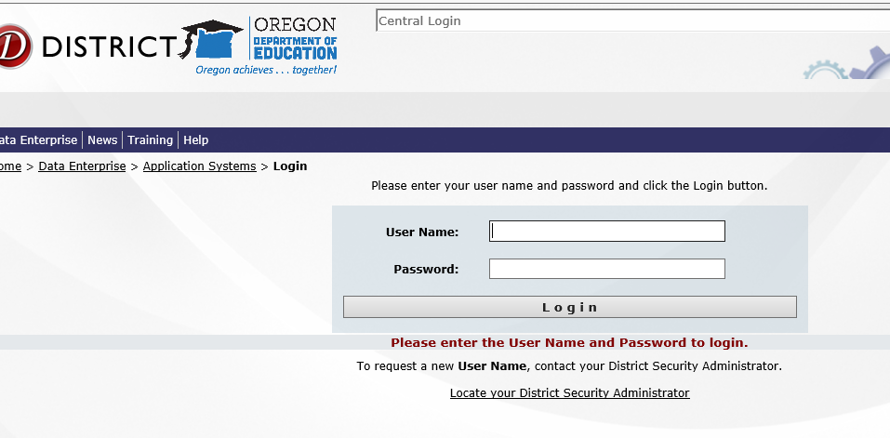

Under Applications, click on CTE Program Update. If you do not see this option, ask your School/District Security Administrator for access.

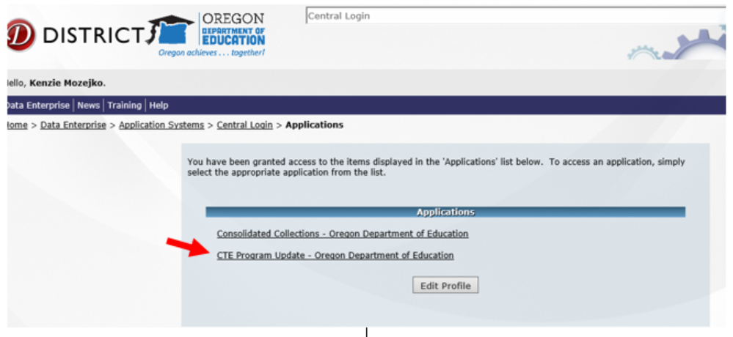

The Web Based Application:
The application will open with the following screen:

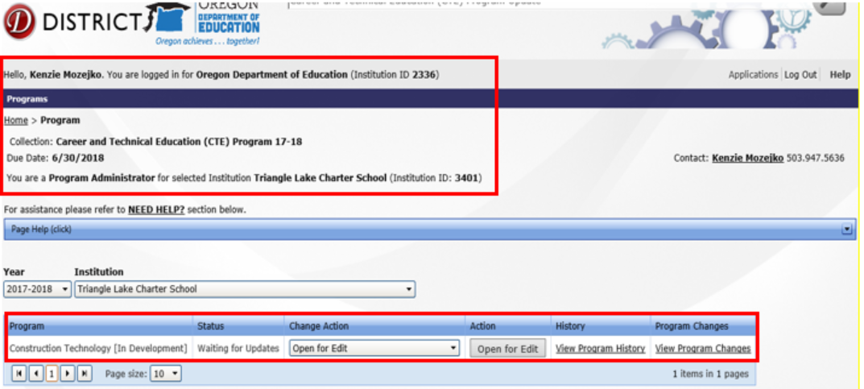

The top of the web page is informational and shows you the institution that you are logged in under, the application that you have opened (CTE…), and the level of permissions that you have.

You can change the School Year and the Institution to any for which you have permissions.

In the working section of the page, you are shown each Program, the Status of the program, and the available Actions, which change, depending on the Status.

The View Program History link will display all recorded actions with user and ODE comments that have happened to the program for the selected year.

The View Program Changes displays approved program changes for that year. This function does not accurately reflect changes that have been made.

Status: Waiting for Updates
Status of all programs will be set to Waiting for Updates initially. Click on Open for Edit under Action.

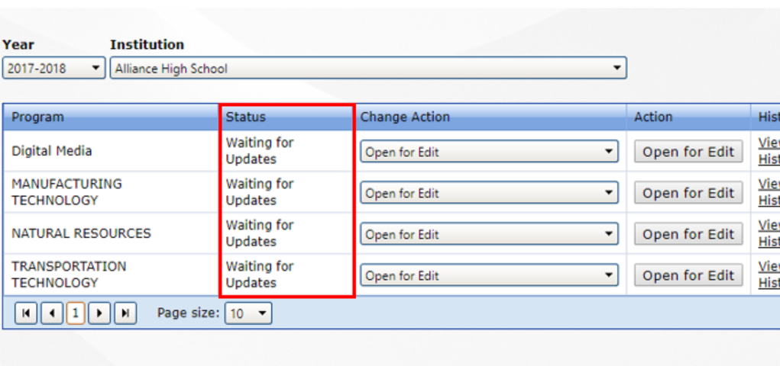

Click on the Change Action dropdown to see the available actions:

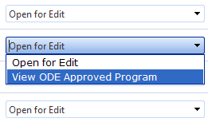

You can set the action to Open for Edit to edit it, or you can set the action to View the ODE Approved Program. When the Status is “Waiting for Updates,” the Existing record is the same as the ODE Approved program because no edits have taken place.

Select Open for Edit from Change Action dropdown, then click on the Open for Edit action button. Scroll to the bottom of the page to see the record and begin editing.

Status: Working

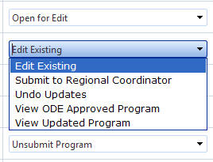

When the Status is working, this means the record has been edited. Click on the Action Dropdown to see the available options:

Edit Existing will open the record (at the bottom of the page), allowing you to continue editing.

Submit to Regional Coordinator submits the record to the Regional Coordinator who can approve the edits and submit the record to ODE.

Undo Updates will drop all the edits on the record and change the status back to Approved (if it was previously approved by ODE) or Waiting for Updates.

View ODE Approved Program will open the ODE approved program in Read-Only mode.

View Updated Program will open the existing record in Read-Only mode.

Status: Submitted to Regional Coordinator for Review
Click on the Change Action Dropdown to see the available actions:

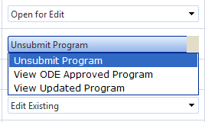

Unsubmit Program will change the Status back to Working and allow you to edit the record.

View ODE Approved Program will open the ODE approved program in Read-Only mode.

View Updated Program will open the existing record in Read-Only mode.

Regional Coordinators will have the following options:

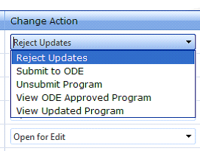

Status: Submitted to ODE for Approval

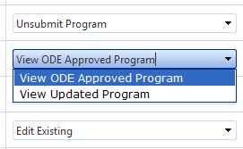

View ODE Approved Program will open the ODE approved program in Read-Only mode.

View Updated Program will open the existing record in Read-Only mode.

Regional Coordinators will see the additional action choice, Unsubmit Program.

Editing Program Records
When the action is set to Open for Edits or Edit Existing, you can edit the Program record.

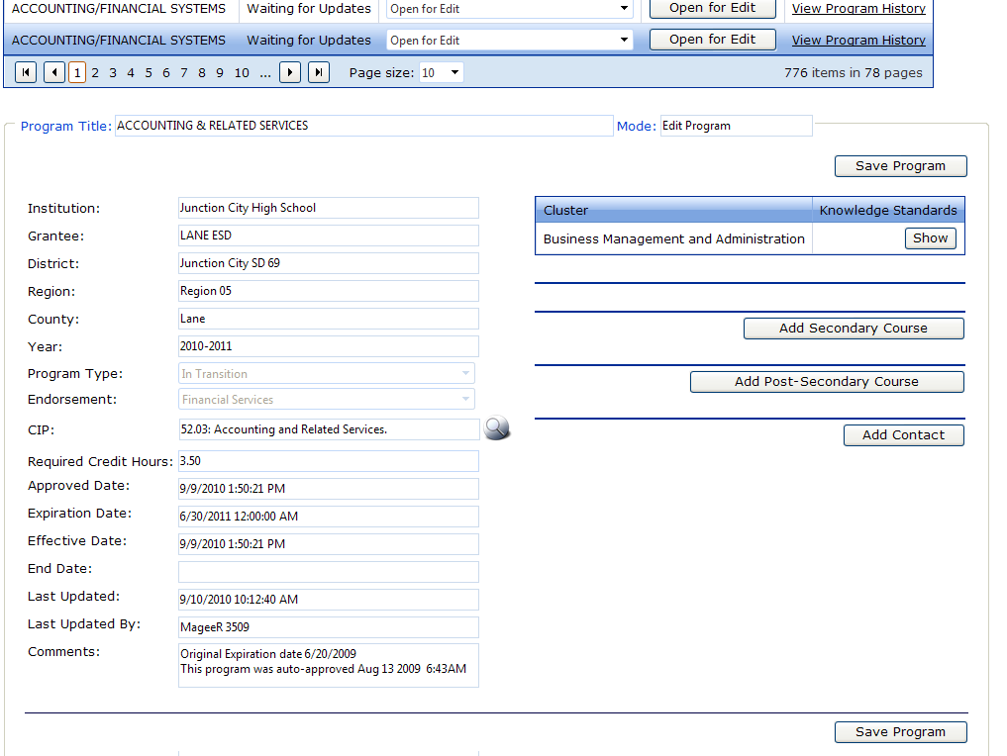Click the button to open the record at the bottom of the page, then scroll down to see it.

Click in the fields you want to edit. Remember to click Save Program after making changes.

The editable fields are:
Program Title
CIP (Classification of Instructional Programs)
Required Credit Hours
Secondary Courses
Postsecondary Courses

Search Icon:
You cannot directly edit a field with the Search icon…. ... next to it. You must click on the Search icon and select the appropriate item from the items returned by the Search.

Change the search in the Code and/or Description boxes and click the Search button to refresh the list and find the item that you need.

Click the Select button to fill the program field with the Search item.

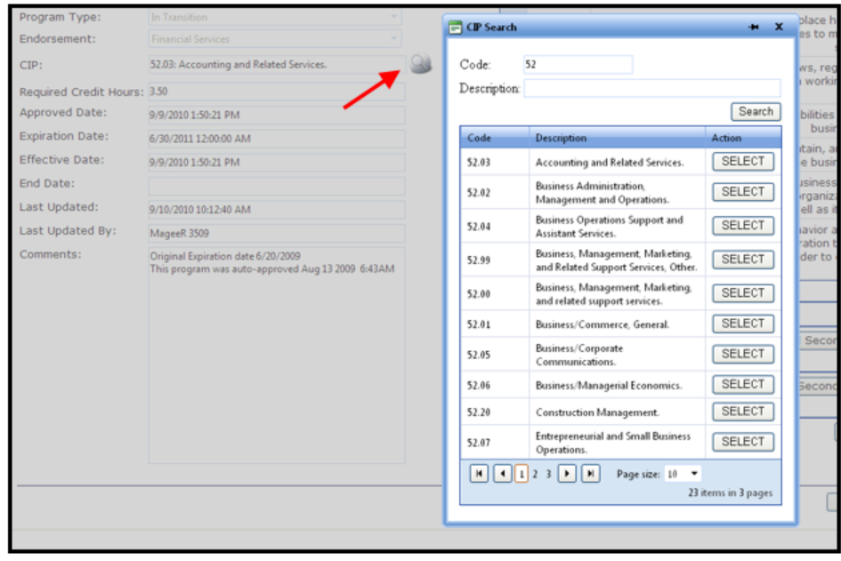

Add/Edit Secondary Course:
Click the Add Secondary Course button at the bottom of the Secondary course area or click the Edit Course button next to the course you wish to edit. A new window will open. Make edits as needed. Don’t forget to press Save at the bottom when finished making course edits.

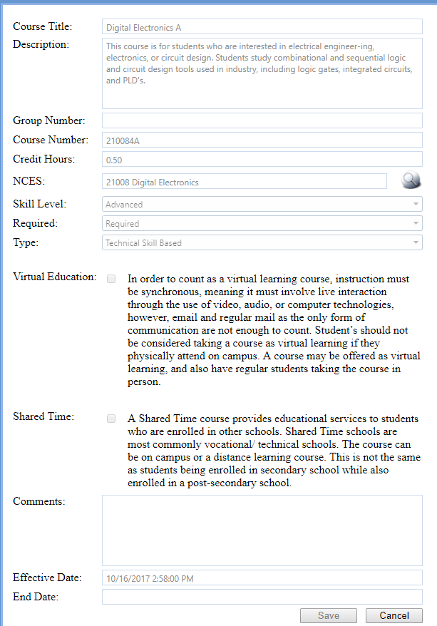

Add/Edit College Course:

Click the Add Post-Secondary Course button at the bottom of the Post-Secondary course area, or click Edit Course to make changes to an existing course. A new window will open.
Click the Search Icon. A new window will open.

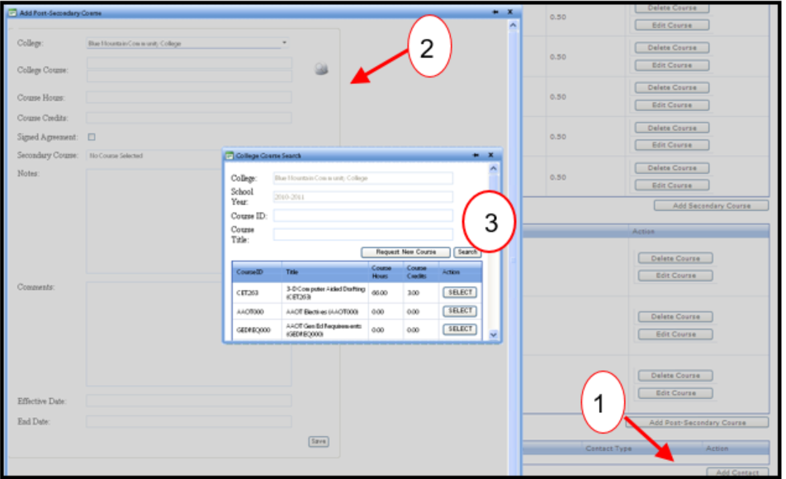
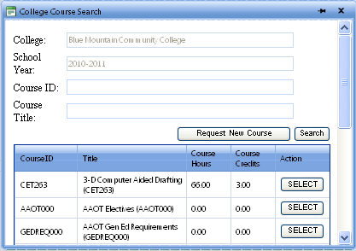

Fill in a partial Course Title or ID and click the Search button. A list of courses based on your search criteria will be displayed. Click the Select button to select that course and return to the previous window. Remember to press Save when done adding or editing courses.

If you cannot find the course that you want, you may click the Request New Course button. The following page will open.

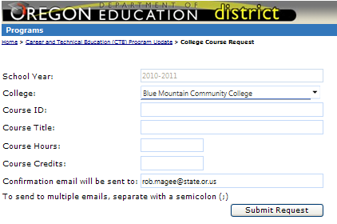

Enter the Course information and click Submit Request. The request will be sent to the ODE Data Owner for approval.

Add/Edit Contact:
Click the Add Contact button to request a new contact for the program.
Click the Search icon to find an existing contact or to Request a New Contact.

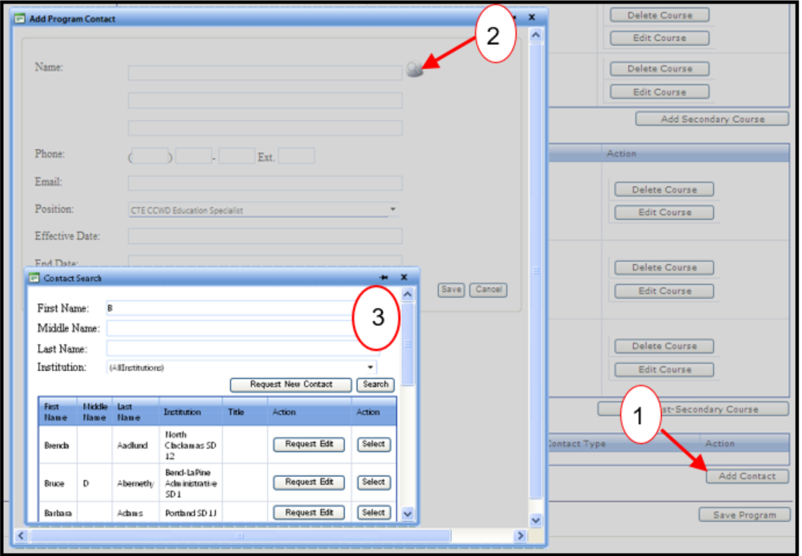

Fill in a partial First Name and/or Last Name to find and Select the correct Program Contact.
If you cannot find the contact you need, you can Request a New Contact, or an Edit to an existing contact. The change must be approved by ODE.

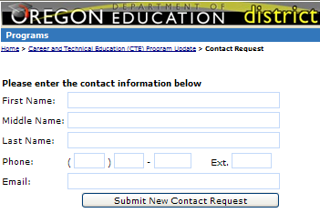

View Program History
Click the View Program History link to see the actions related to that program record.

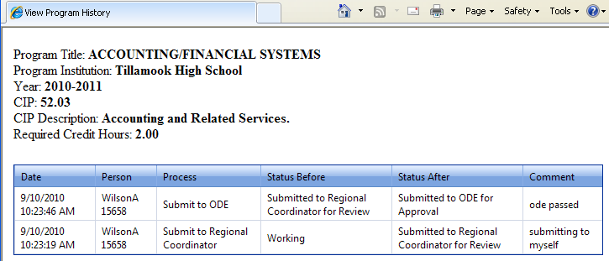

Validation Error Messages
Please ensure pop-ups are enabled. Switching to a different browser may be required to see error pop-ups.

NCES Code Error
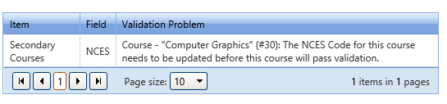
Click on Edit Course. The Edit Secondary Course window will open. If the NCES code says Inactive, click on the magnifying glass and search for the NCES course by name or code. Press enter on keyboard to display search results.

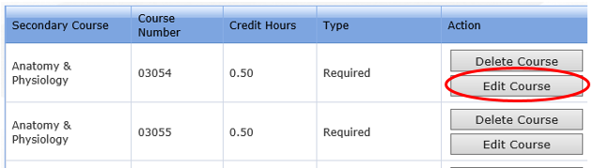

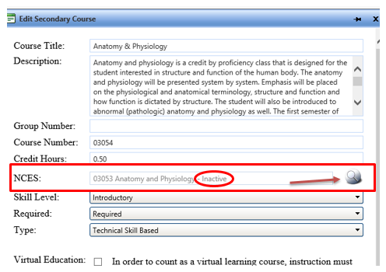

Click Select next to correct course.
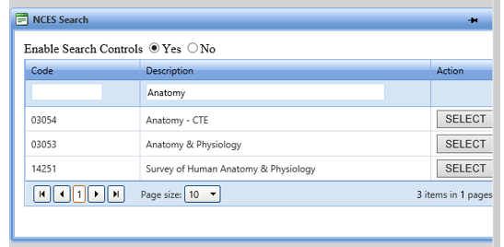
The NCES window will close and Inactive should no longer display. Scroll down to bottom of window and Click on Save.

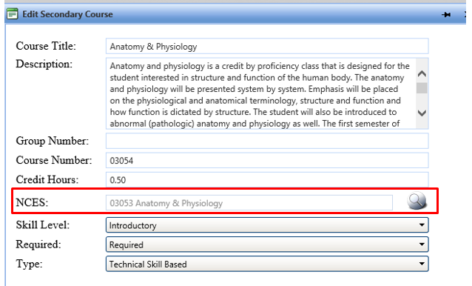

CIP Code Error
Ignore the CIP code error. It is outdated and no longer applies to the program update process. It displays with all other validation errors but does not actually hinder the program from passing validation. The program will pass validation upon fixing all other validation errors listed.

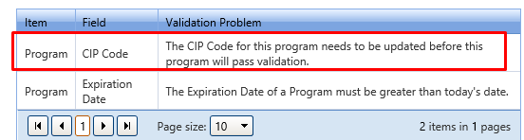

Expiration Date Error
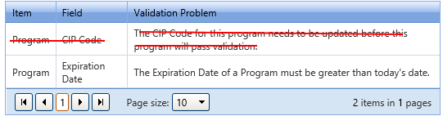

Solution:
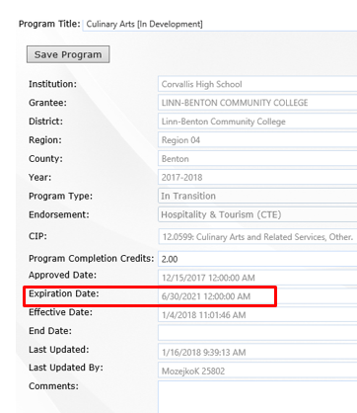

Program Completion Credits Error

Less than
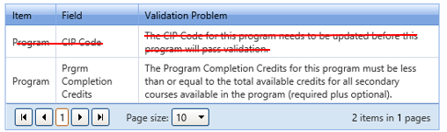
Solution: Change the number of program completion credits to be equal to or less than the number of credits shown under all credits. Click save at top.

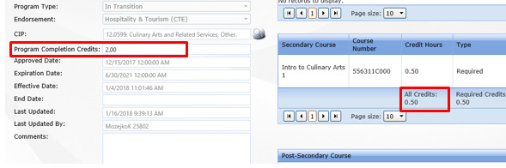

Greater than
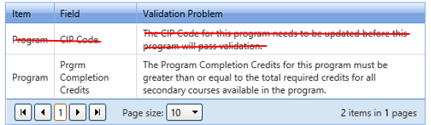

Solution: Change the Program Completion Credits to be equal to or greater than the number listed below required credits at the bottom of the Secondary Course section. Click Save at top.
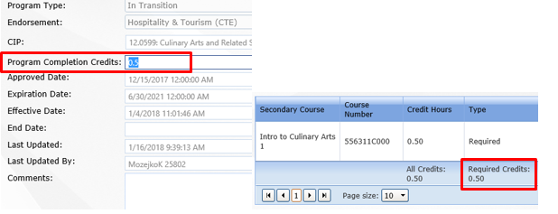

Postsecondary Course Error
A minimum of one postsecondary course is required for all full Programs of Study.
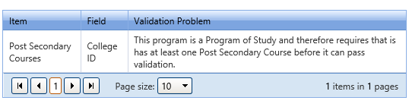

CTE Student and Course Collection - Secondary
As stated earlier, the implementation of Perkins V has allowed for a complete overhaul of the CTE Program of Study Application and the CTE Program Update, with minor changes to the CTE Student and Course Collection and the 90% Reporting. All of these items will be tied together in a single system. The IT Department at ODE will complete programming and testing during early 2020-2021, and further guidance will be available as each phase is completed.
For the 2020-2021 school year, please refer to guidance available on the ODE and District Data websites. This guidance will be updated prior to school starting, but not in time to be included in the Guidebook this year.

CTE Data Collections – Postsecondary
The Higher Education Coordinating Commission (HECC) is responsible for collecting data and providing reports on the postsecondary accountability measures for Perkins V. Data is collected through collaboration with Institutional Researchers at each college. For more information about the postsecondary data collection, contact Kelly Zinck.

Data Literacy
The vision set forth in the Oregon CTE State Plan requires more in-depth use of data and feedback. In the Plan there are three goals associated with data literacy and accountability:
- Improve the use of data to inform continuous improvement in CTE with a specific focus on equitable access, participation, and outcomes for historically underserved students.
- Improve data reporting systems for various end users of the data.
- Improve data quality.

Technical Assistance
ODE offers ongoing technical assistance and a variety of workshops, webinars, and other training opportunities each year to help local personnel better understand data collection and use.

ODE staff is also available, upon request, to provide individualized technical assistance as capacity permits.

16 - Financial Requirements

16.1 Overview of Perkins Grant Resources
As stated earlier, Congress reauthorized the Carl D. Perkins Act as the Strengthening Career and Technical Education for the Twenty-First Century Act in 2018. This law—commonly referred to as Perkins V—went into effect July 1, 2019; following a transition period, full implementation of the law is in effect beginning July 1, 2020.

As this is a federal grant, recipients must meet specific Perkins V requirements as well as adhere to general federal grant requirements. In addition to this Guidebook, the following sources are examples of guidance that informs the implementation of Perkins V:
- The Strengthening Career and Technical Education for the Twenty First Century Act (Public Law 115- 224)
- The Uniform Administrative Requirements, Cost Principals, and Audit Requirements for Federal Awards (Uniform Grant Guidance) (2 C.F.R. Part 200)
- Education Department General Administrative Requirements (EDGAR) (34 C.F.R. Parts 75-99), particularly Part 76 State-Administered Programs o Part 99 FERPA
- State Perkins Plan

Perkins grant recipients are expected to effectively manage the many federal and state requirements associated with accepting a federal Perkins grant award. This section of the Guidebook provides a helpful point of reference for some common areas of Perkins grant management in addition to the sources of guidance noted in the resources above. While Oregon Department of Education (ODE) staff are available for technical assistance and can provide helpful references to guidance, the Perkins primary contact at each local grant recipient also serves as a subject matter expert for their organization and has a gatekeeping role to help ensure both strategic implementation of Perkins awards and compliance. Unless otherwise specified, Perkins grant management topics included in this section pertain to both basic and reserve grants.

Perkins Fiscal FAQ
Additional information and relevant frequently asked questions may be accessed by reviewing the Perkins Fiscal FAQ. The FAQ will be updated as topics and questions arise within a given area. Additionally, the questions and guidance may be included within this Guidebook, based upon the agreed upon Guidebook review cycle.

16.2 Grant Type and CFDA Number
The Perkins CFDA number is 84.048. Perkins is primarily a reimbursement-based formula grant, distributed annually to eligible recipients by ODE. Reimbursements may be requested via the Electronic Grants Management System (EGMS) housed at ODE. Noncompliance with grant requirements may result in conditions on future grant awards and/or some grant reimbursement requests being deemed unallowable.

16.3 Grant Award Period
The grant award period is from July 1 through September 30 of the following year (15-month grant cycle). All expenditures, purchases, and deliverables must be completed during the grant award period. All reimbursement claims must be made by November 15 following the closing date of the grant.

16.4 Period of Obligation
Funds must be obligated by the end of the fiscal year and according to definitions outlined in EDGAR (34 C.F.R. § 76.707) regarding when they are “obligated.” The chart below provides selected examples of these definitions.
Selected Examples of When Funds Are Obligated:
If the obligation is for: | The obligation is made:
Acquisition of real or personal property | On the date on which the local Perkins subrecipient makes a binding written commitment to acquire the property
Personal services by a contractor who is not an employee | On the date on which the local Perkins subrecipient makes a binding written commitment to obtain the services.  The work described in the contract must be completed by June 30
Travel | When the travel is taken
Rental of real or personal property | When the property is used
Conference or event registration | On the date on which the local Perkins subrecipient makes a binding written commitment to attend the event
Personal services by an employee | When services are performed

16.5 Suspended and Debarred Service Providers
It is the responsibility of local recipients to check the Excluded Parties List System website to assure that any vendor with which they do business is not on this suspended and debarred list. This check should be explicitly and accurately documented in procurement records; otherwise, it is as if the check never happened.

16.6 Expectations of Perkins Grant
When utilizing Perkins funding expenditures in the local plan, these expectations must be met:
  - The funding is for the purpose of development, implementation, refinement, or support of approved CTE Programs of Study.
  - Funding is allocable according to the Perkins V Act.
  - There is no supplanting. You cannot use federal funds to pay for staff, programs, or materials that would otherwise be paid for with state or local funds. In other words, the expenditure was not previously paid for with local funding.
  - The expenditure is reasonable and necessary for the plan’s execution.

16.7 Requirement for Local Use of Funds Sec 135(b)
Local use of funds must be tied to the CTE Needs Assessment and shall support CTE Programs of Study that are of sufficient size, scope, and quality to be effective and that
- provide career exploration and development activities through an organized, systematic framework designed to aid students, including middle grades, in making informed plans and decisions about future education and career opportunities.
- provide professional development for educators involved with CTE which can include support personnel, career guidance, and academic counselors.
- provide within CTE the skills necessary to pursue careers in high-wage, high-skill, or in-demand industry sectors or occupations (consult local CTE administrators for details).
- support integration of academic skills into CTE Programs of Study.
- plan and carry out elements that support the implementation of CTE Programs of Study and that result in increasing student achievement.
- develop and implement evaluations of activities carried out with funds, including evaluations necessary to complete the CTE needs assessment and local reports.

16.8 Algorithm for Making Local Funding Decisions
When determining whether the use of federal Perkins V grant funds is appropriate, local and consortia leadership should consider the following questions:
- Does this use of funds constitute “supplanting” of other funding sources? For example, if an individual’s salary was funded through state funds previously, federal Perkins V funding cannot be used to fund the salary now or in the future unless the job duties have changed and have been documented in a revised position description. The position description must specify which duties are funded with Perkins grant funds and what percentage of the overall duties are funded by federal Perkins grant funds.
- Is the expense reasonable? Does it meet the intent of size, scope, and quality as specified in the Perkins V law and in the Oregon CTE State Plan?
- Is the expense necessary? For example, what are the consequences if Perkins funds are not used?
- Is the expense allocable? For example, does the expenditure comply with the six required uses of funds specified in Section 135(b) of Perkins V and with the Education Department General Administrative Regulations (EDGAR)? Be prepared to identify and describe the following specific considerations as they apply to the expenditure:
  - Which Perkins V required use of funds under Section 135(b) is being addressed?
  - How does the expenditure support the Program of Study?
  - How does the expenditure support the recruitment, retention, and training of CTE professionals?
  - How does the expenditure support special populations as identified in Perkins V?
- Does your comprehensive local needs assessment support the expenditure?
- Has the expenditure been vetted with your district, college, or consortia governance team?
- Is the focus of the expenditure on systems alignment and program improvement?

16.9 Allowable and Unallowable Costs and Activities
To understand whether an activity is allowable under Perkins V, local grant recipients should refer to Section 135 of the Perkins Act, which outlines the types of items for which Perkins funds may be used at the local level. Additionally, the Uniform Grant Guidance provides insight as to whether specific purchases to implement the activities planned are allowable.
For example, it may be an allowable activity under the Perkins Act to teach students in a culinary program how to flambé, which requires the use of alcohol. However, the Uniform Grant Guidance prohibits using federal funds to purchase alcohol, so that cost would ultimately be unallowable to the Perkins grant.

Below is a general outline of guidance on allowable and unallowable costs and activities; however, it may still be necessary to refer to the source of the guidance noted in Section 16.1. All activities will need to be approved in the Perkins budget narrative in the local application.

Allowable Costs/Activities | Unallowable Costs and Activities
- Costs associated with expansion of CTE Programs of Study into work-based learning (non-supplanting in nature)  - CTE Interest, Aptitude, and Ability Inventories (with state approval)  - CTE-related software (with state approval)  - CTSO expenditures for newly chartered CTSO programs, 0-3 years  - CTSO expenditures for re-birth of CTSO programs or a new teacher to a CTSO program, 0-2 years  - Curriculum development/curriculum modification within Programs of Study (curriculum to be shared)  - Curriculum expansion or supplemental resources, 0-3 years’ investment  - Equipment and upgrade to meet industry standards  - Expenditures for CTE career exploration and awareness down to the middle grades, including grades 5 through 8  - Marketing and outreach activities related to specific CTE Programs of Study (brochures, videos, flyers, web design), not school or college-wide promotion  - Meetings and conferences (registration fees, travel costs) related to CTE Programs of Study  - Membership dues/fees to a professional, service, or brotherhood organization that is connected to an explicit conference or Professional Development deliverable (seek ODE input)  - Professional development costs for CTE personnel  - Professional development related to CTE for non-CTE teachers/faculty/counselors (involved in CTE initiatives such as advising, academic technical integration, career awareness activities, and school administration)  - Professional service costs (consultants)  - Repair of equipment (with ODE approval) if the cost of the repair is of greater benefit than upgrading to new industry grade equipment. The local educational agency has obligation for equipment repair and maintenance.  - Subscriptions to industry based software or resources  - Substitute pay for teachers, activities, and staff development related to CTE  - Supplemental Support Services for Perkins special populations  - Transportation costs incurred through professional development activities associated with approved CTE Programs of Study, workshops (administrators, counselors/advisors, CTE instructors, Perkins staff)  - Working lunch at CTE meeting with high burden of proof (seek guidance from ODE) | - Administration costs above the 5% cap  - Alcoholic beverages  - Alumni activities  - Base classroom furniture  - Basic classroom/CTE supplies (pencils, toner, ink, paper, bits, blades, measuring cups, pots, pans, screwdrivers, wrenches, wood, metal, welding electrodes, gas, resin, etc.). The local educational agency has the base obligation offering a program.  - Building maintenance and repairs  - Bus or Metro Transport pass  - Child care  - College credit to an individual student or teacher/instructor  - Commencement and convocation costs  - Construction, renovation, and/or remodeling of facilities  - Consumable supplies  - Contributions and donations (cash, property, services)  - CTSO competitions  - CTSO expenditures to programs that are fully established  - CTSO uniforms  - Custodial service  - Entertainment – amusement and social activities (sports tickets)  - Expenditures for career education unrelated to Approved CTE Programs of Study (Career Education)  - Expenditures for non-approved CTE Programs of Study  - Expenditures that supplant  - Fines and penalties  - Food, beverages, snacks, meals for CTE meeting  - Fundraising  - Gifts/gift cards  - Goods or services for personal use (laptop, phone, tablets, etc.)  - Individual awards, recognition, trophies, plaques, or gifts  - International travel  - Items for young children to play with, manipulate, read, be entertained by, or eat, or sleeping items associated with an early childhood education Program of Study. The Program of Study responsibility is items for the secondary and postsecondary age students and not facilitating a day care facility  - Items retained by students (supplies, computer equipment, thumb drives, tools, calculators)  - Landscaping  - Licensure and/or exam fees for individual (student or teacher) certificate or licensure  - Membership dues/fees for a professional, service, or brotherhood organization without being connected to Professional Development deliverables of attending a specific event. General membership year after year is not allowed (seek ODE input).  - Monetary awards  - Non-instructional furniture  - Political activities such as contributions, fund raising, or lobbying  - Promotional materials (T-shirts, pens, cups, key chains, book bags, etc.)  - Remedial (developmental) courses at both secondary and postsecondary levels  - Routine operating expenses  - Safety equipment (gloves, goggles, helmets, glasses, air filter, lab/chef coats, boots, dust masks, etc.)  - Scholarships  - Student expenses/direct assistance to students (tuition, tools, fees, car repair, etc.)  - Student stipends  - Student transportation (state transportation fund covers a significant portion of the cost associated with approved academic activities) excluding recreational/entertainment activities  - Subscriptions to periodicals, journals, and newspapers  - Teacher/instructor salaries  - Textbooks (local educational institutions have the base obligation for curriculum), toys, games, entertainment devices (video games), movies  - Travel to exotic locations associated with professional development (seek ODE input)  - Tuition that is awarding college transcripted credits

If a specific investment or activity is in question, please reach out to the Perkins Fiscal Education Specialist at ODE.

16.10 Supplement not Supplant
Section 211 of the Perkins Act states that Perkins funds “shall supplement, and shall not supplant, non-federal funds expended to carry out career and technical education activities.”
- Supplement means “to add to, to enhance, to expand, to increase, and to extend”
- Supplant means “to take the place of, to replace”
Educational institutions may use federal Perkins fund only to supplement, and to the extent practical, increase the level of funds that would, in the absence of the federal funds, otherwise be made available from nonfederal sources for the education of participating CTE students. Perkins funds are not used to replace any funds from other sources currently used to support CTE Programs of Study. Seek ODE/CCWD fiscal advice before proceeding with a questionable expense under this exception.

16.11 Administrative Cost
Section 135(d) of Perkins V stipulates that each local recipient receiving funds “shall not use more than 5 percent of such funds for costs associated with the administration of activities” related to the grant. These grant administration charges may be direct or indirect and must be outlined in the local application. It is optional whether a local recipient decides to seek administrative cost recovery; however, the total direct administrative and indirect costs recovered cannot exceed five percent of the allocation. Additionally, the amount of administrative costs reimbursed is calculated based on the total grant funds actually expended, not on budgeted amounts included in the annual Budget Narrative.

Indirect Cost Rate (ICR)
Indirect costs are essentially the costs of overhead associated with managing a federal grant without the need to directly account for them in the budget narrative or annual report. The indirect cost rate helps ensure that local recipients electing to take it are compensated through one convenient rate for costs like office space for grant accountants, copies, grant accountant time, postage, writing the local application, etc. Indirect costs rates are negotiated and set at the agency level for districts and colleges.

For the Perkins grant, the ICR cannot exceed the lesser of the recipient’s negotiated rate or five percent.

Direct Administrative Costs
Direct administrative costs are budgeted in the annual Budget Narrative; it is essentially a project that is not designated to a CTE Program of Study. These costs must be built into the local application as individual expenses and would be reimbursed as such up to the maximum of five percent of grant funds expended. Personnel costs associated with managing the Perkins grant would be part of the five percent allowance (note time and effort must be tracked for staffing expenses).

Costs associated with the comprehensive regional and local needs assessment process may, but are not required to, be considered direct administrative costs, and are also required to be detailed in the annual Budget Narrative section of the local application.

16.12 Repayment of Reimbursed Expenses
ODE reserves the right to request repayment of reimbursed expenses submitted that are not in the local application in any of these circumstances:
- Purchase causes the budget variance to exceed the 10% variance threshold described in the Revisions section below
- Purchase is not an allowable Perkins expense
- It is not clear how the purchase supports the recipient’s priorities and projects outlined in the local application
- It is not clear how the purchase relates to the results of the required regional/local needs assessment process
- Equipment was purchased that was not approved prior to issuance of a purchase order
- Documentation is insufficient to support payment
- Reimbursement is for travel or professional development that was not approved in the local application
- Purchase represents supplanting of non-federal funds

16.13 Eligibility Exclusion Lists (Sec 135(b)) CFR 200.328 & 200.330
Eligible recipients that fail to complete the following items in an accurate manner, on time, may be excluded from Perkins V fund eligibility:
- Obtain approval for the Perkins V CTE Strategic Plan (four-year plan), Yearly CTE Action Plan, Perkins Budget Narrative, Spending Workbook and supporting documentation (Local Needs Assessment)
- Submit a Perkins V Annual Report and all its related components by the designated date (November 15)
- Submit the local educational agency Perkins V program assurances
- Submit accurate CTE Program of Study update and course data by the designated closing date
- Submit student enrollment and performance data by the designated closing date
- Submit and obtain approval for applications for CTE Programs of Study
- Demonstrate that the use of Perkins V funds meets the purpose and intent of the Carl D. Perkins Act of 2018 and the Oregon CTE State Plan

16.14 Funding CTE Programs
In order to qualify for Perkins investments, all local educational agencies must have an approved Program of Study within the specific career learning area. A Program of Study is a seamless model that connects the secondary to postsecondary CTE programming. The Programs of Study are built upon the same CTE Skill Sets at both levels. The secondary CTE licensed teachers and college instructors work collaboratively within individual Professional Development plans to strengthen the CTE Program of Study. Additionally, authentic collegial engagement occurs on an annual basis to keep the Program of Study current.

A postsecondary CTE Program of Study is a credit-based program that has secondary partners and provides a seamless transition to students pursuing an approved program as identified in the CCWD Handbook and Planning Guide. The approved postsecondary CTE Program of Study is identified by a Classification of Instructional Program (CIP) code in one of the 16 career clusters designated as “Perkins eligible.”

To be eligible, the program must, among other requirements, terminate in a certificate, diploma, or an Associate of Applied Science (AAS) or Associate of Science (AS) degree. If a postsecondary program does not have a joint application with a secondary CTE partner, the program(s) is not Perkins eligible.

Postsecondary Customized Training Courses and Programs
Perkins resources may not be used by colleges for program expenditures related to students pursuing non-credit courses and programs within customized training or employer sponsored training programs. For example: Perkins funds may not be used for costs related to providing customized training for ABC Corporation.

16.15 Funds for Support Services (Careers Nontraditional by Gender)
If a college or school district determines a need to fund support services for students enrolled in a CTE Program that is nontraditional for their gender, the college or school district must develop local guidelines within state and federal laws to provide assistance with dependent care, transportation services, special services, supplies, books, and materials for nontraditional students in CTE-approved programs and/or services.

The Office of Career Technical and Adult Education (OCTAE) and the U.S. Department of Education have provided the following guidelines:
- Perkins funds cannot be provided to individual students for the purchase of tools, uniforms, equipment, or materials.
- Perkins funds cannot be used for student stipends or tuition.
- Childcare may be provided, but not by direct payments to CTE students. Colleges and districts shall establish procedures for payments to vendors for childcare.
- Transportation costs for postsecondary students may be provided, but not by direct payments to CTE students. Colleges shall establish procedures for payments to vendors for transportation costs (bus or metro pass). Costs for public transportation or rates consistent with the cost of public transportation may be allowed only to provide transportation for postsecondary students to attend a CTE approved education activity. (In areas where public transportation is not appropriate/available, colleges shall develop equitable options for students by providing vouchers or purchase orders.)
- Perkins funds may not be used for car parts and/or maintenance.

At the secondary level—with the state pupil transportation funds and Oregon’s pupil transportation reimbursement—the use of Perkins funds for CTE educational activities and events, including student/pupil transportation, would be considered supplanting; this is not allowed under Perkins.

Single gender, single demographic, or protected class status explicit activities must be carefully assessed to ensure that they do not violate Civil Rights and protected status for other students within the school system. A simple “girls only welding” is prohibited and is a violation of the Title IV law. Reach out to ODE and CCWD for further clarification as it relates to single gender or single demographic initiatives.

16.16 Perkins Funds in the Middle Grades
Prior to Perkins V, restrictions were in place for middle grade participation in Perkins funded programs and activities. Perkins V has lifted these restrictions to allow funds to be spent on career exploration activities at the middle grades. “Middle grades” includes grades 5-8. This flexibility allows recipients to offer innovative programs that provide students with earlier opportunities to explore career options.

Career Exploration and Development
Section 135(b)(1) provides the required use of funds for career exploration and career development activities. These activities may include students in the middle grades. This section calls out an organized, systematic framework to aid in making informed plans and decisions about education and career opportunities and programs.

This systematic framework may include the following:
- Introductory course or activities focused on career exploration and awareness
- Career and labor market information – supply and demand, educational requirements, economic priorities, and employment sectors
- Programs and activities related to the development of education and career plans
- Career guidance and counseling activities that assist students in making informed decisions
- Providing students with strong experience and comprehensive understanding of all aspects of an industry. Events and activities need to be intentional and focused. The maker space—building a birdhouse, baking cookies, or making paper airplanes—would not qualify.

Reach out to the CTE content Education Specialist at ODE for further details within career areas.

Programs of Study
Section 215 states that no Perkins funds may be used to provide CTE Programs of Study or Programs of Study prior to the middle grades. Equipment and facilities purchased with Perkins funds may not be used by these students.

16.17 Braided Funding
Braided funding is the act of co-mingling funds from several sources in a coordinated manner to support a single goal, initiative, or activity. 34CFR 76.580 allows and encourages “federal (Perkins) grant recipients to coordinate each project with similar ones in same locale.” Within the Perkins grant, the deliverables are clearly identified within the Budget Narrative and maintain the single cost objective for each funding source that is contributing to the braiding of funds. If the braiding of funds is being used on inventory items, the percentage of Perkins investment needs to be identified within the inventory documentation and the disposition process needs to adhere to the Perkins and local requirements.

16.18 Perkins One-Stop Collaboration - 1.5% Set-aside
In compliance with the Workforce Innovation and Opportunity Act of 2014 (WIOA) and provisions regarding mandatory partnerships between postsecondary Perkins programs and the One-Stop Employment Centers, there is an expected cost sharing agreement between the designated postsecondary Perkins recipient and local workforce board. (Section 135(d))

The WIOA One-Stop Contribution from Perkins could be at the level of 1.5% of the Perkins postsecondary grant award and would be part of the indirect portion of the Perkins grant. The indirect portion of the Perkins grant is limited to 5% and the 1.5% if allocated to the WIOA One-Stop Centers would limit the remaining indirect allotment to 3.5% for other fiscal indirect costs. If the Perkins postsecondary institution is part of a consortium, only the Perkins postsecondary award total is part of the 1.5% WIOA One-Stop Center contribution. With the WIOA One-Stop Center funding, there needs to be a signed agreement that documents the shared resources and proportionality of CTE students that are being served within the postsecondary system.

16.19 Individual Elements of Cost
The following subsection deals with select individual elements of cost. These are areas where there are common questions, or more nuanced implementation. Refer to the Uniform Grant Guidance 2 CFR 200.420 for more items.

16.19.1 Equipment
The Uniform Administrative Requirements, Cost Principles, and Audit Requirements for Federal Awards defines certain requirements for pre-approval of equipment purchases and equipment tracking. Federal guidance defines equipment as a single unit with a useful life of greater than one year and an acquisition cost of greater than or equal to $5,000.
Acquisition cost of equipment means the net invoice price of the equipment, including the cost of modifications, attachments, accessories, or auxiliary apparatus necessary to make the property usable for the purpose for which it was acquired. Other charges, such as the cost of installation, transportation, taxes, duty, or protective in-transit insurance, shall be included or excluded from the unit acquisition cost in accordance with the recipient’s regular accounting practices. (2 C.F.R. § 200.33 and 200.2)
Purchase orders for equipment should not be issued until the equipment is included as an Equipment spending category expense within an APPROVED local application relevant to the year of the purchase and receipt of the equipment. No revisions can be made to equipment expenses in either the annual Budget Narrative or the voucher once an equipment expense has been submitted for reimbursement.
The Regional Coordinator or Perkins grant manager should review and approve all purchase orders being charged to Perkins. This is especially important when an item in the local application was categorized as equipment, regardless of what the estimated Perkins portion of the expense was and when the requisition reflects costs equal to or greater than $5,000. If either situation occurs, the requisition should not be approved and forwarded until AFTER the local application is APPROVED with the relevant expense listed as equipment. This will also help the local recipient identify, track, and dispose of equipment that was purchased in whole or in part with federal funds.
Equipment purchased with federal funds, including Perkins funds, must have the following (200.313 (d)):
- Property records including acquisition date, cost, source, percent of federal funds used to purchase the item, location, use, and condition of the equipment and ultimate disposition
- A physical inventory of the property, which must be taken and the results reconciled with the property records at least once every two years
- Adequate safeguards to prevent loss, damage, or theft
- Adequate maintenance procedures

Equipment Inventory -200.313(d)
Within the annual fiscal reporting, an inventory submission of purchases with Perkins resources during the current year is required. All equipment and non-consumable supplies of more than $200 of value or which have a useful life of more than one year are presented as part of the inventory.

Additionally, Perkins recipients are required to conduct a complete inventory review and update every two years. Local educational agencies are expected to follow local policies and process for disposition, and/or reporting lost or delinquent inventory items and documenting inventory changes respective of the inventory change dates. All inventory documentation will be presented during a fiscal audit and/or Perkins program monitoring (see Perkins monitoring manual).
The following elements are required within the inventory documentation:
- Property records, including equipment description (serial numbers, model numbers, physical description, etc., as applicable) acquisition date, cost, source, percent of federal funds used to purchase the item, location, use, and condition of the equipment and ultimate disposition
- A physical inventory of the property, which must be taken and the results reconciled with the property records at least once every two years
- Original expenditure/percent of grant funding
When possible, a physical tag should be permanently fastened to, or stamped on, each item of equipment/curriculum indicating Perkins funded expenditure. This tag must be identifiable to the inventory record. A copy of the current inventory needs to be maintained by the Regional Coordinator or Perkins grant manager and kept within the business office of the local fiscal agent.

Incidental Use
Equipment purchased with Perkins funds may be used as described in the Perkins Local Plan/Update but may also be used in other programs under certain conditions. The equipment may be used if the use is incidental and does not interfere with the original purpose of the acquisition and does not add to the cost of using the equipment. Incidental use activities should not generate revenue for individual businesses or organizations and/or be used by the school district or college to generate revenue by leasing the equipment. Examples of multiple uses of equipment purchased with federal funds include but are not limited to the following:
- Computer labs at a summer computer camp or an after-school program
- CNC lathe in an adult training program
- Career exploration events
- School or college open houses

Disposal of Equipment
The disposition of equipment and non-consumable supplies must follow parameters of the local educational agency that is acting as the fiscal agent of the Perkins grant. The following considerations should be utilized when the disposition of equipment and non-consumable supplies occurs:
- The Perkins fiscal agent has the obligation to dispose of equipment and non-consumable supplies purchased within the Perkins grant management (consortium or direct recipient).
- All disposition of equipment must be identified within the current year’s Perkins closing inventory, and inventory documentation should be retained for Perkins financial records purposes. The inventory records would be presented at a Perkins monitoring and/or audit review.
- Equipment disposal records including inventory documentation, disposal, salvage recovery funds, and any transfer information need to be retained by the consortium for three years and/or follow the local Perkins fiscal agency protocols if longer than three years of financial document retention.
- Prior to disposition of equipment and non-consumable supplies, other Perkins approved Programs of Study should be considered as an acceptable recipient for transfer or title relocation. The transfer or title relocation would mutually benefit both Perkins programs.
- Acquisition inventory process and disposition of curriculum software/licenses follow the same guidelines as stated above for equipment and non-consumable supplies.

16.19.2 Professional Development – Waived for 2020-2021 due to COVID-19 Impacted School Year
In Oregon, each eligible local educational agency that submits a Perkins CTE Strategic Plan (four-year plan) must use 15% of the allocation grant for professional development consistent with the requirements of the law. The Professional Development funding totals approved by ODE October 1 within the Budget Narrative and Spending Workbook form the threshold of investment within Professional Development; it is not allowed to be re-invested to other function and object codes in the budget and expenditure process.

16.19.3 Personnel
The school district or college has the obligation to fund teachers, instructors, faculty, and administrators’ instructional support staff with state or local funds.

30% Cap - Waived for 2020-2021 due to COVID-19 Impacted School Year
There is a 30% cap limit on personnel costs and leadership staffing within the Perkins grant. Leadership is not to be viewed as administrative activities. The 30% staffing rule should be leadership focused or have a specific deliverable that is intended to meet a need identified within the Local Needs Assessment. Examples of an expense under this cap may include the following:
- Staffing for a pilot program to determine if the potential solution would work within an educational service area. The staffing cost should be short-term in nature (e.g., 1-3 years) and have a sunset date.
- Personnel assigned to projects designed to improve CTE as specified in the Local Application.

Please note: Building ongoing staffing infrastructure through the 30% personnel costs and leadership staffing would be considered supplanting. In all staffing cases, several documents will be required to be uploaded or submitted along with the local application.

Personnel Activity Reports
Personnel who are compensated in whole or in part with federal grant dollars are required to report on their duties/activities funded under the grant. This time and effort reporting, or Personnel Activity Reporting, reflects how teachers, faculty, and/or staff spent the time for which they were compensated through federal grant funds. For the sake of the Perkins grant, we refer to these as Personnel Activity Reports (PARS).
The purpose of federally mandated time and effort reporting is to provide documentation to substantiate payroll charges. For example, if 25% of an individual’s time was charged to a federal grant, time and effort reports must substantiate that the individual spent at least 25% of their time working on activities to support that federal grant. Time and effort reports must be a single, certified document that reflects 100% of an employee’s time worked in a given period.
OMB Uniform Guidance Subpart E §200.430 contains the federal regulatory requirements for time and effort reporting.

16.19.4 Field Trips
Field trips and student transportation activities that are in direct support of CTE students and programs are allowable under the Perkins grant funding. This can include middle school career awareness activities that support CTE Program enrollment at the secondary level. This funding may not be used for support of individual classes at the middle school level. If the field trips/activities are listed, budgeted, and approved as part of the annual Perkins consortium grant application, additional pre-approval is not required. The pupil transportation should be covered by the state transportation fund and not Perkins funds. Additionally, food and meal costs should not be covered with Perkins resources.

16.19.5 Career and Technical Student Organization (CTSO) Activities
Investment of Perkins resources within CTSOs is limited to three key areas:
- The CTSO is a “new program” - 0-3 years.
- A new teacher to the school, career area, and/or CTSO. There is an allowance for a limited 2-year investment.
- Reestablishment of a CTSO that has been dormant for 4 years. The reestablishment investment is limited to a 2-year investment.

CTSO investments need to rely upon the Local Needs Assessment and stakeholder input to determine prioritization of funding. Additionally, other rules associated with supplanting and direct benefit apply to the CTSO investments. Perkins resources may be utilized to provide professional development exposure for administrators or counselors at CTSO events. The focus of attending a state or national CTSO event by an administrator or counselor should focus on professional development and not student supervision or recreation associated with the event.

Additional guidance:
- Individual student lodging and meals do not qualify as a permissible Perkins expenditure.
- Advisor travel, lodging, and meals must include staff development activities for licensed CTE staff (Perkins funds are not allowable for chaperones).
- All Perkins funding recipients must be licensed CTE teachers/administrators or counselors.
- Perkins funding can be used for the purchase of branded organizational materials as long as those materials remain the property of the program and are not distributed to individual students upon program completion.
- All members of the student organization or class/program must have an opportunity to participate in the funded activity (this opportunity may reflect qualifying competitive performance or participation).

16.19.6 Perkins Funding for Curriculum Software/License
- Acquisition and disposal of curriculum software/licenses follow the same guidelines as stated above for equipment.
- Perkins funding is not a sustainable long-term funding source for secondary and postsecondary initiatives. (Consequently, license and curriculum program funding are restricted to two-three years of support.)
- Inventory control must be maintained in the same manner that was recommended for equipment.

16.20 Required Local Policies
According to the Uniform Grant Guidance, all recipients of federal grant funds must have the following written policies in place. These policies will be used by auditors and in the event of a Perkins monitoring visit.

Written Cash Management Procedures –200.302(b)(6); 200.305
These are written procedures regarding cash management and claiming of Perkins funds that include “advance payment” and “cost reimbursement.”

Advance Payment policy must cover the following:
- Rationale why the “cost reimbursement” was not an option
- Advance funds limited to the minimum amounts needed
- Be timed to be in accordance with the actual deliverable
- Immediate cash requirements of the local educational agency in carrying out the purpose of the approved Perkins deliverable
- As close as administratively feasible to the actual disbursements

Cost Reimbursement must be expenditures that are obligated, delivered, completed, and liquidated prior to reimbursement.

Written Conflicts of Interest Policy - 200.318(c)
Each local Perkins fiscal agent must have a written conflicts of interest policy and procedures. The written procedures should answer such questions as: What is considered a conflict of interest? How is it determined that an employee has a conflict of interest? How it is determined the procedures are being followed, when the steps are performed, and what is being verified?

Written Procurement Procedure 200.319(c) &200.320
Each local Perkins fiscal agent must have a written procurement policy and procedure process that ensures all solicitations will
  - incorporate clear and accurate description of the technical requirements for the material, product, or service to be procured or provided.
  - identify all requirements which the offerors must fulfill and all other factors to be used in evaluating bids or proposals.
  - have consistent small purchase procedures.
  - manage procurement by sealed bids (threshold, format, process).

Written Travel Policy - 200.474(b)
Each local Perkins fiscal agent must have a written travel policy and procedure process that ensures any and all travel is consistent with Perkins deliverables and conforms with the local fiscal agent’s internal protocols. Additionally, all travel to vacation or entertainment-based destinations requires ODE approval. International travel with Perkins is not allowed.

Written Procedures for Managing Equipment - 200.313(d)
Each local Perkins fiscal agent must have a written policy and procedure for the management of equipment. Additionally, the policy must be consistent with Oregon’s Perkins equipment, inventory, and disposition policies.

Written Time and Effort Policies and Procedures §200.430(i)
Each local Perkins fiscal agent must have a written policy and procedure for Perkins Staffing, time and effort reporting, and documented position descriptions for each staff member funded by the Perkins grant (whole or part). Additionally, the policy must be consistent with Oregon’s Perkins staffing thresholds and expectations. Sample time and effort form.

Written Teacher Stipend/Curriculum Rate Policy - Employee Benefits – 200.431
Each local Perkins fiscal agent must have a written policy and procedure for Perkins funds being utilized for teacher stipend/curriculum rate compensation.

The use of a teacher stipend to compensate educators for non-contract hours may be utilized as they are participating within professional development, developing curriculum, or engaging in business and industry partnerships and/or other activities that are not administrative in nature (paperwork). If a teacher stipend is going to be utilized, the compensation rate needs to be consistent with the governing fiscal agent’s policy on non-contract compensation or “curriculum rate,” and be applied evenly across the institution(s).

16.21 Budget Narrative Changes and Revisions §200.308
Any changes to the approved Perkins Budget Narrative expenditures that result in a variance of more than 10% in any function code or object code require advance permission and amendment to the Perkins Budget Narrative. In order to request a change, please follow these steps.
- Send an email to ODE staff – Reynold Gardner. In the email, describe:

  - The Program of Study involved and the proposed changes (What is or is not being done or purchased and at what cost?)
  - The rationale for the change (Why is the change needed?)
  - The new course of action and the Programs of Study involved (What are you now going to do and what are the costs associated with the course of action?)
  - How the new course of action aligns with the local needs assessment and priorities
- Email verification will be sent from ODE staff providing authorization to move forward and implement the changes within the Perkins Budget Narrative within SMApply.
- The revised plan is not authorized for spending until approved changes are included within the SMApply Perkins Budget Narrative.

16.22 Records Retention 200.333
Perkins financial records, budget narrative, expenditure reports, annual report, personal activity reports, inventory, and other documents used within the local Perkins management are required to be maintained for three years unless the local educational agency records retention policy extends beyond the three-year period. The Perkins financial records documentation is required to be made available upon request during a fiscal audit and/or Perkins program monitoring event.

16.23 Appeals Procedure Section 131 (e)(3)
Each eligible recipient may appeal a decision concerning a fiscal matter following the Perkins Appeals process.

Level 1: Review
The superintendent of a school district or the president of a community college may request a review of any dispute arising between a school district or community college with respect to the allocation procedures in Perkins section 131 (e)(3), including the decision by a school district to leave a consortium. A letter giving the details of the dispute must be sent to the State Director of Career and Technical Education, Oregon Department of Education, within 30 days of receipt of the computed allocation amount. A letter to the school district or community college with the results of the Level 1 Review will be issued within 30 days.

Level 2: Appeal
The superintendent of a school district or the president of a community college may appeal the findings of the Level 1 Review within 60 days of receipt of the results of the Level 1 Review. A letter requesting an appeal hearing must be sent to the State Director of Career and Technical Education, Oregon Department of Education. The request must include
- a statement of the issues being appealed alleging a violation of state or federal law, regulations, or guidelines governing Perkins, including an itemization of the matters of fact and law upon which the applicant bases the appeal.
- copies of all documents, correspondence, data, exhibits, and other information which the school district intends to introduce at the hearing to support the school district’s position.
- a list of witnesses whose testimony will be introduced.
The hearing, conducted by a hearing officer designated by the Director of Career and Technical Education, takes place within 30 days and with at least seven calendar days’ notice to the school district or community college. The hearing officer will issue a written decision of the appeal, no later than ten calendar days after the hearing.

16.24 Technical Assistance
ODE offers ongoing technical assistance and a variety of workshops, webinars, and other training opportunities each year to help local personnel better understand proper use and management of Perkins funds. Additionally, new CTE Regional Coordinators or program managers for direct grant recipients are required to participate in a two-year training cadre.

ODE staff is also available, upon request, to provide individualized technical assistance, including on-site as is necessary and as capacity permits.

17. Charter Schools and CTE
In Oregon, charter schools are public schools with all the roles and responsibilities associated with being a public school–with some flexibility in how they organize and deliver instruction. Charter schools in Oregon offer instruction in a variety of formats: in person, online, or a hybrid approach blending online and in person. Regardless of instructional mode, charter schools are specifically called out in Perkins law as an eligible recipient of funds.

Charter schools may be a direct grant recipient or may be part of a Perkins consortium, depending on the size of the allocations. As mentioned elsewhere, Section 131c1 states that schools generating less than $15,000 must join a consortium. Currently, all Oregon charter schools are part of a consortium.

As a public school in consortia for Perkins funding, charter schools are held to the same programmatic, oversight, and fiscal requirements as the other schools in a Perkins consortium.

18. Correctional Education Programs and CTE
The Oregon Department of Education (ODE) collaborates with the Oregon Youth Authority (OYA) to implement and improve CTE Programs and Programs of Study for individuals in State correctional institutions, including juvenile justice facilities.

18.1 Juvenile Detention Education Program (JDEP)
The Juvenile Detention Education Program (JDEP), also established within ODE, provides education to youth held in county juvenile department detention centers. ODE presently contracts with 11 school districts and three educational service districts to administer the education programs in the 14 county detention centers.

18.2 Youth Corrections Education Program (YCEP)
The Youth Corrections Education Program (YCEP), also established within ODE, provides a standard high school education to all eligible youth incarcerated in OYA close custody correctional facilities. All programs are accredited to offer credits and high school diplomas. ODE presently contracts with four school districts and educational service districts to administer the education programs in the 11 OYA close custody facilities.

18.3 Oregon Department of Corrections
The Oregon Department of Corrections has partnered with various community colleges around the state, with the goal of having local colleges facilitate some, or all, of the above educational programs offered in the Oregon Department of Corrections. Additionally, inmates who are eligible to take college-level courses may do so at their own expense when the opportunity is available. Community partners include:
- Blue Mountain Community College
- Central Oregon Community College
- Chemeketa Community College
- Portland Community College
- Southwestern Oregon Community College
- Treasure Valley Community College

18.4 Funding
Two percent of the Leadership fund set-aside mentioned in Section 9 is earmarked to serve individuals in State institutions. In Oregon, those institutions include adult correctional institutions, juvenile justice facilities, and Oregon School for the Deaf (which is discussed in the next section).

The Oregon Department of Corrections is a direct grant recipient. The youth correction facilities are all part of a regional consortium. Perkins funds are made available through grants to local consortia made on behalf of youth corrections so that learners will have career knowledge and experiences to transition back into their communities.

Adult and youth corrections are required to follow the same fiscal guidance as other grant recipients; that guidance can be found in Section 16.

18.5 Administration and Guidance
Correctional facilities will use the funds provided under the Perkins Act to implement CTE Programs and Programs of Study for individuals in State correctional institutions, including juvenile justice facilities. (Section 122 (d)(13)(D) of Perkins V)

The ODE SPST (Secondary-Postsecondary Transitions) team will provide an Educational Specialist to collaborate and assist in monitoring outcomes and funding. The ODE SPST Education Specialist will work with the ODE Office of Enhancing Student Opportunities Education Specialists to arrange and facilitate quarterly meetings of all grant recipients.

ODE and Oregon Youth Authority (OYA) contract with Education Service Districts to provide education programs for students. This education program operates on a year-round calendar and provides instruction for a total of 220 days annually.

18.6 CTE Program Requirements
For adult and youth corrections CTE Programs, adjustments are made to the Program of Study requirements in order to address the unique needs in each location. The CTE Regional Coordinator will meet with youth corrections staff and the Education Specialist at ODE to design programming that is appropriate.

19. Oregon School for the Deaf and CTE
The Oregon School for the Deaf (OSD) is a state school in Salem, Oregon; it is considered a state institution under Perkins federal definitions. It serves approximately 125 deaf and hard of hearing students from kindergarten through high school, and up to 18 years of age. Perkins requires small schools that generate less than $15,000 in Perkins funding to join a consortium. The Oregon School for the Deaf is a member of the Mid-Willamette Education Consortium (MWEC).
As a public school in consortia for Perkins funding, the OSD works closely with the MWEC and ODE state staff in order to make the necessary accommodations to CTE programming to ensure access to High Quality CTE Programs of Study.

20. Private Nonprofit School Participation
A private institution does not meet the definition of an eligible recipient under Perkins definitions and therefore cannot receive a Perkins allocation. Section 217 of Perkins V discusses the participation of private school personnel and students in Perkins activities.

(This section does not apply to charter schools— charter schools are public schools. Please refer to Section 17 for information on working with charter schools.)

Personnel
A Perkins recipient (college, district, or consortia) that uses funds for in-service and preservice CTE professional development programs for CTE teachers, administrators, and other personnel shall permit private nonprofit school personnel to participate under the following conditions:
- It is practical to allow participation – for example, there is space available in the workshop or the cost to include the private school personnel is minimal.
- A request for participation from the private school is made in writing. The request should be from the administration of the private school to the Perkins program administrator.
- The private school is located in the geographical area served by the Perkins recipient.

Student Participation
Section 217 states: Except as prohibited by State or local law, a local recipient may, upon written request, use Perkins funds for the meaningful participation in secondary CTE Programs and activities, as long as the nonprofit private school attended is within the geographical areas served by the local recipient. Some questions to ask may include:
- What does meaningful participation include?
- The local recipient may allow students to participate. What is the impact of participation on the program, students, and families from both the public and private schools, and the community?

Consultation
An eligible recipient shall consult, upon written request, in a timely and meaningful manner with representatives of nonprofit private schools in the geographical area served by the eligible recipient described in paragraph (1) regarding the meaningful participation of secondary school students attending nonprofit private schools in CTE Programs and activities receiving Perkins funds.

21 - Methods of Administration
The Methods of Administration (MOA) Program is a federal requirement resulting from court decisions in the 1970s finding discrimination in the administration of CTE Programs. As a result, states are required to adopt a compliance program to prevent, identify, and remedy discrimination on the basis of race, color, national origin, sex, and disability for all CTE and potential CTE students. In February of 2020, the U.S. Department of Education, Office for Civil Rights, requested that states revisit current practice and submit a new MOA Plan.

This opportunity to reimagine the Methods of Administration Program will be part of a larger effort focused on bringing equity to Oregon’s schools by building a foundation that can disrupt the patterns of injustice. As a result, this plan is being created with the input of multiple agencies, offices, and departments—including input from community organizations and advisory committees—and centering on the Oregon Equity Stance:
Education equity is the equitable implementation of policy, practices, procedures, and legislation that translates into resource allocation, education rigor, and opportunities for historically and currently marginalized youth, students, and families, including civil rights protected classes. This means the restructuring and dismantling of systems and institutions that create the dichotomy of beneficiaries and the oppressed and marginalized.

The Oregon Department of Education (ODE) is tasked by the USDOE to create a plan that describes how Oregon will
- collect and analyze civil rights related data and information used by the state, colleges, ESDs, districts, or schools.
- conduct compliance reviews of selected institutions receiving federal funds and offering a CTE course. If the review determines there is discrimination in any aspect of a program, then the institution will be notified of steps required to remedy the findings through corrective actions in a Voluntary Compliance Plan, to be monitored and completed in concert with ODE.

ODE is also reviewing Technical Assistance and professional development options in an effort to be proactive and to provide supports to all schools, districts, ESDs, colleges, and stakeholders. This can be provided in multiple formats, and in collaboration with other teams at ODE and across stakeholders.

This revised Oregon Methods of Administration Plan is due to the U.S. Department of Education on September 1, 2020. The new Plan and further information will be posted on the ODE website.

22. Monitoring

22.1 Oregon’s Approach to Monitoring
The Oregon Department of Education (ODE), Office of Teaching, Learning and Assessment, Secondary-Postsecondary Transitions Team, and the Higher Education Coordinating Commission (HECC), Office of Community College and Workforce Development (CCWD), as staff to the Oregon State Board of Education, will annually monitor the Carl D. Perkins Act of 2018, ​The Strengthening Career and Technical Education for the 21st Century Act (Perkins V) eligible recipients and their subrecipients for the purposes of

- assuring that Carl D. Perkins funds have been expended appropriately to meet the intent of the legislation and in compliance with federal and state laws, regulations, and policies;
- reviewing and verifying accurate data collection;
- ensuring that reporting policies are established and implemented;
- analyzing, identifying, and changing policies and activities that hinder quality program development and student achievement; and
- ensuring that equal educational opportunities are provided to all students, including full opportunity to participate in programs, activities, and career opportunities, and to benefit from services.

The Uniform Grant Guidance 2 CFR 200.331, 200.205 & 200.519 delineates requirements for monitoring, clearly stating that as the eligible subrecipient for Perkins funds, ODE is responsible for monitoring the “day to day” operations of supported activities to assure compliance with applicable federal requirements. Accordingly, ODE is responsible for developing a monitoring process with an adequate scope, frequency, and timeliness to ensure compliance. Annually, four to six Perkins grant subrecipients will be selected for Monitoring Review.

A webinar provided by the U.S. Department of Education, Office of Career, Technical, and Adult Education, Division of Academic and Technical Education, entitled Using a Risk-Based Approach for Effective Subrecipient Monitoring, recommends using a risk-based approach to monitoring. There are four steps in risk-based monitoring:

- Identify Risk Indicators
Typical risk indicators for Perkins programs include the following:
- history of poor student or program performance
- difficulty with timely and accurate submission of data and fiscal information
- change in scope of grant project
- new program or fiscal staff
- change in size of grant

- Conduct Risk Assessment
- Conduct unbiased review of risk indicators. Rank subrecipients based on the selected criteria. In some cases, it is important to determine high, medium, and low risk participants.

- Perform Resource Assessment
- Identify the need for monitoring and the agency and local resources available.

- Develop Monitoring Plan
- Develop monitoring plan based on need and resources available that will ensure the obligation to assure federal requirements are being met.
Based on needs and resources available, monitoring may look quite different between subrecipients, depending on varying levels of intervention and intensity. Examples of monitoring practices include:
- Annual plan review of every Perkins Plan with follow up to those needing technical assistance
- Technical assistance phone calls prior to data collection to subrecipients with prior difficulties to ensure understanding and capacity to provide accurate and timely data
- Workshops targeting specific areas that many subrecipients struggle to meet
- Desk review/monitoring of financial documents
- Onsite visit to meet and discuss areas of concern

This guide will focus primarily on the obligation of the state to ensure funds have been expended appropriately to meet the intent of the legislation and in compliance with laws, regulations, and policy. There will also be sections to address data accuracy and reporting, program quality and outcomes, equity and access, and other components of the State CTE Plan at a high level and to provide additional resources and technical assistance to Perkins Grant subrecipients.

22.2 Carl D. Perkins Monitoring

Identification of Risk Factors
The risk factors that may hinder full fiscal compliance with Perkins requirements have been identified as the following:
- Perkins leadership and staff
  - Is there a full-time person responsible for program implementation?
  - Does the program manager have multiple job assignments?
  - Has the program manager been in the position less than two years?
- Program performance
  - Are local programs meeting Perkins performance indicators?
- Late, substandard, or inaccurate submissions
  - Are all reports submitted on time with a high level of accuracy?
  - Are there requests for extensions on deadlines?
  - Is data submitted with unresolved errors?
  - Do applications and other submissions require major or minor revisions?
- Local budget management
  - Are funds spent as approved?
  - Is prior approval obtained before budgetary changes?
  - Are the standards met regarding professional development and administrative caps?
  - Does inventory match approved budget?
  - Are there findings on their annual audit?
  - Are funds drawn down in a timely fashion to ensure allocability requirements are met?

Conducting the Risk Assessment
A risk assessment rubric has been developed to assist in identifying subrecipients who could benefit from technical assistance and supports within Perkins compliance. Each year, the indicators and associated level of risk are reviewed and revised as necessary. The risk assessment is conducted by multiple Education Specialists from ODE and CCWD during the early fall of each year using information gained from the risk assessment activities described below.

Annual Report Review
The annual report is submitted in November of each year for the preceding year. The annual report is reviewed for program-related information not associated with fiscal monitoring, but it is also reviewed by fiscal staff to verify that expenditure categories match the approved budget, administrative costs are capped, professional development expenditures are met, and goals and activities are on track and progressing within the strategic plan timeframe. Additionally, this report contains inventory records which are compared to the approved budget.

Consortia Updates
Each year, consortia updates are done in February. At that time, consortia agreement and job description of program managers are collected.

Data Submission
Data submission and validation takes place from mid-May until the end of June. Validation issues often occur during the summer and warrant a data submission reopen for many districts. The data specialist keeps track of districts which have known validation errors or have large year-over-year changes in the number of students enrolling in CTE.

Fiscal Analysis
The grant drawdown patterns are analyzed to ensure funds are expended early in the grant award period. The federal audit clearinghouse is accessed to check for single audit (A-133) findings. Agency records are reviewed to check local audit concerns.

Application and Annual Report Quality
As various applications and reports are submitted, staff keep track of the timeliness and quality of submissions.
Using the information collected through these activities, the risk assessment rubric is used to assign a numeric risk. Themes across indicators are analyzed to identify widespread need for monitoring and technical assistance. The subrecipients are ranked according to level of risk to identify those needing targeted monitoring. Annually, four to six grant subrecipients will be selected for further analysis and monitoring.

22.3 Technical Assistance and Support Resources
The agency has identified the following resources available for assistance in Perkins monitoring and technical assistance:
- Individual technical assistance through phone calls, digital conferencing, or in person, tailored toward individual area of need or non-compliance
- New Perkins grant manager/regional coordinator onboarding workshops
- Recorded webinars and written guidance to target areas of common need or non-compliance
- Conference/workshop presentations
- Technical assistance webinars
- Desk audit with technical assistance call
- Desk audit with onsite monitoring visit
- Intensive and regular technical assistance and corrective action plan support

22.4 Fiscal Monitoring Elements
Staff at ODE and CCWD take a multipronged approach to fiscal monitoring of Perkins subrecipients. Leveraging a long history of technical assistance and support over heavy-handed compliance practices, staff strives to quickly identify and anticipate potential issues and deal with them in a proactive fashion.

Annual Budget Approval and Revision Process
Each July, subrecipients submit a detailed budget narrative in conjunction with their Perkins Plan Update and Application. The budget narratives are reviewed based upon: 1) the rules of supplanting, and 2) permissible use of funds; a follow-up technical assistance webinar is scheduled with each applicant.
During the webinar, agency staff begins with a broad discussion about any issues that need reinforcement with all recipients, and then turns toward more specific conversation to clarify the goals and deliverables related to the Budget Narrative requests. Specific problem solving takes place to ensure budgets were for allowable and allocable expenditures. These conference calls offer significant specific technical assistance and problem solving to ensure local recipients have a high understanding of fiscal expectations.

General Technical Assistance Activities
When reviewing the risk assessment rubric, themes are often identified that may indicate a general need for clarification and technical assistance. Technical assistance activities are designed based on these results, and typically include:
- Direct telephone conference calls/visits when appropriate to discuss more detailed or in-depth needs that cannot be handled in a group setting
- Technical assistance webinars to discuss aspects of fiscal grant management
- Presentations at the CTE Network Meetings or to other audiences

Targeted Monitoring Activity
Each year, four to six subrecipients will be identified for Perkins Monitoring. Education specialists utilize the risk assessment to provide recommendations of the subrecipients that should be monitored. The recommendations are then presented to the leadership team for approval. The following high-level timeline guides the targeted monitoring activity:

Month | Activity
September/October | - Conduct risk assessment rubric  - Identify monitoring participants
November | - Notify participants in writing
January | - Submit documents for desk review  - Chart of accounts  - Detailed expenditure report  - Inventory  - Personnel activity reports
February | - Education Specialist provides desk review of Fiscal, Data, and Quality Programs
March | - Conduct follow-up conversation by telephone or in person
May | - Provide written report identifying findings, corrective action, and exemplary practices – complete with follow-up plans  OR  - Provide written report of compliance

Data Accuracy and Reporting Elements
Part of the Perkins Accountability framework includes making sure accurate data and reporting strategies are in place. There are different data collection and reporting systems used to capture secondary and postsecondary Perkins data.

At the secondary level, there are three separate collections. These collections capture information about courses being offered and the students taking them. At the postsecondary level, institutions submit similar information through their collection system.

Technical assistance webinars, phone calls, and workshops are provided to maintain data quality.

As part of the Perkins Monitoring framework, data components are included within the risk assessment rubric and in the event a subrecipient is selected for monitoring. A specific evaluation of the data and data quality will be conducted for the subrecipients. Further technical assistance, if needed, will be provided specific to the individual needs of the subrecipient.

For more information about Perkins Data and Reporting, please visit the ODE website .

Program Quality and Outcome Monitoring Elements

Oregon has a four-year approval process for CTE Programs of Study. The original application requires that the Program of Study adequately meet criteria for five core elements:

- Standards and Content using Oregon industry endorsed standards—The Oregon Skill Sets
- Alignment and Articulation between a secondary institution and a community college
- Work-Based Learning where students are given opportunities to meet the individual metrics associated with the business and industry Work-Based Learning elements of the local Program of Study
- Student Support Services providing guidance and help in navigating the career pathways for each student
- Professional Development that responds to the needs imposed by the evolving Program of Study and the needs of the teachers and students who participate in that Program of Study

After four years, each Program of Study is assessed through the renewal process; based on that evaluation, teachers, instructors, and industry partners re-evaluate the Program of Study and make appropriate adjustments. Regional Coordinators in each region lead this local evaluation for each program and submit their recommendations to ODE for another four-year renewal of those Programs of Study that are of sufficient size, scope, and quality. Only those that are approved as High Quality CTE Programs of Study receive Perkins funding. An ODE team member will be at meetings to discuss any programs showing low performance indicators.

Annually, the Perkins performance indicators, and the annual application and report, are used to monitor program quality. In addition to overall performance, attention is paid to special population performance and gaps. Pivot tables have been created to drill deeper into data to examine different student group performance and participation. Additional information regarding Oregon CTE requirements to address program development and quality may be found on the ODE website.

As part of the Perkins Monitoring framework, High Quality Program of Study components are included within the risk assessment rubric and in the event a subrecipient is selected for monitoring. A specific review with the elements listed above will be conducted for the Program of Study within the service area of the subrecipient. This review will be part of the Perkins 4-year strategic plan monitoring, done at the time of the fiscal and data monitoring. It will include:

- CTE Strategic Plan
- 2-5 Goals
- Equity
- Partnerships
- 2- and 4-year measurement/assessment
- Evidence
- Activities
- How these are preparing special populations and ensuring equitable access
- How students are being prepared for nontraditional careers
- Other Goals to address (if not mentioned in the Strategic Plan)
- Workforce development/career development
- Academic and technical skills gaps
- Work-based learning opportunities
- Postsecondary credit opportunities
- Teacher recruitment and training

- Stakeholders
- How they will be kept involved in your ongoing continuous improvement of your CTE Programs and systems

Further technical assistance, if needed, will be provided specific to the individual needs of the subrecipients and may include onsite visits to individual Programs of Study.

22.5 Monitoring Resources

Sample Letter of Notification | Process Outline
Checklist | Sample Compliance Letter

