How to Access SECC Production Download Reports
- Login through the district home page site https://odedistrict.oregon.gov/Pages/default.aspx. The Login web application link is located in the center of the page.
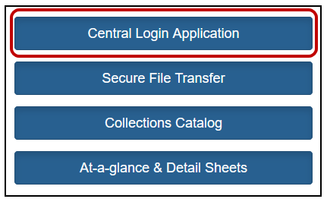
- Login on the district Central Login web application.
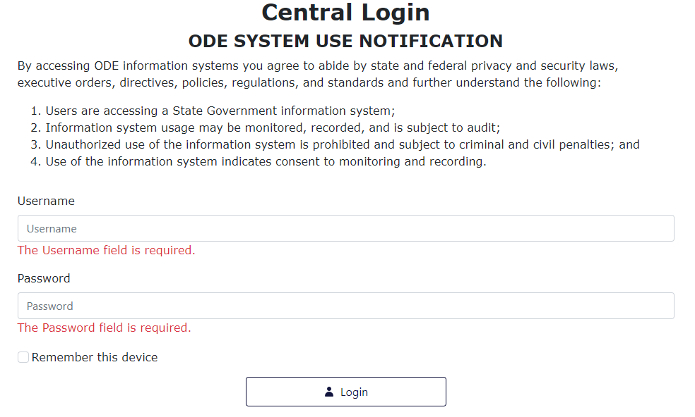

- An Applications list will appear on the next page. Click on Consolidated Collections.
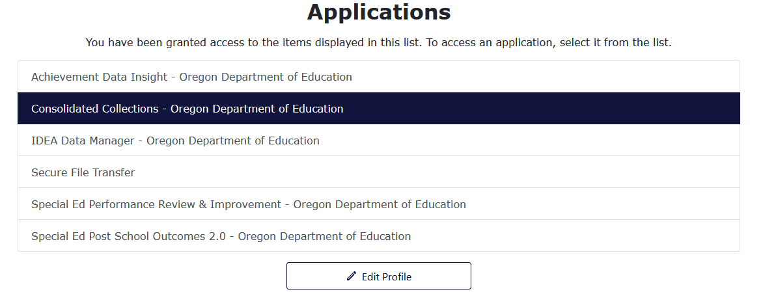
- Select the Reports tab, located next to the Status Tracking tab.
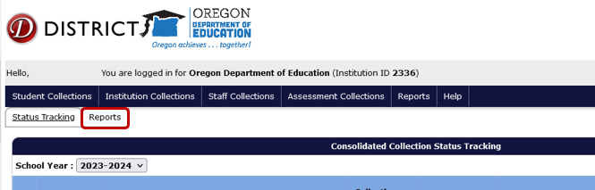
- In the Collection menu, select Special Education Child Census (SECC).
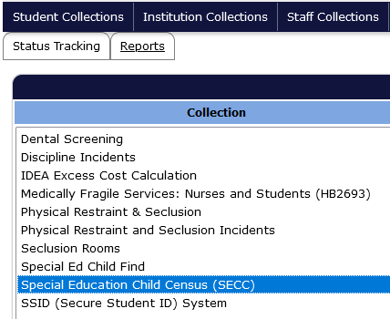
- In the Report Year menu that appears below or to the right, select the DecSECC Report from the collection year needed.
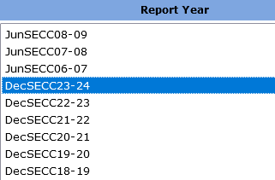
- In the Report menu that appears below or to right, select Production Download Report.
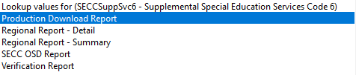
- A new tab will open notifying which report was selected, and identifying the collection and year requested.
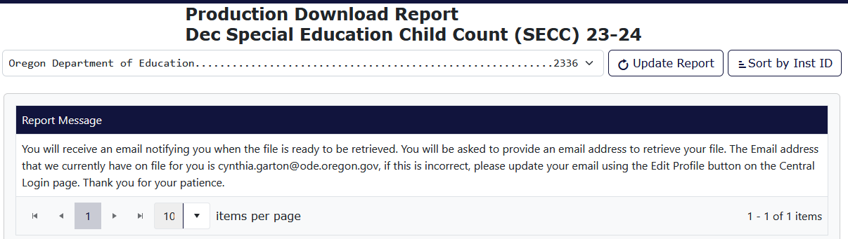

- Consolidated Collections will send the user an email, using the email address associated with the users login/account. Click the link in this email.
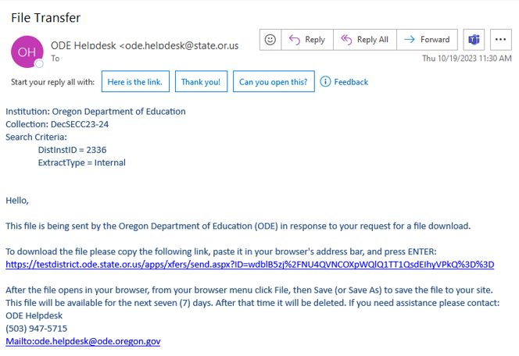
- The link will take users to a Secure File Transfer page on the ODE District website. Enter the user’s email address, the same address the email was sent to, and click the Submit Email Address button.
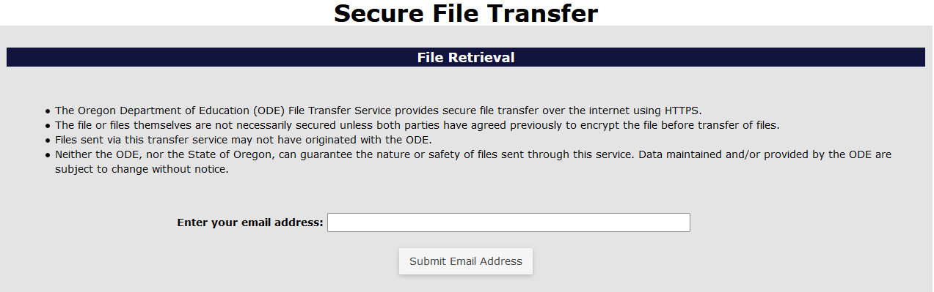
- After the Submit Email Address button is clicked, the page will generate a Download button. Click the Download button to download the zip file of the Production Download Report.
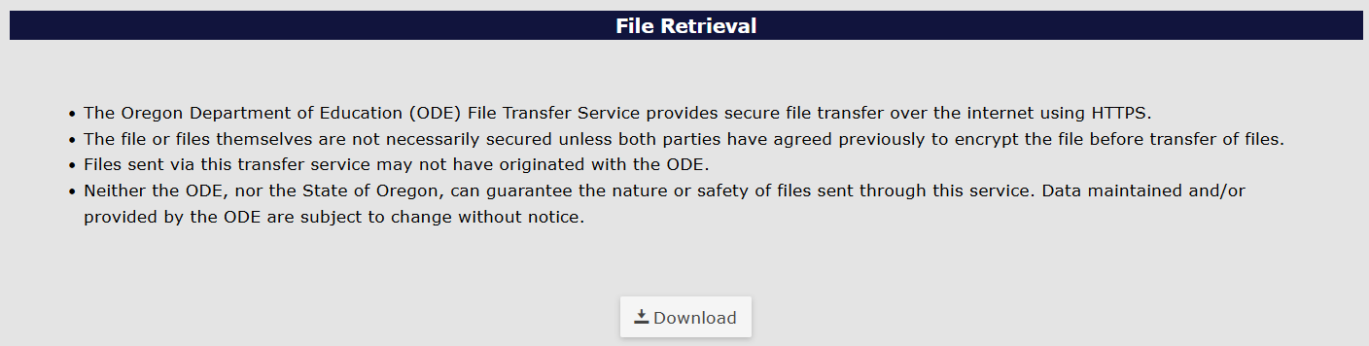

- The system will generate a download box in the top right of the bowser. Users can click on the file name or the folder icon. Clicking the file name will open a zip folder containing a CSV workbook. Clicking the folder icon will open the Downloads folder where the file has been saved.
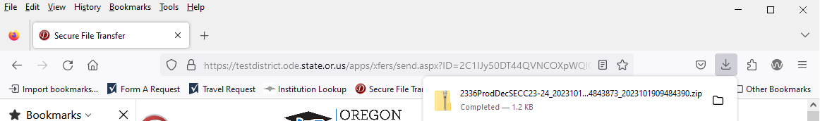
The same steps can be used for June Exit, which is also located in the Special Education Child Census (SECC)” in the Collection menu. For Child Find, select “Special Ed Child Find” in the Reports menu.
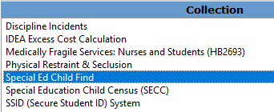
If you need assistance with this process, call anyone in the Data Team:
- Jackie McKim, 971-240-0234 or jackie.mckim@ode.oregon.gov
- Cynthia Garton, 503-508-7492 or cynthia.garton@ode.oregon.gov
- Maxwell Swope, 971-208-0259 or maxwell.swope@ode.oregon.gov

