**Validations:**

When files are uploaded here are the items that are checked:

1. The file is not empty

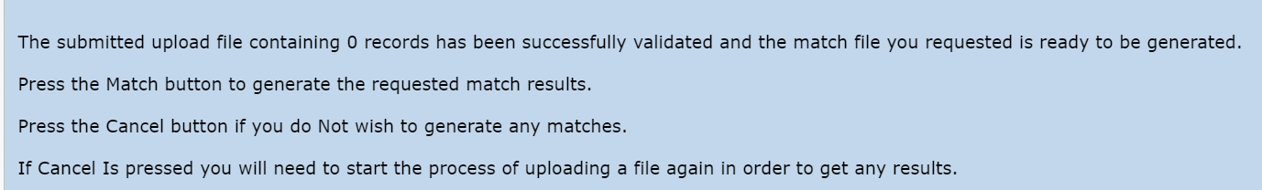

1. The file does not exceed size limit

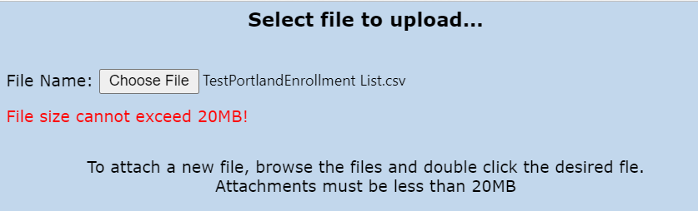

1. Required column headers are present

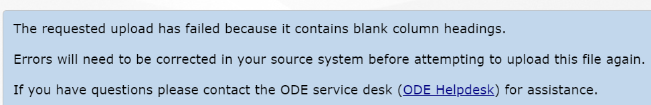

1. Verify the correct number of columns are present

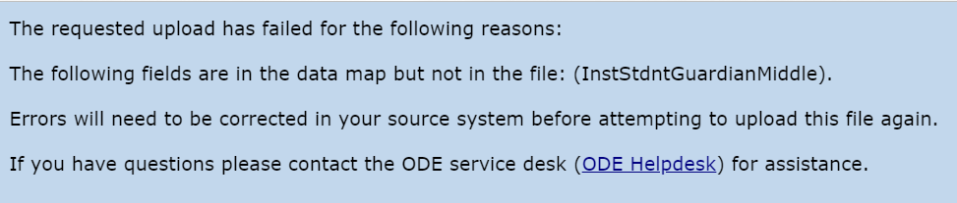

*(This could be any missing column heading)*

1. Data length checks for each field

*Example when the State field used 6 characters instead of 2*

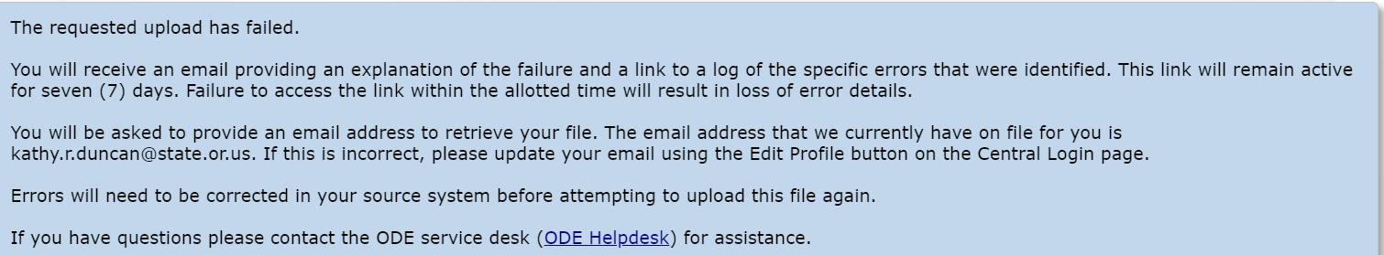

*Or you could get a message like this for length checks. Example when DOB was entered using 2 characters instead of 4 in the year field*

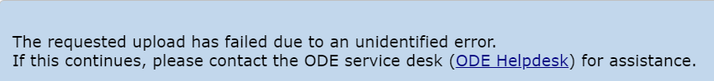

1. Data type checks for each field

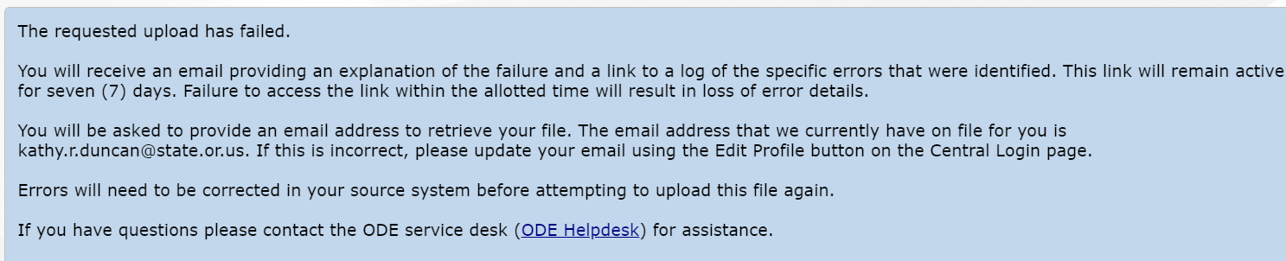

When errors are found the submitter receives an email with a file of the errors found.  The email will contain the information below. It will contain the CSVFileRowID, the field that contains the error, the value, and the error summary.   If errors are found the submitter would correct them in their source file and upload the file again.

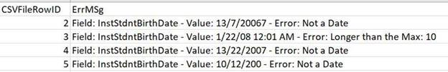

Note: The validations are not checking that the data matches against what is in a student record it is just checking to make sure that the correct fields and data format is in the uploaded file.