Seclusion Rooms Collection
User Guide
  - May 2024
Oregon Department of Education
Office of Enhancing Student Opportunities
255 Capitol Street NE
Salem, OR 97310-0203

It is the policy of the State Board of Education and a priority of the Oregon Department of Education that there will be no discrimination or harassment on the grounds of race, color, religion, sex, marital status, sexual orientation, gender identity or expression, national origin, age, or disability in any educational programs, activities or employment. Persons having questions about equal opportunity and nondiscrimination should contact the Director of Public Instruction at the address above; phone 503-947-5740; or fax 503-378-4772.

Table of Contents
Collection Overview 1
What’s New 2
May 2024 2
Institutions with Zero Seclusion Rooms to Report 2
General Information 3
Introduction 3
Important dates 3
Contact List 3
Training & Materials 4
Listserv 4
Data Collection Contacts Information 4
Restraint & Seclusion OARs 6
ODE Help Desk & Data Security and Privacy Overview 7
Contact Information 7
Services 7
Help Desk vs. Data Team – who to call? 7
ODE Help Desk: What to Expect 7
Data Security and Privacy 8
Student Data Security: Handle With Care 8
ODE Policies 8
Information Security Questions 8
Navigating the Seclusion Rooms Collection 9
Login Information 9
Getting Access 11
Submitting Data to the Seclusion Rooms Collection 12
File Upload 12
Add a Single Record 14
Roll Forward Feature 17
Seclusion Rooms Field Descriptions 19
Edit a Record 21
Delete a Record 22
Correcting Errors 23
Verification 26
Verifying Zero Records 27
Review Window 28
Secure File Transfer 29
Frequently Asked Questions 33
Seclusion Rooms File Format 36

Collection Overview
On June 6, 2019, Senate Bill 963 was signed into law by Governor Kate Brown. Senate Bill 963 changed the restraint and seclusion laws in Oregon public education programs, effective July 1, 2019. Oregon Administrative Rule (OAR) 581-021-0559, which previously detailed the annual reporting requirements for restraint and seclusion was repealed in October 2019. In its place, a new rule with the annual reporting requirements has been added to Division 22, making compliance with reporting mandatory to be considered a standard school. See OAR 581-022-2267. Division 22 assurances signal a commitment to providing a high-quality educational experience and equitable opportunities for all students.
The Oregon Department of Education (ODE) uses restraint and seclusion data to assist in monitoring areas in need of attention and to assure technical assistance is provided. Frequent use of non-standard spaces, or reports of seclusion incidents occurring in districts without catalogued rooms, may signify to ODE a need for technical assistance.
Training and Other Technical Assistance for the use of Restraint and Seclusion located at the School Discipline, Restraint and Seclusion webpage.
Restraint and Seclusion reporting is completed in Oregon via the following collections:
Restraint and Seclusion Incidents Collection
The Restraint and Seclusion Incidents Collection is a student level collection. This collection assures compliance with required annual reporting detailing the use of restraint and seclusion. See OAR 581-021-0568 and OAR 581-022-2267.
Seclusion Rooms Collection
The Seclusion Rooms Collection is an institution level collection that provides a mechanism for reporting that compliance standards are met for the structural and physical requirements of rooms designated to be used for seclusion. See OAR 581-022-2267(1)(f).
The remainder of this manual will focus on guiding users through the Seclusion Rooms Collection.

What’s New
This section outlines changes to this document or the Seclusion Rooms collection for 2023-2024.

May 2024
- Clarifying guidance on which institutions to login as.
- Added instructions on how to edit a record.
- Added instructions on how to delete a record.

Institutions with Zero Seclusion Rooms to Report
Please complete, submit, and verify a submission to the Seclusion Rooms Collection, even if there are no seclusion rooms to report.
If there are zero seclusion rooms to report, clicking the Verify Submission button confirms the agency has zero seclusion rooms. For steps on verification, go to the section on Verification and Verifying with Zero Records.

General Information

Introduction
The purpose of this document is to be an easy reference tool for staff responsible for reporting data related to the Seclusion Rooms Collection.
If this manual does not provide the guidance necessary to answer a specific data collection question, please contact any of the staff in the Contact List. It is extremely important that data submitted for all collections are timely, accurate, valid, and reliable. If an error is located anywhere in this manual, please feel free to inform any of the staff in the Contact List.
Throughout this manual, the following icons are used to help inform readers about the information displayed.
Icon | Description
 | An information circle indicates an informational note.
 | A light bulb indicates a useful tip.
 | A warning triangle indicates a warning and the user should use caution.

Important dates
Seclusion Rooms Collection Window | Open 5/16/2024 | Close 7/8/2024
Review Window | Open 8/15/2024 | Close 9/16/2024

Contact List
Lisa Joy Bateman Education Specialist (503) 569-2951 lisajoy.bateman@ode.oregon.gov
Jackie McKim Research Analyst (971) 240-0234 jackie.mckim@ode.oregon.gov
Cynthia Garton Research Analyst (503) 508-7492 cynthia.garton@ode.oregon.gov
Maxwell Swope Research Analyst (971) 208-0259 maxwell.swope@ode.oregon.gov
Amanda Claycomb Research Analyst (503) 931-8003 amanda.claycomb@ode.oregon.gov
Cara McMurry Research Analyst (503) 689-2783 mcmurryc@ode.oregon.gov

Training & Materials
Training for the Seclusion Rooms Collection is located at the Collection page. Other technical information can be found in the Schedule of Due Dates.

Listserv
Staff who submit and maintain Discipline data will be added to the Discipline and Restraint/Seclusion GovDelivery Listserv. If you should not be on this list or if you wish to be added to this list, please contact a staff member on the Contact List.

Data Collection Contacts Information
The Office of Enhancing Student Opportunities uses the IDEA Data Manager web application for maintaining various Listserv lists so ODE knows who to contact if we have any questions. It is important that each agency maintain the most up-to-date information in the IDEA Data Manager. It is the responsibility of each agency to update their agency contact information when there is a staff change.

Important - Please Read
Eight Rules for Submitting Timely & Accurate Data
- Keep your data up to date at all times. The more up to date the data, the less time it will take to prepare data for submission.
- Read all the instructions and documentation related to the data collection.
- Submit data as early as possible, but do not rush! Technology, weather, and other factors can suddenly keep a district from being able to submit data on the final day.
- Join the Special Education Data Submitters Listserv and read all messages carefully.
- Train at least one backup person to submit, validate, and correct data for each data collection. Key people may get sick, injured, or leave without notice. Do not forget to have the district security administrator grant appropriate permissions to the backup staff member. Your District’s Security Administrator can be found on the ODE District website.
- Back up the data often to a secure location other than your computer’s hard drive (e.g., network drive or disk). Technological mishaps are sometimes unavoidable and frequently lead to loss of data.
- Make a plan. Use the Schedule of Due Dates to plan your data submission calendar.
- If you have questions, contact the data owner at ODE as soon as possible. The data owners are here to help you.
Following these rules throughout the year will help reduce the risk of your district’s data becoming late and/or inaccurate.

Restraint & Seclusion OARs
581‐021‐0550
Definitions: Restraint and Seclusion
581‐021‐0553
Use of Restraint and Seclusion in Public Education Programs
581‐021‐0556
Procedures Regarding Restraint and Seclusion
581‐021‐0563
Approval of Restraint and Seclusion Training Programs for School Staff
581‐021‐0566
Required Use of Approved Restraint and Seclusion Programs
581‐021‐0568
Standards for Seclusion Rooms
581‐021‐0569
Use of Seclusion Cells Prohibited
581‐021‐0570
Complaint Procedures
581‐015‐2181
Functional Behavioral Assessments
581‐022‐2267
Annual Report on Use of Restraint and Seclusion

ODE Help Desk & Data Security and Privacy Overview

Contact Information
ODE Helpdesk ODE.Helpdesk@ode.state.or.us (503) 947-5715

Services
ODE Help Desk can
- Provide technical assistance with how to submit your data
- Check to see if your data has been submitted
- Provide assistance with questions about access rights and permissions
ODE Help Desk can not
- Submit your data for you
- Make changes to your data
- Answer content area questions

Help Desk vs. Data Team – who to call?
Question | Answer
How to report a student? | Data Team
Why won’t my data submit? | Data Team (will refer to the Help Desk if needed)
Audit/Error Corrections? | Data Team
How can I get a new user added? | ODE Help Desk

ODE Help Desk: What to Expect
The best way to contact the ODE Help Desk is at ODE.helpdesk@state.or.us or (503) 947-5715.

Data Security and Privacy
The student data that you collect, handle, and submit is protected student data governed by:
- Family Educational Rights and Privacy Act (FERPA) (34 CFR Part 99)
- Oregon Identity Theft Protection Act
- And in some cases, the Health Insurance Portability and Accountability Act (HIPAA), such as the transfer of records between agencies
Consequences: Loss of protected data can have financial impact to your school, district, or ESD, including fines and cost of remediation!

Student Data Security: Handle With Care
Basic tips to protect student level data:
- Use Secure File Transfer. Never send information that would identify an individual student via email, not even to the ODE Help Desk or a member of the Data Team. Emails sent to and from the ODE are considered public record.
  - In order to provide information to ODE, it is advisable to send only the student’s SSID number.
  - Never send students’ name, birth date, telephone number, grade or anything else that could be used to identify a specific student.
  - On ODE’s Secure File Transfer users can send secure documents to ODE Staff.
- Never share your username and password
  - You are responsible for everything done in the system using your username and password
  - Avoid storing your password in an obvious place (desk drawers, under keyboards, sticky notes on monitors are all bad places to store passwords)
- Use a Passphrase instead of a Password
  - Passphrases are sentences you can remember and include spaces and punctuation.
  - Example: Trust the force, Luke!
  - Example: Scotty, beam us up.
- Lock your computer monitor (Window key +L) when you leave your desk
  - Avoid leaving your monitor open and unattended
- Never store or transport student data on an unencrypted thumb drive/flash drive
  - Portable drives are one of the biggest risk factors for losing large volumes of data
The privacy and security of student data depends upon you.
People are the most important part of information security

ODE Policies
Handling Confidential Information
Information Asset Classification

Information Security Questions
Contact ODE Chief Information Security Officer and Team at ODE.Infosec@ode.state.or.us.

Navigating the Seclusion Rooms Collection
The Seclusion Rooms data collection opens May 16, 2024 and closes July 8, 2024. The review window for the collection opens August 15, 2024 and closes September 16, 2024. The review window is the period during which corrections can be made to the data submission.

Login Information
Access your applications list from the ODE District site at https://odedistrict.oregon.gov/Pages/default.aspx. Select the Central Login Application button.
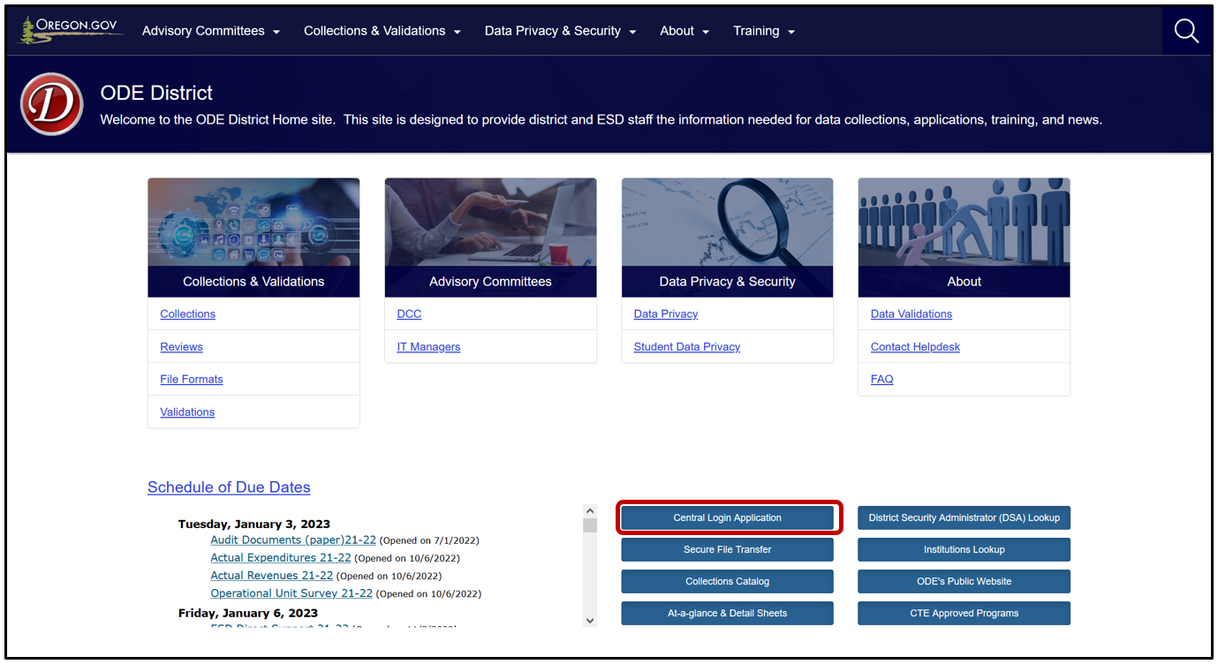
Logging in takes Users to their Applications List, (yours might appear differently). Users must only log in as the School District or ESD to report records. Do not use a school as report records. Select the School District or ESD in the Application List, e.g., “Consolidated Collections – School District.”
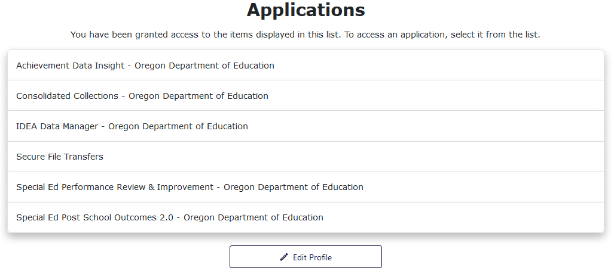
From the Applications list, click on Consolidated Collections.
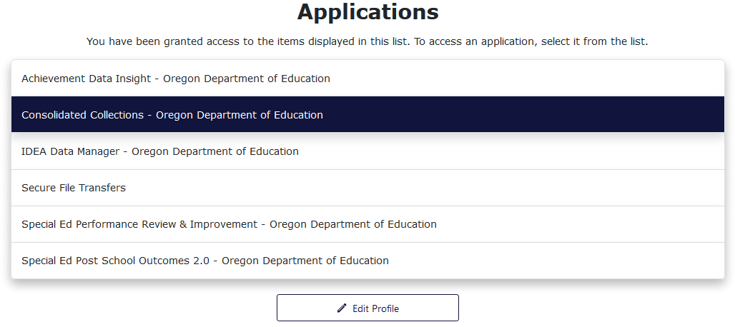
Users should see a screen that looks similar to this:
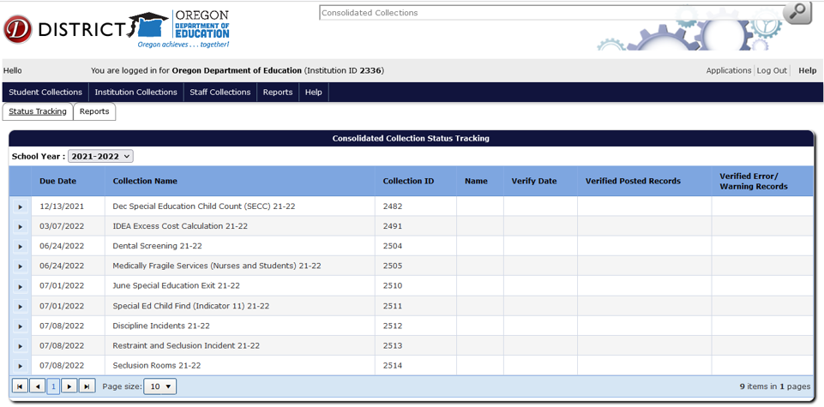
The list of collections users see will depend on the collections they have permissions to view and/or modify. If a user does not see the specific collection for which they are submitting data, they will need to contact their District Security Administrator for permissions outlined in Getting Access.

Getting Access
When requesting access to one of the District Applications, contact your district’s Security Administrator.
If you do not know who your District Security Administrator is, go to the District Home page, and on the right-hand side beneath Quick Links, click Find Security Administrator.
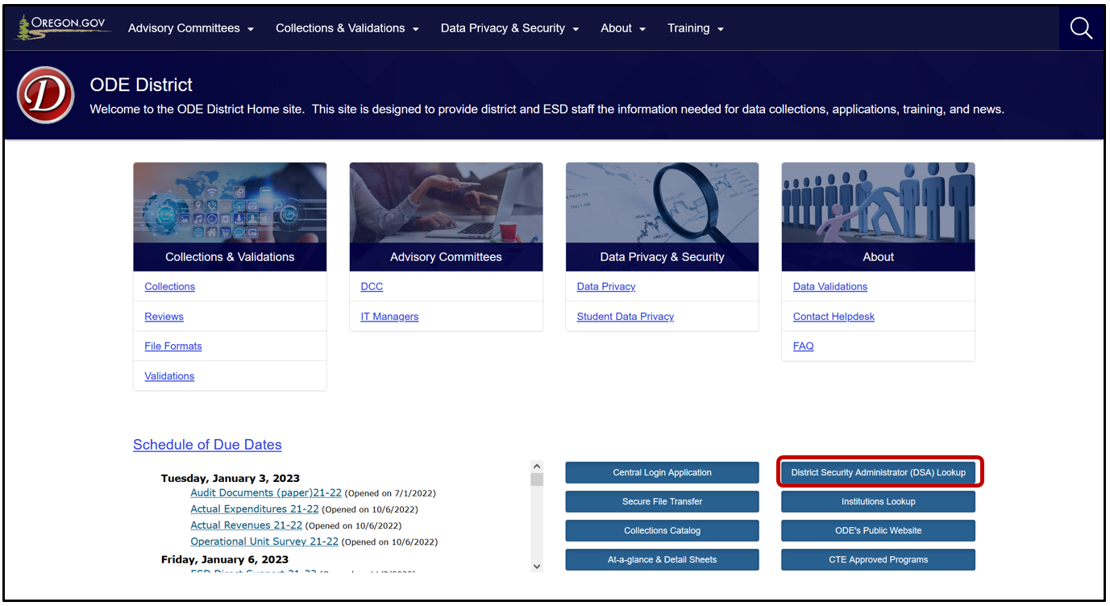
On the Search for Security Administrator page, enter an institution ID or District Name, then click the Search button.
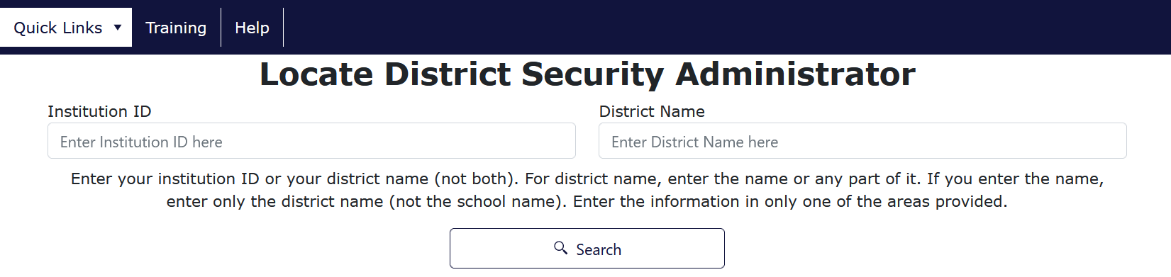
When requesting access to applications such as Consolidated Collections, data submitters must request Submitter rights and Modify rights. Users should verify with their District Security Administrator that they have both permissions. Without both, users will not have the ability to view, submit, edit and verify data.
Below is an overview of the process for submitting records for Seclusion Rooms. For detailed instructions on how to navigate Consolidated Collections, see the OESO Consolidated Collections User Guide. Each collection will display the applicable collection year in the title.

Submitting Data to the Seclusion Rooms Collection
The Seclusion Rooms Collection is an institution level data collection. The data reported will be used to determine and ensure compliance standards are met for the structural and physical requirements of rooms used for seclusion. See OAR 581-022-2267(1)(f). Seclusion room data needs to be submitted by all districts, including those with no rooms to report.
Reminder: Use the School District or ESD login to report records. To submit data, hover your mouse over Institution Collections. A drop menu will appear, containing a list of open collections. When ready to submit, hover over the collection name, in the following example case, Seclusion Rooms. A fly out menu will appear with four options: Submission/Maintenance, Web Submission, Error Management and Production Download.

File Upload
To upload a submission file, hover your mouse over Institutions Collections in the top menu bar. From the drop menu, hover over Seclusion Rooms 23-24. From the fly out menu, click File Upload. The example is for 2021-2022 Seclusion Rooms.
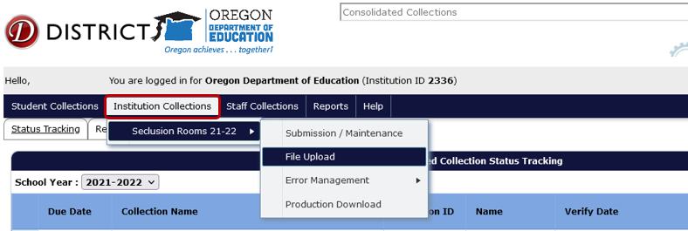
The File Upload menu option takes you to an upload screen. Click on Browse (may look different depending on browser) to locate the file containing Seclusion Rooms records. The file can be in .CSV or .XML format. After selecting the file, click Upload.
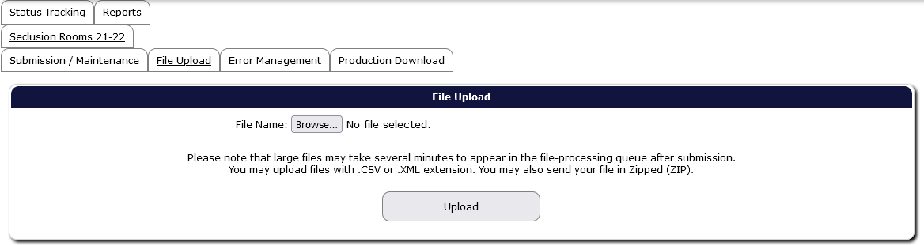

A File Upload dialog box will appear. Select the submission file and then click the Open button.
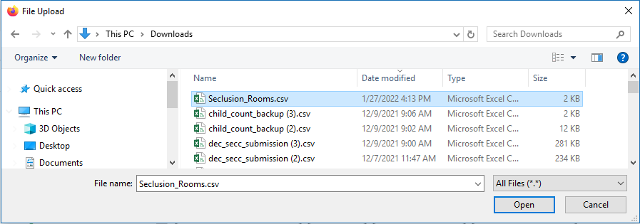
Finally, click the Upload button to submit the file to ODE.
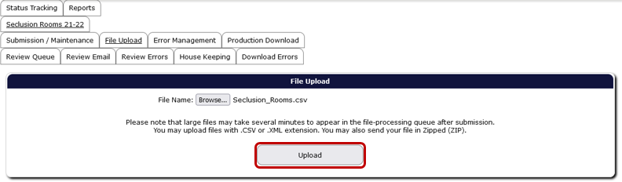
If the upload is successful, the screen will display information boxes with information on the file and processing status. Consolidated Collections will notify users by email when the validation processing is complete.
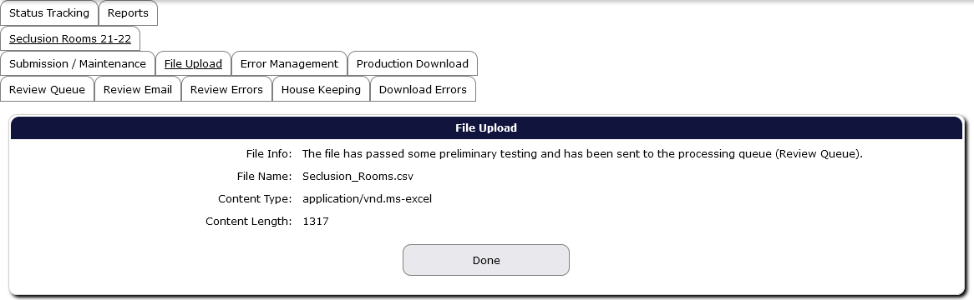
Users are not finished submitting data to ODE until all errors are corrected AND the collection is verified. Please see sections Correcting Errors and Verification.

Add a Single Record
To add a single record, hover over Institution Collections. From the drop menu of currently open collections, hover over the needed collection name to access the fly out menu, then click Submission/Maintenance.
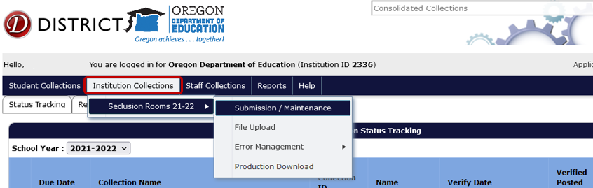
This screen allows users to enter one record at a time. Click Add New Record.
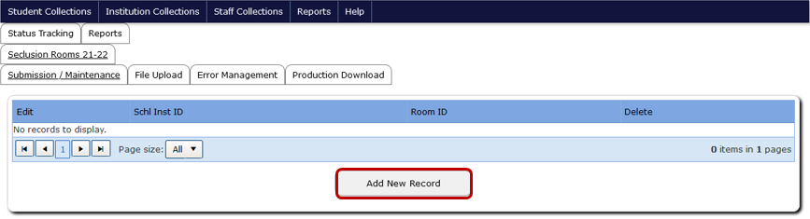

Enter the Seclusion Room information and then click the Save button, located at the top and bottom of the record screen.
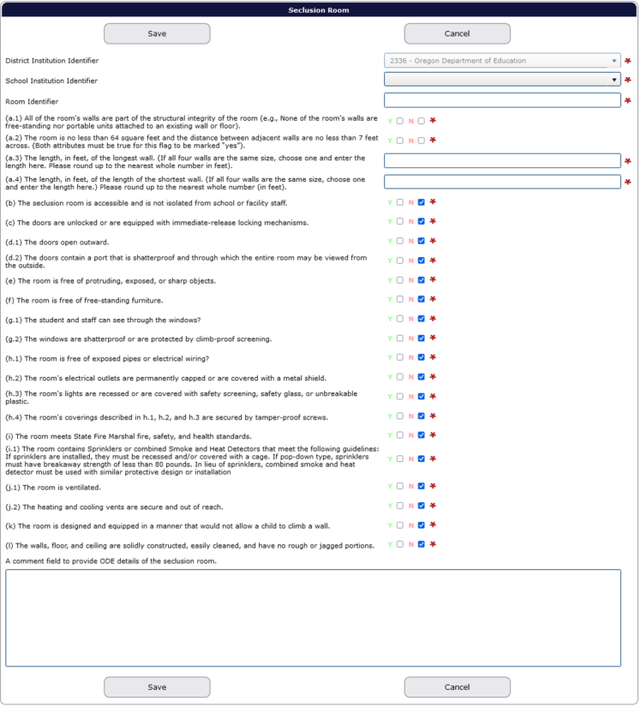
After clicking Save, if there are any required fields not completed, the system will generate pre-check error messages at the top of the record screen. The corresponding fields also will have a red outline around them.
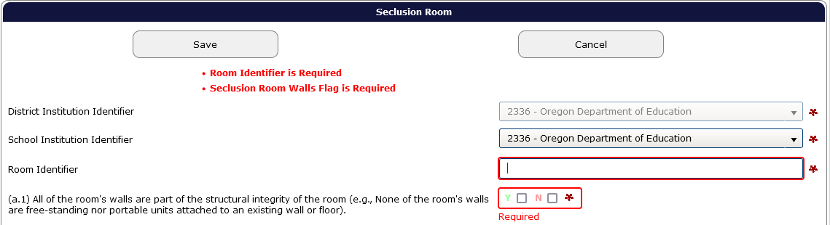
After filling in the fields, be sure to check for validation errors. See Correcting Errors for steps on correcting validation errors.
Warning: if any required field is not completed and pre-check error warnings are present when the user exits the record screen, the record will not save. Be sure to clear all pre-check errors before leaving the record. If there are no validation errors, the record will appear in the Submission/Maintenance screen. If there are any validation errors, the record will appear in Error Management.
If there are no errors or empty required fields and the record successfully saves, the application will display the message “Record Saved” in green. Users can continue to add new records or delete records.
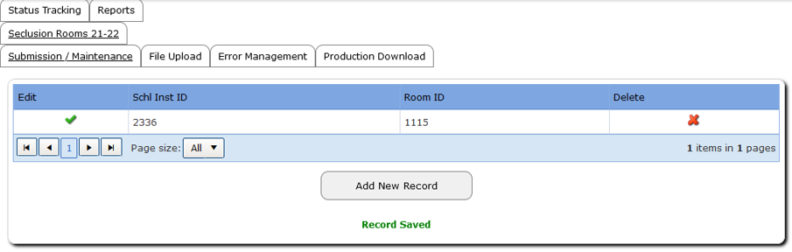

Roll Forward Feature
When there are no changes, or minimal changes, to the seclusion room records the district is submitting, users can select the Roll-forward from Previous Year menu option. From the fly out menu, hover over Institution Collections, then hover over Seclusion Rooms, then click Roll-forward from Previous Year.
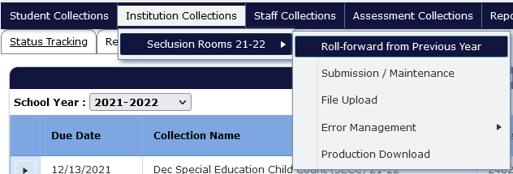
This screen allows users to select one room at a time or select all rooms. Either click the green plus sign icon next to the desired room or click the Select All button. Users can click the plus sign icon to roll forward as many rooms as necessary.
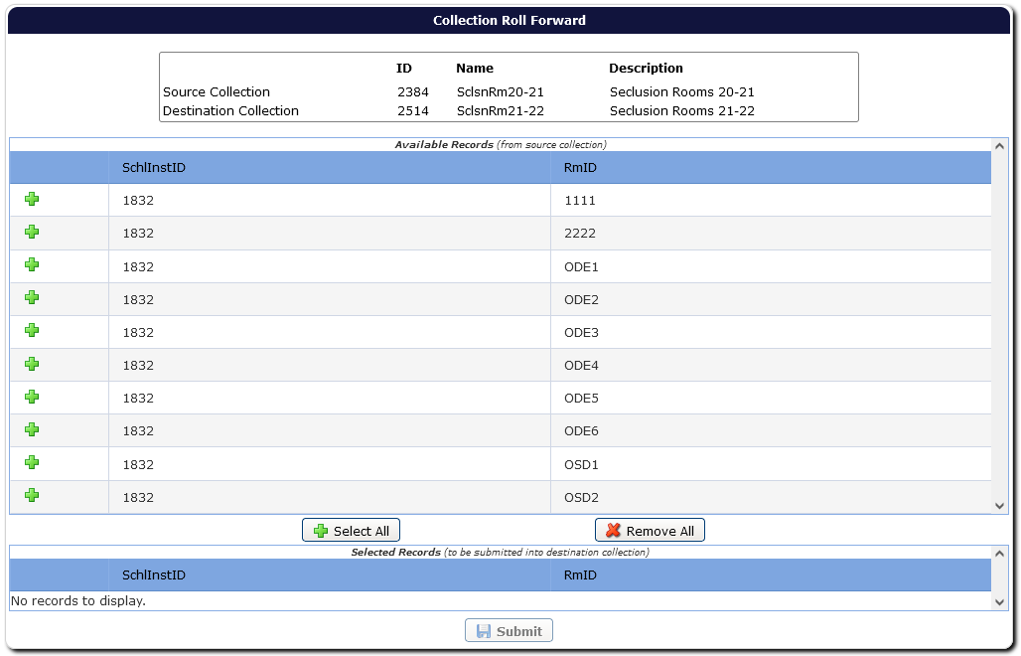
Users can select all records, but if a user decides not to, users can click the Remove All button.
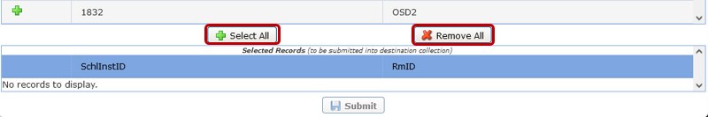
When rolling forward, after selecting a room, the screen will update to display the selected record(s) at the bottom of the screen. Users can update the Room ID if that has changed. Click the red X to remove a record from the roll forward list, if necessary. When ready to roll forward the record(s), click the Submit button.
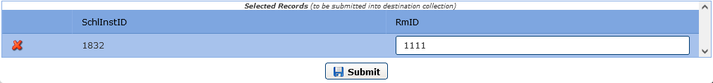
After clicking the Submit button, the screen will generate a message that the record has been submitted and that the user will receive an email.
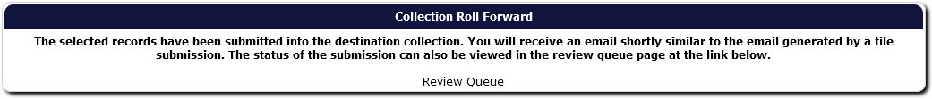
The email will contain the number of records submitted, the number of records in error, and number of records posted to Submission/Maintenance.
Users can go to the Submission/Maintenance screen to review the records and make updates as needed by clicking the green checkmark to access the record.
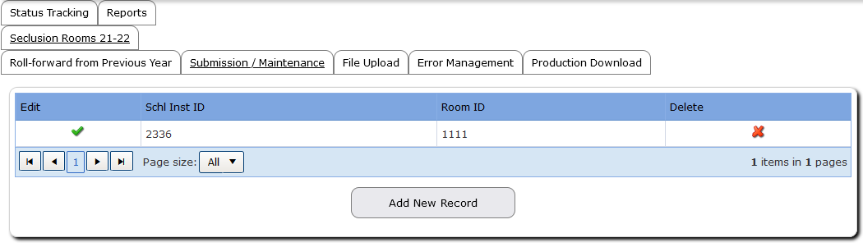

Seclusion Rooms Field Descriptions
From Top to Bottom:
Select Your District and School Identifiers.
Room Identifier is a unique (per institution) alphanumeric identifier for the room. This is the naming convention the institution uses to uniquely identify the room. Users will need to enter data for each room separately, either by submitting a new record for each one via web submission or by entering each room on a separate row in a file upload.
Confirm or enter, as appropriate, the following:
(a.1): All of the room’s walls are part of the structural integrity of the room.
(a.2): The room is no less than 64 square feet and the distance between adjacent walls are no less than 7 feet across. (Both attributes must be true for this flag to be marked “Yes”).
(a.3) The length, in feet, of the longest wall. (If all four walls are the same size, choose one and enter the length here. Please round up to the nearest whole number in feet).
(a.4) The length, in feet, of the length of the shortest wall. (If all four walls are the same size, choose one and enter the length here.) Please round up to the nearest whole number (in feet).
(b) The seclusion room is accessible and is not isolated from school or facility staff.
(c) The doors are unlocked or are equipped with immediate-release locking mechanisms.
(d.1) The doors open outward.
(d.2) The doors contain a port that is shatterproof and through which the entire room may be viewed from the outside.
(e) The room is free of protruding, exposed, or sharp objects.
(f) The room is free of free-standing furniture.
(g.1) The student and staff can see through the windows.
(g.2) The windows are shatterproof or are protected by climb-proof screening.
(h.1) The room is free of exposed pipes or electrical wiring.
(h.2) The room’s electrical outlets are permanently capped or are covered with a metal shield.
(h.3) The room’s lights are recessed or are covered with safety screening, safety glass, or unbreakable plastic.
(h.4) The room’s coverings described in h.1, h.2, and h.3 are secured by tamper-proof screws.
(i.1) The room meets State Fire Marshal fire, safety, and health standards.
(i.2) The room contains Sprinklers or combined Smoke and Heat Detectors that meet the following guidelines: If sprinklers are installed, they must be recessed and/or covered with a cage. If pop-down type, sprinklers must have breakaway strength of less than 80 pounds. In lieu of sprinklers, combined smoke and heat detector must be used with similar protective design or installation.
(j.1) The room is ventilated.
(j.2) The heating and cooling vents are secure and out of reach.
(k) The room is designed and equipped in a manner that would not allow a child to climb a wall.
(l) The walls, floor, and ceiling are solidly constructed, easily cleaned, and have no rough or jagged portions.
Use the comment field to provide ODE details of the seclusion room.
This field is only required if the seclusion room does not meet standards. Do not use commas and/or special characters in the comment field. If a seclusion room does not meet standards, please provide the agency’s plan to bring the room up to standards. Any seclusion rooms that are not compliant must be decommissioned until such point as they have been brought into compliance.

Edit a Record
To edit a record, hover over Institution Collections. From the drop menu of currently open collections, hover over Seclusion Rooms to access the fly out menu, then click Submission/Maintenance.
The system will generate a table with the institution’s Seclusion Rooms. To edit, click the green checkmark to the left of the record.
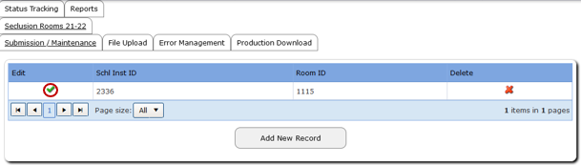
Clicking the green checkmark will open the record for users to edit. Once done, click the Save button. Be sure to check for validation errors. See Correcting Errors for steps on correcting validation errors.
If there are no errors and the record successfully saves, the application will display the message “Record Saved” in green.

Delete a Record
To delete a record, hover over Institution Collections. From the drop menu of currently open collections, hover over Seclusion Rooms to access the fly out menu, then click Submission/Maintenance.
The system will generate a table with the institution’s Seclusion Rooms. To delete, click the red “X” to the right of the record. If deleting duplicate record(s), click green check mark to the left of the record, located in the Edit column, next to School Inst ID column. This will allow users to double check they are deleting the applicable record.
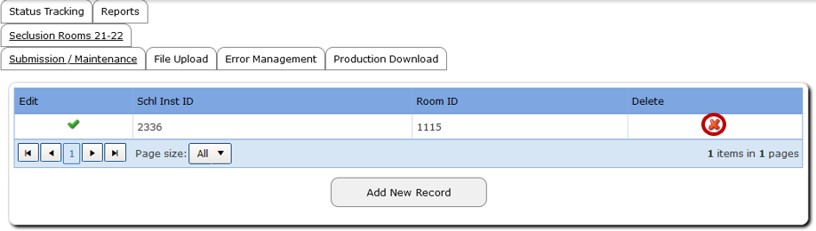
Users can double check the record has been successfully deleted by searching for the record in the search screen located under Submission/Maintenance.

Correcting Errors
Once all data has been loaded, the next step is to correct errors. To view and correct errors, hover your mouse over Institution Collections in the top menu bar. From the drop menu, hover over Seclusion Rooms, then from the fly out menu, hover over Error Management, and then click on Review Errors.
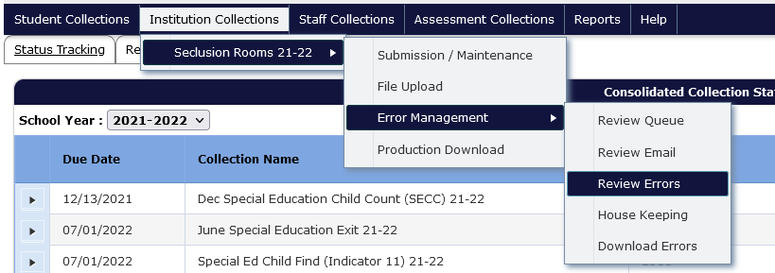
The Review Error screen displays by type of error. Click the triangle expand button, in the row of the type of error you wish to correct.
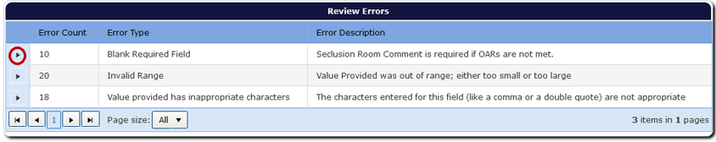
Clicking the triangle expand button expands the screen to display a grid of all records with that error.
After clicking on a triangle expand button, the grid in the expanded error screen contains a table with a green check mark to access the record, a red “x” to delete the record, the values causing the error, and the column names for these values.
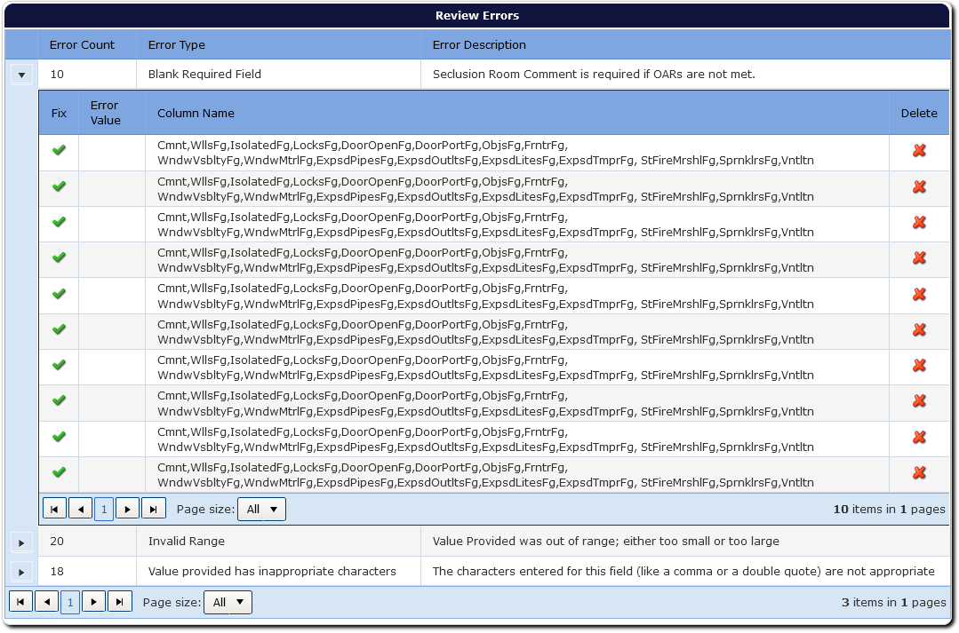
The other error types are still accessible by clicking the corresponding triangle expand button. To edit a record from the list, click on the green checkmark for the applicable record, which will open the record. The top of the record screen will display each validation error for the record.
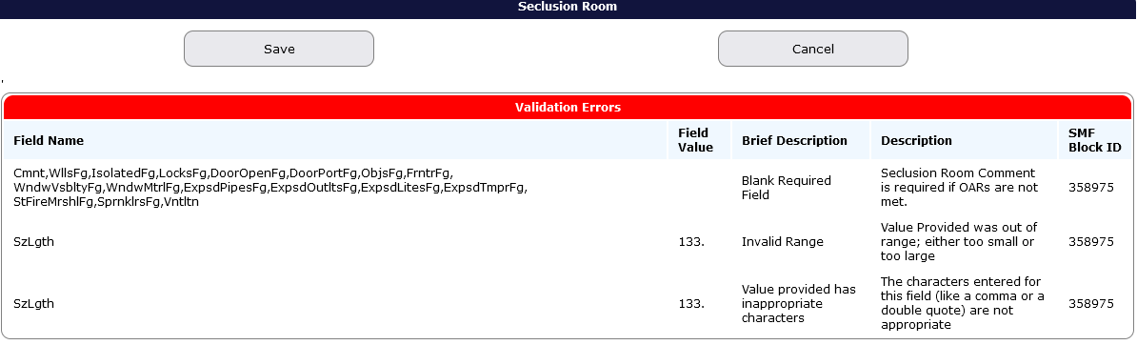
Consolidated Collections puts a red outline around the field that contains a validation error. If there is more than one validation error, each field that is in error will be outlined in red.
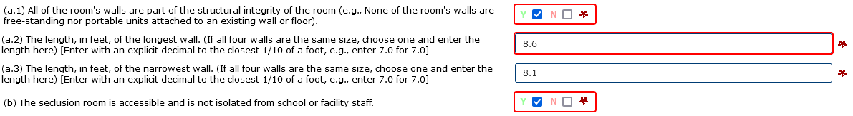
After fixing each error, click the Save button, located at the top and bottom of the record, which will clear the error. After clicking Save, the system will produce a green “Record Saved” message. The system also will revalidate the entire record, to check for any further errors.
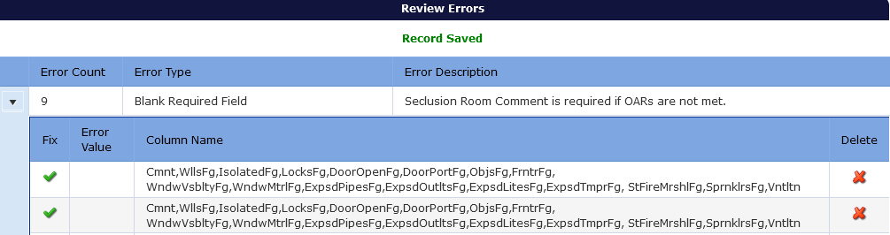Once all errors are fixed, the record will post to Record Management. If there is more than one error in the Error Type, the system will keep that type of error grid expanded.

Verification
The final step is verifying the submission. ODE cannot consider the collection complete until the submitting district verifies it as complete. All districts (even districts with no seclusion rooms during the school year) are required to complete the verification process on the Status Tracking tab.
From anywhere in the Consolidated Collections application, click the Status Tracking tab to go to the list of collections. Make sure the School Year dropdown displays the correct school year. This dropdown will automatically advance to the next school year on July 1. If the 2023-2024 collection closes on July 8 and is verified after June 30, 2024, when users arrive at the Status Tracking page, the dropdown will show 2024-2025 and all the collection names on will end with “24-25.” Use the School Year drop menu to change the collection year to 2023-2024. The example below uses 2021-2022 collections.
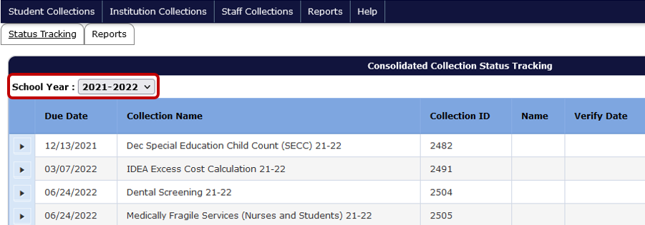
Click the expand arrow next to the collection to be verified. The screen will expand to show the Verify Submission button and record information.
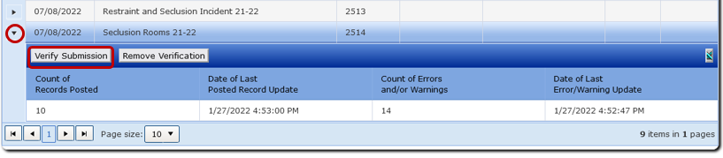

Under the Verify Submission button is a table grid with the count of records posted, date of last update, count of errors and warnings, and date of last error/warning update. Review the grid to ensure accuracy and that the data is error free.
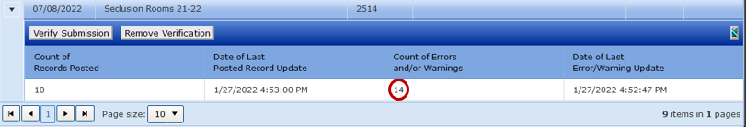
When the Verify Submission button is clicked, a popup message will appear indicating that the submission has been verified. The following will display in the columns to the right of the collection ID: the staff name and date of verification, as well as the number of records that posted and number of records in error, if there are any errors.
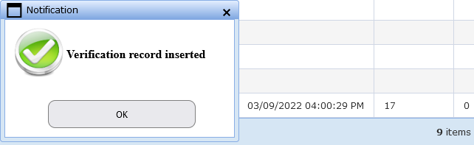
When these final steps have been completed, districts attest that they submitted accurate and complete data and that submission is considered complete.

Verifying Zero Records
If a district has no rooms to report for Seclusion Rooms, then users will click the Verify Submission button. Districts with zero rooms do not need to submit data, as clicking the Verify Submission button with zero posted records indicates to ODE that there were zero rooms.

Review Window
The Review Window opens on August 15, 2024 and closes on September 16, 2024. This correction window gives public education programs an opportunity to make additions/deletions and corrections to the posted records. If ODE finds data anomalies, districts will be contacted. Agencies must review, correct and/or confirm the errors, and confirm the collection has been verified.

Secure File Transfer
To send personally identifiable information to ODE staff, use Secure File Transfer. Go to the District Home page, and in the center right-hand side beneath Applications, select Secure File Transfer.
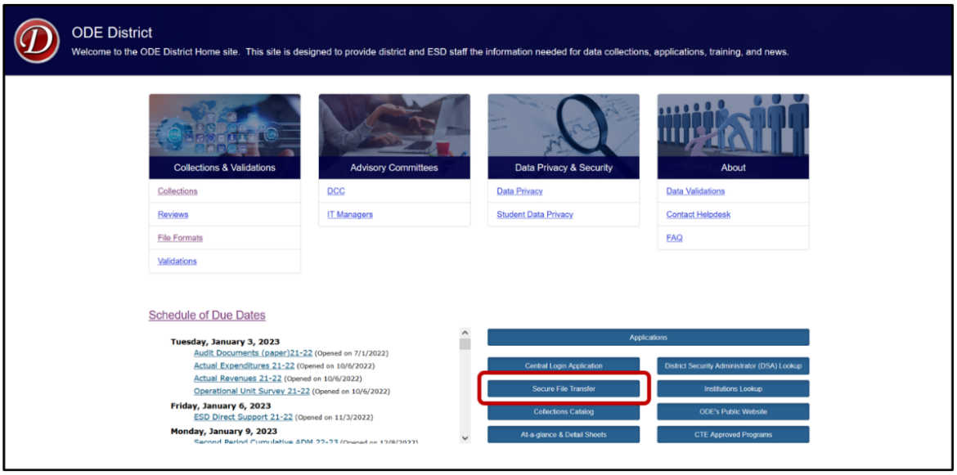
Secure File Transfer is behind a secure log in. The system will open a new tab to the Central Login page. Login to the District website by entering your User Name and Password, then press enter or click on the Login button.
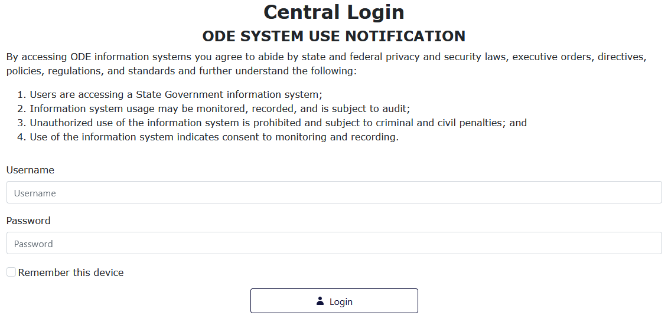

After signing in, users will be taken to their Applications List. Select Secure File Transfer.
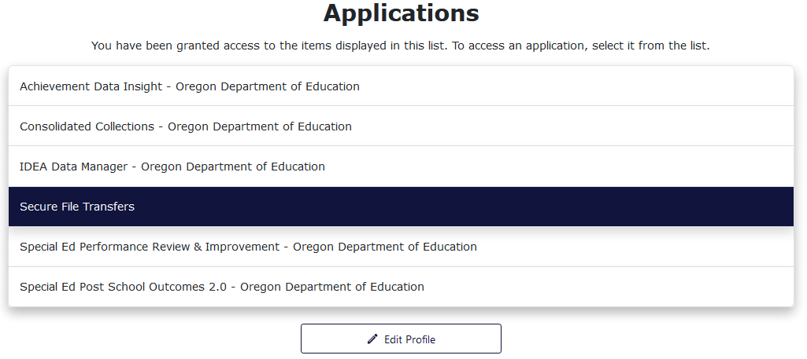
On the Secure File Transfer page, type the recipient’s email address. Click the To button to search the list of recipients. To select an email to add to the recipient list, click on the name or email address, then click Add Email.
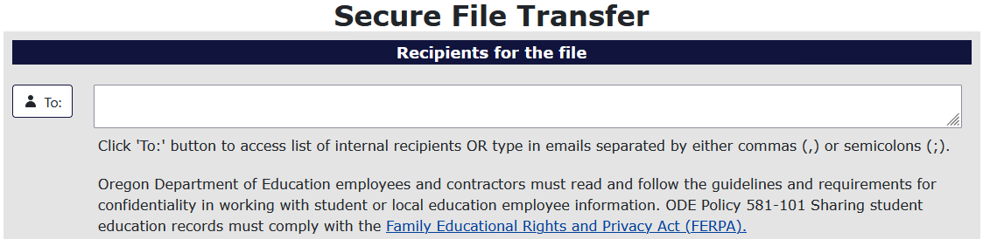To add the file to be sent, select the Select File button.
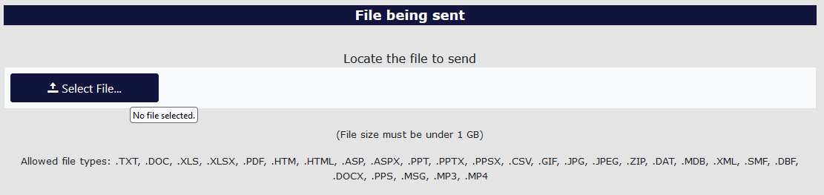
Find the desired file and select it. To select the file there are two methods. For the first method, users select the desired file, and then select the Open button in the window. For the second method, users double click the desired file.
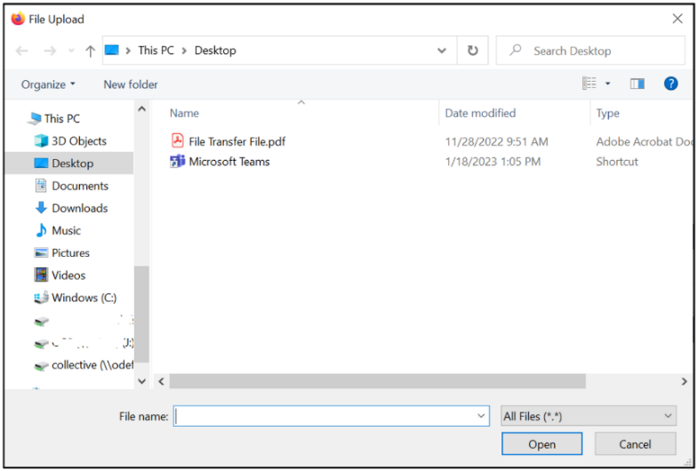
Users can type a message at the bottom of the page to add context and or anything else necessary for the recipients to know. This section is best thought of as the body of an email.
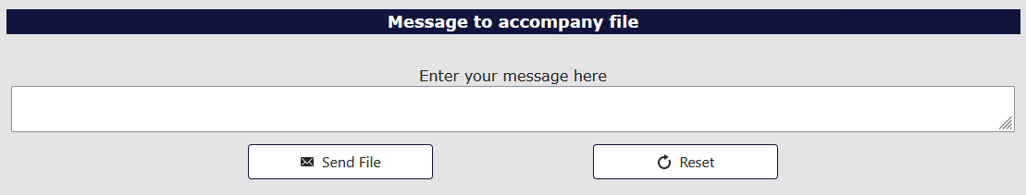
Finally, to send the file, select the Send File button.
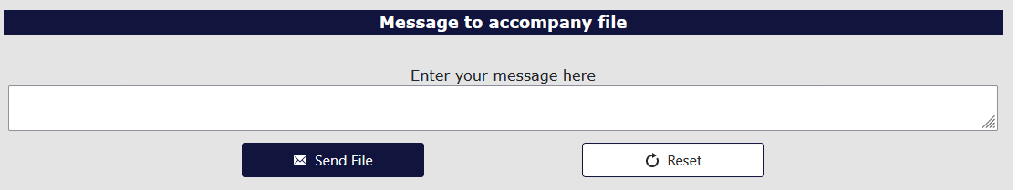
The recipient will receive an email with a web link. This link will take the recipient to a Secure File Transfer page on the ODE District website. They will enter their email address, the same address the user selected, and click the Submit Email Address button. The page will generate a Download button for the recipient to click, which downloads a zip file of the document the user sent.
If the recipient does not have a Central Login account, use the Link to external users section at the bottom of the screen.
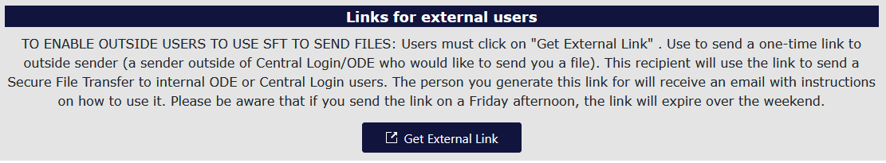
The system will generate a popup for users to enter the external repent email and message. Click the Generate External Link to send the secure file.
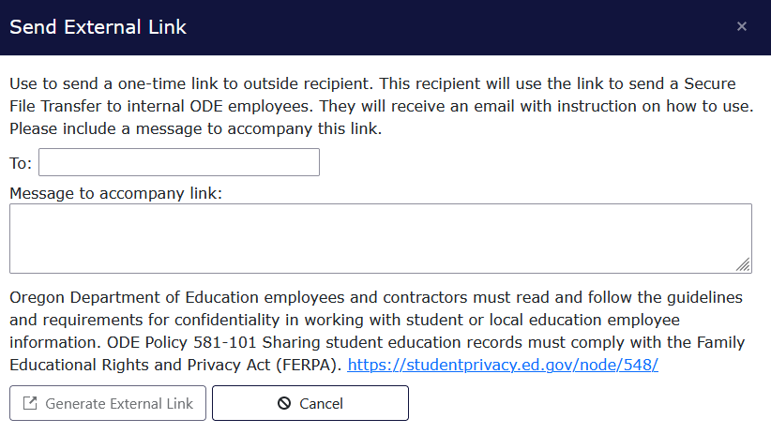

Frequently Asked Questions
Q: How do I log into the district site?
A: Visit the ODE’s District webpage. Your district’s Security Administrator must give you Primary Submitter rights and Modify rights to submit and edit records, and verify the submission.
Q: Where do I find the Seclusion Rooms Collection once I have logged into the site?
A: It is in Consolidated Collections under Institution Collections.
Q: What is the best way to submit data for my district?
A: Districts with fewer seclusion rooms may want to submit the data through the web submission process. Districts with more seclusion rooms will likely prefer to use the file upload process.
Q: How do I submit online through the web submission process?
A: 1) Go into Consolidated Collections. From the Institution Collections menu, hover over Seclusion Rooms 23-24.
2) Hover over Submission/Maintenance.
3) Click on Add New Record.
4) The District Institution Identifier field should display your district name.
5) In the School Institution Identifier field, choose a school from the drop-down list.
6) Provide a district generated alphanumeric Room Identifier of up to thirty characters. This is a unique ID for each room entered.
7) Enter the record data in the fields. Required fields have a red asterisk. Then click Save.
Q: How do I upload files to the ODE for the Seclusion Rooms Collection?
A: You can submit a file in Comma Delimited (.csv) or XML Data (.xml) format via the Department interface. To do so:
- From the from the Institution Collections menu, hover over Seclusion Rooms 23-24.
- Click on File Upload.
- Click on Browse and select the file you want to submit.
- Click Upload.
You will then receive an email indicating the total number of records posted and the number that had errors. If any records had errors, users will go through the error checking and clearing process until the data are error free.
Q: How can I see the successfully submitted records?
A: To view your current seclusion rooms records:
- In Consolidated Collections, hover over Institution Collections.
- Then hover over Seclusion Rooms 23-24.
- Click on Submission/Maintenance to view the submitted records.
- Click on the green checkmark next to each record to open the record, to either view or edit the record.
Q: How do I do a Production Download?
A: From Consolidated Collections, click the Reports tab, located next to the Status Tracking tab
- In the Collection column, click on Seclusion Rooms.
- In the Report Year column, click on the applicable collection year.
- In the Report Column, select Production Download Report.
- The system will generate an email to your email address, which contains a secure file link.
  - On the generated web page enter your email address and the page will generate a Download icon.
  - Click the icon to access the Production Download Report file
Q: How do I measure the length of longest and narrowest walls of a room that is not standard in shape?
A: Please provide the length of both the longest and narrowest walls. Each room must be no less than 64 square feet and the distance between opposite walls must be no less than 7 feet across. The comments field may be used to add any clarifying information.
Q: When is the best time to complete the Seclusion Rooms data report and submit it to ODE?
A: Public education programs are required to have all seclusion room data reported to ODE by the time the collection closes on July 8, 2024. Staff are encouraged to start the reporting process when the collection opens on May 16, 2024 in order to correct any errors and verify that the data are correct before the collection closes. Please do not delay in starting the reporting process, as this could result in inaccurate and untimely data submission. Districts with zero rooms do not need to submit data, as clicking the Verify Submission button with zero posted records indicates to ODE that there are zero rooms.
Q: Are there reporting requirements pertaining to restraint and seclusion in addition to the ODE state collections?
A: Yes. OAR 581-022-2267(2)(a) requires each entity that has jurisdiction over a public education program to make its annual report about restraint and seclusion available to:
- The public at the entity’s main office and the website of the entity;
- The school board or governing body overseeing the entity;
- If the entity is an education service district, the component school districts of the education service district; and if the entity is a public charter school, the sponsor of the public charter school.
Additionally, parents and guardians of students in a public education program shall be advised at least once each school year about how to access the report.
Q: What does seclusion mean?
A: Seclusion means the involuntary confinement of a student alone in a room from which the student is physically prevented from leaving. Seclusion includes, but is not limited to, the involuntary confinement of a student alone in a room with a closed door, whether the door is locked or unlocked. See OAR 581‐021‐0550.
If seclusion is used on a student, the seclusion must be used only for as long as the student's behavior poses a reasonable risk of imminent and serious bodily injury to the student or others and less restrictive interventions would not be effective.
Q: What is the definition of a student being alone in a room?
A: Being alone means that the student is the only one in the room and is physically separated from others. There are no other students or staff in the room. When a student is alone in a room, they must be continually visually monitored by staff.
Q: What other statute or rule is associated with serious bodily injury and supporting students on IEPs or 504 Plans?
A: Under OAR 581-015-2181, a school district must conduct a functional behavioral assessment and develop, review or revise a behavior intervention plan within 45 school days of receiving parental consent to conduct the assessment for every student who:
- Has an individualized education program (IEP) or a 504 Plan; and
- Placed the student, other students or staff at imminent risk of serious bodily injury as a result of the student’s behavior.
Q: Does a description and the location of every room and place used for seclusion need to be reported?
A: Each seclusion room available, including a description of the dimensions and design of the room(s), needs to be reported, per OAR 581-022-2267.
Q: What if a seclusion happened in a classroom, office, or other non-standard space. Do we include that room?
A: If there are rooms utilized by the district for seclusion, the district must make annual assurances each room meets the standards for seclusion rooms, as set forth in 581-021-0568. As there are times when events do not go as planned, there is a mechanism to report seclusion events that occur in both standard/non-standard rooms (field 67 within the Restraint and Seclusion Incidents collection). Frequent use of non-standard spaces, or reports of seclusion incidents occurring in districts without catalogued rooms, may signify to ODE a need for technical assistance.
Q: What is an appropriate seclusion room?
A: An appropriate seclusion room is a room that meets the standards and specifications of OAR 581‐021‐0568: Standards for Seclusion Rooms.
Q: What constitutes safe screening to ensure student safety from lights, electrical outlets, windows, etc., as noted in the seclusion standards OAR 581‐021‐0568?
A: Safety screens should be designed in a manner that prevents students’ fingers from becoming entangled in the screens.
Q: My district has no seclusion rooms to report. Do I need to complete a report?
A: Yes. All districts must complete the Seclusion Rooms Collection. Districts with zero rooms can click the Verify Submission button with zero posted records to indicate to ODE that there are zero rooms.

Seclusion Rooms File Format
Row | Column | Data Element | Data Element Name | Width | Data Type | Zero Padded | Required | Data Element Description
1 | A | DistInstID | District Institution Identifier | 4 | int | N | Y | ODE Institution Identification number for the District. Institution ID numbers can be found at: http://www.ode.state.or.us/instid/.
2 | B | SchlInstID | School Institution Identifier | 4 | int | Y | Y | The School Institution ID where the seclusion room(s) are located. This can be the district ID if the room is located in the district offices.
3 | C | RmID | Room Identifier | 30 | varchar | N | Y | An identifier, assigned by the district, used to uniquely identify the seclusion room(s). Can be alpha-numeric.
4 | D | WllsFg | Seclusion Room Walls Flag | 1 | char | Y | Y | (a.1) All of the room's walls are part of the structural integrity of the room (e.g., None of the room's walls are free-standing nor portable units attached to an existing wall or floor).
5 | E | SzLgth | Seclusion Room Size - Length | 4 | numeric | Y | Y | (a.2) The length, in feet, of the longest wall, rounded to the nearest tenth. If all four walls are the same size, choose one and enter that length here.
6 | F | SzWdth | Seclusion Room Size - Width | 4 | numeric | Y | Y | (a.3) The length, in feet, of the narrowest wall, rounded to the nearest tenth. If all four walls are the same size, choose one and enter the length here.
7 | G | IsolatedFg | Seclusion Room - Isolated Flag | 1 | char | Y | Y | (b) The seclusion room is accessible and is not isolated from school or facility staff.
8 | H | LocksFg | Seclusion Room - Locks Flag | 1 | char | Y | Y | (c) The doors are unlocked or are equipped with immediate-release locking mechanisms.
9 | I | DoorOpenFg | Seclusion Room - Door Open Flag | 1 | char | Y | Y | (d.1) The doors open outward.
10 | J | DoorPortFg | Seclusion Room - Door Port Flag | 1 | char | Y | Y | (d.2) The doors contain a port that is shatterproof and through which the entire room may be viewed from the outside.
11 | K | ObjsFg | Seclusion Room - Objects Flag | 1 | char | Y | Y | (e) The room is free of protruding, exposed, or sharp objects.
12 | L | FrntrFg | Seclusion Room - Furniture Flag | 1 | char | Y | Y | (f) The room is free of free-standing furniture.
13 | M | WndwVsbltyFg | Seclusion Room - Window Visibility Flag | 1 | char | Y | Y | (g.1) The student and staff can see through the windows?
14 | N | WndwMtrlFg | Seclusion Room - Window Material Flag | 1 | char | Y | Y | (g.2) The windows are shatterproof or are protected by climb-proof screening.
15 | O | ExpsdPipesFg | Seclusion Room - Exposed Pipes Flag | 1 | char | Y | Y | (h.1) The room is free of exposed pipes or electrical wiring?
16 | P | ExpsdOutltsFg | Seclusion Room - Exposed Outlets Flag | 1 | char | Y | Y | (h.2) The room's electrical outlets are permanently capped or are covered with a metal shield.
17 | Q | ExpsdLitesFg | Seclusion Room - Exposed Lights | 1 | char | Y | Y | (h.3) The room's lights are recessed or are covered with safety screening, safety glass, or unbreakable plastic.
18 | R | ExpsdTmprFg | Seclusion Room - Exposed Tamper Flag | 1 | char | Y | Y | (h.4) The room's coverings described in h.1, h.2, and h.3 are secured by tamper-proof screws.
19 | S | StFireMrshlFg | Seclusion Room - Exposed State Fire Marshall Flag | 1 | char | Y | Y | (i) The room meets State Fire Marshal fire, safety, and health standards.
20 | T | SprnklrsFg | Seclusion Room - Sprinklers Flag | 1 | char | Y | Y | (i.1) The room contains Sprinklers or combined Smoke and Heat Detectors that meet the following guidelines: If sprinklers are installed, they must be recessed and/or covered with a cage. If pop-down type, sprinklers must have breakaway strength of less than 80 pounds. In lieu of sprinklers, combined smoke and heat detector must be used with similar protective design or installation
21 | U | VntltnFg | Seclusion Room - Ventilation Flag | 1 | char | Y | Y | (j.1) The room is ventilated.
22 | V | VntsFg | Seclusion Room - Vents Flag | 1 | char | Y | Y | (j.2) The heating and cooling vents are secure and out of reach.
23 | W | ClmbngFg | Seclusion Room - Climbing Flag | 1 | char | Y | Y | (k) The room is designed and equipped in a manner that would not allow a child to climb a wall.
24 | X | CnstrctnFg | Seclusion Room - Construction Flag | 1 | char | Y | Y | (l) The walls, floor, and ceiling are solidly constructed, easily cleaned, and have no rough or jagged portions.
25 | Y | Cmnt | Seclusion Room Comment | 5000 | varchar | N | N | A comment field to provide ODE details of the seclusion room.
26 | Z | SzAreaAdjWlls | Seclusion Room Size – Area/Adjacent Walls | 1 | Char | N | Y | The room is no less than 64 square feet and the distance between adjacent walls are no less than 7 feet across. (Both attributes must be true for this flag to be marked “yes”)

Division 22 Requirement OAR 581-022-2267(2): “(a) Each entity that has jurisdiction over a public education program shall make its annual report about restraint and seclusion available to: (A) The public at the entity's main office and the website of the entity; (B) The school board or governing body overseeing the entity; (C) If the entity is an ESD, the component school districts of the ESD; and (D) If the entity is a public charter school, the sponsor of the public charter school. (b) Parents and guardians of students in a public education program shall be advised at least once each school year about how to access the report.”
https://district.ode.state.or.us/apps/login/searchSA.aspx
https://odedistrict.oregon.gov/CollectionsValidations/Collections/Pages/default.aspx?wp9068=l:100

