LPHA Logo placed here
Oregon Medical Countermeasure Workgroup
January 2019
Point of Dispensing Field Operations Guide

TABLE OF CONTENTS

Topic Page #

Acronyms and Terms 4
Overview 5
POD Operations – A Primer 6
POD Management Structure/Organization Chart 8
Dispensing POD Staffing Guidelines. 9
Vaccination POD Staffing Guidelines 10
POD Layouts
Fig. 1 Basic, emphasizing unidirectional flow 12
Fig. 2 Detailed, emphasizing stations 13
Fig. 3 External Model for POD ground layout 14
Signage and Color-Coding 15
Local to Federal SNS Resource Request Flow Chart 17
Medical Section Considerations 18
Dispensing Algorithm 20
Exposure Roster Planning 21
Resources. 30
Appendix A – Standard Operating Procedures A-1
SOP 1 - POD Activation and Deployment
SOP 2 - POD Stand Up
SOP 3 - POD Operations
SOP 4 - Supply and Inventory Operations
SOP 5 - POD Personnel Credentialing
SOP 6 - POD Personnel Management and Scheduling
SOP 7 - POD Security
SOP 8 – Safety
SOP 9 - Resource Accountability
SOP 10 - POD Demobilization
SOP 11 - POD After Action Reports
Appendix B – Job Action Sheets (JAS) B-1
Job Action Sheet - Group 1..................POD Supervisor
JAS 1-1 - Personnel Coordinator
JAS 1-2 - Public Information Officer
JAS 1-3 - Liaison Officer
JAS 1-4 - Safety Officer
Job Action Sheet - Group 2……….……Medical Unit Leader
JAS 2A-1- Medication Task Force Leader
JAS 2A-2 – Pharmacist
JAS 2A-3 - Vaccinators/Dispensers
JAS 2A-4 - Vaccinator/Dispenser Asst
JAS 2B-1 – Screening/Triage Task Force Leader
JAS 2B-2 - Triage Physician/Nurse
JAS 2B-4 - Intake Form Screener
JAS 2B-5 - Medical Forms Screener
JAS 2B-6 – Triage
JAS 2C-1 - Behavioral Health Staff
Job Action Sheet - Group 3…Facilities Unit Leader
JAS 3-1 - Facilities Representative
JAS 3-2 - Information Technology
JAS 3-3 - Communications/Ham Radio
JAS 3-4 - Inventory Manager
JAS 3-5 - Supply Runners
JAS 3-6 - Dispensing Supply Runners
JAS 3-7 – Runners
Job Action Sheet - Group 4…POD Flow/Education Unit Leader
JAS 4-1 – Greeters
JAS 4-2 - Forms & Distribution
JAS 4-3 – Interpreters
JAS 4-4 - Flow Monitor
JAS 4-6 - Health Educator
Job Action Sheet - Group 5...Security Unit Leader
JAS 5-1 – Security
JAS 5-2 - Traffic Control
Appendix C – Just In Time Training (JITT) Sheets C-1
JIT #1 - Badging and Credentialing
JIT #2 – Communications.
JIT #3 - Information Technology (IT)
JIT #4 - Traffic Control
JIT #5 – Triage
JIT #6 - First Aid
JIT #7 – Signage
JIT #8 - Materials Handling
JIT #9 - Pharmaceutical Inventory Room (PIR)
JIT #10 – Dispensing
JIT #11 - Staff Briefings
JIT #12 - Shift Change Briefings
JIT #13 - Runners
Appendix D – Blank Forms D-1
- - Master Personnel Roster
- - Sign In/Out Logs
- - Personnel Shift Schedule Form (Word and Excel)
- - Example POD Badges
- - POD Supply BIN Cards
- - Intra-POD Dispensing Log (Word and Excel)
- – Antibiotic Screening Form
- – Antibiotic Screening Form with Contact Information
- - Medical Referral Letter
- - Doxycycline Crushing Instructions (Home Preparation) - FDA approved .. .
- - Drug/Agent Fact Sheets – Instructions and special considerations
- – Exposure Roster……………………………………………………………………
* A scanable influenza vaccination intake form is forthcoming. For updates, contact the Oregon Immunization Program’s (OIP) Preparedness Epidemiologist or the OIP ALERT Immunization Information System manager.

ACRONYMS AND TERMS

AOC | Agency Operations Center
Category A Agents | Anthrax, Botulism, Plague, Smallpox, Tularemia, and Viral Hemorrhagic Fevers including Ebola
CDC | Centers for Disease Control and Prevention
CPR | Cardio-Pulmonary Rescue
CERT | Community Emergency Response Team
CRI | Cities Readiness Initiative
DOC | Department of Operations
ECC | Emergency Coordination Center at State OEM
EMS | Emergency Medical Services
EMT | Emergency Medical Technician
EOC | Emergency Operations Center
ESF | Emergency Support Function
FDA | United States Food and Drug Administration
FOG | Field Operations Guide
HAN | Health Alert Network
HHS | U.S. Department of Health and Human Services
IAP | Incident Action Plan. A document that communicates response objectives, strategies and tactics. Resources are identified and assigned are communicated within the IAP.
ICP | Incident Command Post
ICS | Incident Command System
IT | Information Technology
JAS/JAG | Job Action Sheet/Job Action Guide
JITT | Just-In-Time Training
LDS | Local Distribution Site
LE | Law Enforcement
LPHA | Local Public Health Authority
MCM | Medical Countermeasures
MRC | Medical Reserve Corps
OHA | Oregon Health Authority
OIP | Oregon Immunization Program
OEM | Oregon Office of Emergency Management
PHD | Public Health Division
PIO | Public Information Officer
POD | Point of Dispensing
PPE | Personal Protective Equipment
Prophylaxis | A medicine, vaccine or device used to prevent disease
RSS | Receiving, Staging and Storing
SNS | Strategic National Stockpile
SOP | Standard Operating Procedures
Throughput | The rate of people moving through a POD over a given period (e.g., number of individuals per hour)

OVERVIEW

The purpose of this document is to provide a standardized point of dispensing (POD) field operating guide (FOG) for use in POD planning by counties and tribes in the state of Oregon. The POD FOG describes how to set up and manage PODs that are scalable and adaptable in the field. The information in the FOG may be:
- Adopted by local public health authorities (LPHAs) and tribes that do not have a POD section in their emergency response plan
- Used by counties and tribes to amend existing POD plans, and
- Used by State, County, and Tribal personnel to stand-up a POD anywhere in Oregon.
The FOG assumes that POD staff are working under the Incident Command System (ICS), which is a widely-used management tool for organizing and coordinating a response.

The Three POD Models
This document addresses mass dispensing medical countermeasures (MCM) using antibiotics and antivirals and administering vaccines of a given population. The mass dispensing portion addresses two types of PODs: medical model at which clients are screened for drug allergies, drug interactions, and health conditions that may affect what medications they should receive; and non-medical model at which clients are expected to self-screen themselves to determine whether they should be taking the medications being distributed. Each of the three POD types (dispensing medical model, dispensing non-medical model, and vaccination POD) have slightly different characteristics and operational requirements. When planning for PODs be sure to take the different models into account.

During public health emergency, the County and State public health officials work together to determine whether a medical or non-medical model is used in the PODs. The criteria for the Health Officer selecting a non-medical model for rapid dispensing depends on the estimated number of people exposed, potential severity of the disease and/or the amount of time available to dispense the medication. Health officials consult with the policy makers and notify them of the decision to use a medical or non-medical model.

Legal Authorities and Policy Considerations
<<Annex XX>> contains Legal Authorities pertaining to rules and statutes related to public health emergencies.

The following Policy Considerations are allowable but may be adapted to support your county or tribal nation’s operations:
- There is no limit to the number of antibiotic regimens that one individual may pick up at a POD. The POD Group Supervisor may impose a limit if an individual’s actions are suspect.
- Child 12 years of age and older, if unaccompanied by an adult, may pick up medication at a POD. Permitting child less than 12 years of age to pick up medication is at the discretion of the POD Supervisor.
- No identification is required to pick up medication at a POD.
- If possible, a pharmacist, physician or dentist is at each POD, to provide consultation for dispensing of medications.
- Each county Emergency Operations Center (EOC) is responsible to provide security and crowd control with local law enforcement officers for the PODs. This may be a combination of law enforcement (LE) and private security officers. LE and security officers follow the Use of Force guidelines of their respective employing agency.

POD OPERATIONS

This section of the POD FOG contains a basic overview of POD operations. Refer to the Appendices for more detail.

Appendix A - Standard Operating Procedures

POD Management and Structure/Organization Chart and Staffing Guidelines
FOG reference: Appendix A, SOP #2, Attachment 2-1
The Incident Command System (ICS) organization chart provides positions and lines of authority and communication in a POD. This structure can expand and contract according to the needs and capabilities of the jurisdiction.

Internal POD Layout
FOG reference: Appendix A, SOP #2, Attachment 2-3.
The first internal layout presents the basic station concepts for standing up a POD. This basic layout emphasizes unidirectional flow for dispensing medication or vaccine to the public. The second internal layout provides more detailed information about PODs by emphasizing POD stations.

External POD Layout
FOG reference: Appendix A, SOP #7, Attachments 7-2, 7-3, and 7-4.
Planning considerations for functions outside of the POD are presented in the external layout.

Resource Requests Procedures
FOG reference: Appendix A, SOP#4
Local resources must be exhausted, or expected to be exhausted, before state and federal resources can be requested. All requests for resources go from the LPHA to the County EOC to the State Emergency Coordination Center (ECC) using OpsCenter. From the State ECC requests are forwarded to the State ESF-8 (Public Health and Medical) Agency Operations Center (AOC), in this case Oregon Public Health Division’s (PHD) AOC. The PHD requests federal assets as soon as the Governor or their designee determines that it is prudent to do so to protect the public’s health. Please refer to Page 18 Local to State to Federal SNS Resource Request Flow Chart for resource request flow from LPHA to State.
Oregon Public Health Division receives the SNS assets at its Receiving, Staging and Storing (RSS) warehouse and ships the Medical Countermeasures (MCM) and materiel to one preidentified site per county known as the Local Distribution Site (LDS) as requested by each County.

Medical Section Considerations
FOG reference: Appendix A, SOP #3 and Appendix D, POD Forms and Information.
Planning for the dispensing of medical on a large scale requires special forms and considerations. This section discussed a few larger issues and provides recommendations for tools to consider in supporting this effort.

Appendix B - Job Action Sheets

On page <<10>> there is an organizational chart which outlines possible positions in a POD. In Appendix B, the accompanying Job Action sheets are made available to inform people of their roles and responsibilities.

Appendix C – Just-In-Time Training (JITT)

Signage and Color-Coding
FOG reference: Appendix C, JITT #7.
This section discusses how signs and color-coding can be used to ensure good POD throughput including a model color-coded algorithm for post exposure anthrax.

JITT includes:
- Response objectives and communication messages for the current shift
- Knowledge of the reporting structure within each team, e.g., POD organization chart and flow; task training based on Job Action Sheet (JAS)
- Other job aide information such as checklists, standing orders, guidelines, fact sheets, radio use, supply order and re-order procedures, etc.

Additional briefings and JITT occurs by supervisors and team leads at each shift change and as needed. Additionally, a summary about a helpful resource, the Inclusive Just-in-Time Training (IJITT) Toolkit for Mass Prophylaxis/Point of Dispensing (POD) Operations is made available in this appendix.

Appendix D - POD Forms
The templates of all the forms you need in the POD are in this Appendix.
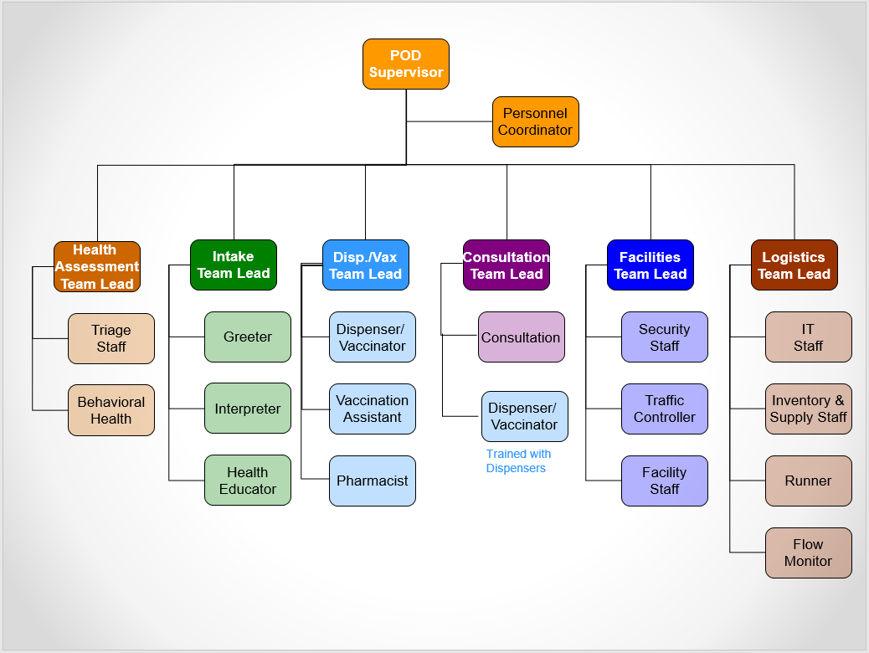
Example Organization Chart
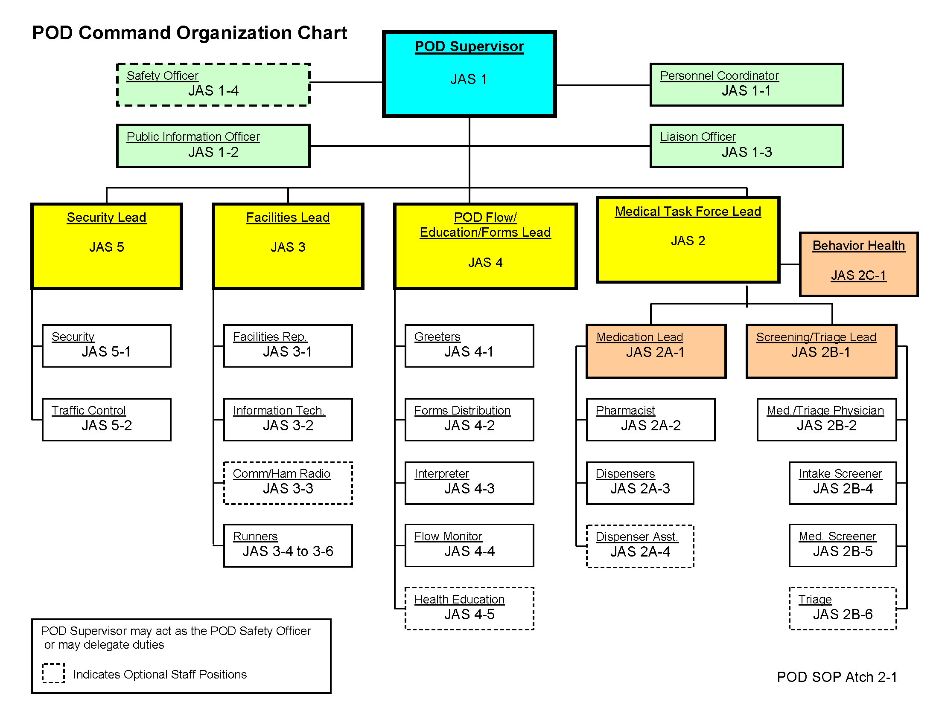
Example Organization Chart

Minimum POD Staffing and Space Planning Chart

Instructions for this chart:
- These estimates are based on dispensing antibiotics within an 8-hour period (a typical work day).
- The estimated number of people coming through per hour is in the left-hand column.
- The minimum number of recommended staff are suggested and listed by position. Anytime there are POD sites without staff in all possible positions, it is expected that existing staff perform multiple job functions (i.e. an Operations Chief performs functions of helping to complete forms, screening and dispensing if they are the only person working - or the Logistics chief performs inventory and personnel coordination work).
- Breaking functions down increases efficiency but also requires more space.
- The two functions that take the most time include completing the screening form and making screening recommendations.
- Incident Command System (ICS) suggests Span of Control when assigning people to positions. Three to seven people are assigned to one supervisor or team lead in the Span of Control model. Five people assigned to one supervisor is optimal.
- Please see next page for the Planning Chart.

Minimum POD Staffing and Space Planning Chart
Total # of ppl  Served | # of Ppl/ Hour | Minimum Square Feet* | POD Sup. | Runner | Greeter | Forms Reviewer | Screeners | Dispensers | Inventory Manager | Security Lead | Safety Officer | Total Recommended Staff
400 | 50 | 200 | 1 | 1 | 1 |  | 1 |  | 1 | 1 |  | 6
800 | 100 | 300 | 1 | 1 | 1 |  | 3 |  | 1 | 1 |  | 8
1200 | 150 | 500 | 1 | 1 | 1 |  | 2 | 2 | 1 | 1 |  | 10
1600 | 200 | 1,000 | 1 | 1 | 2 | 1 | 3 | 2 | 1 | 1 | 1 | 14
2000 | 250 | 2,000 | 1 | 1 | 2 | 1 | 3 | 3 | 1 | 1 | 1 | 15
2400 | 300 | 3,000 | 1 | 1 | 2 | 2 | 4 | 4 | 1 | 2 | 1 | 19
2800 | 350 | 3,000 | 1 | 1 | 3 | 3 | 5 | 4 | 1 | 2 | 1 | 22
3200 | 400 | 4,000 | 1 | 1 | 4 | 2 | 5 | 5 | 1 | 2 | 1 | 24
3600 | 450 | 4,000 | 1 | 1 | 4 | 3 | 6 | 5 | 1 | 2 | 1 | 26
4000 | 500 | 5,000 | 1 | 1 | 4 | 3 | 6 | 6 | 1 | 3 | 1 | 28
4400 | 550 | 5,000 | 1 | 1 | 5 | 4 | 7 | 6 | 1 | 3 | 1 | 32
4800 | 600 | 6,000 | 1 | 1 | 6 | 4 | 7 | 7 | 1 | 3 | 1 | 34
5200 | 650 | 6,000 | 1 | 1 | 6 | 4 | 8 | 7 | 1 | 3 | 1 | 35
5600 | 700 | 7,000 | 1 | 1 | 6 | 4 | 8 | 8 | 1 | 3 | 1 | 36
6000 | 750 | 7,000 | 1 | 1 | 6 | 4 | 9 | 8 | 1 | 3 | 1 | 37
6400 | 800 | 8,000 | 1 | 1 | 6 | 5 | 9 | 9 | 1 | 3 | 1 | 39
6800 | 850 | 8,000 | 1 | 1 | 6 | 5 | 10 | 9 | 1 | 3 | 1 | 40
7200 | 900 | 9,000 | 1 | 1 | 6 | 5 | 10 | 10 | 1 | 3 | 1 | 41
7600 | 950 | 9,000 | 1 | 1 | 6 | 5 | 11 | 10 | 1 | 3 | 1 | 42
8000 | 1000 | 10,000 | 1 | 1 | 6 | 5 | 12 | 11 | 2 | 4 | 1 | 47
Modified NACCHO Closed POD Toolkit Chart

Staffing for Standard Positions in a POD – Non-Medical and Medical Models

Position | JAS | JITT | POD Location | POD Role
POD Supervisor | G-1 | #1, #7, #11, #12 | Command Post (CP) | Oversees POD Response
Personal Coordinator | 1-1 | #1 | Command Post | Personnel Assignments
Public Information Officer | 1-2 | #2 | Command Post | Media
Liaison Officer | 1-3 | #2 | Command Post | EOC/Volunteer/Mutual Aid Liaison
Safety Officer | 1-4 |  | Command Post | POD Safety
Medical Task Force Leader | G-2 | #10, #11, #12 | CP/POD Floor | Supervise Medical Unit
Dispensing Crew Lead | 2A-1 | #10 | POD Floor | Oversees Dispensing Stations
Dispensers | 2A-3 | #10 | POD Floor | Provides/Dispenses MCM
Dispenser Assistants | 2A-4 | #10 | POD Floor | Assists with Dispensing MCM
Screening/Triage Crew Leader | 2B-1 | #5,#10 | POD Floor/Triage | Oversees Screening and Triage
Screeners | 2B-4 | #5, #10 | POD Floor | Reviews forms
Medical Screener | 2B-5 | #5, #10 | POD Floor | Reviews forms for contraindications
Triage Medical Staff | 2B-2 | #5 | Triage | Provide medical input for triage
Triage Staff | 2B-6 | #5 | Triage | Screen clients entering POD
First Aid | 2B-3 | #5, #6 | POD Floor | Provide First Aid
Behavioral Health Staff | 2C-1 | #5 | POD Floor | Provide assistance
Facilities Unit Leader | G-3 | #7, #11, #12 | Command Post | Supervises Facility/Logistics Related Functions
Facilities Representative | 3-1 |  | Roving | Provide Facility & Custodial Services
Information/Technology (IT) | 3-2 | #2, #3 | Communications | Set Up Computers, Software & Communications
Communications/Radio | 3-3 | #2 | Communications | Set Up & Operate Amateur Radio Communications
Inventory Manager | 3-4 | #13, #8, #9 | Inventory Control Room | Account for all MCM and Supplies released & returned to Inventory Room
Runners (Supply) | 3-6 | #13, #8 | Roving | Stock/Restock Supplies throughout POD
Runners (MCM Supply) | 3-5 | #13, #8 | Roving | Supply/Resupply Dispensing Stations
POD Flow Unit Leader | G-4 | #1, #4, #7, #11, #12 | CP/POD Floor | Supervises POD Flow & Stations
Greeters | 4-1 |  | POD Floor | Greet, Direct & Distribute Forms
Forms Distribution | 4-2 |  | POD Floor | Distribute, Collect & Review Forms
Interpreter | 4-3 |  | POD Floor | Provide Language Interpretation
Flow Monitors | 4-4 | #7 | POD Floor | Direct foot traffic throughout POD
Health Educators | 4-6 |  | POD Floor | Provide Information & Answer Questions
Security Unit Leader | G-5 | #1, #4, #11, #12 | CP/POD Floor | Supervise all aspects of POD Security
Security | 5-1 |  | Roving | Provide Security & Crowd Control
Traffic Control/Parking | 5-2 | #4 | Exterior | Direct Traffic, Parking & Crowd Control

Additional Staffing Considerations for Medical Model Dispensing and Vaccination PODs

Position | JAS | JITT | Location | Role
Medical Unit
Medication Lead |  | #9 | POD Floor | Oversee Dispensing Stations
Pharmacist | 2A-2 | #9 | Vaccin. Stations | Oversees Dosages & Inventory Room
Vaccinators/Dispensers | 2A-3 | #10 | Vaccin. Stations | Dispense Medications
Vaccinator/Dispenser Asst. | 2A-4 | #10 | Vaccin. Stations | Assist in Dispensing Medications
EMS/First Aid | 2B-3 | #6 | First Aid Station | Respond to POD Medical Emergencies
Medical/Triage Physician | 2B-2 | #5 | Triage/POD Floor | Screen & Assess Symptomatic Persons
 |  |  | Staff guidelines are general estimates; to be adjusted as needed.

Basic Example of Standard POD
Step One: Fill Out Form Step Two: Show Form Step Three: Get Meds Step Four: Exit
Public Exit
Supply
Receiving
Inventory
Step Four: Exit and Data Collection Station(s)
Layout will vary based on facility. Unidirectional flow is essential.

Step Three: Dispensing Station(s)

Step Two: Screening Form Station(s)

Step One:
Fill Out Form Station(s)

Option: Merge steps two and three into one station.
Greeters: Ask questions, distribute forms, & direct to enter POD

POD Supervisor/Incident Command Post
Staff Entrance
Public Entrance

Detailed Example of Standard POD
Layout will vary based on facility. Unidirectional flow is essential.
Supply
Receiving
Inventory
Public Exit
Data Collection Station(s)

Medical Evaluation

Behavioral Health Station – position in POD for access to the Public
Family and Assisted Dispensing
Vaccination Station(s)

Screening Station(s)
Health Education
Interpretation
Express Dispensing
Expressing Dispensing
Vaccination Station(s)

Greeters: Ask questions, distribute forms, & direct to enter POD

Express Dispensing
Vaccination Station(s)

Fill Out Form Station(s)
Express Dispensing
Vaccination Station(s)
Public Entrance

Medical Triage Evaluator
POD Supervisor/Incident Command Post
Staff Entrance and Check In

EXTERNAL POINT OF DISPENSING CONSIDERATIONS

The list below are aspects to traffic flow and parking to consider when choosing facilities for Points of Dispensing (POD).

- As within the POD, unidirectional flow for the parking lot should be considered
- Entrance for the Public
  - Entrances are accessible for populations with disabilities and access and functional needs
- Exit for the Public
- Parking for the Public
  - Ensure parking is accessible for populations with disabilities and access and functional needs
  - Reserve parking is recommended for populations with disabilities and access and functional needs
  - Overflow parking lot with provided transportation to POD
- Well-lighted parking lot(s), especially if POD is operating 24 hours
- Space for Parking Attendants and External Security to perform response operations
- Appropriate barriers, cones and signage to direct the Public into the POD
  - Work with Public Works Departments, Emergency Management and Law Enforcement to procure necessary equipment
- Additional restroom facilities such as rented Port-a-Potties placed near POD entrances
- Loading dock or a secured separate entrance into the POD, near inventory control station for medical countermeasures and supplies delivered
- Separate and secured entrance and exit for POD staff and volunteers
- Separate and secured parking for POD staff and volunteers
- Streets surrounding the POD can be adjusted for unidirectional flow to prevent traffic bottlenecks entering and exiting the POD site

SIGNAGE AND POD COLOR CODES

Signage
- Basis for the signage in this POD FOG is from the Washington State Department of Health’s Medication Center. Links to the Adobe InDesign and PDF Formats for the signs listed below are in the Resources section.
- Size and layout of the POD influences number of signs and specific messages needed.
- Various signs are translated in the following languages:

  - Spanish
  - Russian
  - Vietnamese
  - Chinese

- Suggested signs to use in PODs are:

  - Entrance
  - No entrance
  - Prohibited
  - This is a medical services facility
  - Symptoms signs according to incident
  - Four Simple Steps
  - Step 1: Fill In Form
  - Step 2: Show Form
  - Step 3: Please Wait
  - Step 4: Turn In Form & Exit
  - Thank you for your cooperation
  - First Aid
  - Exit
  - No Exit
  - Arrows

- Additional signs area available by clicking here:

  - To POD (with arrows)
  - To Parking (with arrows)
  - Entrance (with arrows)
  - Restrooms (with arrows)
  - Pocket Communicator

Color Coding Positions
Color-coding each function or station to the staff vests may improve the throughput at the POD. Colors provide a visual path or cues to direct the public through the POD, if too many colors are not used. Access to vest and other identification for positions may not be available readily. Consider other options to identify POD stations and personnel working within the stations with resources available.

Recommendation to use vest with inserts to further identify POD staff by position. For insert templates, please refer to <<Annex XX>>.

*Example*
POD Staff Position | Color-Code
POD Command Staff including: Supervisor, PIO, Safety, Liaison | White. This is consistent with ICS section color-codes.
Forms, Flow Monitors, Educators including: Greeters, Intake/Registration | Green. Consistent with the Washington State signs. Consideration: Place Educators or Flow Monitors in an alternate color to make them easier to see.
Screener and Triage | Orange. Consistent with Washington State signs for screening. Consideration: Place Medical Screener is an alternate color to make them easier to see.
Dispensing | Blue. Consistent with Washington State signs.
Runners | Red

Vests, caps, nametags, floor tape and tablecloths are items that can be color-coded to distinguish the various functions. The use of small, hand-held flags is helpful to indicate an available dispenser or for POD staff to call a Runner.

No

Yes
Local supplies not sufficient to respond to Public Health threat – Local health department requests resources from county EOC
Local resource request received by county Emergency Operations Center (EOC) ESF-8 Logistics Unit

If county EOC cannot find the resource, county EOC submits request to Oregon’s ESF-8 Logistics Unit through the state Emergency Coordination Center (ECC)

SNS assets along with SNS technical staff deployed to Oregon’s Receiving, Staging and Storage (RSS) site
Oregon’s state ESF -8 Logistics Unit in coordination with state RSS staff process resource requests and distribute orders and re-orders to PODs
Resource demobilized or expended
If state ESF8-Logistics Unit cannot find the resource, state ECC submits request to Federal Joint Field Office Request for SNS assets comes from the Governor or his/her designee (i.e., State Health Officer). President Declares Emergency

Note: Resources must be exhausted or expected to be exhausted locally and at the state level before federal assets are requested.
Additional resources required?

SNS Resource Request Flow Chart

(Local to State)

MEDICAL CONSIDERATIONS

Standing Orders and Emergency Dispensing
Sample standing orders for anthrax, tularemia and plague are available by clicking here. Dosing charts and standing orders provided are examples.

The Local Health Officer is responsible for signing the standing orders and approving all medication and vaccination dosing for all incidents as delineated in the IAP.

In an emergency, sufficient licensed health professionals (nurses, nurse practitioners, physician assistants, pharmacists, emergency medical technicians, and physicians) may not be available to dispense medications. In these instances, a health educator, other allied health professional, or trained staff may be used to dispense medications. Just-in-time-training with adequate supervision is provided to all dispensing and POD staff. Optimally, at least one pharmacist, physician or dentist is available for dispensing consultation at each POD. In emergency situations, consider integrating web-based screening into existing dispensing practices. Tools such as Dispense Assist can help increase efficiency in the POD. More information on Dispense Assist can be found in <<Annex XX>>.

Intake Form (Appendix D)
Mass production of all forms, intake, and medication and disease fact sheets is the responsibility of each county. Intake forms here describe medical and non-medical model examples for modification in PODs.

The full-page form, with multiple household members’ information, is given to the public to complete prior to receiving medication when a modified medical model is in use at a POD.

An individual may pick up medication for him/herself and other people, who may or may not live within the same household. It is at the discretion of the POD Supervisor to determine if an individual is requesting an unreasonable number of doses.

The half page form, containing just three questions, is given to the public to complete when a non-medical model is used at a POD.

Pediatric Suspension Dosing Charts
Limited amounts of pediatric suspension are available through the SNS, so this guide provides links to emergency dosing charts for infants and children courtesy of the Oregon Health Authority. See reference section for the Model Standing Orders for Anthrax. Due to limited quantities of suspension, most of pediatric dispensing is handled through pill crushing.

Information on pill crushing of Doxycycline for children and those who cannot swallow pills: Not everyone is able to swallow pills or requires a full dose. The United States Food and Drug Administration (FDA) provides information on how to prepare Doxycycline for those with swallowing difficulties. Double and single sided pamphlets are available in both English and Spanish entitled, “In an Emergency: How to Prepare Doxycycline for Children and Adults Who Cannot Swallow Pills” electronically by clicking here. English versions are included in the Forms Appendix <<D, 15a and 15b>>.
Note: The FDA does not approve the crushing of Ciprofloxacin. Infants, children and adults who cannot swallow pills are given Doxycycline along with the FDA pill crushing instructions listed above.

Post exposure dispensing Algorithm
The algorithm on the next page is a tool for determining who gets what medications in an antibiotic mass prophylaxis campaign. This algorithm is based on a modified medical model so only takes into account the most important medical interactions. This algorithm takes into account the new guidelines by the FDA that do not support the crushing of Ciprofloxacin pills. The major demographic group that requires consideration to this issue is children under nine years of age who cannot swallow pill
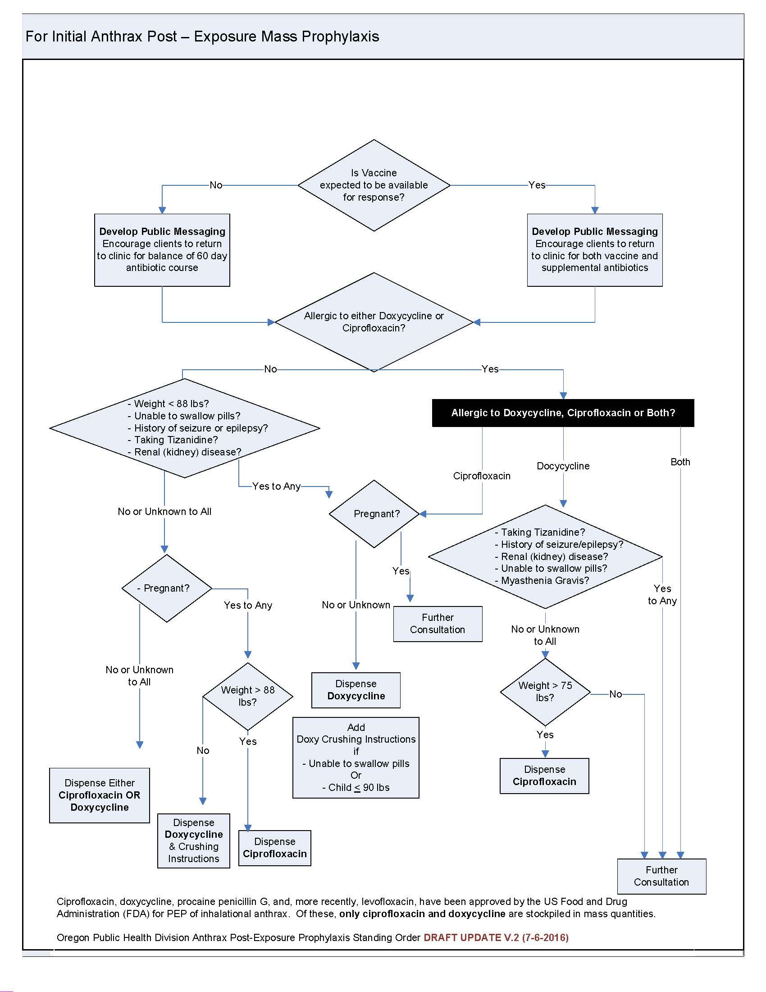
RESOURCES

MCM/POD/JITT Information
Portland Metropolitan Cities Readiness Initiative
http://crinorthwest.org/index.html
Inclusive Just-In-Time Training (IJITT) Toolkit for Mass Prophylaxis/POD Operations
http://crinorthwest.org/pod-tools.html
Oregon Health Authority Medical Countermeasures
https://www.oregon.gov/oha/PH/PREPAREDNESS/PARTNERS/Pages/medicalcountermeasures.aspx
Washington State Department of Health Medical Center
https://www.doh.wa.gov/ForPublicHealthandHealthcareProviders/EmergencyPreparedness/EmergencyCommunicationsToolkit/MedicationCenterResources
Medical
Dispense Assist
https://www.dispenseassist.net/
Model Standing Orders from Oregon Health Authority Public Health Division
https://www.oregon.gov/oha/PH/PreventionWellness/VaccinesImmunization/ImmunizationProviderResources/Pages/stdgordr.aspx
U.S. Food and Drug Administration Emergency Use Authorization
https://www.fda.gov/emergencypreparedness/counterterrorism/ucm182568.htm
Communications
Oregon Health Authority Health Alert Network (HAN)
https://www.oregon.gov/oha/PH/Preparedness/Partners/HealthAlertNetwork/Pages/index.aspx
Oregon Health Authority Crisis and Emergency Risk Communications Toolkits
https://www.oregon.gov/oha/PH/PREPAREDNESS/PARTNERS/Pages/riskcommunicationtools.aspx
Emergency Preparedness and Response
Oregon Health Authority Health Security Preparedness and Response
https://www.oregon.gov/oha/PH/Preparedness/Pages/index.aspx
CDC Emergency Preparedness and Response
https://emergency.cdc.gov/
Health and Human Services Public Health Emergency
https://www.phe.gov/preparedness/pages/default.aspx
Population Data Sources
Portland State University Population Research Center
https://www.pdx.edu/prc/about-prc
U.S. Census Bureau Fact Finder
https://factfinder.census.gov/faces/nav/jsf/pages/index.xhtml

