Logic Model

Developing your Logic Model

Special Note
This activity builds upon the work done in Activity #1 that focused on the Theory of Change. It’s recommended that you complete that work prior to developing your Logic Model.

Introduction
A Logic Model is a more detailed, visual representation of a program’s Theory of Change. The Logic Model communicates how a program works by depicting the intended relationships among the resources available to operate the program (inputs), the activities the program carries out, and the results the program hopes to achieve (outputs and outcomes). Because it details the core activities and outcomes of the program design, the Logic Model serves as a road map to how you’ll evaluate your program, helps you define how you will measure success (i.e. your performance measures), and helps you plan training, replication, etc.
While many organizations have engaged in a process to create a Logic Model, the planning grantee cannot assume that the organization-wide Logic Model will address AmeriCorps’ needs and should plan to spend time adopting it for the AmeriCorps program and/or creating a new AmeriCorps-specific Logic Model.

What your Logic Model will include:
For AmeriCorps, your Logic Model will include six main sections as depicted and described below.
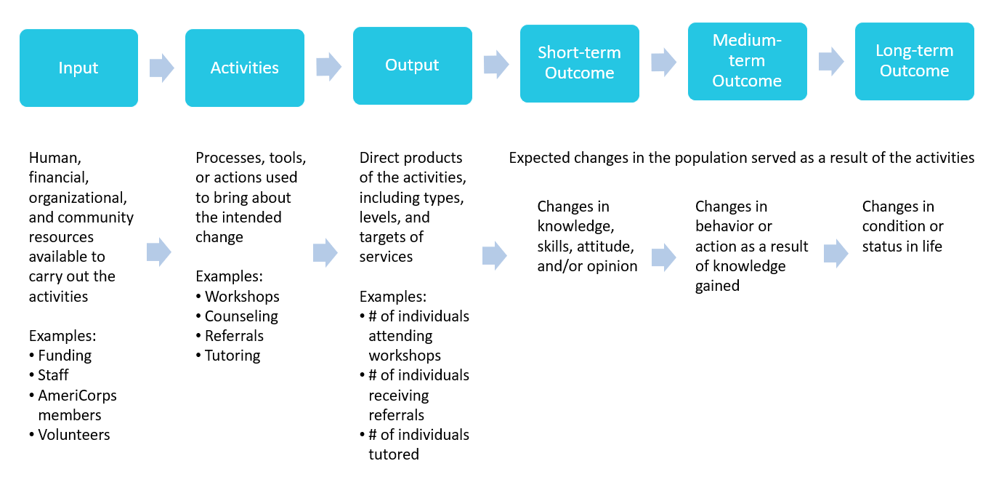
Sections of the Logic Model
- A summary of the community problem/need outlined in the narrative. While not depicted here, the AmeriCorps Logic Model does require a summary of the community problem/need as described in your Theory of Change. This is a good opportunity to use additional statistics that support the description of your community need.
- The inputs or resources that are necessary to deliver the intervention, including but not limited to:
  - Number of locations or sites in which AmeriCorps members will provide services
  - Number of AmeriCorps members that will deliver the intervention
  - Other resources to consider:
- Funding
- Local partners
- Training
- Materials used (e.g., curricula, supplies, etc.)
- The core activities that define the intervention or program model that AmeriCorps members will implement or deliver including:
  - A description of the intervention
  - The duration of the intervention -- the total intended number of sessions, meetings, or events, or weeks or months of the intervention; this may be described or defined as a minimum threshold of time (e.g., patients will be trained within a time period of at least two months)
  - The dosage of the intervention -- the number of hours per session, sessions per week, or a description of the nature of the intervention). This may be a minimum amount of intervention that defines who has received your program vs. who has not (e.g., youth will attend at least six 30-minute sessions), and is ideally based on research or other evidence.
  - The target population or service beneficiary for the intervention (e.g., disconnected youth, third graders at a certain reading proficiency level)
- The measurable outputs that result from delivering the intervention (i.e. number of beneficiaries, or people, served). While outputs are the essential elements that enable change, they do not represent benefits or changes in and of themselves. Program outputs are direct products of a program’s activities or services. Outputs quantify the services that were delivered.
  - If applicable, identify which National Performance Measures will be used as output indicators. If there is no relevant National Performance Measure, it is still helpful to use other CNCS performance measures as a model for how you construct your own.
  - If possible and relevant, choose at least one “high-priority” Performance Measure (PM).
- Outcomes demonstrate changes in knowledge/skills, attitudes, behaviors, or conditions that occur as a result of the activities (intervention). If applicable, identify which National Performance Measures will be used as outcome indicators.
  - Programs may include short (typically within 1 program year), medium (typically within 2-4 years), or long-term outcomes (typically 5 years or more following an intervention or after a long-term intervention) in the Logic Model.
  - The outcomes you measure must be feasible to measure and report on within 1 program year; PMs must be measured and reported on each program year. So typically, you will only be measuring and reporting on “short-term” outcome(s).
  - Although performance measure outcomes should be consistent with the program’s theory of change, programs are not required to measure all outcomes that are included in the Logic Model.

Note: applicants with multiple interventions should complete one Logic Model chart that incorporates each intervention; logic model content that exceeds three pages will not be reviewed.

Definitions
Community problem is the specific need in the community you have chosen to address through your program/project.
Inputs or resources include the human, financial, organizational, and community resources available for carrying out a program’s activities.
Activities are the processes, tools, events, and actions that are used to bring about a program’s intended changes or results.
Outputs are the direct products of a program’s activities and may include types, levels and targets of services to be delivered by the program.
Outcomes are the expected changes in the population served that result from a program’s activities and fall along a continuum, ranging from short to long term results

Developing Your Logic Model
There are two main approaches used to develop a Logic Model:
- Reverse logic (right to left) – Starting with the Long-Term Outcome, work backward toward the Inputs needed by asking “but how” questions. For example, if our long-term outcome is to increase the number of healthy families, we would ask but how can we do that?
- Forward logic (left to right) – Starting with the Inputs, working forward toward Outputs, by asking “if…then” questions. For example. If we had x resources, then what activities would be possible? If we did x activities, then what outputs would be possible? And so on.

Sticking Points and Common Issues
- The Logic Model exceeds 3 pages in length.
  - Only content on the first three pages of the Logic Model, as printed from eGrants, will be reviewed.
- The Logic Model includes extraneous information to demonstrate the complexity of the program.
  - Only content that is relevant to the proposed AmeriCorps program’s design should be included in the Logic Model. Adding additional information opens the applicant to the risk of leaving out important details about the AmeriCorps design.
- The Short-term Outcomes are erroneously categorized as Outputs, and/or Medium- and Long-term Outputs are intermingled with Short-term Outcomes.
  - Accurately labeling the various outputs and outcomes can be challenging.
    - Outputs are easily quantifiable and are the direct product of the activities (e.g., # of individuals receiving services, # of house built).
    - Consider both the timeframe of when one might see the outcome (short-term = with 1 program year; medium-term = 2-4 years; long-term = 5+ years) and changes in knowledge, skills, attitudes (short-term) versus changes in behavior (medium-term) versus changes in condition (long-term) to help delineate these.
- Outputs are expressed as percentages instead of numerical values.
  - Outputs that will be used as PMs must be expressed as numerical values, not percentages.
- Outputs and/or outcomes are not reasonable or attainable and/or do not match the outcomes described in the Theory of Change and/or Performance Measures.
  - Ensure that all targets are numerical values that are consistent throughout the various sections of the application. Make sure to set targets that are reasonable and attainable and take the realities of the program into consideration (i.e. attrition).

Instructions
Fill in the table below using bullet points to express each new idea. Make sure to cite sources in the community need section. Where possible, try to visually align outputs and associated outcomes across the table. Ensure that your Logic Model does not exceed 3 pages (please note, this table may not align with the Logic Model format in eGrants). When you are done, use the checklist at the end to review the worksheet and identify where you have written a well-defined element and/or which elements need further strengthening.

PROBLEM | INPUTS | ACTIVITIES | OUTPUTS | OUTCOMES
 |  |  |  | Short-term | Medium-term | Long-term
What is the community need | What we invest | What we do | Direct products from program activities | Changes in knowledge, skills, attitudes, opinions | Changes in behavior or actions that result from participants’ new knowledge | Meaningful changes, often in their condition or status in life

Logic Model Checklist
Use the following checklist to determine if the theory of change has all needed components.
Element | Criteria | Status | Ideas for improvement
Need/Problem Statement | - Have you identified the needs that AmeriCorps members will address? | ❑ Yes   No
 | - Have you cited sources and used statistics to demonstrate this need? | ❑ Yes   No
 | Local (Relevant to the proposed service locations) | ❑ Yes   No
 | Current (if not within past few years provides explanation) | ❑ Yes   No
Inputs | - Identifies the key resources or assets that the organization will provide in this program/leverage to address the needs? | ❑ Yes   No
 | - Where applicable, includes resources like:  # of AmeriCorps members | ❑ Yes   No
 | # partners sites, trainings, curricula, etc. | ❑ Yes   No
Activities | - Identifies the specific and detailed activities that AmeriCorps members will do to address the needs listed. | ❑ Yes   No
 | - Provides evidence from research on the program or similar programs (emphasize programs with similar activities/strategies) | ❑ Yes   No
 | - Activities are appropriate for:  AmeriCorps members | ❑ Yes   No
 | the level of training you will provide (or the skills you will recruit for) | ❑ Yes   No
 | Able to make an impact in 1 year | ❑ Yes   No
 | Aligned with outcomes | ❑ Yes   No
Outputs | - Outputs are measurable and are numeric (not percentages) | ❑ Yes   No
 | - Outputs are ambitious, but also reasonable and achievable. | ❑ Yes   No
 | - Program has or can develop a system to measure outputs. | ❑ Yes   No
 | - National Performance Measure identified where applicable. | ❑ Yes   No
Outcomes | - The outcomes you care about and intend your program to influence are included. | ❑ Yes   No
 | - Includes some outcomes that AmeriCorps members could impact in 1 year. | ❑ Yes   No
 | - It is reasonable to assume that the program can achieve the expected outcomes? | ❑ Yes   No
 | - The long-term outcomes you hope this program will address (5+ years out) are identified. | ❑ Yes   No
General | - Does the logic of the model seem correct? Are there any gaps in the logic of the program? | ❑ Yes   No
 | - Does your model contain an appropriate amount of detail for its intended use? | ❑ Yes   No
 | - Do program staff (and external stakeholders) agree that the model accurately depicts the program and its intended results? | ❑ Yes   No

