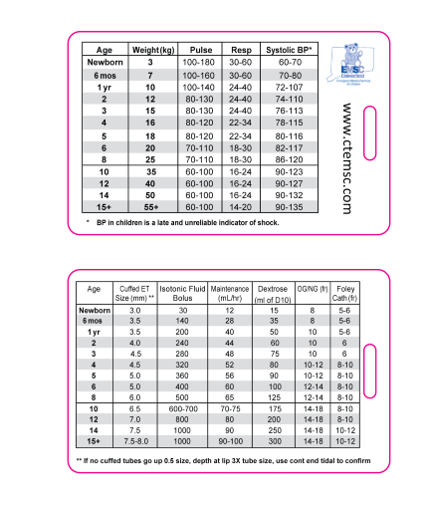

Qty: 2,000
3.375” x 2.125”
30-mil
Ship asap

