Patient Attendant
Phone Numbers
CED Charge Nurse: 66730 Bedside Nurse: ____________ Social Work: x66895

Thanks for helping!! Please call the above numbers if you need anything or have any questions!
Things to remember:
- Engage with the patient. Options - play a game, watch a movie, talk to them, go for a walk around the unit. Some patients may want to just be quiet – spending time journaling or doing art. That’s ok too. Just be present.
- Be alert to possibility of patient obtaining or concealing medications or dangerous objects from other patients, visitors, or environment that could be used for self-harm. ​
- Charting required Q 1 hour. If you do not have Epic access, downtime documentation will be given to you. For Epic documentation see screen shot below.

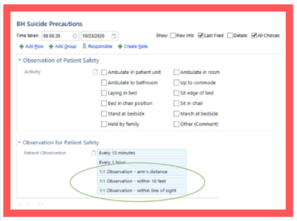

Name: _______________________________________________________________________________________________

Date: ________________________ Shift Worked: __________________________ Home Unit: ____________________

Were you welcomed and introduced in unit huddle? q YES q NO q N/A (I wasn’t at huddle)
Was your assignment appropriate? q YES q NO
If not appropriate, did you let the charge nurse know? q YES q NO
If NO, why not q I can do anything for 12 hours
- I didn’t feel comfortable approaching anyone in the CED
- It didn’t meet the guidelines, but I have the appropriate skill set and could do the assignment
- I didn’t have time
- Patient condition changed

Was report clear and complete, allowing you to effectively care for your patient and his/her family? q YES q NO
Did you receive appropriate in-time education from the off-going staff member? q N/A q YES q NO
Did you receive the support you needed?  YES q NO
If you answered NO to any of the above questions, did you share your feedback with the CED?  YES q NO
If NO, why not? q I wasn’t comfortable talking to charge nurse
- I didn’t have time
q I didn’t feel my feedback would change things

What was the most challenging part of your day?

What would have made the day go more smoothly for you?

What was the best part of your day?
Thank-you for taking the time to help us improve floating to the CED.

